Background
- The National Assessment Circular 01 of 2021 contains the GET subject weightings for 2021.
- The SBA weightings is displayed as weights out of 80%
- SA-SAMS is a standard system with weighting shown as 100 %. This is to convert the SBA total to any other percentage % e.g. 100%, 80%, 75%, 60% etc.
- This guide is to show the equivalent weight numbers when converted from 80% to 100%.
The print screens contain the conversions for the following GET subjects:
 | Grade |  | Subjects : Non - Languages | Page
 | 4-6 |  | Life Skills | 1
 | 4-9 |  | Mathematics | 2
 | 4-9 |  | Social Sciences | 2
 | 4-6 |  | Natural Sciences & Technology | 2
 | 7 -9 |  | Natural Sciences | 3
 | 7 -9 |  | Economics and Management Sciences | 3
 | 7 -9 |  | Technology | 3
 | 7 -9 |  | Creative arts | 4
 | 7 -9 |  | Life Orientation | 4
Grades |  | Subject: Life Skills |  |  |  |  | Remarks
Grades 4 -6 |  | Term 1 to 3 contributes 80 % to the promotion mark.  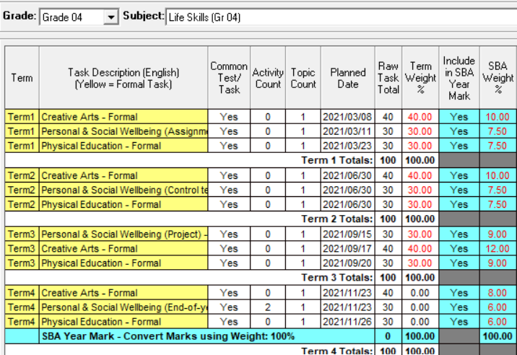  T4 20%  T1-3 80% |  |  |  |  | - SBA Weighting for as per revised ATP’s.  - Dates must be adjusted to school assessment program – also to order the tasks on the capturing sheet.  - Learner assessment scores are captured and reported per task  - A score of “-1” is captured for absenteeism (or if no assessment was done) with valid reason.  - 1 score required if “Activity Count” is 0 (1 Column of marks)  - **2 sets of scores required if “Activity Count” is 2  - Analysis marks available in different reports on 12.9 e.g.
  12.9.16 | Subject performance
  12.9.16.8 | Separated analysis for tasks if “Yes”
  12.9.13 | Learners at risk  Top achievers
Grades |  | Subject: Mathematics |  |  | Remarks
Grade 4 -6 |  | 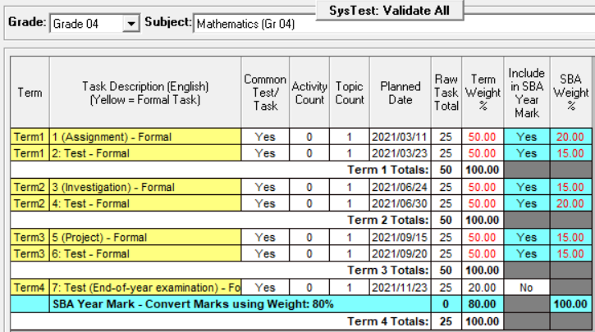 |  |  | SBA (Term 1-3) contributes 80 % to the promotion mark and is calculated as follows:
  SBA 80% | SA-SAMS
  16 | 20
  12 | 15
  12 | 15
  16 | 20
  12 | 15
  12 | 15
   | 100% converted to 80%
Grades |  | Subject: Social Sciences |  |  | Remarks
Grade 4-6 |  | 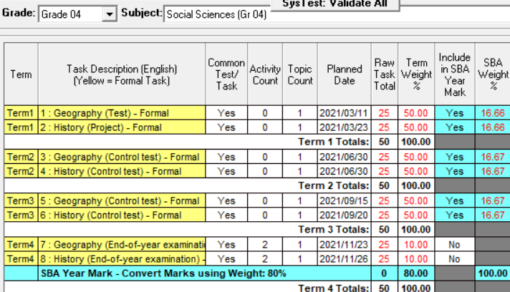 |  |  | SBA (Term 1-3) contributes 80 % to the promotion mark and is calculated as follows:
  SBA 80% | SA-SAMS setting
  13.33 | 16.66
  13.33 | 16.66
  13.33 | 16.67
  13.33 | 16.67
  13.33 | 16.67
  13.33 | 16.67
   | 100% converted to 80%
Grades |  | Subject: Natural Sciences & Technology
Grade 4 -6 |  | 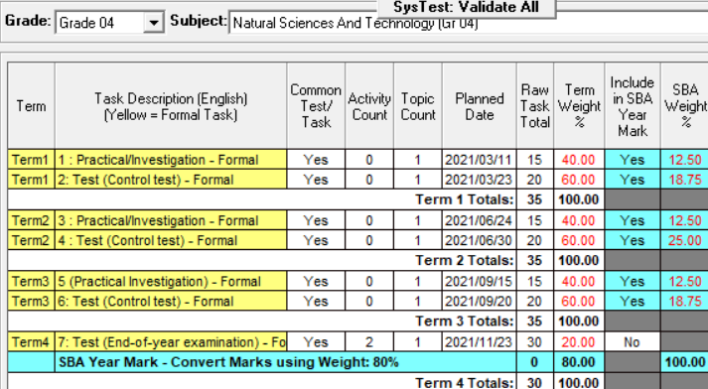 |  |  | SBA (Term 1-3) contributes 80 % to the promotion mark and is calculated as follows:
  SBA 80% | SA-SAMS setting
  10 | 12.5
  15 | 18.75
  10 | 12.5
  20 | 25
  10 | 12.5
  15 | 18.75
   | 100% converted to 80%

Grades | Subject: Natural Sciences
Grade 7-9 | 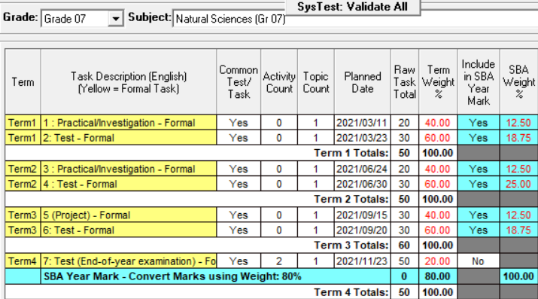 | SBA (Term 1-3) contributes 80 % to the promotion mark and is calculated as follows:
  SBA 80% | SA-SAMS setting
  10 | 12.5
  15 | 18.75
  10 | 12.5
  20 | 25
  10 | 12.5
  15 | 18.75
   | 100% converted to 80%
Grades | Subject: Economic Management Sciences
Grade 7-9 | 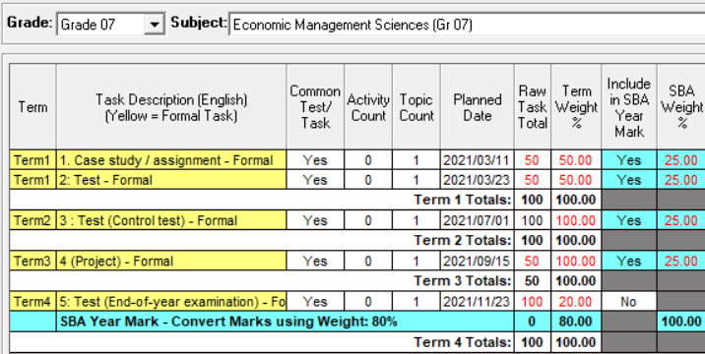 | SBA (Term 1-3) contributes 80 % to the promotion mark and is calculated as follows:
  SBA 80% | SA-SAMS setting
  20 | 25
  20 | 25
  20 | 25
  20 | 25
   | 100% converted to 80%
Grades | Subject: Technology
Grade 7-9 | 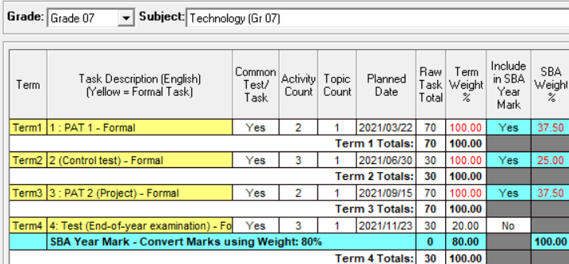 | SBA (Term 1-3) contributes 80 % to the promotion mark and is calculated as follows:
  SBA 80% | SA-SAMS setting
  30 | 37.5
  20 | 25
  30 | 37.5
   | 100% converted to 80%

Grades | Subject: Creative Arts
Grade 7-9 | 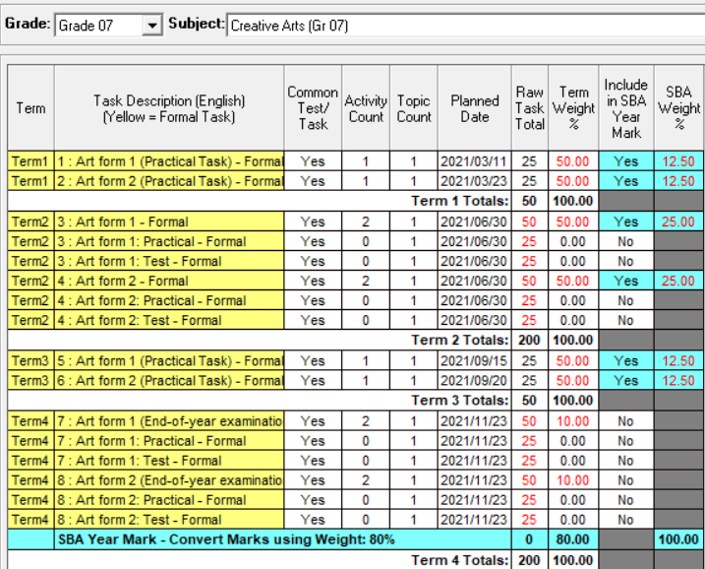 | SBA (Term 1-3) contributes 80 % to the promotion mark and is calculated as follows:
  SBA 80% | SA-SAMS setting
  10 | 12.5
  10 | 12.5
  20 | 25
  20 | 25
  10 | 12.5
  10 | 12.5
   | 100% converted to 80%
Grades | Subject: Life Orientation
Grade 7 | 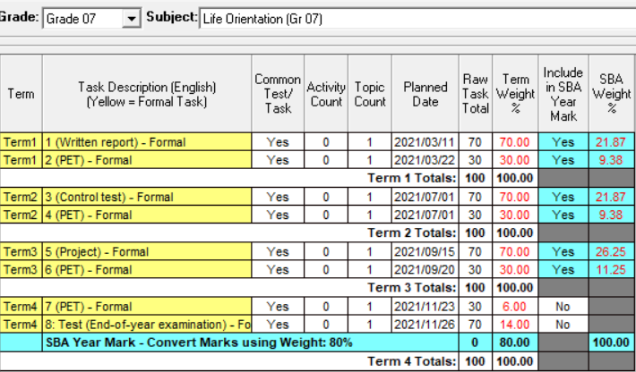 | SBA (Term 1-3) contributes 80 % to the promotion mark and is calculated as follows:
  SBA 80% | SA-SAMS setting
  17.5 | 21.67
  7.5 | 9.38
  17.5 | 21.67
  7.5 | 9.38
  21 | 26.25
  9 | 11.25
   | 100% converted to 80%

