
The South African School Administration and Management System (SA-SAMS), is designed for the South African Education Sector and is therefore policy based to standardise implementation across all provinces. To keep the system valid and data credible it will be updated quarterly with the latest requirements to assist schools with administration and reporting.
This version contains many new updates but the following changes are very important:
- It should be noted that the security on SA-SAMS has been improved and that the password of all registered users will expire every month.
- The following Gr 12 subjects were updated in accordance with the DBE and Interprovincial subject meetings: Technical science, Civil technology (all specialisations), Nautical Science and Maritime science. All other subject updates are listed at the end.
- New reporting functions are IQMS (2.18), SIAS (3.1.9), NSNP (3.8), SGB Quarterly Reporting (5.1.2) New Annual Academic Report included (7.3)
The changes for Version 18.1.1/2 are listed in the table below.
- User Access
Description | Screen nr | What is new / changed | Action by the school
Updated user access | On Landing page:  User preferences  16.12 | User access was updated as requested by AGSA in order to improve the data security.  - The password of all registered users (16.12) will expire every month. Administrator Password should be shared with the Principal or SMT Administrator Head.  - The password can be reset by the Administrator on 16.12  - All staff need to get own username and passwords in order to complete the IQMS and other sensitive information. | - The password can change on User Preferences

- School General Information
Description | Screen nr | What is new / changed | Action by the school
Additional options for Focus schools | 1.1 tab 3 | - Additional categories available to identify Focus schools  - School of skill  - MST Grants  - Sports | - Update if school is a focus school
New curriculum types for Independent schools | 1.1 tab 2 | Independent schools to select the type of curriculum that they offer  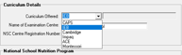 | - Independent schools to update this field
New types of specialisations for SNE schools | 1.2 | - Updated SNE specialisation for special schools  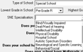 | - Special schools to update this field
New types of schools | 1.2 | - Included option “Home schooling” for provinces where EMIS number is issued to Home schooling  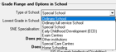 | - Relevant sections to update

- New additions
Description | Screen nr | What is new / changed | Action by the school
New function for NSNP | 3.8 | - New function for NSNP management and reporting  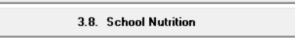  - Manages menus, ingredients required daily, stock taking, finances  - Daily feeding numbers depends on number of learners that were identified on 3.1.1 | - Use if schools participate with NSNP

- HR
Description | Screen nr |  |  | What is new / changed | Action by the school
Additional Educator categories | 2.1 |  |  | - Additional personnel categories available for teaching staff  - ECD Practitioner  - Additional qualification categories available for teaching staff  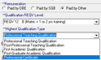  - ECD Practitioner is “Paid by Other” (project funds) and qualifications type to update with “Certificate or NQF 1-5” | - Archive Practitioner on 2.3 - then recapture Practitioner under 2.1
Additional Educator categories |  |  |  | - Additional personnel categories available for IQMS process where using EXTERNAL DSG  - External DSG Principal | - Schools with external DSG to update this field
Additional Educator and Non-Teaching Staff categories | 2.2 |  |  | - Additional personnel categories added – categories on SA-SAMS are: | - Capture staff accordingly
Additional Educator and Non-Teaching Staff categories
  Administration & General Maintenance | Curricular / Extra Curricular | Inclusive Education – Learner Support | NSNP
  Admin Staff | After School Care | Audiologist | Food Nutrition staff
  Financial Officer | Class assistant | Mobility Instructor
  Caretaker | Librarian | Occupational Therapist | Hostel
  Support Staff | Librarian assistant | OT Assisstant | Hostel Parent
   | Practitioner | Physiotherapist | Hostel staff
  Bus Driver | LSA | Physio Assisstant | Food Aid
  IT Technician (school) | Teacher assistant | Professional Non Teaching Staff | Other
  Security | Class assistant | Professional Nurse | Volunteer
  Tuck shop | Sport administrator | Psycologist | School transport
  Auxillary nurse | Sport coach | Social Worker | Circuit manager
   | Extra-curricular Administrator | Speech Therapist | District Official
   | Extra-curricular coach | Education Therapist
Funding updated |  | 2.1 | - “ Paid by R3 Subsidy” changed to “Paid by other” which includes Project funds and State departments: other than Education |  |  | - For notice -Update if needed
HR attendance |  | 2.12 and 2.13 (reports 2.10) | - “Unknown” removed as a reason on attendance of educator and staff  - “Special leave: training” added when attending official training arranged by the province / districts. |  |  | - For notice -Update if needed
INSET Training |  | 2.4/5 | - Updated fields – remember to add hours and SACE points (if any)  - CAPS  - Classroom management  - Inclusive Education  - ICT training courses (Levels basic to Advanced) |  |  | - For use when capturing teacher/ staff training
IQMS management |  | 2.18 | Access to IQMS management is strictly managed by individual usernames and passwords.  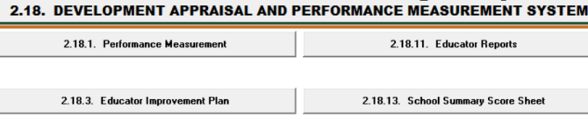  - Functions includes selection of DSG on 2.18.1  - Capturing of scores for performance measurement by Self and then the 2 DSG’s with final score  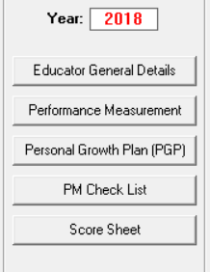  - PGP prepopulates educator’s identified needs captured as 1&2 on Teacher load and IQMS areas with scores of 1 &2  - Available DSG for School principal is Circuit manager (captured as staff) and DSG Principal (Principal from other school). These officials need to be captured for the assessment and then be archived for purposes of the attendance register.  - Summary Score sheet can be printed and e-mailed when finished |  |  | - Capturing for IQMS reporting

- Learner information
Description | Screen nr | What is new / changed | Action by the school
New reason for absenteeism | 3.3.3 | - New option “attending extra murals and school tour | - Update if school is a focus school
Monthly attendance report and annual/quarterly statistics at |  | - Generate and print official “Monthly attendance report” as follows: Tick “Print Monthly”, then Select a Month, Click directly on Print button  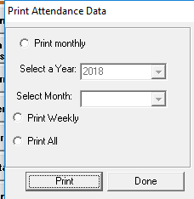  - Generate and print annual and quarterly statistics as follows: After verification of attendance every Month then , Tick ”Print all”, then click on Print and thereafter select the format of the attendance statistics needed – generate and print stats.
New drop down option for religions | 3.1.1./4 | - New drop down option with various major religion groups  - Field open to capture other religion or church group  ( This is important for reasons of absenteeism and selecting support to learners) | - School to update
New types of disabilities | 3.1.1./4 | - LSEN learners are captured only if it is SNA 3 approved. New categories for learner disabilities  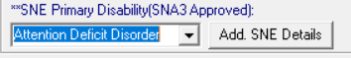 | - Verify disabilities against new list (used for SIAS and NSC exam registration ).
New types of chronic illnesses | 3.1.1 tab 3  Button  Medical & Mental health | - New categories for learner disabilities | - Update medical and Mental Health (used for SIAS)
New Medical consent form | 3.1.1/4  Button  Permission / Consent form | - Button for Medical consent form available for printing per learner  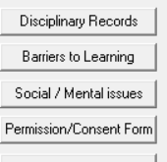 | - Print per learner when required.  - Capture type consent when received
New types of Incidents to be reported | 3.1.1 Button  Social and Mental issues | - Button incidents renamed to Social and Mental issues  - Updated categories for incidents (other that illness and disciplinary transgressions) to be reported:  - Pregnancy  - Bereavement  - Neglect  - Child Headed Household  - Domestic violence  - Racial conflict  - Substance abuse  - Sexual Abuse | - Update Social and Mental issues for learners when reported.  - Action by school also to be captured  - (used for SIAS)
Updated NSC exam registration form | 3.1.1  Button  NSC Exam Registration | - NSC Exam Registration prepopulated form available  - All LSEN, subject, address data to be updated  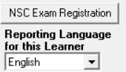 | - Validate each learners subject then print forms
Forms not showing SID and LSEN Learners | 3.5.6.2  3.5.6.5  3.5.6.7  3.5.6.9 | - Corrected option to count SID and LSEN learners on Learner aggregated data printouts  - Report on the number and type of LSEN learners available on SIAS
Updated SIAS | 3.1.9 | - Updated SIAS to be aligned with policy  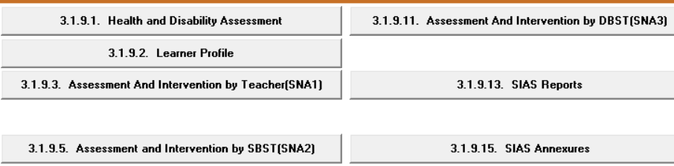  - The following information is pre-populated from other fields:  - Learner biographic data, LSEN, medical, incidents reported, poor assessment results, reported disciplinary transgressions.  - Strength and needs and ISP pre-populate as follows :  - Learning barriers from all subjects with marks below 40  - Communication from Social and Mental issues  - Behavior and social competence from demerits under level 3 to 4  - Classroom from demerits: levels 1 to 2  - Health and wellness from Learner medical Conditions  - Family Home and community from Learning Barriers. | - SNA 1 (& 2) and ISP to be completed for all learners that experience some form of barrier to learning

- Parent information
Description | Screen nr | What is new / changed | Action by the school
Date of Birth and ID field for Parent | 3.1.1  Button:  View parent | - New date of birth field for parent  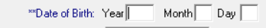  - Reason for no parent ID / passport included | - School to capture  - SA-SAMS could not convert as this will impact on the credibility of the data
New option for poverty list | 3.1.1  Button:  View parent | - New option “Pensioner” under the poverty indicator dropdown list.
New design list for parent information | 3.1.14 | - New function to design own “Parent list” (similar to learners and educators) | - Design when needed
Update account payer / residential | 3.1.1  Button:  View family | - Account payer updated to include more than one parent  - To be able to reset account payer and residential Parent
Select as SGB parent | 3.1.1  Button:  View family | - Click on “SGB Parent registration” to select 2 parents for SGB purposes. Only the selected parents appear on the voter’s roll  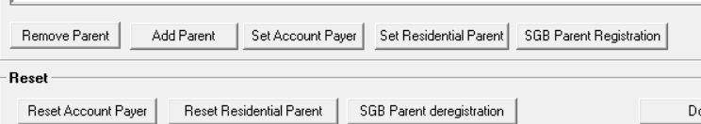 | - Select up to two parents, guardians.
New Voters role option | 3.1.12  Button: Voters roll | - New option to print “Voters roll” that contains ONLY SGB selected parents  - Parents are linked to learners and column for signature  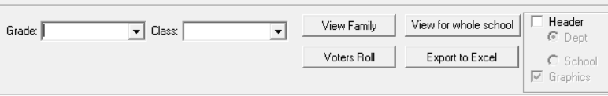 | - Generate and print when needed

- SGB Functions
Description | Screen nr | What is new / changed | Action by the school
Members of SGB archived | 5.1.1  5.1.11 | - All SGB members prior to 2018 were archived for this cycle.  - New Filter option for active and archived members. | - Updates on SGB membership
List of SGB documents extended | 5.1.3 | - List of SGB documents to be reported on is extended  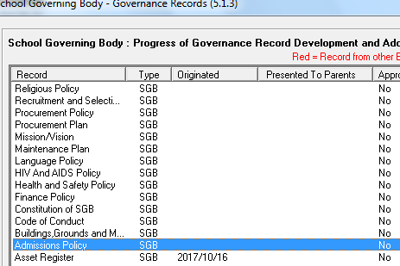 | - School to complete the status of the documents and print the Register 5.1.13 for submission to Districts.
SGB Quarterly reporting tool | 5.1.2 | - The SGB Quarterly reporting tool is included  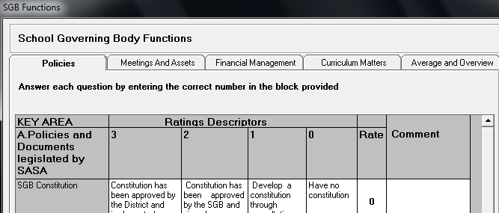 | - Principals/ SGB Chair person to complete the SGB tool quarterly for submission to the District / circuit office
New committees | 5.2, 5.3, 5.4, 5.6 , 5.8 | New committees similar to School Safety Committee added.  - Finance committee  - Building and Maintenance Committee  - School Based Support Team (SBST)  - Disciplinary Committee | - School to assign names of the committee members

- Extra-curricular programmes
Description | Screen nr | What is new / changed | Action by the school
New options for Sport and Enrichment programmes | 1.13.4 | - New options for Enrichment Programmes:  - Gems and Bems  - Morabaraba  - Clubs  - New options for Sport:  - Jukskei  - Goalball  - Table tennis | - School to select the types of sport and programmes  - School to assign learners to the types of sport and programmes

- Curriculum
Description | Screen nr | What is new / changed | Action by the school
Foundation phase subjects SBA Term Weight % corrected | 12.3.11 | Grade 1-3 SBA weight % corrected for terms 1-4  - All Terms to count 25% to final promotion  - This need to be done before printing Promotion schedules | - School only need to resave the “Weights Validation” on 12.3.11 for term 4
SBA Changes: Technical Science Gr 10-12 | 12.3.11 | Technical Science tasks and weights corrected  - School need to save the “Weights Validation” on 12.3.11 and then 12.7.16.3 and 12.7.18  - This need to be done before printing Promotion schedules | - All Schools offering this subject must validate the settings before submitting Gr 12 SBA
SBA Changes: Civil Technology Gr 10-12 | 12.3.11 | Civil Technology (all specialisations) Gr 10 -12 tasks and weights updated  - School need to save the “Weights Validation” on 12.3.11 and then 12.7.16.3 and 12.7.18  - This need to be done before printing Promotion schedules
SBA Changes: Nautical Science Gr 10-12 | 12.3.11 | Gr 10 -12 tasks and weights set up according to CAPS  - School need to save the “Weights Validation” on 12.3.11 and then Capture marks for all tasks, Validate and save on 12.7.16.3 as well as on 12.7.18  - This need to be done before printing Promotion schedules
SBA Changes: Maritime Economics Gr 10-12 | 12.3.11
SBA Changes: Gr10 & 11 Dramatic Arts Design  Dance  Visual Arts | 12.7.18 | Dramatic Arts, Design, Dance and Visual Arts Gr 10 -12 tasks and weights updated  - School need to save the “Weights Validation” on 12.3.11 and then 12.7.16.3 and 12.7.18  - This need to be done before printing Promotion schedules | - All Schools offering this subject must validate the settings
New report that will list the classes per educator | 12.1.16 | New report that will list the classes per educator.  - Report per educator showing the subject groups and number of learners in the class | - All Schools offering this subject must validate the settings
Updated list for changed promotion decisions (Progression) | 12.7.14  12.7.18 | - Circular E1 of 2018 included for Grades 7-9  - Changed decision is included as additional options on General comments – will read Promoted after mark were adjusted  - School option to change the wording of PG selection on 12.7.13  - New option added for Grades 10-12 “Passed with endorsed Curriculum” | - Change NP to PG to identify learner as “Progressed”  - These learners can then be tracked in the following year
Amended Quarterly schedule | 12.9.15.7 | Schedule updated as follows:  - Marks of subjects that are identified in circular E1 of 2018 is printed in bold and red.  - Shows per learner more than one HL and FAL | - Generate and reprint
Updated Bachelor pass requirements | 12.9.16.8 | Aligned and updated the Bachelor pass requirements to the latest circular | - Generate and reprint
Immigrant Pass Gr 1-3 | 12.7.18 | Corrected Immigrants pass requirement according to policy  - It should be the same as ordinary learners | - Important for promotion

- Physical resources
Description | Screen nr | What is new / changed | Action by the school
Updated list of Textbooks | 14.1 | - Updated list of books with latest category | - School to select books from new list
Updates on Infrastructure | 14.5 | - New ICT Section Added  - Page 10 and 11 added to report on ICT status | - Schools to capture according to the status at the school

