MY LIFETIME JOURNEY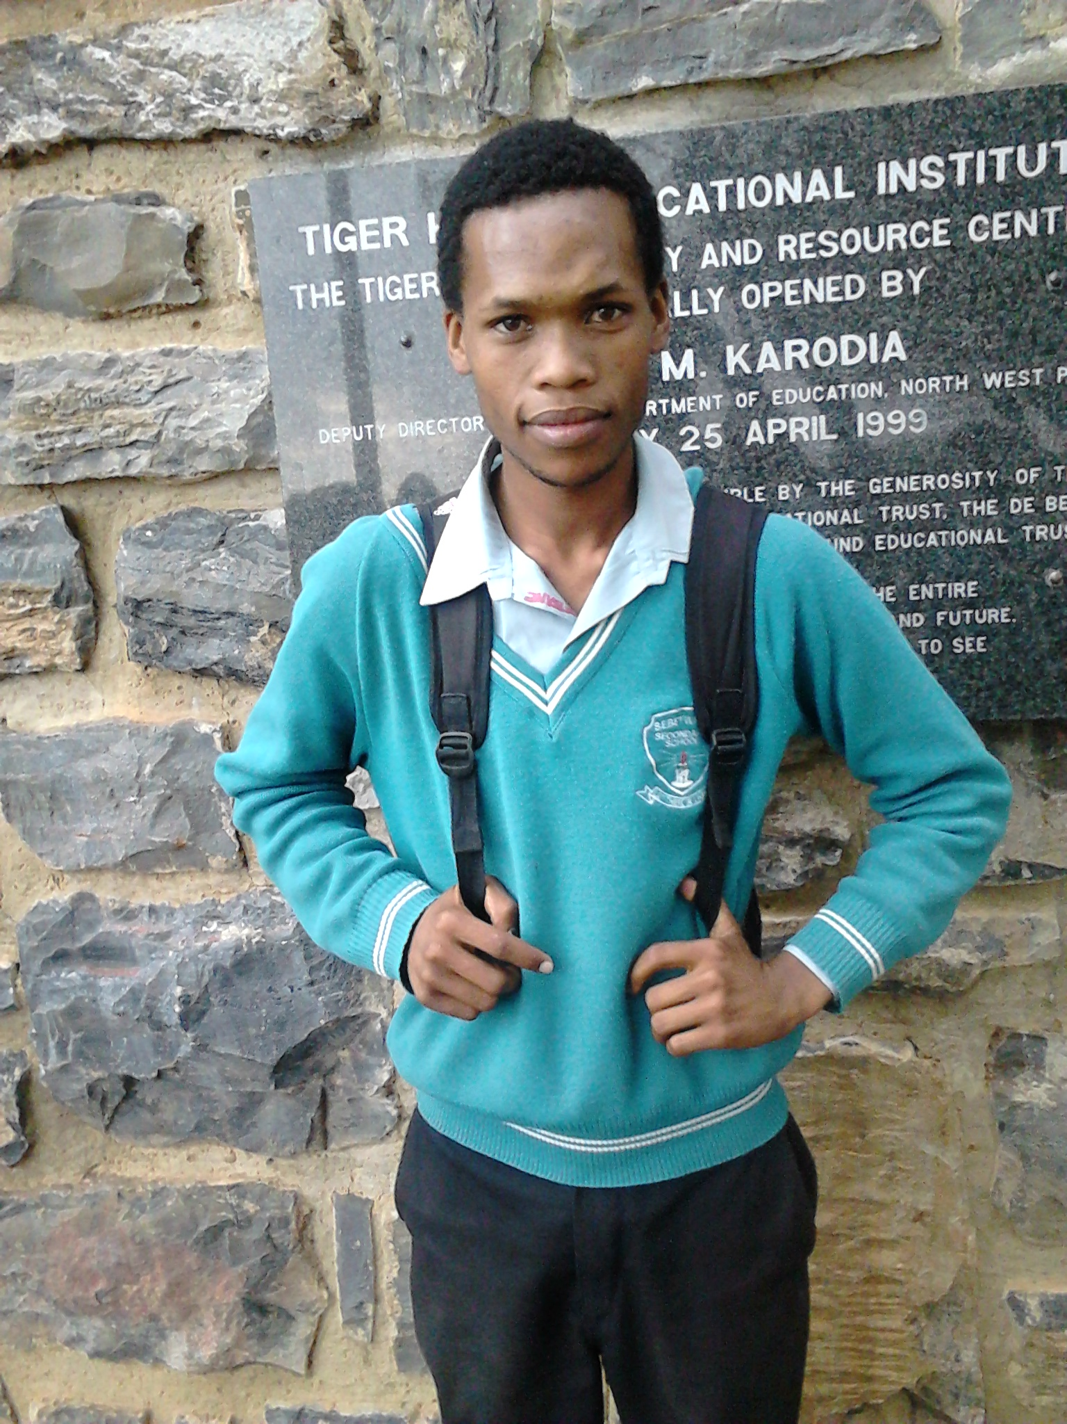
Thatoyaone Moepetsane
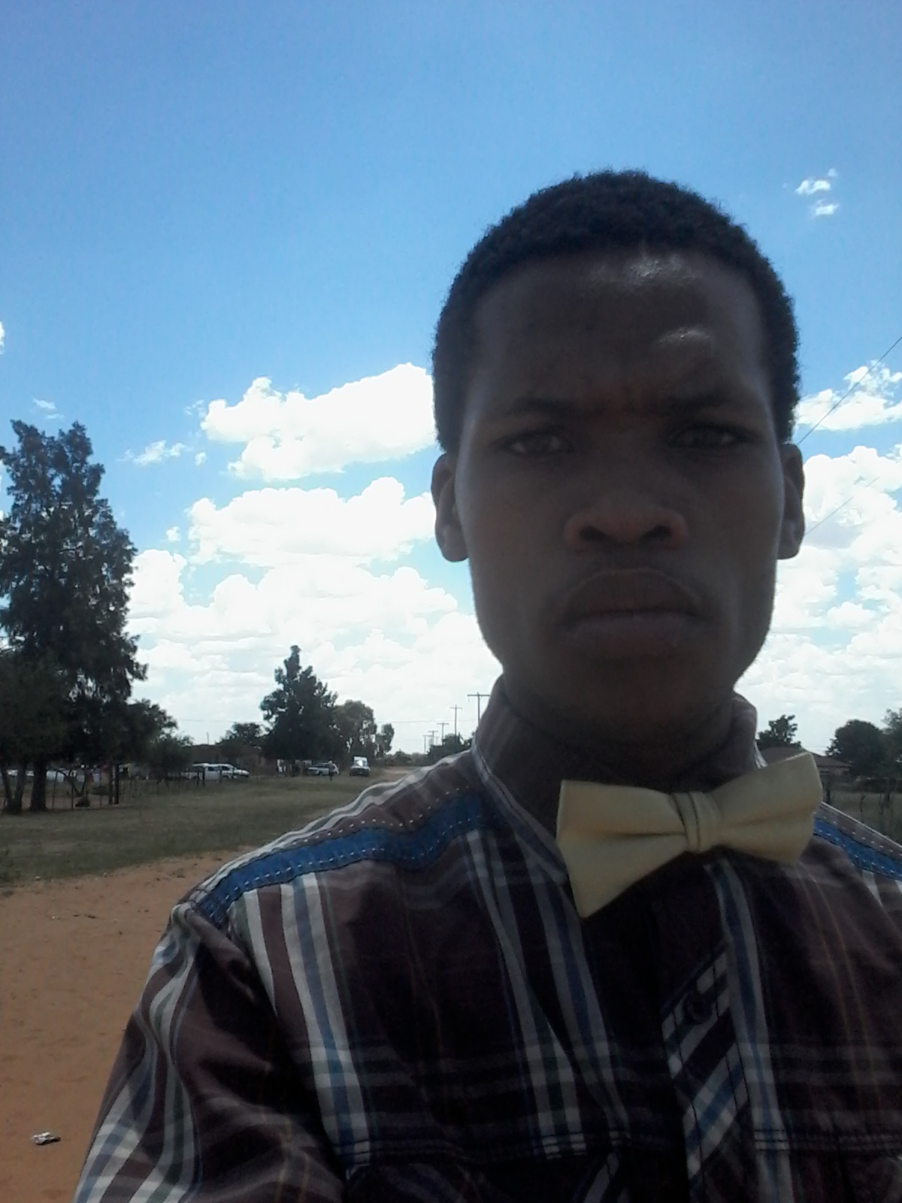

Biography of Thatoyaone Moepetsane

Thatoyaone Moepetsane is one of COSAS leadership. He is member of the following organizations ANC, ANCYL, SACP, YCL-SA, SANCO, COSAS and SADO.

Thatoyaone Moepetsane was born in Tlakgameng in 05 October 1992. He is the first of the five children. He grew up in Tlakgameng-Gamodisenyane section, he introduced in COSAS politics by Gopolang Molale who was regional leadership of COSAS by that time.

Introduction

That name "My lifetime journey" is to give people understanding about my life, know about my past, my present and my future. That is to encourage young people not let their failure to discourage them.

That name I take it as the voice of encouragement not discourage, don't let your failure determine your destiny and don't let your poor family background destroys your future.


First chapter

My childhood was so good and interesting one, it was interesting by that time in children's perspective, by that time everything was possible and that time as child I did not know different between bad things and good things, everything was just the same, as child I did not focus on consequences I just done things in the sake of done them.

I started school at Seitsang primary in the year 1999, by that time things were not easy, we paid school fees, my teacher was Mrs Matabane who was passed away when I was still in grade 1, after that we got new teacher by the name of Mrs Mabogola, principal was Mrs S.K Sehere and his deputy was Mrs Tsogang.

I and my cousin by the name of Olebogeng Moepetsane we arrived late at school, it was the time when corporal punishment was allowed at schools, we beaten by teacher that I forgot his/her name, it was time when we fought myself and my friend Boikanyo Mosimeng, it was in the morning on our way to school, I was in grade 3 by that time but my friend was in grade 4/5 if I'm not mistaken, by that time my teacher was Mrs Shashape.

Second chapter

I continued with my schooling at Seitsang Primary school from grade 4 until grade 6, I failed grade 6 in the year 2004, repeated it in 2005, in that year i suppose to be in grade 7, the problem was that I failed Setswana and no way can you pass hence you failed language even if you passed all subjects.

In 2006 I went to Sebetwane secondary school to continue my schooling, continue with grade 7, I got friendby the name of Tshepang Bareki, we pass from grade 7, to grade 8, in grade 8 I fought with boy known as Boitshepo Moilakgotlha, principal was Mr M.D Mochware and his deputy was Mr J Mokebe.

I and my friend and others we promoted to the next classroom grade 9, I and my friend failed grade 9 two times, first time when I failed in the secondary level life it was difficult on my side, but during mid-year things back to normality again, I realized that when you take your school work serious you can make it.

Third chapter

But fortunate part of my life in 2010, I and my best friend we promoted to the next grade which is grade 10, but that happened after community march for tarred road, that march took almost 2-3 months, in that months schools at Tlakgameng and villages around Tlakgameng were closed because of that march.

On the same year I visited my relative at Johannesburg for June school holidays, that march were continued when I'm still at Johannesburg, during that holidays I got friend by the name of Tshepang who originate in Makwasi, I even visited that place, when I came back home, march was still on, schools and other government buildings were burned during that march.

Things were not the same during march, things were out of control, people were arrested, some learners dropped out of schools and other services were stopped at Thusong services center, in media topic it was about Tlakgameng march for tarred road.

Forth chapter

The time when schools re-open in 2011, I and my best friend we in classroom of geography but we decided to be at classroom of mathematics and physical sciences, things were not easy as we thought it will be. We repeated that grade in 2012, also in 2013, but on 2013 we commit ourselves, that commitment we got fruits of it in the end of the when we promoted to grade 11.

I became Regional Task Team (RTT) coordinator of COSAS, on the same year provincial Secretary by that time who was Seatlathebe Lepomane demoted myself from coordination of RTT to be no body, but as loyal and discipline member of COSAS I accepted that decision and work COSAS programmes in my sub-branch Sebetwane.

In the following year I became additional member of newly appointed RTT of COSAS of Dr Ruth Segomotsi Mompati region, on the same year members pronounced my name in the regional congress to became regional deputy chairperson, that gave me hope and realized that members see my capacity and capability.

Fifth chapter
Honestly I did not meet passing requirements to be in grade 12, in simply way I failed my grade 11, but I progressed to grade 12 because of department of education policies, that allowed teachers to progress learners whom did not meet requirements according to learners history from grade 10.

I got call in the morning that tells me that I passed grade 11, I was so happy and excited, it was the time when I was at Christianah, but that time I was with my reliable force Kagiso Kgabo, he congratulate myself for passing my grade 11, I was so happy on my way to COSAS National Congress. 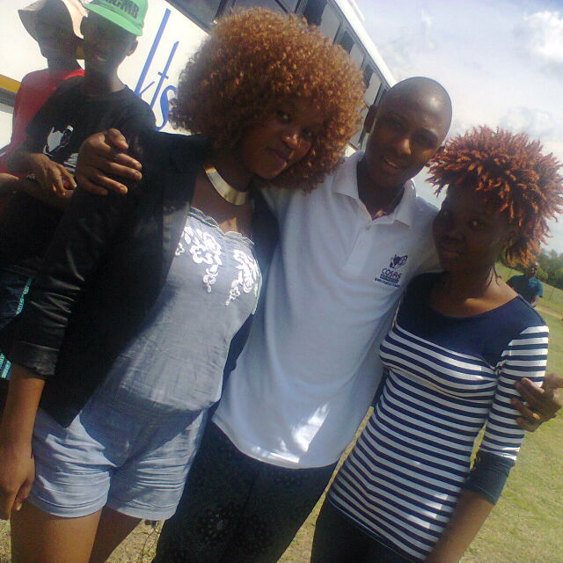

My arrived at home I started by requesting my school report, when I open it with confidence I was disappointed and embarrassed simultaneously, it was not impressive at all, my first day January 2015 when schools re-open I felt as if all learners knew about my school report, but I pretended as if things are okay, when teachers talk about progressed learners I felt small.
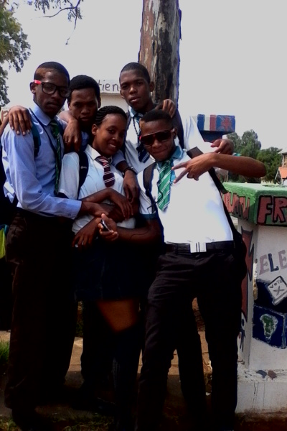

Sixth chapter

When we fill metric registration forms everything be in light from dark, it was day when parents called for meeting and cluster manager was preset to check our school reports whether we progressed or not, the following schools learners were present Sebetwane, Thuso Thebe, Reichokile, Pitso Letlhogile and Kgosi Thebe. Department of education of North West sent pledge to schools of progressed learners, we went to Austrey village to fill pledge at Kgosi Thebe, department of education organized camp for progressed learners as they call us.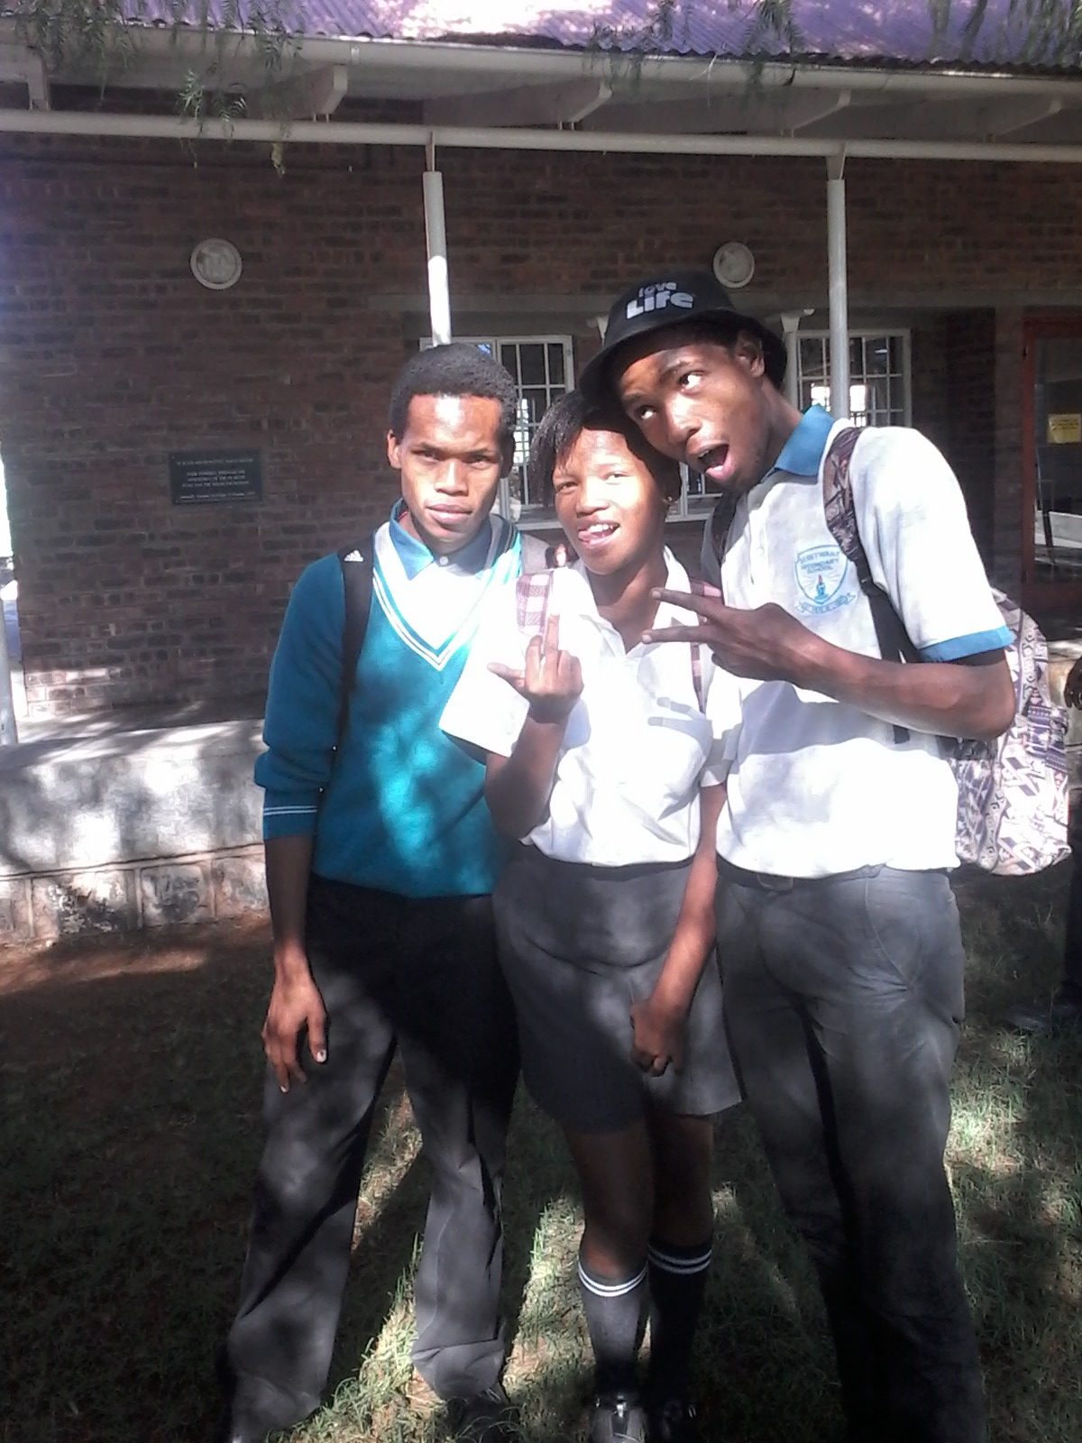
Camp was good in terms of learning and teaching, we attended that camp at Tigerkloof, class was allocated 1 hour but it was just like 20 minutes because we enjoyed and understanding them especially for mathematics and physical sciences, I got friend in the camp who known as Lesedi Disipi, she is my friend in need indeed and I can tell her everything concerning myself because I trust her and she is special in to my life.
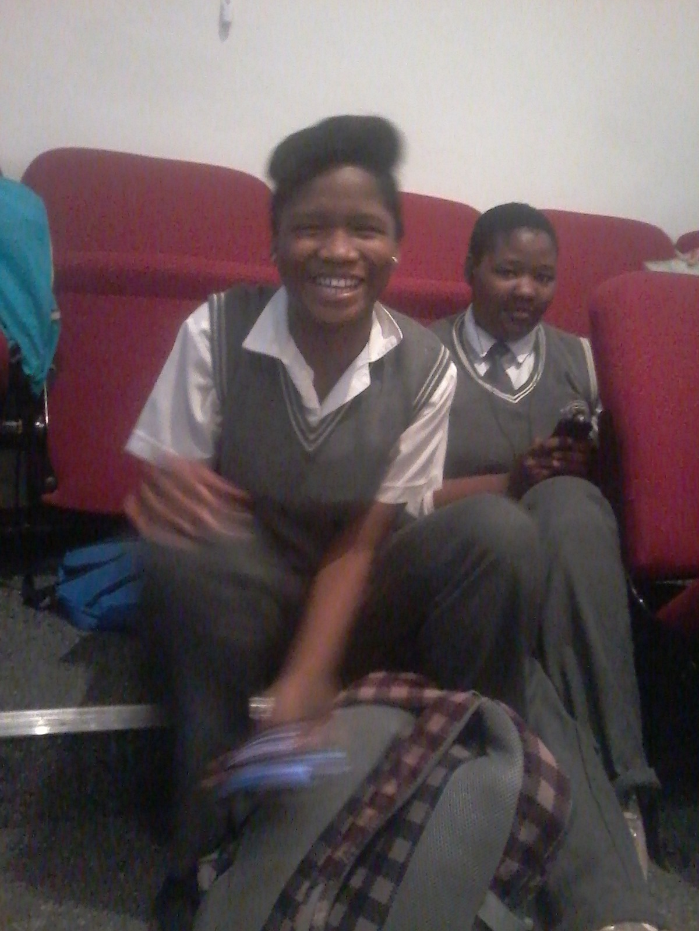
THE END
Questions

1. Who is writer of that book? [1]
2. Where he born and when? [2]
3. In your words tell us what you have
learned from this book? [3]
4. Quote two words from first paragraph
how was his childhood? [2]
5. In which year he started school and in
which school? [2]
6. Who was his teacher in grade 1? [1]
7. Who was principal and deputy
principal of that school? [2]
8. Tell us what happened in school in
terms of learning from primary to
secondary? Briefly. [3]
9. Who introduced him in politics and
politics of which organization? [2]
10.1. How he felt about this issue of
progression? [1]
10.2. Where they attended camp? [1]
Total. [20]
Answers

1. Writer's name is Thatoyaone
Moepetsane.
2. He was born at Tlakgameng in 1992.
3. This book teaches people
fruits of patience, encourage people
to take education serious and to
correct their mistakes and not repeate
them.
4. "Good and interesting".
5. He started school in 1999 at Seitsang
primary school.
6. His teacher in grade was Mrs
Matabane.
7. Principal was Mrs S.K Sehere and
deputy principal was Mrs Tsogang.
8. Thatoyaone Moepetsane was failed
grade 6, because of issue of failing
language (setswana), he was also
failed grade 9 two times and grade
10.
9. He was introduced in politics by
Gopolang Molale, COSAS politics.
10.1. He felt Embarrassed/disappointed.
10.2. They attended camp at Tigerkloof.

By:Thatoyaone Moepetsane

