GRADE 12

PREPRATARORY EXAMINATION

MEMORANDUM

September 2015

INFORMATION TECHNOLOGY

PAPER 2

TIME: 3 HOURS MARKS: 150

This paper consists of 12 pages excluding the cover page.

INSTRUCTIONS AND INFORMATION

1. | This question paper consists of SIX sections:
SECTION A: Multiple-choice questions  SECTION B: System Technologies  SECTION C: Communications Technologies and Network Technologies  SECTION D: Data and Information Management  SECTION E: Solution Development  SECTION F: Integrated Scenario |  | (10)  (24)  (28)  (25)  (23)  (40)
2. | Read ALL the questions carefully.
3. | Answer ALL the questions.
4. | The mark allocation generally gives an indication of the number of facts/reasons required.
5. | Number the answers correctly according to the numbering system used in this question paper.
6. | Write neatly and legibly.

SECTION A: Multiple-choice questions

Question 1

Question | Answer
1.1 | D
1.2 | D
1.3 | D
1.4 | D
1.5 | A
1.6 | C
1.7 | D
1.8 | A
1.9 | A
1.10 | A

SECTION B: System Technologies

Question 2

- Name the hardware component that a notebook has and a netbook hasn’t. (1)

DVD WRITER / OPTICAL DRIVE COMPONENT

- Name 3 advantages of a smart phone? (3)

- Always ‘on’ (no boot or load time)
- Always connected – built-in cellular data
- Convergence device
- Small size – ultra portable (smaller than both laptop and tablet)
- Built-in sensors
- Longer battery life – compared to laptop

- Why would one rather buy a tablet than an E-reader? (1)

Because an E reader is a single purpose device and a tablet can do the same and all the other functions as well, making it a multi-purpose device.

- In table form, mention the average battery life of the following devices:

  - Smartphone
  - Tablet
  - Laptop (3)

Device | Average Battery Life
Smartphone | 10 – 24 hours
Tablet | 6 – 10 hours
Laptop | 3 – 10 hours

Cloud computing is the new way to go and should be implemented as far as possible.

- What is cloud computing? (2)

Cloud computing refers to the use of resources that are offered as services over the internet and that are shared.

- Explain the difference between file synching service and a backup service? (2)

A file syncing service is meant to be treated like an external storage device. A backup service offers incremental backup of a whole system and is only meant to be accessed when you try to restore data after a disaster.

- Name three benefits of cloud computing. (3)

- Resources are scalable
- The ability to work and access resources wherever you have Internet connectivity
- It enables collaboration
- You can outsource maintenance, upgrades of hardware, software installation and upgrades

- Name three tips related to installing anti-virus software. (3)

- Install only one anti-virus product
- Set the software to download new virus definitions automatically
- Set the software to scan removable drives (external drives, flash drives) automatically when they are plugged in.
- Set the software to scan the entire computer automatically at least once a week.

- Give the name of a website where one can go to check for well-known scams. (1)

Feedly – www.feedly.com

- Name three things to consider when following a good password policy. (3)

- Use different passwords for different accounts
- Make your passwords long – a long password is more effective than a short password with funny characters
- Avoid words that can be found in a dictionary
- Avoid personal information about yourself or your family that can easily be researched (nicknames, pet names, phone numbers, birth dates, etc.)
- Change your passwords regularly.

- What does the process of disk defragmentation entail and does it free up disk space or not? (2)

Defragmentation is a task you do by running special software that rearranges the files on a disk so that they are stored in sequence again. It does not free up any disk space.

SECTION C: Communications Technologies and Network Technologies

A school in Pretoria wants to set up a networked class for the new subjects CAT and IT that they are going to present to learners.

Question 3

- Name the essential equipment that is needed to install a cabled network. (3)

Network Interface Controller, Switch, Cables

- Name the two main methods of connecting to the internet. (2)

There are two main methods of connecting to the internet, namely through ADSL and wirelessly using cellular technology such as 3G or 4G (LTE).

- Name 3 characteristics of the wired method mentioned in 3.2. (3)

- A permanent digital connection to the internet using a telephone line
- Different packages are available from service providers
- The download speed is faster than the upload speed
- Different bandwidth specifications are available
- Can be used for small and large networks

- When referring to user rights, what is the difference between an administrator and a standard user? (3)

- Administrator
Have full control over the system. They can install software and hardware drivers. They can create and modify new user accounts and groups and they can reset passwords. They have full access to all the files and folders.
- Standard user
Are permitted to log onto the computer, run programs, customize their accounts, and work with files in their user folders or in those common folders to which they have been granted access. They can change their own passwords, but not those of others. Standard users are restricted from making system changes.

- Write out the following abbreviations in full:

  - ADSL – Asymmetric digital subscriber line
  - LAN – Local area network
  - VPN – Virtual private network
  - NIC - Network Interface Controller
  - UTP – Unshielded twisted pair (5)

- A digital certificate contains details such as the owner’s public key and the owner’s name. Mention 3 other details it should include. (3)

- Expiration date of the public key
- Name of issuer (the certificate authority that issued the digital certificate)
- Serial number of the digital certificate
- Digital signature of the issuer.
- Petcube includes a remote controlled camera, a speaker, microphone and a remote controlled laser to interact with your pet if you are out of town.
Provide three more examples of current consumer level Internet of Things devices. (3)

- Belkin’s WeMo devices
- Philips Hue
- Oregon Scientific’s Weather Anywhere connected weather station
- Nest thermostat
- Edyn / Greenbox / Lono

- Explain the difference between Java and JavaScript. (3)

Despite its name, JavaScript, it has nothing to do with the JAVA programming language. Java was created by Sun Microsystems as a ‘real’ programming language whilst JavaScript was created by Netscape as a tool for automating (‘scripting’) elements on web pages.

JavaScript programming instructions can either be stored as separate text files (usually with the .js extention) or included directly in the text of the .html file. With JavaScript the programming instructions are followed one line at a time by the JavaScript interpreter built into the web browser.

- What is the difference between XML and HTML? (3)

HTML (Hypertext mark-up language) is a set of text- based codes that tell a browser how to display content e.g.
“<b>Hello</b> <i>there</i>.” will tell the browser to display Hello there
HTML has a very specific set of commands (or tags) that can be used-these are defined by the HTML specification.

XML or extensible mark-up language takes the ideas of command codes or tags and text to a new level. It is a set of rules you follow when creating your own codes, to allow you to structure data in a text document in any way that you need to.
XML is there for most often used as a way to store structured data in a text file.
The web page HTML and CSS are used to control the formatting and appearance of the page while separate data is stored and transferred in separate XML files.

SECTION D: Data and Information Management

Question 4

You are provided with the following database structure:
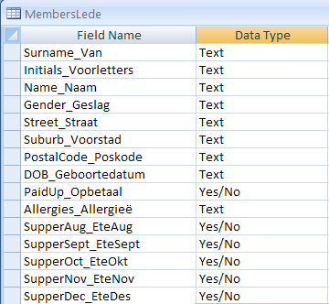
Based on the structure above provide only the SQL statements to accomplish the required actions:

- Retrieve the Surname and Initials from the table where the character d is found in the name field. (3)
Select Surname_van, Initials_Voorletters from Members_Lede Where Name_Naam Like “%d%”
- Insert a new record in the table: provide only the Surname, Name, Gender, and DOB field using your data as the provided values. (7)
Insert into Members_Lede(Surname_Van, Name_Naam, Gender_Geslag, DOB_Geboortedatum) values(“Child Surname”, “Child Name”, “Child Gender”, “Child DOB”)

- Delete all the members from the table who are behind in their payments. (5)
Delete from Members_Lede where PaidUp_Opbetaal = FALSE

- Update the table by checking which members are allergic to pork and replacing the pork allergy with an allergy to Bee Stings. (5)
Update Members_Lede Set Allergies_Allergieë = “Bee Stings” where Allergies_Allergieë = “Pork”

- You will notice that there is no primary key defined for this table. Which field should be used for the primary key, or should a new field be added for use as the primary key? Explain your answer and also explain what a primary key is. (5)
A primary key is a field that identifies each record with a unique value. A new field should be added because there is no suitable field that can be used. An ID number field should be created of data type auto number for this purpose. Check all explanations.

SECTION E: Solution Development
Question 5

As part of a computer system which analysis the results of a school, a program is written which reads the results of the learners from a text file to a two-dimensional array, the contents of which is displayed in a StringGrid. (In a real system there would be calculations done with the values in the array, but we are showing only the basic principles in this short program).

Four test results of learners are stored in a file. Each learners test results are stored on a separate row (learner number 1’s results are stored on row 1 etc.). The results are separated by a semi-colon.
Example:
34.6;45.5;67.9;23.0
Example of interface:
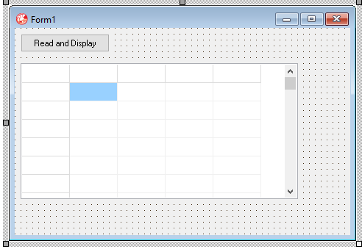

- What follows, is the coding for the above mention application. It contains a number of errors. Fix the errors related to the coding by rewriting the line which contains each error.

unit classmarks_u;

interface

uses
Windows, Messages, SysUtils, Variants, Classes, Graphics, Controls, Forms,
Dialogs, StdCtrls, Grids;

type
TForm1 = class(TForm)
stgClassMarks: TStringGrid;
btnReadAndDisplay: TButton;
procedure btnReadAndDisplayClick(Sender: TObject);
private
{ Private declarations }
public
{ Public declarations }
end;

var
Form1: TForm1;

Implementation (1)

{$R *.dfm}
type
TMarks = array[1..20, 1..4] of real (2);

procedure TForm1.btnReadAndDisplayClick(Sender: TObject);
var
tfMarks : textFile ;
iPlace, iMark, iCountMarks, iCountLearners : integer ;
sOneMark, sOneLine : string;
ar2Marks : TMarks ; (1)
iRow, iCol : integer ;
begin
AssignFile(tfMarks,'marks.txt') ; (1)
Reset(tfMarks) ;
iCountLearners := 0 ; (1)
while (not eof(tfMarks)) and (iCountLearners < 20) do (2)
begin
readln(tfMarks, sOneLine) ; (1)
inc(iCountLearners) ;
for iCountMarks := 1 to 4 do (1)
begin
iPlace := pos(';',sOneLine) ; (1)
sOneMark := copy(sOneLine, 1, iPlace -1) ; (1)
delete(sOneLine, 1, iPlace) ; (1)
ar2Marks[iCountLearners, iCountMarks] := StrToFloat(sOneMark) ; (1)
end ;
end ;
CloseFile(tfMarks) ;

stgClassMarks.RowCount := iCountLearners + 1 ;
stgClassMarks.ColCount := 5 ;
stgClassMarks.Cells[1,0] := 'T1' ;
stgClassMarks.Cells[2,0] := 'T2' ;
stgClassMarks.Cells[3,0] := 'T3' ;
stgClassMarks.Cells[4,0] := 'T4' ;
for iRow := 1 to iCountLearners do
stgClassMarks.Cells[0,iRow] := 'Learner ' + IntToStr(iRow) ;
for iRow := 1 to iCountLearners do
for iCol := 1 to 4 do
Form1.stgClassMarks.Cells[iCol, iRow] := FloatToStrF(ar2Marks[iRow, iCol],ffFixed, 5,2) ; (1)
end;

end.
(15)

- Consider the following program codes and answer the questions:
Program | Unit
Procedure TForm1.ButtonClick(Sender: TObject);  Var  iM, iV : integer;  rE : real;  begin  iM := StrToInt (edtM.Text);  iV := StrToInt (edtV.Text);  Energy (iM,iV,rE);  redOutput.lines.add(‘M = ‘ + IntToStr(iM));  redOutput.lines.add(‘V = ‘ + IntToStr(iV));  redOutput.lines.add(‘E = ‘ +  FloatToStrf(rE,ffFixed,5,1));  End;  End. | Unit Unitformule;  Interface  Procedure  Energy(pV, pM : integer;  Var pE : real);  Implementation  Procedure  Energy(pV, pM : integer;  Var pE : real);  Begin  pE := 0.5 * pM * sqr(pV);  End;  End.

  - What will be displayed in the RichEdit when the following values are entered in the two Edits?
edtM : 3
edtV : 2 (1)

M = 3
V = 2
E = 9.0

  - Indicate in each instance whether the call statements are valid or not. If it is not valid, give an explanation as to why it is incorrect.
    - Energy(3,6,rE);
    - rE := Energy(iM,iV);
    - Energy(rE,3,3);
    - Energy(3.1,4.5,rE); (4)

i) Valid
ii) Invalid: The call statement must not be part of another statement.
Must start with the name of the procedure.
iii) Invalid: Data types of the arguments in the call statement do not
correspond with the data types of the parameters in the definition of the procedure.
iv) Invalid: The first two arguments must be integers.

  - Name three advantages of using units. (3)

- A large program can be broken down into modules on which the programmers can work separately and make changes if necessary. This makes it easier to debug large programs.
- Units can be made available for others to use.
- Units can be shared with other programmers, without giving them access to the source code itself. Units are compiled into machine code and the resulting code is included in the executable file (which means you need only distribute the .exe file, not a number of different files).

SECTION F: Integrated Scenario
Question 6

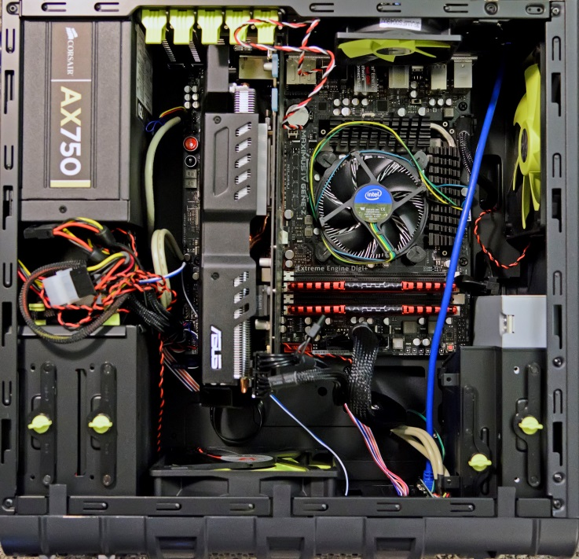

- What do we call the very large circuit board that has many slots and connectors inside the computer casing? (1)

The motherboard

- What are the three main advantages of modular design? (3)
- Repair the computer by replacing a broken or faulty component
- Upgrade the computer by adding new parts or replacing existing ones with more powerful versions.
- Standardisation
- With which hardware device would you associate a SATA connector? (1)

DVD RW Optical drive / HDD / SSD

- With which hardware device would you associate a VGA connector? (1)

Monitor

- Is the CPU the only processor in a computer? Briefly motivate your answer. (2)

No, the graphics card also has a processor inside (namely the GPU).

- What do we mean when we say bus-style connections are ‘legacy’? (2)

Bus style connectors are ‘legacy’ – they are older technologies that are still used for backwards compatibility with older computers, but they have generally benn replaced with point-to-point connections. Most new motherboards do not include the older bus-based expansion card slots, but they do not have a shared bus for connections such as USB.

- What is the main difference between a bus and a point-to-point connection? (2)

A point-to-point connection is dedicated. This means that the wires or paths used to transfer data are not shared between multiple components. The wires or paths in a bus are shared between more than one component.

- What is the main advantage of an SSD (Solid State Drive) when compared to a conventional hard drive? (2)
- Associate the following images with the software or components they are. Write down the name of the software or component. (4)

  - Linux
  - Solid State Drive
  - Windows 8.1
  - Apple

- Explain what the function of the primary memory of a computer is. (2)
RAM is essential for the operation of a computer. All the data and instructions (programs or applications) have to be loaded into the RAM before the CPU can work with them. The more RAM the computer has, the more instructions and data it can hold at any given time.
- Explain what influence the size of primary memory has on the functioning of the computer. (2)
The DIMM sticks that you insert into the motherboard are the RAM. The more the RAM you insert into the computer, the better the performance (faster). It is the most cost effective way to upgrade your PC.
- Explain how the primary memory is used during disk caching. (2)
RAM is faster than a hard drive or other storage mediums. That is why every hard drive has a certain amount of RAM cache built into it and it’s also why all operating systems set aside a part of RAM to cache data that has recently been read from disk.
- Study the technical specifications of the Intel i7 and answer the questions that follow:

6.13.1 How many cores does the i7-processor have? Motivate your answer by referring to applicable terms used in the given specifications. (2)

Quad core processor means that the CPU has 4 cores.
6.13.2 Explain what it means that the processor has a memory bandwidth of 25.6 GB/s. (2)

Memory bandwidth is the rate at which data can be read from or stored into a semiconductor memory (RAM) by a processor. Memory bandwidth is usually expressed in bytes/second (25.6 GB/s).

6.13.3 Would it be possible to expand the memory of the PC and what would be the limit? (Motivate your answer from the given specifications). Also mention what other factors will influence how much memory the computer can accommodate. (3)

It would be possible to expand the memory of the PC. Two things need to be taken into consideration: the motherboard type and the operating system. So a personal computer, with the correct motherboard can take up to 192 GB of RAM. The given specifications refer to 32 GB of RAM as maximum.

- Do these computes use RAID technology? Explain your answer and also refer to what RAID is. (3)

They do not use RAID technology. RAID technology is the redundant array of inexpensive disks. The computers use single hard drives only and for RAID multiple hard drives are necessary – an example is mirroring that utilises multiple hard drives as one and writes the same info to all disks to avoid data loss very effectively.

- What is the HDMI connection used for? (2)

It is used to transfer video to a monitor / screen and to transfer sound to the audio device.

- Is it a problem that the PC does not have a webcam for using programs like Skype? Explain your answer. (2)

No, it is not a problem. An external webcam can be purchased at a very affordable price. And can then be plugged into the USB port of the computer.

- List the output devices of the laptop. (2)

- Integrated webcam
- 15.6” HD LED Display

Source: Me M Möller

