INFORMATION TECHNOLOGY P2
September 2015
GRADE 12

North West Province

NATIONAL SENIOR CERTIFICATE

Marks: 150

TIME: 3 hours

This question paper consists of 16 pages.
READ THROUGH THE INSTRUCTIONS!

INSTRUCTIONS AND INFORMATION
- This question paper consists of SIX sections:
SECTION A: Multiple-choice Questions (10)
SECTION B: System Technologies (25)
SECTION C: Communication and Network Technologies (25)
SECTION D: Data and Information Management (25)
SECTION E: Solution Development (25)
SECTION F: Integrated scenario (40)
- Answer ALL questions.
- Read all the questions carefully.
- Do not generalise your answers. All answers must relate to ICT.
- The mark allocation generally gives an indication of the number of facts required in your answer.
- Number your answers correctly according to the numbering system used in the question paper. Numbers must be in the center of the page and not in the left margin.
- Leave a line open between all answers from Section B to Section F.
- Rule of after each section.
- PLEASE!!!! Draw a margin on the right hand side of each page for mark allocation.
- Write neatly and legibly.
- Good luck.

SECTION A: MULTIPLE-CHOICE QUESTIONS
QUESTION 1
Various options are given as possible answers to the following questions. Choose the answer and write only the letter (A – D) next to the question number (1.1 – 1.10) in the ANSWER BOOK.
1.1 | When you try to sign up for Facebook you find that someone has already created an account in your name. This is an example of:
 | A | Invasion of privacy.
 | B | Bad netiquette.
 | C | Identity theft.
 | D | Identity mismanagement. | (1)
1.2 | Which one of the following statements regarding low-level programming languages is incorrect?
 | A | Low-level programming involves code that the CPU will understand.
 | B | Low-level languages are typically assembly languages.
 | C | It is used when writing ‘embedded’ code.
 | D | These types of programming languages have more commands to learn. | (1)
1.3 | The POP3 protocol is used to:
 | A | Downloading e-mail via the Internet.
 | B | Sending large files between remote computers.
 | C | When making telephone calls between LAN’s.
 | D | Communicate over short distances over a network. | (1)
1.4 | Which ONE of the following is the best description of the Semantic Web?
 | A | Static HTML webpages with hyperlinks.
 | B | Users of the semantic web can create sites as wikis and blogs.
 | C | The Internet’s ability to process data across different platforms.
 | D | Websites are not frequently updated. | (1)

1.5 | An example of database software is:
 | A | OpenOffice Calc
 | B | MySQL
 | C | Adobe Dreamweaver
 | D | QuickTime | (1)
1.6 | Which ONE of the following terms does not logically belongs with the others?
 | A | Firewall.
 | B | Anti-virus software.
 | C | Defragmentation.
 | D | Encryption. | (1)
1.7 | Fuzzy logic is:
 | A | Used as a computerised aptitude test.
 | B | A computer system designed to gather information from a wide range of sources.
 | C | Dealing with reasoning that works with probabilities.
 | D | Used in financial modelling. |  | (1)
1.8 | Which ONE of the following is not a concept that is helping in designing a database?
 | A | Maintaining the accuracy of data stored in a database.
 | B | Overcoming the practical issues dealing with physical storage.
 | C | Data validation.
 | D | Controlling access to data through passwords. |  | (1)
1.9 | …files is files that contains code or subroutine’s that is called and used by programs.
 | A | GVE
 | B | DLL
 | C | RSS
 | D | RAID |  | (1)
1.10 | A user complains that his computer is very slow. What is the most possible cause?
 | A | Application software is not regularly updated.
 | B | No anti-virus program is installed on the computer.
 | C | Al documents are not stored in a single root folder.
 | D | Not enough primary memory installed in the DIMM slots on the motherboard. |  | (1)

SCENARIO
Load shedding is a reality for everyone in South Africa. Especially for the schools that must carry on teaching even if the power is off.
SECTION B: SYSTEM TECHNOLOGIES
QUESTION 2 |  |  |  |  | [27]
The school has a few computer centers, these centers are upgrade on a regular basis, to ensure the learners has access to the newest technologies.
2.1 | The computers in the IT lab are desktop computers. The computers have preloaded operating systems.
 | 2.1.1 | State THREE functions of an operating system |  |  | (3)
 | 2.1.2 | Why should the operating system be updated regularly? |  |  | (2)
 | 2.1.3 | The operating system makes use of a specific method to create space in RAM for programs that has a lot of graphics whose files are too big to store in the RAM.  Name and explain this method used by the operating system |  |  | (3)
 | 2.1.4 | The teacher computer has 8GB of RAM, which was installed correctly and in working order. The system properties showed the following statement for the RAM specifications:
 |  |  | ”Installed RAM: 4.00GB (3.87GB used)
 |  | Give a possible reason why there is only 4GB of RAM available. |  |  | (2)
2.2 | The school gave the teachers a notebook computer which they can use in their classes. The specifications of the notebook computers are listed below:  • Intel® Core i5-4200U 2.6 GHz- processor  • 8GB RAM  • 500GB SSD  • 15.6’ touchscreen  • Ethernet-, WiFi- and Bluetooth – connectivity  • Biometric access
 | 2.2.1 | Give TWO reasons why a notebook computer would be more suitable for the teachers, than the desktop computers. |  |  | (2)
 | 2.2.2 | What is the size of the secondary storage in the notebook? |  |  | (1)
 | 2.2.3 | What is the main difference between Ethernet and a Bluetooth connection? |  |  | (1)
 | 2.2.4 | The notebook computer has a SSD, give TWO advantages of a SSD |  |  | (2)

 | 2.2.5 | Suggest TWO types of biometric input which allow a user to access the notebook computer. | (2)
2.3 | Study the screenshot of the Windows Task Manager below and answer the questions that follow.
 |  | 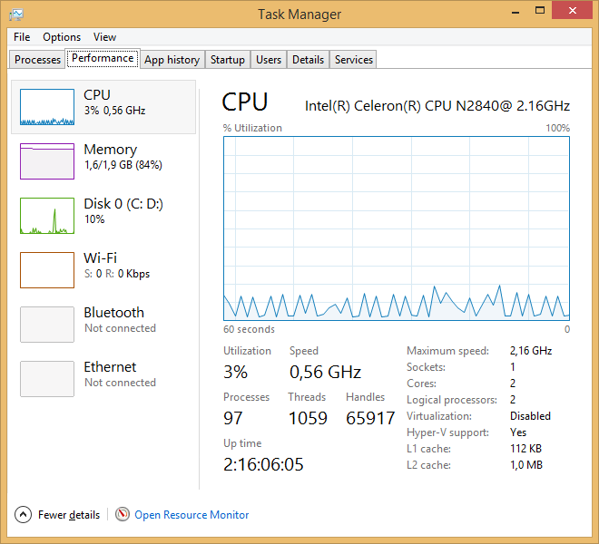
 | 2.3.1 | Use the information in the screenshot to motivate why it can be assumed that this system uses multithreading. | (1)
 | 2.3.2 | Briefly explain the term multithreading. | (2)
 | 2.3.3 | The screenshot shows that 112KB in L1 and 1MB in L2 of the physical memory of the system are cached.  Explain the purpose of caching. | (2)
 | 2.3.4 | The screenshot show that there are 2 cores in the CPU. What is the meaning of this? | (2)
2.4 | It is very important that the data of the school is protected against hard drive failure especially with the power going off at any time. The IT company suggests that the school make use of RAID technology.  Briefly explain how RAID technology works. |  | (2)

SECTION C: COMMUNICATION TECHNOLOGIES AND NETWORK TECHNOLOGIES
QUESTION 3 |  |  | [23]
The computers in the school administration offices are connected to a local area network, as shown in the diagram below.
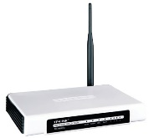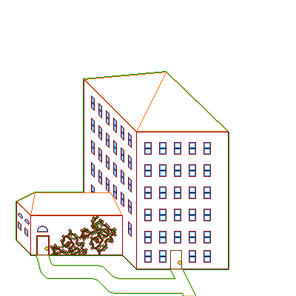
Switch
Network server
ISP
Internet
3.1 | 3.1.1 | Name the network topology used in the LAN diagram above. | (1)
 | 3.1.2 | Name TWO advantages of using the topology mentioned in QUESTION 3.1.1. | (2)
 | 3.1.3 | UTP cables have been used for the network. State TWO disadvantages of using UTP cables. | (2)
 | 3.1.4 | State TWO functions of the network server? | (2)
 | 3.1.5 | The office uses a router to connect to the internet. Briefly explain what a router and a modem are. | (2)
3.2 | One of the employees of the IT company that is responsible for the maintenance of the schools computers also acts as the network administrator. The network administrator is responsible for the regular backup of the schools data.
 | 3.2.1 | Give TWO other duties of the network administrator. | (2)
 | 3.2.2 | Differentiate between the rights granted to a standard user and those generally granted to administrators on a network. | (2)

 | 3.2.3 | An online backup service is considered as a solution for backing up the data.  Explain the term online backup service and give the name of ONE such service. | (3)
 | 3.2.4 | A common feature of these online services named in QUESTION 3.2.3, is the ability to sync (synchronise) files.  Briefly describe what this means. | (1)
 | 3.2.5 | Most of these services provide file sharing collaboration and the ability to simultaneously edit documents.  Briefly explain the difference between these two approaches. | (2)
 | 3.2.6 | The IT company sometimes remotely controls the computer at school by using software such as Remote Desktop Connection to work and fix problems at school. Discuss the differences between remotely controlling a computer with software such as Remote Desktop Connection and using a VPN. | (4)

SECTION D: DATA- AND INFORMATION MANAGEMENT
QUESTION 4 |  |  |  |  |  |  |  |  |  | [25]
4.1 | The following tables are created to save data of load shedding in the database: LoadsheddingDB. The structures of the tables are follows:
 | TownTB
 | Key |  |  | Field name |  | Data type |  |  | Description
 | 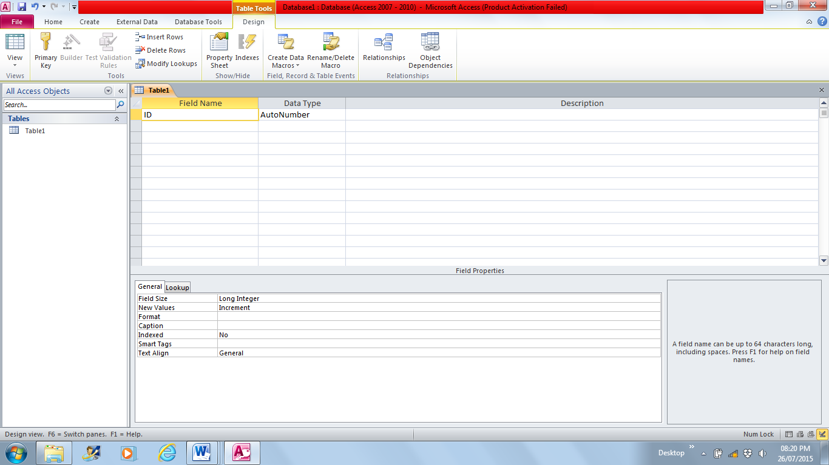 |  |  | TownID |  | Number |  |  | A unique number for each town
 |  |  |  | Substation |  | Text |  |  | The name of the town or city
 | SubLoadTB
 |  |  |  | SubLoadBlockNo |  |  |  | Text | A unique code for each subload address
 |  |  |  | SubLoadAddress |  |  |  | Text | The address of the substation
 |  |  |  | TownID |  |  |  | Number | A unique number for each town
 | TimeDayTB
 |  |  | DayNo |  |  |  | Number |  | A unique number for the day of the week
 |  |  | DaysOfWeek |  |  |  | Text |  | Name of the day of the week, e.g. Monday
 |  |  | Time |  |  |  | Text |  | The specific time of the load shedding
 |  |  | SubLoadBlockNo |  |  |  | Text |  | A unique code for each subload address
 | 4.1.1 | Write down the relationship that is formed between TownTB tablel and the SubLoadTB table and clearly indicate the following:
 |  | a) |  |  | The type of relationship that is formed – from TownTB table’s side. |  |  |  |  | (1)
 |  | b) |  |  | The key types of both keys (primary and foreign) in the relationship – indicate the name of the tables and the field names of the keys. |  |  |  |  | (2)
 |  | c) |  |  | What is the purpose of the primary key in the table? |  |  |  |  | (1)

 | 4.1.2 | Use the table structures in Question 4.1 to write SQL-statements for each of the following queries.
 |  | a) | Display all the fields of the TownTB table and sort the SubStation field in descending order. | (4)
 |  | b) | Display the SubLoadAddress in the SubLoadTB table and the DaysOfWeek and Time of the TimeDayTB table where the day of the week a Wednesday is. | (5)
 |  | c) | The time for load shedding on a Tuesday changed from  12:00-14:00 to 14:00- 16:00. The TimeDayTB table must change accordingly. Write code to make the necessary changes. | (3)
 |  | d) | The town, Stella is left out accidently from theTownTB table. Add the following record to the TownTB table:  TownID: 89  Substation: Stella | (4)
4.2 | The electricity provider use DBMS software. It is software that allows you to work with electronic databases.
 | 4.2.1 | Name THREE typical functions or tasks that a user will be able to do with a DBMS. |  | (3)
 | 4.2.2 | The two main categories of DBMS software is desktop databases and server DBMSs. Will a desktop database such as MS Access be suitable for the electricity provider? Motivate your answer. |  | (2)

SECTION E: SOLUTION DEVELOPMENT
QUESTION 5 |  |  | [25]
In the developing a program, OOP concepts are used.
The following class diagram (UML diagram) shows the attributes and methods that are used to create the EMPLOYEE object for a company.
EMPLOYEE
Fields | Methods
- fWorkerID : string | + constructor(ID, Nm, Nom)
- fName : string | + DetermineAge : integer
- fContactNumber : string | + ………5.2………  + DetermineGender ……5.3.....
- fGender : char
- fFullTime : Boolean

5.1 | Explain the difference between the public and private declarations in relation to OOP. |  | (2)
5.2 | Consider the following:  • the constructor has parameters to initialise the attributes fWorkerID, fName and fContactNumber.  • the gender is determined by the DetermineGender method form the ID of the employee.  Which mutator method(s) must be added to provide values for the rest of the attributes after the constructor has instantiated the object? |  | (2)
5.3 | To determine the gender of an employee, the seventh character is extracted from the ID. The gender is determined through a set of conditions. Write ONLY the definition statement of the DetemineGender method. In other words whether it is a function or a procedure. Indicate also the value parameters and/or reference parameters if necessary. (Do not write the code to determine the gender). |  | (2)
5.4 | Indicate whether the following statements regarding OOP-programs TRUE or FALSE are. |  | (6)
 | 5.4.1 | Private data fields (attributes) can be used by all methods inside the class where it is declared.
 | 5.4.2 | Mutator methods are known as GET methods.
 | 5.2.3 | Accessor methods must have parameters.
 | 5.2.4 | A method with a Boolean return value can only be called in a decision statement.

5.5 | The flow diagram below is designed to determine the maximum value that is a factor (M) of an integer (K). Excluding the number itself.  All variables in the flow diagram is of type integer. All division will return a truncated answer.  Copy the trace table below with columns and the headings as specified in your answer book. Follow the trace table step by step and complete all the columns of the table to determine the result of the algorithm. | (4)
K | M | L | L = K? | M = 1? | (OUTPUT)
Use 15 as the value for K to complete the table for the flow diagram.
Flow diagram
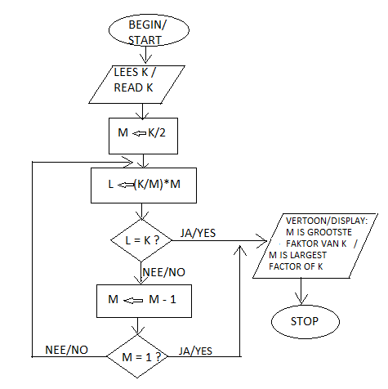

5.6 | A company uses passwords for security and access control.  The criteria for the password is as follows:  - Minimum 8 characters  - Must contain at least one number from 0 to 9.  - Cannot contain the name of the person.  Write an algorithm in pseudo code that will test if the employee’s password meets these requirements. Display a message if the password is valid. | (8)

SECTION F: INTEGRATED SCENARIO
QUESTION 6
A company gives information to residents in connection with load shedding.
6.1 | The company sent electronic brochures to a number of clients via e-mail. Some of the clients informed them that it took a while to download these brochures even if they have a fast internet connection and some couldn’t open the brochures on their computers.  Explain what the possible causes can be for both of these problems and give a solution for each. |  | (4)
6.2 | The company all of a sudden receives a lot of spam.  Give THREE practical solutions for this problem. |  | (3)
6.3 | The company conveyed a survey. They found that most people will use IM such as WhatsApp rather than e-mail. Give TWO reasons why people would make less use of e-mail. |  | (2)
6.4 | A monitor of one of the desktop computers in the office doesn’t display an image. Give TWO ways to determine what the possible cause can be. |  | (2)
6.5 | Most monitors are connected via the VGA port of a computer. Which port of a computer is replacing the VGA port and can be used to connect monitors and TV sets to a computer. |  | (1)
6.6 | It is important that the computers in the office can be used to its full potential due to the workload because of all the power failures.
 | 6.6.1 | Why will it be necessary to upgrade the computers although the hardware is still in a working order? Give TWO reasons. | (2)
 | 6.6.2 | How can the company contribute to green computing when the computers are upgraded? Give TWO methods. | (2)
6.7 | The manager of the company must regularly attend meetings all over the country. One of his friends suggested that he can ’Skype’ to save on expenditures.
 | 6.7.1 | What does it mean to ‘Skype’? | (2)
 | 6.7.2 | Why is it better not to use a webcam during a Skype session? Give TWO reasons. | (2)

6.8 | The company restricts their employees in the AUP (Acceptable Use Policy) in using social networking sites.
 | 6.8.1 | What can be the motivation for the company to impose such a regulation? | (2)
 | 6.8.2 | Name another THREE aspects that can be covered in an AUP. | (3)
6.9 | A client of the company complains about the battery of her smart phone. Give THREE ways in which she can reduce the power consumption of her smartphone. |  | (3)
6.10 | Maintenance tasks like Defragmentation and Disk Cleanup is necessary when using computers
 | 6.10.1 | Name TWO functions of the Disk Cleanup utility. | (2)
 | 6.10.2 | How would using the Defragmentation utility improves the work performance of a computer? | (2)
6.11 | The computer technician warned the company against harmful programs that spread easily over a network. He mentioned the term, Rootkit.
 | 6.11.1 | What is a rootkit? | (1)
 | 6.11.2 | Give TWO examples of dangerous computer activities that can be performed as result of a rootkit installation. | (2)
 | 6.11.3 | What is the function of a computer technician? | (1)
6.12 | Some of the employees of the company is going to attend a course in the designing of web pages.
 | 6.12.1 | Name ONE format that is used in the design of modern web pages. | (1)
 | 6.12.2 | A lot of web sites develop apps for mobile devices. Give THREE advantages of the use of apps for mobile devices. | (3)

