

Grade 12

Information Technology
Preparatory Exam 2015

MARKS: 150
TIME: 3 HOURS

This paper consists of 13 pages.

INSTRUCTIONS AND INFORMATION

1. This question paper consists of THREE questions.

2. Answer ALL the questions.

3. The duration of this examination is three hours. Because of the nature of this examination it is important to note that you will not be permitted to leave the examination room before the end of the examination session.

4. Make sure that you answer the questions according to the specifications that are given in each question. Marks will only be awarded based on the set requirements.

5. Only answer what is asked in each question. For example, if the question does not ask for data validation, no marks will be awarded for data validation.

6. Your programs must be coded in such a way that they will work with any data and not just the sample data supplied or any data extracts that appear in the question paper.

7. Save your work regularly on the disk (CD/flash disk/DVD, et cetera) that you have been given, or on the disk space allocated to you for this examination.

8. Rename the examination folder you received with your name and surname. Make sure that your name and surname appears as a comment in the first line of code of your answer to a question. Include the question number as part of the comment.

9. If printouts are required make printouts of the code of all the programs/classes/units that you did and NOT of the code that is generated automatically.

10. Printing must be done after the examination session within the timeframe provided for printing.

11. At the end of this examination session, you must hand in the disk/CD with all your work saved on it OR you must make sure that all your work has been saved on the disk space allocated to you. Ensure that all files can be opened and read.

12. You are provided with a disk or space on the hard drive that contains the files that you need to complete this question paper.

List of files provided:

QUESTION 1
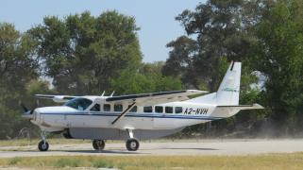
frmQuestion1.dfm
frmQuestion1.pas
Question1P.dpr

QUESTION 2
frmQuestion2.dfm
frmQuestion2.pas
Question2P.dpr

QUESTION 3
frmQuestion3.dfm
frmQuestion3.pas
Question3P.dpr
Animals.txt
00.jpg
01.jpg
02.jpg
03.jpg
04.jpg
05.jpg
06.jpg
07.jpg
08.jpg
09.jpg
10.jpg

SCENARIO:

Private Air is a new airline which does daily flights from South Africa to Botswana. To advertise this new service, they launched a competition where you and other learners from your school can compete to win amazing prizes.
Learners will get the opportunity to visit this amazing animal enriched country for a safari of a lifetime.

SECTION A: GENERAL PROGRAMMING SKILLS (LINEAR PROGRAMMING)
QUESTION 1 [50]

Private Air needs a program with which passengers can book their flights online to Botswana.
An unfinished program was created and you were asked to help finish the program. Afterwards
the program will be judged by four independent judges and the programmer with the best
program will win a week’s holiday in the bushveld.

Open the unfinished program frmQuestion1 and Question1P in your exam folder and complete the questions which follow:

  - A StringGrid (sbLayOut) was created and represents the cabin layout of one of Private Air’s planes. There are four rows of two seats each and is numbered as follows:
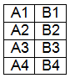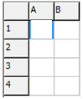
    - When the program starts, the StringGrid (sgLayOut) must be filled with random values of either a one (1) or a zero (0). This will represent the availability of the seats. If there is a 1
in the cell, it means that the seat is already taken. If there is a 0 in the cell, it means that
the seat is unoccupied and therefor still available for booking. [4]
Example of output:
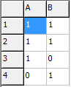
    - Add the headings in the StringGrid (sgLayOut) for the rows and columns to make it
easier for the user to see which seats are still available. [2]
Example of output:

  - Let the user fill in all the fields and when the button (btnReserve) is pressed, do the following in the OnClick-event:

    - Store all the values entered as local variables. [5]

    - Extract the value of the first letter in the user’s name and store it as sInitial. [1]

    - A person’s ID number consists of 13 characters.
The first six numbers are his/her date of birth, followed by four numbers which determine his/her sex.
If the value of the seventh character is between 0 and 4, the person is male.
If the value of the seventh character is between 5 and 9, the person is female.
Use the ID number of the user to determine his/her sex and only store the word “Mr.”
or “Mrs.” in a variable called sTitle. [4]

    - Private Air uses a special code for their flight numbers on different routes. It is compiled using the following rules:

      - All flights start with the letters PA.
      - If the origin of the flight is Durban, the number 10 is added.
If the origin of the flight is Cape Town, the number 20 is added.
If the origin of the flight is Johannesburg, the number 30 is added.
      - If the destination of the flight is Francistown, the number 1 is added at the end.
If the destination of the flight is Maun, the number 2 is added at the end.
If the destination of the flight is Kasane, the number 3 is added at the end.
Example:
If a person is flying from Cape Town to Kasane, the flight number will be PA203.
Calculate the flight number of the user and store it as sFlightNumber. [3]

    - 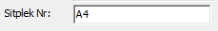The user must choose a seat and type it into the Edit (edtSeatNr).
Use the value in the EditBox to test if the seat he chose, is available or not.
If the seat is NOT available, a suitable message must be displayed and the program
must stop.
If the seat IS available, it must be reserved by changing the value of the StringGrid (sgLayout) to 1. [8]
Example of output:
The user chose seat number A4 which is available because there is a 0 in the cell.

    - Passengers who sit in the first two rows (Row 1 and Row 2) will have to pay R5000.
Passengers who sit in the last two rows (Row 3 and Row 4) will have to pay R3000.
NB: Due to the fact that seat A4 is next to the door and therefor has more legroom, a person would have to pay an extra R150.50 for this seat.
Passengers also have the option to insure their baggage and if they do, they will
have to pay an additional R120.10 for this service. Note that you have to show on
the receipt later on, just a “yes” or a “no” depending on if the user selected the service
or not. (See example of output)
Use the information above to calculate the final cost of the flight and store it as rPrice. [8]

    - Using all the information gathered, create a boarding pass for the user in the RichEdit (redReceipt) as shown in the example. [14]

    - When the user click on the btnExit-button, the program must exit. [1]
Example of output:
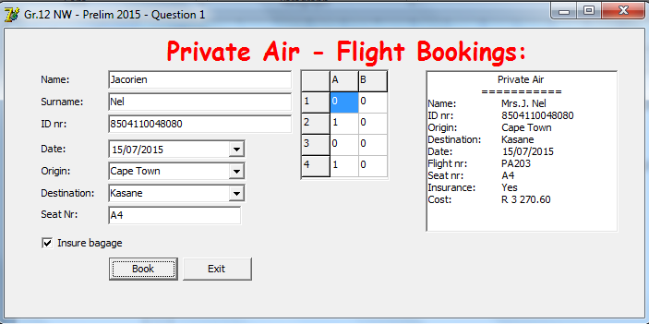
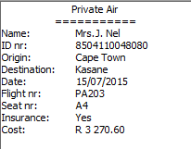
1.2.1 – 1.2.3
1.2.4
1.2.6
Total Section A: [50]

SECTION B: OOP OBJECT ORIENTATED PROGRAMMING
QUESTION 2 [50]
REMEMBER: Object Orientated programming requires that an own class object be created. No marks will be allocated if OOP requirements are not met and coding is done in the Delphi unit only.

Four well known programmers are appointed as judges of the program, participants wrote in question 1. The judges will each look at the program and give it a score out of 100 for his/her attempt.
The rules for the competition are as follow:
- None of the judges may award the same mark. If it so happens, they must speak to each other and one has to change his mark.
- There are four judges, but only the three best marks will be taken into account when an average is calculated.
- The participant with the highest average will be the winner of the competition.
  - Create a new unit and save it as clsClass.pas.

  - Define a new class with the name TBotswana. [1]

  - Define two new datatypes namely: [1]
    - sArray – This will be an array that can store 20 String values.
    - rArray – This will be an array that can store 20 Real values.
  - The class will have the following private fields: (Choose the correct datatypes) [2]
    - fName – Name of the user.
    - fSurname – Surname of the user.
    - fM1 – First judge’s mark.
    - fM2 – Second judge’s mark.
    - fM3 – Third judge’s mark.
    - fM4 – Fourth judge’s mark.

  - Create a constructor (create) that will receive the name and surname of the user as
well as the four different marks given by the judges as parameters to initiate the corresponding private attributes with them. [2]

  - Write a function called DetermineLowestMark, which will determine the value of the
lowest mark (of the four marks given by the judges) and make it globally available in
the class. [5]

  - Write a procedure called CalculateAverage, which will calculate the average of the
three highest marks and make it globally available in the class. [3]

  - Write a function called, GetAverage, which will send the calculated average of the
user as a parameter back to the main unit. [2]

  - Write a function called ToString, which will send back the name and surname of the user, followed by the three best marks, as well as the average to the main unit in the following format:
<Name>space<Surname>TAB<MarkA>TAB<MarkB>TAB<MarkC>TAB<Average>%
Example: Elmien Mattheus 56 67 65 62.66%
Note: The average is rounded to two decimals. [5]

  - Write a function called, DetermineWinner, which will receive (i) an array with the names of the participants, (ii) an array with average percentages of the participants, as well as (iii) a counter with the number of entries in the array, as parameters. This function must sort the learners according to their averages to determine and send back the name and average of the learner with the highest average. It should be send in the following format:
<Name> with <average> % average.
Example: Elmien Mattheus with 85% average. [10]
-------------------------------------------------------------------------------------------------------------------

  - Save the class unit and open the main unit called Question2P.dpr.
Connect the main unit to the class unit and answer the questions that follow: [3]
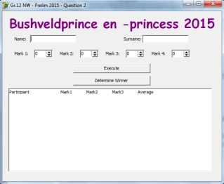

  - When the program starts, a new (blank) text file (Winners.txt) must be created.
This file will be used later on to store the names of certain participants. [3]

  - Add the following headings in the RichEdit (redOutput), neatly in five columns.
Participant Mark 1 Mark 2 Mark 3 Average [1]

  - Let the user enter a name, surname and four different marks given by the judges and
click on the btnExecute-button. [10]

    - Save the six values the user entered as variables.
    - Send the values to the class unit, by calling the constructor method.
    - Call the given function, TestValid, in the class to test if there are any two marks given by the judges with the same value.
    - If two or more marks are the same, an error message must be displayed.
    - If the marks are valid, the average must be calculated and the values displayed in the RichEdit (redOutput) by calling the toString-method.
Example of output:
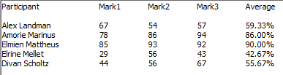

    - If the average of the participant is greater than 80% do the following:
(i) The participant’s name and surname must be added to a single array called
ArrNameAndSurname.
(ii) The average of the participant must be added to an array called ArrAVG.
(iii) Use a counter to count the number of entries entered into the arrays.
(iv) Write the info of the participants that qualify to the text file (winners.txt) that was created in the beginning of the program in the following format:
<Name>space<Surname>space<Average>%
Note: The average must have no decimal values.
Example of output in the text file:
Amorie Mariunus 86%
Elmien Mattheus 90%

  - When the user clicks the btnDetermineWinner-button, the necessary methods in
the class must be called to determine the participant with the highest average and
be displayed in the RichEdit (RedOutput) as follow: [2]
Example of output:
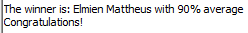

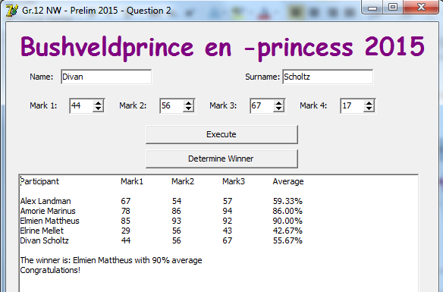
Total Section B: [50]

SECTION C: PROBLEM SOLVING

QUESTION 3 [50]

Private Air has set up computers outside of the airports for the tourists to see which animals
was recently seen in the area and to add sightings if new animals are sighted. An incomplete program is given and they’ve asked you to help the finish the program so that they can use it
on their computers.

  - Open Question3P.dpr and do the following:
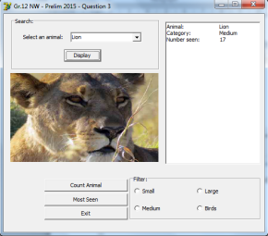

  - A text file called Animals.txt was created in which the data is stored as follow:
00.Lion#M$6
01.Leopard#M$15
02.LilacRoller#B$23
...
* The number of the photo followed by a . (full stop)
* The name of the animal followed by a # sign.
* Category of the animal followed by a $ sign.
S = Small M = Medium L = Large B = Birds
* Number of times the animal has been seen.

    - When the program starts the info of the animals must be read out of the text file and
into four different arrays. [13]
ArrPicture – Number of the photo.
ArrAnimal – Name of the animal.
ArrCategory – Category of the animal.
ArrTimesSeen – Number of time the animal has been seen.
    - Add the names of the animals to the ComboBox (cbxAnimals). [1]

    - Create a dynamic picture object (image) with the following properties: [7]
Name := 'imgAnimal';
Top := 120; Left := 14;
Height := 180; Width := 300;
AutoSize := False; Stretch := True;

  - When the user clicks on the btnDisplay-button, the following should happen:

    - Search through the array to see if the animal that the user selected in the ComboBox
exists and load the picture of the selected animal into the image object (imgAnimal).
Display the rest of the information of the selected animal in the RichEdit (redOutPut)
neatly as in the given example.
Example of output: [8]
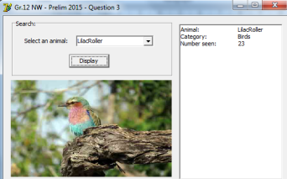
    - If the animal was found in the array, the btnCountAnimal-button must be enabled. [1]
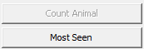 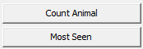

  - When the user clicks on the btnCountAnimal-button, the number of times the selected animal has been seen, must be increased by updating the correct entry in the array.
Note: No output is required. [1]

  - When the user clicks on the btnExit-button, the text file (Animals.txt), must be rewritten
with the update information in the arrays and the program must close. [3]
  - When the user clicks on the btnMostSeen-button, do the following:
    - Disable the btnCountAnimal-button. [1]

    - Display a list of all the animals in the text file as well as the number of times they
have been seen in order of most seen to least seen in the RichEdit (redOutput). [6]

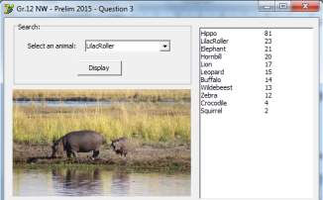
    - Display the picture of the animal that has been seen the most in the image object (imgAnimal).
Example of output: [1]
(3.5.2 and 3.5.3)

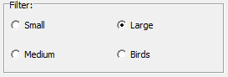
  - When the user clicks on the RadioGroup (rgpCategory), do the following:

    - No image must be displayed in the image object (imgAnimal). [1]

    - Display all the names of the animals in the chosen category. [2]

    - Calculate and display the number of animals in the selected category.
(Not the number of times seen) [1]

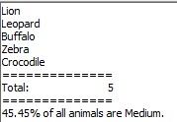
    - Calculate and display the percentage which the animals in the selected category
represent. (Assume that all the animals in the park are entered into the text file. In this example it means that there will be a total of 10 animals in the park.) [3]
Example if Medium is selected:

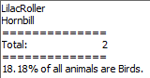
Example if Birds is selected:

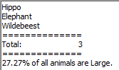
Example if Large is selected:
Total Section C: [50]
Grand total: [150]

ERRATA/FOUTE : PAPER 1
QUESTION 1 (English versión Only)
1.2.3
If the value of the seventh character is between 0 and 4, the person is male.
If the value of the seventh character is between 5 and 9, the person is female.
1.2.3 Corrected to
If the value of the seventh character is between 0 and 4, the person is female.
If the value of the seventh character is between 5 and 9, the person is male.
__________________________________________________________________
QUESTION 2/Vraag2
The teachers must rename the heading of the function (Datafile-Given Code.txt/ Gegewe Kode.txt). The learners must copy this code to the class because it is given code and they are going to use it in the main program with a call statement.
function TBotswana.TestValid: Boolean; (WRONG)

function TBushveld.TestValid: Boolean; (CORRECT)
--------------------------------------------------------------------------------------------------------------------------
Gegewe Kode.txt
function TBotswana.ToetsGeldig: Boolean; (verkeerde)

function TBosveld.TestValid: Boolean; (KORREKTE)

