

UMLAZI DISTRICT
TRIAL EXAMINATION
INFORMATION TECHNOLOGY P2
GRADE 12

DURATION: 3Hrs MAX MARKS:150

INSTRUCTIONS:

- This paper consists of 11 pages and 6 questions:
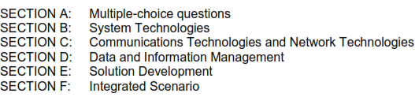
- Answer ALL the questions.
- Write neatly and legibly.
- Number your answers as the questions are numbered.
- Rule off after every question.

SECTION A: MULTIPLE CHOICE
QUESTION 1 :

Choose the option that best matches the given statement. Write only the number and the LETTER corresponding to your choice

  - A software program that records what you type on the keyboard or the mouse clicks you make is called a …
A) worm.
B) honeypot.
C) keylogger.
D) cookie

1.2 …… refers to a network of remotely controlled and malware infected PC’s
- remote access
- zombies
- botnets
- keygens

1.3 Organisations with large databases, use this to keep track of who made changes to the database and when these changes were made
- access controls
- data validation
- SQL injections
- audit trails

1.4 Dropbox, iCloud and oneDrive are examples of….
- Online storage – backup
- Online storage –file synching
- Media repositories
- Cloud applications

1.5 In the following pseudocode of an IF-statement the incrementing of a counter is dependant on the value of B:
IF (B < 4) AND (B > 12)

increase counter by 5
Else
display message
The value of the counter will never be incremented because …

A) the value of B is smaller than 4 and smaller than 12, for example 3.
B) a negative value has been assigned to B.
C) the value of B is greater than 12.
D) both conditions will never be true at the same time.

1.6 A virtual machine is …
A) a new prototype for a computer.
B) a theoretical computer such as the Turing machine.
C) software emulating a computer.
D) a computer running multiple operating systems.

1.7 Which ONE of the following statements is TRUE?
- A class may NOT have more than ONE constructor.
- A mutator method provides the facility to change a class variable.
- A class is an instantiation of an object.
- An accessor method provides the facility to change a class variable.

1.8 GIGO …
- refers to a situation where there is too much data for a program to handle properly.
- is an acronym for Gigabyte of Graphic Output.
- refers to incorrect information obtained from incorrect input.
- is an acronym for a Google's latest freeware program.

1.9 ICT has changed education by ...
A) creating a job market that requires more skills and therefore better education
B) raising the expected standard, quality and appearance of 'products' (projects,
etc) that learners must deliver.
C) forcing a shift in focus from knowledge-based learning to information
gathering and analysis skills.
D) all the above-mentioned.

1.10 Intellectual property rights …
- indicate the permission granted to an individual to refer to a document created
by another author.
- refer to the situation where the author of a software application claims
ownership of the idea behind his program.
- refer to the rights a web site has over its pictures on the site.
- refer to the published document outlining the rights of an individual who
published a book on the internet.

TOTAL SECTION A:[10]

SECTION B: SYSTEM TECHNOLOGIES
QUESTION 2

2.1 Technology keeps improving at a fast rate as newer devices are advertised
almost on a daily basis. This trend is becoming increasingly prevalent
amongst cellphones.
.
2.1.1 What is a smartphone? [1]
2.1.2 Briefly describe TWO advantages and TWO disadvantages of
smartphone technology. [4]
2.1.3 Name an operating system exclusively for use on smartphones. [1]

2.2 A tablet uses an SSD for storage of data and files.

2.2.1 What does the acronym SSD stand for? [1]
2.2.2 List THREE comparative differences between the features and
performance of an SSD and an HDD in table format. [3]

2.3 All computer systems have RAM and ROM.

2.3.1 State two major differences between RAM and ROM. [2]
2.3.2 Virtual memory is often used while managing RAM. Explain what
virtual memory is. [2]

2.4 Briefly describe how the following components affect the performance of the computer:

2.4.1 CPU [2]
2.4.2 cache [2]

2.5 Computers today are built using a modular design principle.

2.5.1 Explain the term ‘modular design’. [1]
2.5.2 State 1 advantage of modular design. [1]

2.6 What is the difference between open-source software and freeware? [2]

TOTAL SECTION B: [22]


SECTION C: COMMUNICATION & NETWORK TECHNOLOGIES
QUESTION 3
Your school has recently refurbished their IT Centre. The computers in the centre will now be networked, allowing for the easy transmission and distribution of data….

3.1 A network for the new IT Centre in your school will be run on a server and will
need one printer at the front of the room. All users will need access to the printer
and to the Internet.

Explain the purpose of the following hardware in the network:

3.1.1 100Mbps Ethernet network cards [1]
3.1.2 Switch [2]
3.1.3 Router [1]

3.2 Cabling is a part of networking. The school has two options: UTP cable or
fibre-optic cable.

State ONE characteristic of each type of cable above and make a
recommendation to the school on which type of cable to use. [3]

3.3 Depending on where a network is, various topologies are used.

3.3.1 Define the term ‘topology’. [1]
3.3.2 Explain why the star topology is a popular choice in most
businesses? [2]

3.4 What do the following acronyms stand for? Briefly describe each one.

3.4.1 WAP [2]
3.4.2 PAN [2]

3.5 Your school would like learners and teachers who have internet access to be able to use the school’s network from home. They have been advised to make use of a VPN.
Briefly explain what a VPN is? [2]

3.6 Security over the internet is an important issue.

3.6.1 Define the term encryption. [1]
3.6.2 A digital certificate is needed in order to use SSL as an encryption
protocol.
a) What type of encryption does SSL use? [1]
b) Define the concept digital certificate. [2]

3.7 Skype is probably the most popular form of VoIP software.
Briefly explain what VoIP is. [2]

3.8 What is BitTorrent? [1]

TOTAL SECTION C: [23]
SECTION D: DATA & INFORMATION MANAGEMENT
QUESTION 4

4.1 In setting up and maintaining a database, it is important for us to ensure that the
data we have is reliable and correct. Various methods can be used to achieve
this, including validation and verification…

4.1.1 What is data validation? [2]
4.1.2 Give an example of a validation rule. [1]
4.1.3 State TWO ways in which a person can check the data for errors and
inconsistencies [2]

4.2 A travel agency has a database called AZToursDB, which contains details of their clients as well as their staff, stored in two separate tables called tblTourists and tblTourGuides, respectively.
Details of the tables are indicated as follows:

tblTourists
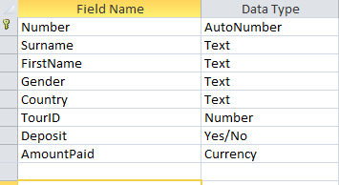

tblTourGuides
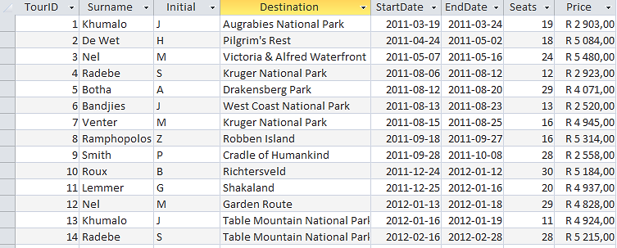

4.2.1 Give the appropriate field types for the following fields in
tblTourGuides:
a) Initial [1]
b) StartDate [1]
c) Price [1]

4.2.2 With respect to relational databases, what is a foreign key? [2]

4.2.3 Identify the foreign key, and the table in which it exists, in the above
example. [2]

4.2.4 Explain the purpose of the field type used for the primary key in tblTourists. [1]

4.2.5 Write appropriate SQL statements for the following :
a) The manager wants an alphabetical listing of the various destinations, that the travel agency organises tours to . [3]

b) The auditor wants a list of the highest tour price as well as the average price of all the tours, correct to 1 decimal place. The following captions may be used respectively: ‘Highest Cost’ and ‘Average Cost’ [4]

c) The secretary requires a list containing the tourID, surname, initial and destination of all tour guides whose tour to any of the parks, began during May 2012. [5]

TOTAL SECTION D: [25]

SECTION E: SOLUTION DEVELOPMENT
QUESTION 5

5.1 Looping structures are often used in programming when the need arises. There
are generally two types of loops, namely conditional and unconditional loops

5.1.1 In programming terms what is a loop? [2]
5.1.2 Mention an example of an unconditional loop [1]
5.1.3 Under which conditions, would it be more preferable to use an unconditional loop, rather than conditional loop [2]

5.2 Consider the GUI screen below, developed for a Pizza parlour to capture telephonic orders.
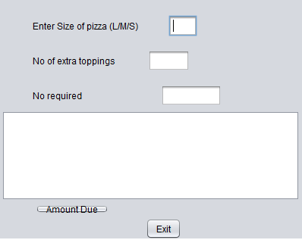

Component A

5.2.1 State two improvements that can be made to this GUI design, that would enhance its’ usability. [2]
5.2.2 State one shortcoming of using component A, to enter the size of the
pizza. [1]
5.2.3 State TWO other possible GUI components that would be more suitable to use in this instance. [2]

5.3 AZTours would like to create an application that would input details of their clients. The following class called Tour is suggested:
Tour
- tourRef
- name
- dateOfTour
- destination
+ Tour()
+ Tour(tourRef,name, destination)
+ getName()
+ getDateOfTour()
+ getDestination()
+ setDestination()
+ toString()

5.3.1 What is the purpose of a constructor in a class? [1]
5.3.2 Identify and explain the differences between the two types of constructors shown in the class diagram. [3]
5.3.3 Which one of the methods in the class is declared incorrectly?
Explain how this should be corrected. [2]
5.3.4 Which methods of the class would you use if you wish to:
a) display the details of an instantiated object
b) change the destination for a client
c) instantiate an object
d) retrieve the destination [4]

  - Consider the following algorithm which determines if a number is prime or not and answer the questions that follow :

- read num
- count 0
- countFact ….
- loop num times
- inc(count)
- if …(a)….. then
…(b)…….
- end loop
- if countFact = 2 then
print …(c)…..
else
print …(d)…

5.4.1 Explain the purpose of the following counters in the algorithm:
a) count [2]
b) countFact [2]
5.4.2 Complete the initialisation in line 3 [1]
5.4.3 Complete the rest of the algorithm(a- d) [5]

TOTAL SECTION E: [30]

SECTION F: INTEGRATED SCENARIO
QUESTION 6

6.1 Recently, a security company received an e-mail from an unauthorized source requesting the security password for the building. According to the e-mail, one of their employees had to urgently collect important documents from the building
and he had forgotten the password.

6.1.1 Which term is used when an unauthorised source uses an e-mail to try to convince someone to provide security-related information? [1]
6.1.2 A link in the e-mail navigated the user to a web page that looked almost exactly like that of the security company. What is this type of
communication scam called? [1]

6.2 Fingerprint readers are used for authorized access in many companies.

6.2.1 What is technology such as a fingerprint reader called? [1]
6.2.2 Name TWO other examples of this type of technology that could also be used. [2]

6.3 A database was planned and created by the database administrator at the
your school. The data on all the educators and learners were entered
into the database tables. All the educators have access to the database.

6.3.1 Explain the difference between data and information. Use examples as part of your answer. [3]
6.3.2 Explain why record-locking is necessary when different educators/
staff are working on the same table in a database. [2]
6.3.3 Besides planning and creating a database, name TWO other tasks
that a database administrator has to perform as part of his/her duties.
[2]

6.4 Caution must be exercised when using Wi-Fi Internet access in public places such as coffee shops, airports and shopping malls, because malicious people can intercept their data when it is transmitted.

6.4.1 What is Wi-Fi? [1] 6.4.2 Name TWO types of devices that are able to make use of Wi-Fi. [2]
6.4.3 Explain why connecting to a Wi-Fi network does not necessarily mean you will have free Internet access. [2]
6.4.4 Which term is used to refer to the practice of intercepting data packets
on a network? [1]

6.4.5 For EACH of the following technologies, state whether or not it is able to protect your data from being intercepted and used. Clarify your answer in
EACH case:
(a) Firewall [2]
(b) Encryption [2]
(c) Virus scan [2]

6.4.6 You decide it is safer not to use any Wi-Fi networks. Suggest an
alternative Internet connection which is portable and can be used almost anywhere. [1]

6.5 Due to the increasing availability of online information, such as travel blogs
and forums, the tourism industry might find itself out of business.

6.5.1 Define a travel blog. [2]
6.5.2 Give TWO examples of how ICT can be used to assist potential travellers in planning and organising their own holiday trips. [2]

6.6 A pamphlet received from a Mike’s Game Reserve contained the following information:

98,9% of all tourists who visited South Africa in 2010 during the
Soccer World Cup visited Mike's Game Reserve.

Someone queried this statistic, believing it to be incorrect. State THREE ways
of verifying the trustworthiness of data/information. [3]

6.7 ADSL or a 3G Internet connection…

6.7.1 Expand the acronym 3G. [1]
6.7.2 State TWO possible problems that could occur when using a 3G
connection. [2]
6.7.3 ADSL is an asymmetric service. Briefly explain what asymmetric
service means. [1]

6.8 In a recent sporting event in South Africa, one of the organisers stumbled upon information on a social media website indicating that a specific athlete used a banned substance.

6.8.1 Give an example of a social media website that could have been used to publish this information about the athlete. [1]
6.8.2 Is the organiser allowed to act upon this information? Motivate your
answer. [2]
6.8.3 It was established that the profile does not belong to the athlete
implicated. What kind of computer crime was committed against the athlete in this case? [1]

TOTAL SECTION F: [40]

GRAND TOTAL : 150 MARKS

