

<SCHOOL NAME>

NATIONAL

SENIOR CERTIFICATE

COMPUTER APPLICATIONS TECHNOLOGY
GRADE 12
PAPER 2: THEORY
(Written paper)
18 SEPTEMBER 2014
JU

MARKS: 150
TIME: 3 hours

This exam paper consists of 17 pages.

INSTRUCTIONS AND INFORMATION
- This question paper consists of:
SECTION A (25 marks)
SECTION B (75 marks)
SECTION C (50 marks)
- Answer ALL the questions.
- Number the answers correctly according to the numbering system used in this question paper.
- Start EACH question on a NEW page.
- Do NOT write in the right-hand margin.
- Leave a line between each sub-question.
- In general, a mark is allocated per fact. A 2-mark question would therefore require TWO facts, et cetera.
- Write neatly and legibly.

SECTION A

QUESTION 1: MULTIPLE CHOICE QUESTIONS

Various options are given as possible answers to the following questions. Choose the answer and write only the letter (A–D) next to the question number (1.1 to 1.7) in the ANSWER BOOK, for example 1.8 D.

1.1 | Developers of the … use code names such as KitKat, Jelly Bean and Ice Cream Sandwich for the different versions of their systems.
 | A | Apple operating system for mobiles
 | B | Windows operating system
 | C | Linux operating system for mobiles
 | D | Android operating system for mobiles |  | (1)
1.2 | Which ONE of the following is a chip that uses battery power to store configuration information about the computer, even when the computer is off?
 | A | BIOS
 | B | CMOS
 | C | POST
 | D | RAM |  | (1)
1.3 | Which ONE of the following is an example of a microblogging site?
 | A | Facebook
 | B | Twitter
 | C | MXit
 | D | Instagram |  | (1)
1.4 | The HTML attribute which allows for a cell to be stretched over multiple columns is known as …
 | A | Cellspacing
 | B | Colwidth
 | C | Cellpadding
 | D | Colspan |  | (1)

1.5 | You should use footnotes in a report …
 | A | on at least every page and as much as possible.
 | B | to include material that you forgot to write in the body.
 | C | to shorten the length of your text in the body.
 | D | to explain the content and acknowledge copyrighted material. |  | (1)
1.6 | The process in which a user is redirected from the right website to a fake website without the user being aware of it, so that the user's personal details can be stolen.
 | A | Pharming
 | B | Phishing
 | C | Click-jacking
 | D | Spoofing |  | (1)
1.7 | Which ONE of the combinations below best describes the advantages of WLAN?
 | A | Mobility, flexibility, planning
 | B | Security, range, flexibility
 | C | Cost savings, flexibility, speed
 | D | Reliability, mobility, speed |  | (1)
 |  | Sub-Total: |  | [7]

QUESTION 2: MATCHING ITEMS
Choose a term/concept from COLUMN B that matches a description in COLUMN A. Write only the letter (A – R) next to the question number (2.1 – 2.10) in the ANSWER BOOK, for example 2.11 U.

Column A |  |  |  | Column B
2.1 | A technology that uses radio signals to communicate with a tag placed in an object or animal. |  |  | A Micro USB  B Touch screen  C Uniform Resource Locator  D Netiquette  E Phablet  F QR code  G LED Monitor  H F1  I Ergonomics  J URL shortner  K Amazon  L Near Field Communication  M RFID  N Kickstarter  O F12  P Metadata  Q Barcode  R BYOD
2.2 | Information about the size of an image or who the author is of a text document.
2.3 | An example of a website that allows donors or volunteers to contribute to a business concept or idea.
2.4 | A method whereby wireless devices can be connected by touching each other or being brought very close together.
2.5 | A method used to ensure links to websites are not broken when copied to other documents or places.
2.6 | The practice of respecting other peoples' privacy and not doing anything online that will annoy or frustrate them.
2.7 | Dragging, pinching, flicking are all concepts, motions or actions linked to this device.
2.8 | A group of black and white squares using OCR and camera technology on a mobile device to read a URL or other information.
2.9 | A way to connect your smartphone to your computer.
2.10 | A shortcut to access the help function in the Office applications.
 |  | Sub-Total: 10 x 1 = [10]

QUESTION 3: TRUE/FALSE ITEMS

Indicate whether the following statements are TRUE or FALSE. Choose the answer and write 'True' or 'False' next to the question number (3.1—3.5) in the ANSWER BOOK.

Correct the statement if it is FALSE. Change the underlined word(s) to make the statements TRUE. (You may not simply use the word 'NOT' to change the statement.)

Examples:

QUESTION: | ANSWER:
System requirements describe which hardware and software is needed for software to be installed. | True.
The 'Print Screen' key on the keyboard takes a screenshot and sends it directly to the printer. | False.  The 'Print Screen' key on the keyboard takes a screenshot and sends it directly to the clipboard.

3.1 | A webcam is an input device.
3.2 | A virus is an error created by accident in the development of a program.
3.3 | A Trojan is a spyware program that records your keystrokes to capture secure information like passwords.
3.4 | Select Previous in the Tracking Changes option when you want to remove any proposed changes from another author/user.
3.5 | All formatting of a word processing document is lost when you save it as a text file, i.e. with a .txt file extension.
 | Sub-Total: [8]

SECTION B

QUESTION 4: SYSTEMS TECHNOLOGIES

4.1 | Most operating systems make use of a graphical user interface (GUI).
 | 4.1.1 | Explain the term graphical user interface (GUI). |  |  | (2)
 | 4.1.2 | List TWO items (features) you would find on a GUI. |  |  | (2)
4.2 | Give TWO technologies that could be used for daily data backups other than optical media and flash drives. |  |  |  | (2)
4.3 | Backup utilities enable users to make copies of certain files or the entire hard disk to another disk or other storage medium. You can also archive your files.  Explain the term archive in this context. |  |  |  | (2)
4.4 | Many applications running at the same time on your computer can slow it down.  Explain how you can find out what applications are currently running on your computer. |  |  |  | (1)
4.5 | The operating system of your computer is able to co-ordinate the printing of two documents at the same time.  Explain how the print spooler and the buffer can stop problems from occurring during the printing process. |  |  |  | (2)
4.6 | Study the computer specifications shown below and answer the questions that follow.
- Processor: Intel® Core™ I7-3770 (8 MB Cache, 3.40 GHz)
- Memory: 4 GB DDR3 (+3 slot free)
- HDD: 1 TB / 7200 rpm
- Warranty: 3 Year Carry-In
- Optical Drive: DVD+-RW
- Graphics: INTEGRATED
- OS: WIN 8.1 PRO 64 bit
- Front: Two High Speed USB 2.0
- Back: Four High Speed USB 3.0, one integrated VGA port, one integrated Display port

 | 4.6.1 |  |  | Explain TWO major differences between USB 2.0 and USB 3.0 with regards to data transfer. | (2)
 | 4.6.2 |  |  | The storage capacity of the secondary memory (storage) of this computer far exceeds the storage capacity of primary memory (RAM).  Briefly explain why storage would always have to have a larger capacity than RAM. | (2)
 | 4.6.3 |  |  | This computer system has a cache capacity of 8 MB.  Briefly explain what caching is. | (2)
 | 4.6.4 |  |  | Explain how caching improves Internet browsing and give the name of this type of caching. | (3)
 | 4.6.5 |  |  | Windows 8.1 was released quite soon after Windows 8.  Suggest TWO possible reasons for an early release of the updated system, i.e. Windows 8.1. | (2)
 | 4.6.6 |  |  | You are looking into the merits of adding a SSD (Solid State Drive) to your computer.  Give TWO advantages and ONE disadvantage of a SSD over a traditional (mechanical) hard drive. | (3)
 |  |  |  |  | [25]

QUESTION 5: INTERNET AND NETWORK TECHNOLOGIES

5.1 | "The Internet is the ultimate network." – www.netmarket.com  What type of network would you consider the Internet to be? |  | (1)
5.2 | Other than cables, suggest TWO other communication methods that are used to connect the computers and servers together in a network. |  | (2)
5.3 | Communication on the Internet takes place using a set of protocols.
 | 5.3.1 | Give the name of the Internet standard that permits file exchange with other computers on the Internet. | (1)
 | 5.3.2 | What is the correct term for the process where a web page author transfers his web page from his computer to a web server? | (1)
 | 5.3.3 | What is the term used for the set of protocols that allow telephone calls to be made over the Internet?  (Write out the protocol in full and do just not give the acronym). | (1)
5.4 | Grid computing refers to the use of multiple computer systems as if they were one computer.  State TWO advantages of grid computing. |  | (2)
5.5 | Explain the purpose of cloud computing. |  | (2)
5.6 | Web browsers may require plug-ins.  Briefly explain what a web browser plug-in is and include ONE example in your answer. |  | (3)
5.7 | Broadband can be accessed via an ADSL landline, 3G or LTE (Long Term Evolution).  Briefly explain the difference between ADSL and LTE by stating the function of each of these connections. |  | (2)
 |  |  | [15]

QUESTION 6: INFORMATION MANAGEMENT

6.1 | The PAT (Practical Assessment Task) is a research project involving independent work and an opportunity to demonstrate your information management skills.  List any TWO requirements of the PAT in CAT. | (2)
6.2 | Give ONE purpose for creating a list of research questions when doing a research project such as the PAT. | (1)
6.3 | "A questionnaire is a tool used for a survey."  Explain what a questionnaire is and give the purpose of a questionnaire. | (2)
6.4 | One of the CAT learners created and shared a spreadsheet for respondents to fill in their data such as their name, e-mail address, contact details, etc.  The CAT learner now finds that his spreadsheet is no longer capturing accurate data.  Explain a possible cause for this problem and supply a solution to the problem. | (2)
6.5 | Discuss TWO instances where it is better to use a database than a spreadsheet application to process data so that information can be presented in a meaningful way. | (2)
6.6 | Explain ONE possible problem of relying only on the Internet for information. | (1)
 | Sub-Total: | [10]

QUESTION 7: SOCIAL IMPLICATIONS

7.1 | Describe TWO ways in which technology can have a negative effect on people’s lives. |  | (2)
7.2 | Explain the purpose of using parental control software programs such as Net Nanny, Safe Eyes or Family Shield. |  | (1)
7.3 | Suggest ONE reason why passengers on a commercial flight may be requested to switch their mobile computing device to 'airplane mode' or 'flight mode'. |  | (1)
7.4 | Explain why it is necessary or not necessary to regularly update anti-virus software and/or a firewall. |  | (2)
7.5 | Criminals can use computing power and Internet connections in the form of zombie computers to perform multiple DoS attacks.
 | 7.5.1 | Explain what a DoS or DDoS attack does and what the goal of such an attack is. | (2)
 | 7.5.2 | Other than relying on anti-virus software or a firewall, give TWO ways to fix the problem of a botnet application. | (2)
 | Sub-Total: |  | [10]

QUESTION 8: SOLUTION DEVELOPMENT

8.1 | Screenshot 1 below gives the erroneous html coding for correct display of a web page shown in Screenshot 2.
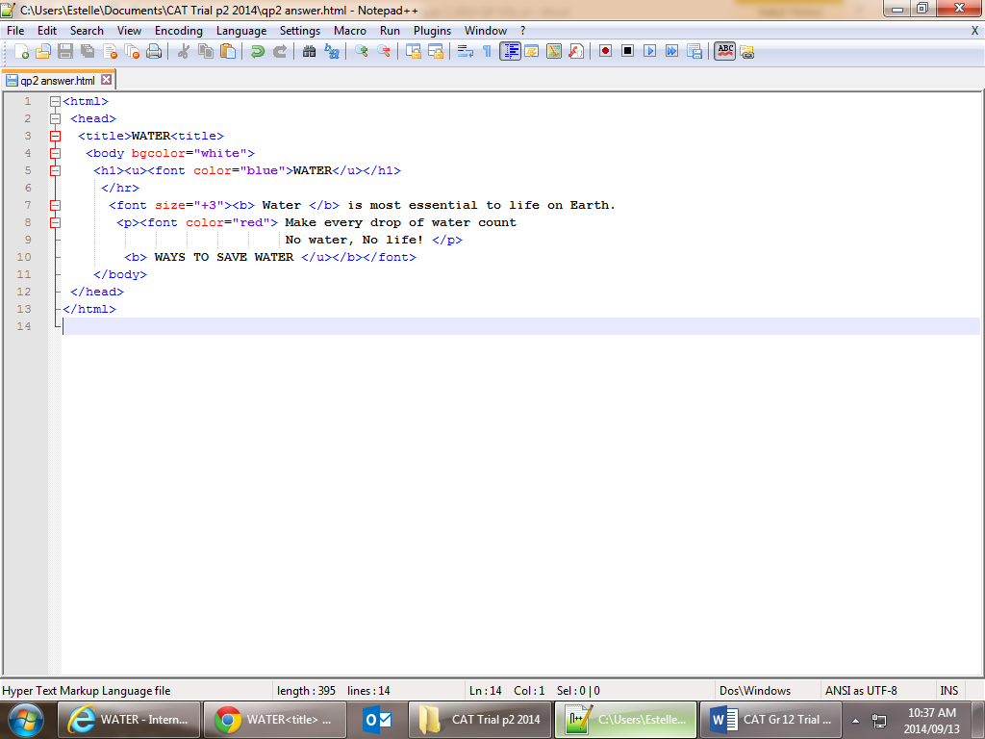
Screenshot 1
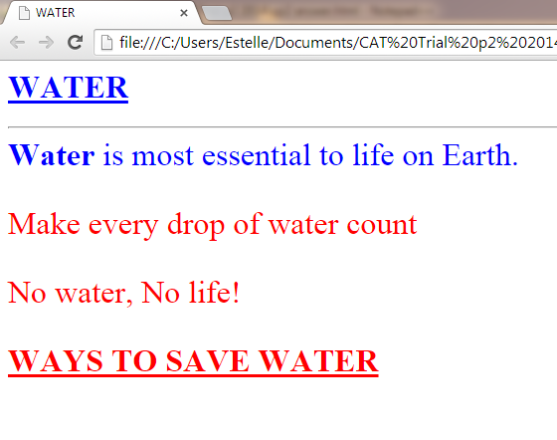
Screenshot 2

 | 8.1.1 | Identify any THREE errors in the HTML coding found in Screenshot 1 that will cause the web page not to display as shown in Screenshot 2.  Write down the line number in which the error occurs and then the error found in that line. | (3)
 | 8.1.2 | Other than text editors such as Notepad or Notepad ++, name TWO other types of programs or web-design tools used to create web pages. | (2)

8.2 | With reference to the use of spreadsheets:
 | 8.2.1 | Explain the purpose of the DATE function, i.e. =DATE, in a spreadsheet and why it is not suitable to be used if the current date is required whenever a spreadsheet is opened. |  | (1)
 | 8.2.2 | Give a function that would be suitable if you want the spreadsheet to return the current date. |  | (1)
8.3 | The screenshot below reflects a database query.  Use this screenshot to help you answer the questions that follow:
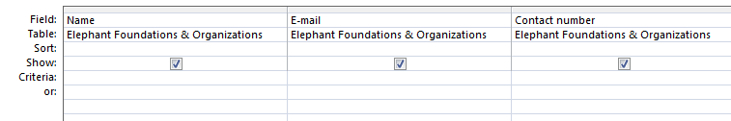
 | 8.3.1 | The user would like to extract a list of only the names and contact numbers that start with '083' of all the Elephant Foundations and Organisations contained in the database table.  - What problem is the user likely to encounter with the query shown in the screenshot above?  - State why this problem is occurring. |  | (2)
 | 8.3.2 | Wildcards are useful when you need to locate records with similar data or you are trying to find a specific record in a database.  Explain the use of each of the following wildcard characters in criteria expressions:  - Question mark (?)  - Asterisk (*)  - Hash tag (#) |  | (3)
8.4 | With reference to the Widow/Orphan control in word processing:
 | 8.4.1 |  | Describe the function of the Widow/Orphan control | (1)
 | 8.4.2 |  | Give an example of how/where/when you would use the Widow control option. | (1)
 | 8.4.3 |  | Give an example of how/where/when you would use the Orphan control option. | (1)
 | Sub-Total: |  |  | [15]
SECTION C

QUESTION 9: INTEGRATED SCENARIO

SCENARIO
The teacher in charge of your school's conservation club wants the club members to make use of ICTs to manage the activities of the club.

You are required to use your computing skills to assist the club and answer the following questions.
9.1 | The club plans on taking many photographs and videos during their field trips to create powerful presentations to promote conservation.  Explain TWO specifications when purchasing a notebook computer that they may need to consider for this purpose.  (Hint: They will have to purchase more than an entry-level notebook.) |  | (2)
9.2 | The treasurer of the club arranged to set up the new notebook computer and will have the Windows Operating System installed on it.
 | 9.2.1 |   Explain TWO ways in which proprietary software such as Microsoft Windows differs from open source software (OSS) such as Linux. | (2)
 | 9.2.2 | One of the members inserted a flash disk into a USB port on the computer and got a message saying that the disk and some of the files may be corrupted.  What Windows operating system utility program can be used to diagnose and possibly 'fix' the flash disk? | (1)
 | 9.2.3 | During the installation of a new software package on the notebook computer the technician was asked to accept the terms and conditions of the EULA.  Explain what an EULA is.  (Do NOT merely write out the acronym in full.) | (1)

9.3 | Club members need to be able to transfer data from their devices to the computer.
 | 9.3.1 | Suggest TWO reasons why you recommend wired technology for data transfer. | (2)
 | 9.3.2 | Discuss TWO problems which may be experienced with wireless technology for data transfer. | (2)
9.4 |   The World Wildlife Fund (WWF) organisation has offered each member of the club a smartphone.
 | 9.4.1 | Give TWO features of smartphones when compared to a basic cell phone. | (2)
 | 9.4.2 | SMS messages on some smartphones are displayed as 'threads'.  Explain the concept of a message 'thread' in this context. | (2)
9.5 | The WWF organisation requested the club to scan and attach photos of the club members in an e-mail message.  Provide a possible solution for each of the following problems that the club members experienced with the scanner:
 | 9.5.1 | The edges of the document did not get scanned. | (1)
 | 9.5.2 | The OCR application cannot recognise any text in the scanned document. | (1)
 | 9.5.3 | The members found that the memory card on the digital camera needs to be emptied regularly as the photographs take up a large amount of storage space.  Explain TWO possible ways in which more photographs can be taken before it is necessary to empty the memory card. | (2)
 | 9.5.4 | List ONE example of data that can be retrieved from the metadata in an image file from a digital camera. | (1)
9.6 | The club members want to publish a quarterly report on all their activities.
 | 9.6.1 | State TWO reasons why a word processing application would be more suitable for publishing a quarterly report as opposed to using a presentation application such as PowerPoint. | (2)
 | 9.6.2 | The club secretary is experiencing difficulty in printing the quarterly report.  Assume the problem lies with the printer. Suggest TWO methods of solving printer problems. | (2)
 | 9.6.3 | List TWO page set-up options the club secretary could select from the printer options to print the report in multiple pages. | (2)
9.7 | The club would like to host their own website.
 | 9.7.1 | Suggest THREE design elements to be considered in the design of the web page. | (3)
 | 9.7.2 | The president of the club would like the quarterly report to be added to the club's website.  How would it be possible to include the quarterly report on the club's website? | (1)
9.8 | One of the club members prefers to store her collection of Wildlife books on her Kindle e-reader.  Describe TWO possible advantages of using an e-reader in this situation. |  | (2)
9.9 | The club needs to be able to connect the computer to the Internet.
 | 9.9.1 | List THREE criteria that should be considered when choosing a broadband package, other than cost. | (3)
 | 9.9.2 | Identify TWO advantages of using a 3G connection. | (2)
9.10 | The club members want to invite readers from around the world to invest in their conservation idea. It was suggested that they use a 'crowd funding' website for their conservation presentation.  Briefly explain the process of crowd funding. |  | (2)
9.11 | It was suggested that Geo-tagging be used when the club members go on wildlife conservation excursions (field trips).
 | 9.11.1 | Explain to the club members what Geo-tagging is. | (2)
 | 9.11.2 | What device would you associate with Geo-tagging? | (1)

9.12 | The president of the club heard that around five million usernames and passwords for Gmail accounts were recently posted on a Russian forum or message board.
 | 9.12.1 | State the term used to describe people who commit the kind of deed mentioned in the statement above. | (1)
 | 9.12.2 | Explain the purpose of an online forum. | (2)
 | 9.12.3 | With reference to the theft of the Gmail accounts, it appears that the usernames and passwords did not come from a direct attack on Google.  What is the name given to this kind of cyber-attack? | (1)
 | 9.12.4 | Suggest ONE piece of advice you would give to the Gmail account holders? | (1)
9.13 | The club has teamed up with another conservation club from a school in a different province.
 | 9.13.1 | Suggest ONE input device that could assist the learners in the club that have poor eyesight. | (1)
 | 9.13.2 | Suggest ONE input device that could assist the learners in the club that are physically challenged with poor motor control. | (1)
 | 9.13.3 | Some of the club members feel the club should use Skype to communicate with members in the other province.  Take into account that the club has a 3 GB cap on their bandwidth, comment on the impact that Skype is likely to have on the club's budget. | (1)
 | 9.13.4 | The two clubs would like to share photographs with each other.  Suggest ONE way in which they could do this. | (1)
 | Sub-Total: |  | [50]

GRAND TOTAL : 150 MARKS

