

APOLLO SECONDARY SCHOOL
TRIAL EXAMINATION-2014
INFORMATION TECHNOLOGY P1
GRADE 12

DURATION: 3Hrs MAX MARKS:150

INSTRUCTIONS AND INFORMATION
1. Answer ALL the questions.
2. Because of the nature of this examination it is important to note that you will not be permitted to leave the examination room before the end of the examination session.
3. Make sure that you answer the questions according to the specifications that are given in each question. Marks will only be awarded based on the set requirements.
4. Your programs must be coded in such a way that they will work with any data and not just the sample data supplied or any data extracts that appear in the question paper.
5. Save your work regularly on the disk (CD/flash disk/DVD, et cetera) that you have been given, or on the disk space allocated to you for this examination.
6. Make sure that your name and surname appears as a comment in the first line of code you did to answer a question. Also include the question number as part of the comment.
7. At the end of this examination session, you must hand in the disk/CD with all your work saved on it OR you must make sure that all your work has been saved on the disk space allocated to you. Ensure that all files can be read

SCENARIO
Blue Crane Tours is a local travel agency that offers different tour packages to various destinations around South Africa. They are currently upgrading their computer systems, with new software that could be useful when dealing with clients
As a budding computer programmer, you have been approached by this organisation to assist with developing software for them.
QUESTION ONE – GENERAL PROGRAMMING
The following software application, called Quest1, in Question1 package, will be used by the travel agency to book passengers onto flights and confirm bookings
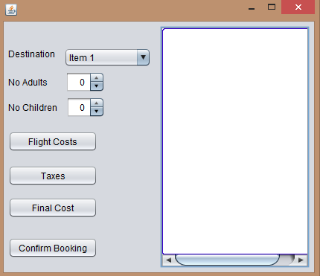
    - In the constructor of the class, dynamically instantiate a label just above the label Destination with the following specifications:

Name of Panel : jPanel1
Name of the label : label
Text on the label : Blue Crane Tours
Font color : Blue
Bounds : 40,20,250,10
(5)
    - Populate the combo-box cmbDest, with the following options : Cape Town, Johannesburg, Bloemfontein (2)

    - The following schedule gives a break-down of the cost of flights according to destination :
DESTINATION | ADULT PRICE | CHILDREN PRICE
Johannesburg | R780 | R658
Cape Town | R1020 | R965
Bloemfontein | R945 | R835

Code the following behind the Flight Costs button :

- Retrieve the values for the destination, number of adult tickets, and number of children’s tickets and calculate the flight cost of the trip, based on the above schedule
- Display the flight cost in the text area, correct to 2 decimal places, with a suitable caption (12)

    - In addition to the cost of the flights, passengers also pay airport taxes as per the following
schedule
NUMBER OF TICKETS PURCHASED | TAXES
- Tickets | 5% of total ticket cost
3-5 tickets | 7% of total ticket cost
>5 tickets | 9% of total ticket cost

Code the following behind the Taxes button:

- Calculate the amount due for taxes, based on this schedule, and the total cost calculated in (1.2) above.
- Display the taxes due in the text area, correct to 2 decimal places, with suitable captions/messages (8)

    - Code the following behind the Final Cost button:
- Calculate and display the final cost due for the trip, including airport taxes (3)

  - When the Confirm Booking button is clicked, the following form, called Quest1b is opened :

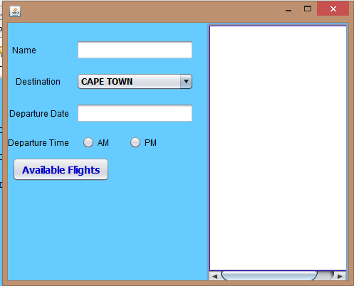

NOTE :The components lblFlight and cmbFlight are currently disabled !

This form will be used to generate and display available flights to the requested destination. The names of the flights will be randomly generated and stored in the declared 1D array called flights.
Thereafter the combo-box(cmbFlight) will be enabled and populated with the generated flight names.

    - Code the following behind the Available Flights button :
- All AM flights begin at 6 AM and all PM flights begin at 12PM, with a 1 hour gap between each flight.
- Since the number of flights to each destination varies, generate a random number in the range 1..7 and use this value to run a loop to generate names for the flights
- Each six digit flight name is generated in the following manner :
- The first digit is first letter of the destination
- The next two digits are randomly selected alphabetic characters from the keyword “MULTIRANGE” (declared as the variable wrd).

HINT: Generate random numbers, in the range of the keyword’s length!

- The last three digits is a random number in the range 100…400
- Store each flight name in the array flight, declared!

- Display the flight names and their scheduled times in the text-area, with suitable captions
- Enable combo box cmbFlight and label lblFlight and populate the combo-box with the elements of the array, flights
(25)

SAMPLE OUTPUT
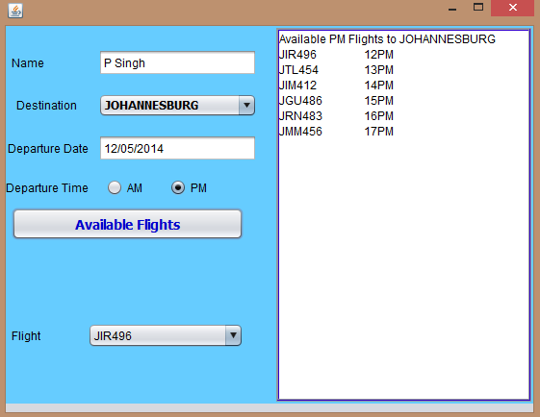

[55]

QUESTION TWO - OOP
The prices of the tours depend on the time of year the tours take place. As part of a marketing campaign, the company offers 15% discount on tours, depending on the number of tour members, or the number of days touring.
In Question2 Package:
You have been provided an incomplete application that consists of:
• An object class called Tour.java which describes the attributes of a tour and contains some
methods
• A form called Quest2x.java

2.1 Do the following to complete the code in the object class:

The Tour class contains the declaration of six attributes for a tour object and the default
constructor. The six attributes are:

Description | Name of attribute
Surname and initial of the tour guide | gName
Destination of the tour | dName
Month when the tour takes place | mName
Duration of the tour (number of days) | numD
Number of tour members | numT
Tariff per day | tariff

Write code for additional methods as described below:
2.1.1 Write code for a constructor method using parameter values to initialise ALL the attributes of the
class (4)

2.1.2 Write the following accessor methods, each returning their respective attributes :
a) getDays() – to return the duration of the tour
b) getNumTourists()- to return the number of tourists
c) getMonth()- to return the month of the tour (6)
2.1.2 Write code for a method named calcTariff(String month) to calculate and return the tariff per
day. The standard tariff per day depends on the month (passed as a parameter), of the year
when the tour takes place. The following applies:

Month | Tariff
April, September, December | R1250.00
January, February, August, October, November | R1000.00
March, May, June, July | R900.00

(7)

2.1.3 Write code for a method called calcCost() to calculate and return the total cost of the trip, based
on the tariff per day, number of days and the number of people in the group. (4)

2.1.4 Write code for a toString() method that will construct and return a string with labels and
information about a tour object in the following format:

Month: <name of the month >
Destination: <destination of the tour> with <name of tour guide> as the tour guide
Price: <tariff per day in rand currency rounded to 2 decimal places> per day for a
period of <number of days> days
<number of tour members> tourists are taking this tour.

Example of the output when the string returned by the toString method is displayed:

Month: October
Destination: Garden Route with J Martin as the tour guide
Price: R 1 000.00 per day for a period of 11 days
20 tourists are taking this tour.
(5)
2.2 Open the form Quest2x, having the following format :

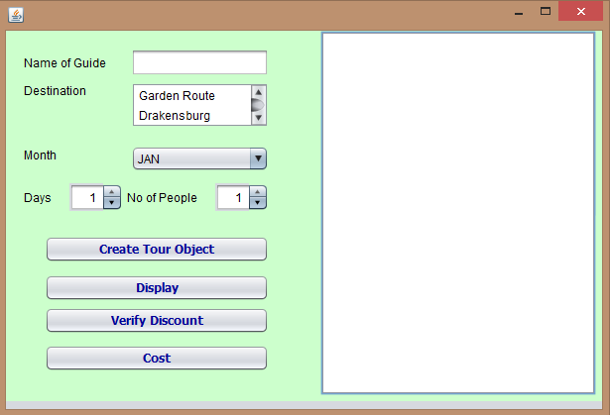

2.2.1 Create an object of the Tour class (2)

2.2.1 Code the following behind Create Tour Object button :
- Retrieve the values from the components of the form, and store in appropriate variables
- Using the object created, call the appropriate method of the tour class, passing the month of the tour as an argument.
- Thus instantiate an object of the tour class, passing the necessary variables as arguments
- Display a confirmation message in the text area, indicating that an object has been created
(12)
2.2.2 Display the details of the tour, using the toString() method of the tour class, when the Display
button is selected (2)

2.2.3 A tour will qualify for a discount of 15% off the total cost if either of the following criteria is met :
- The tour group consists of 5 or more people, and the tour takes place in August
OR
- The tour is in excess of 3 days and occurs in September or May

Code the following behind the Verify Discount button :
- By using the necessary accessor methods of the tour class, verify if this tour qualifies for a discount based on the above criteria
- Do the following thereafter :
- use the appropriate method of the Tour class, obtain the current cost of the tour
- determine the discount if applicable (7)

2.2.4 When the Cost button is selected, display the initial cost of the tour, the discount received and
the final amount due, in the text area, with a suitable message, Display all outputs correct to 2
decimal places (4)
[53]
QUESTION THREE - PROBLEM SOLVING

Blue Crane Tours needs statistics on the amount of foreign currency brought into the country by a number of tourists from various countries visiting South Africa.

In Question3 Pacakage you have been supplied with :
- a text file called DataQ3.txt
- a form called Quest3.java
The text file contains data on tourists who visited South Africa recently. The data for each tourist in the text file is in the following format:

<Name of the tourist>@<country where the tourist is from>#<first two characters representing the tour destination captured as capital letters>#<total amount spent on the tour in dollars (USD)>

SAMPLE DATA from text file

Rachel Delarosa@Canada#SH#1186
Corradino Grande@Spain#RO#5422
Lucas Herder@Germany#KR#7709
Estotz Lizarazu@France#GA#12349
Chynna Taylor@England#GA#8551
Renata Di@Spain#RO#4906
Ugs Boulot-Tolle@France#CA#7300
Lena Bucholtz@Germany#GA#10344
Maria Heimpel@Germany#SH#9438
……..

Open the Quest3 form

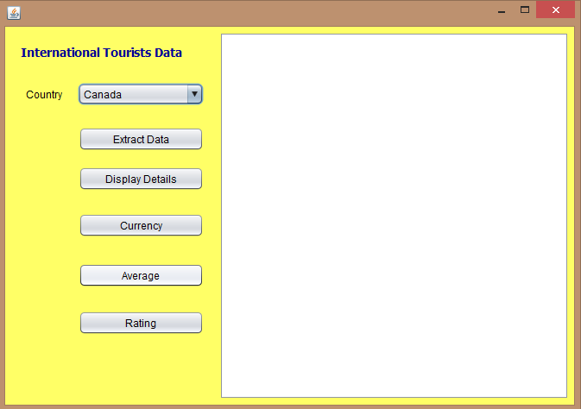
Code the following behind each button as specified below :

3.1 Extract Data button :
- Retrieve the name of the country selected from the combo-box
- Scan through the text file, using appropriate error catching techniques
- Separate the data from each line of the text file, and store the name, country and amount spent by the tourists from the SELECTED COUNTRY, in the respective arrays declared.
- Use counters to keep a count of the number of entries sent to the arrays, as well as the total number of entries in the text file
- Calculate and store the total amount of money spent by ALL the tourists
- Display the following in the text area with appropriate captions :
- The total number of tourists visiting the country
- The total revenue earned from the tourists in dollars
- A confirmation message indicating that details of the tourists from the selected country have been extracted
(16)
3.2 Display Details button :
- Display the details of the tourists stored in the array, in the text area sorted from the highest to lowest amount, using appropriate headings and captions (8)

3.3 Currency button :
- Convert and display, the total amount of money collected from all the tourists to Rands(ZAR), using the following exchange rate :
1 USD = 10.70 ZAR
- Calculate the total amount of money collected from the selected country, and convert to Rands, using the same exchange rate.

Note :
- All displays correct to 2 decimal places
- The values of both totals calculated here need to be available to be used in other parts of the program (6)

3.4 Average button :
- Calculate and display the average amount of money(in dollars) spent by all the tourists as well as the average spent by the tourists from the selected country
(5)
3.5 Rating button :
- Determine and display the percentage revenue obtained from the selected country
- The selected country will receive a rating based on the following criteria:

CONDITION | RATING PHRASE
Percentage revenue exceeds 40% | 5 Star
Percentage revenue between 20-39% | 3 Star
Percentage less than 20% | 1 Star

Determine the rating of the selected country and display the result in the text area (7)

[42]

TOTAL = 150

