INFORMATION TECHNOLOGY
GRADE 12
PREPARATORY EXAMINATION
PAPER 1(Practical)

DATE: September 2014
TIME: 3 HOURS
TOTAL: 150

Surname and Name: ..................................................................... Grade 12 .......
Computer Number: ………………

THE EXAMINATION PAPER MUST BE HANDED IN WITH THE PRINTOUTS OF YOUR ANSWERS.
QUESTION 1 | QUESTION 2 | QUESTION 3 | TOTAL
/ 50 | / 50 | / 50 | 150

150

Read through all the instructions carefully.
This question paper consists of three questions and 14 pages (title page included).
GENERAL INSTRUCTIONS AND INFORMATION
- This is a three hour examination.
- Answer ALL the questions. Read them carefully and do only what is required.
- A Learnerdata folder is supplied. It contains subfolders and data for the applications that you must develop.
- Change the name of this Learnerdata folder as instructed by your teacher.
- Type in your name and surname as a comment in the first line of each unit.
- Save ALL your solutions in the correct folders and sub folders.
- Save your work at regular intervals as a precaution against power failures.
- During the examination you may use the HELP function (F1) of Delphi. You may NOT make use of any other resources.
- At the end of this examination session you must make sure that ALL the files with your work have been saved as explained to you by the invigilator/educator. Ensure that ALL files can be read.
- Printouts of the programming code of the units will take place after the completion of this examination session as instructed by the invigilator.
FILES PROVIDED:
The following subfolders and files are provided inside the Learnerdata folder:
Q1xx:  Q1_p.dpr  Q1_u.dfm  Q1_u.pas  Candidates.txt | Q2xx:  Q2_p.dpr  Q2_u.dfm  Q2_u.pas  clsNewVoter_u
Q3XX:
Q3_p.dpr
Q3_u.dfm
Q3_u.pas

General Scenario
The election committee of the College Student Union (CSU) requested that, during the election, the voters must not only vote for student representatives but also evaluate the candidates on a scale of 1 to 5. A rating of 1 represents a voter’s opinion that the candidate will not be a good leader whereas a rating of 5 will mean that the voter is of the opinion that the candidate will be a good leader.

The College Student Union asked you to use your problem solving skills to develop a computer application for the election.
QUESTION 1 |  |  | [50]
The files needed for this question can be found in the folder named Q1XX. Rename the folder by replacing the XX with your name and surname e.g. Q1PietCilliers.
You have been provided with an incomplete program. Open the project file Q1_p and complete the program.

1.1 | The text file Candidates.txt contains the information of the election candidates. The candidates’ information is stored in the following format:  ID number%Name and surname%Cellphone number%Email address  Example of the information for Delaan Glory:  8801198585081%Delaan Glory%0775896589%delaanglory@nowitwiz.co.za  Follow the guidelines 1.1.1 to 1.1.5 to complete the code of the ‘Display Candidate’-button:
 | 1.1.1  1.1.2 | Test whether the file exists or not. Display an appropriate message if it doesn’t exist and close the program.  Read the candidate’s information from the text file, split the information to get the ID,name and celphone number. Save the candidates’ information in an appropriate data structure for later use. There are only 9 candidates for the election. | (4)  (12)
 | 1.1.3 | Calculate the candidate’s age by subtracting the candidate’s year of birth from the current year. A Delphi function must be used to determine the current year. Assume that all candidates were born in the 20th century (1900s). Also calculate the total age for all the candidates. | (4)
 | 1.1.4 | Use the seventh digit of the ID number to determine the gender (male or female) of the candidate. If the seventh digit is greater than 4, it is a male. Keep count of the number of male and female candidates. | (4)
 | 1.1.5 | Then only display the name and surname, the ID number and the age of the candidates in neat columns with headings.  Example of the output:  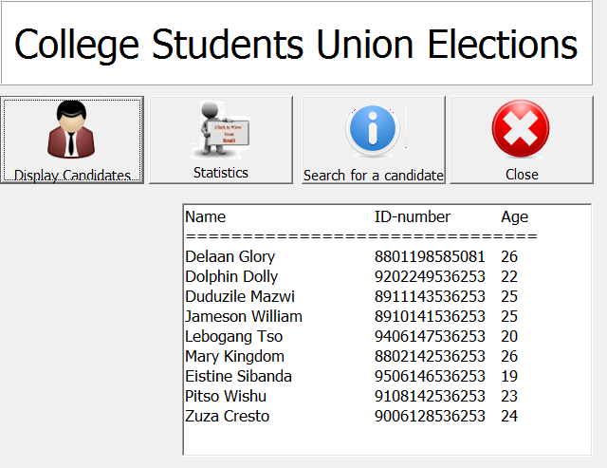 | (3)
1.2 | When the user clicks on the ‘Search a candidate’ button, the program must determine whether a candidate with a specific ID number exists or not.
 | 1.2.1 | In the OnCLick event of the ‘Search a candidate’ button, create a dynamic component on the form. This component, a label called lblInfo, will be used to display the candidate’s information. It must adhere to the following requirements:  - The form is the owner and the parent.  - Set the left property to 100.  - Set the top property to 600.  - The caption property must be empty.  - The font size must be 14.  - The font colour must be red.  If you are unable to create the label dynamically, add the label using the tool pallet so that you can complete 1.2.2. You will still lose the 7 marks for 1.2.1 though. | (6)
 | 1.2.2 | The user must be able to use an inputbox to capture an ID number and then determine whether a candidate with such an ID number does exist or not.  Use a search with a Boolean flag to stop the search as soon as the ID is found.  If such a candidate does exist, the candidate’s information must be shown in the lblInfo with the different information underneath each other (see sample output in screenshot below) . If no such candidate appears on the list, the user must be informed with the use of an appropriate message in a showmessage window.  Example of output of ID number 8801198585081 that exists:  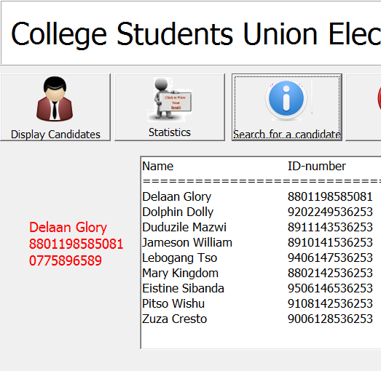 | (12)

1.3 | The ‘Statistics’ button provides interesting information about the candidates.  Follow the guidelines in 1.3.1 to 1.3.2 to complete the code of the ‘Statistics’ button:
 | 1.3.1 | Determine the average age of the candidates rounded to the nearest integer. | (2)
 | 1.3.2 | Display the average calculated in 1.3.1 and the number of male and female candidates determined in 1.1.4 in neat columns with suitable descriptions, in redInfo:  - The number of male candidates.  - The number of female candidates.  - The average age of the candidates.  Sample output:  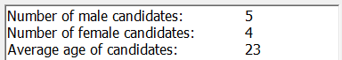 | (3)
 |  | TOTAL FOR QUESTION 1: | 50
QUESTION 2 - Object-orientated programming [50]

As preparation for the elections, new voters must be able to register. The information has to be tested for validity before it is written to the file that contains the information of all these prospective voters.

The files needed for this question can be found in the folder named Q2XX. Rename the folder by replacing the XX with your name and surname e.g. Q2PietCilliers. Open the project Q2_p and complete the program.

Complete the code for each section of QUESTION 2. QUESTION 2.1 must be completed in the object class clsNewVoter_u and QUESTION 2.2 in the main unit Q2_u.

2.1 An object class called TNewVoter has already been created.
The diagram below contains the names of the methods that are described in QUESTION 2.1.1 to 2.1.4:

tNewVoter
Attributes:
- fID, fCell, fEmail
Methods:
- Constructor Create (ID, Cell, Email)
- ValidDigits(string)
- ValidCell
- ToString

The following table contains a description of the different attributes of TNewVoter:
Attribute | Description
fID | The identity number of the new voter
fCell | The cellphone number of the new voter
fEmail | The email address of the new voter

Write code for the methods of the class as described in 2.1.1 – 2.1.4:
2.1.1 Constructor Create that receives parameters to initialise all attributes of the class. (4)

2.1.2 ValidDigits receives a string as parameter and tests whether the string only consists of digits. The returned Boolean value must indicate whether it is a valid string or not. (6)
2.1.3 ValidCell must test whether the cellphone number meets the following conditions:
- It may not be an empty string.
- It must consist out of 10 digits. (Use the ValidDigits method)
An empty string must be returned if it is a valid cellphone number. If it is an invalid cellphone number, then a suitable message must be returned as a string value, stating the reason for the invalid condition. (10)

    - ToString that will return a string that must be formatted as follows:
ID number%Cellphone number%Email address (2)
[22]
2.2 Do the following to code the tasks that must be performed in the main unit Q2_u. The new voter’s information, which was captured via the edits on pnlInfo, must be tested for its validity by using the methods of question 2.1. If all the data is valid, the voter’s information must be written to the text file called ‘Voters.txt’.

2.2.1 Declare an object NewVoter based on the TNewVoter class. (2)

2.2.2 Create a user defined procedure AppendToFile to write the information of a new voter to the text file called ‘Voters.txt’.
- If the file does not yet exist, it must be created, otherwise the information must be added at the bottom of the existing text file.
- The information must be in the following format: (Use the ToString method and insert the full name entered in the edit)
ID number%name of the voter%cellno%email address

- Display a message indicating that the information has been written to the file. (10)

2.2.3 Write the code for the button Register voter (btnRegisterClick event handler):
- Create the object that was declared in question 2.2.1.
- Use the object’s methods to test the validity of the cellphone number that was captured in the edit on pnlInfo. Display the messages on the lblMessage component.
- If the cell phone information of the new voter is valid, then the AppendToFile method must be called to write the voter’s information to the text file. (5)

2.2.4 A non-local variable arrVoters (array[1..9] of string) was declared to tally the number of voters that has voted for each candidate. Each vote is represented with the @ character. If 6 people have voted for Dolphin Dolly, the contents of the second element of the array would be @@@@@@ .
- Initialise the array in the Form onActivate- event. It must only contain empty strings. (2)

- Each time a voter clicks on the Vote button the voter must enter the number of the candidate he/she votes for. You can use any method to obtain the voters choice. E.g.
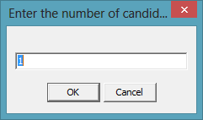

- The contents of the specific element of the array must be adjusted by adding an @ to the relevant element in the array. (3)

2.2.5 Write the code for the Display results button (btnResultsClick event handler) which will display the number of voters that have voted for each candidate as well as the string of @’s that represents the number of voters visually. Ensure that the correct output is displayed even if the button is clicked more than once.
The following screenshot is an example of the output: (6)
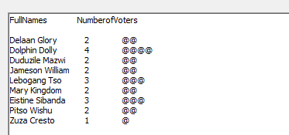
[28]
Below is an example of possible input and how the error messages can be displayed:
Instructions for the execution of the program:
- When the program executes, all the relevant information must be captured in the edits. Click on the Register button. (btnRegister)
- If any error messages are displayed on lblMessages, the Clear Messages button (btnClear) must be clicked and errors can then be corrected. Then click on the Register button again.
- If no error messages are displayed and the message 'New Voter details saved in textfile' is displayed, the button New (btnNew) can be clicked. All the edits will be cleared so that you can register a new voter.
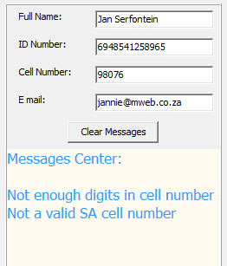

If the data was valid, a message (like shown below) must be displayed:
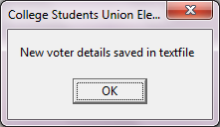 TOTAL FOR QUESTION 2: [50]

QUESTION 3 : (Two-dimensional arrays) [50]
The files needed for this question can be found in the folder named Q3XX. Rename the folder by replacing the XX with your name and surname e.g. Q3PietCilliers.
You have been provided with an incomplete program. Open the project Q3_p and complete the program.

  - Write code to complete the following tasks in the OnActivate event handler: (10)
- Display captions in the string grid, stgDisplayResults. The rows are numbered as V: 1, V: 2 up to V: 10 and the different movement names of the candidates are used as captions for the respective columns. (Get the movements from the radiogroup.)
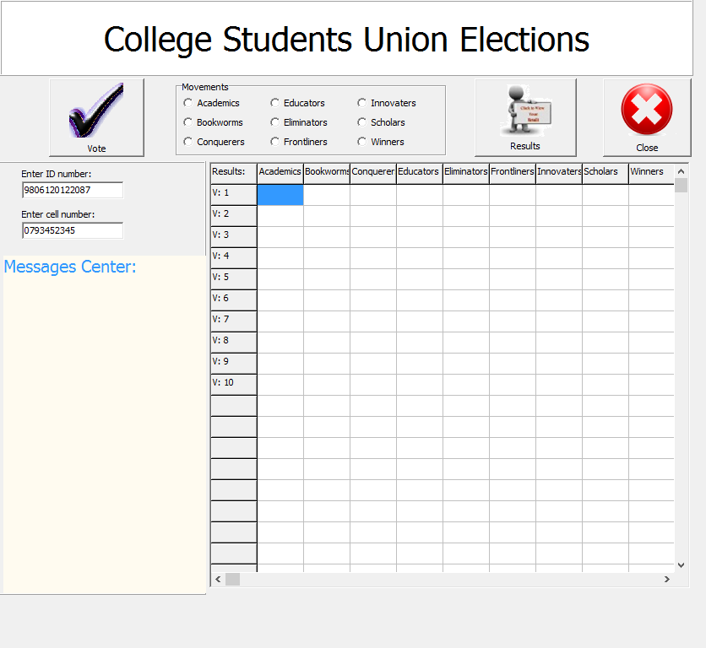
- Initialise all the cells in the string grid to contain empty strings.
- Initialise a variable to keep track of the number of the voter who is voting.

  - Write code to complete the following tasks in the btnVote event handler:
- A random number consisting of five digits must be generated to be used as a pin code. You must create your own global variable for this purpose. Display the pin code and cellphone number on lblMessage as shown in the screenshot below.
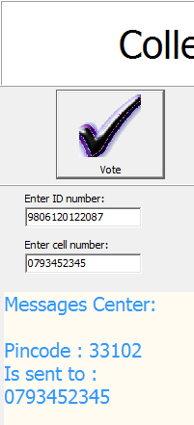

- Call the user defined procedure Vote – you will write the code for this procedure in question 3.3. (6)

  - Complete the code for the existing procedure by completing 3.3.1 – 3.3.2. Only ten voters will vote for the purpose of the paper.

    - Write the code for the user defined Vote procedure:
- Ask the voter to type the pin code that he/she has received.
- Test whether the correct code has been typed in – the voter gets three attempts to type in the correct code.
- Every time that a wrong code was typed in, a suitable message must be displayed.
- If all three attempts were unsuccessful, the method must be ended. (13)
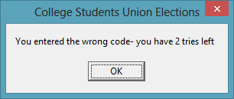

- If the pin code is entered correctly:
  - Enable the radiogroup
  - Display a message in a message dialogue that the user must select a movement in the radiogroup to vote.

    - If a movement is selected(rgpMovementClick):
- The voter must be asked to capture a rating for the movement. The rating may only be between 1 and 5 (both included).
- The rating must be displayed in the stringgrid.

This is an example of the output after voter no 1 voted for the Bookworm movement and gave it a rating of 4: (4)

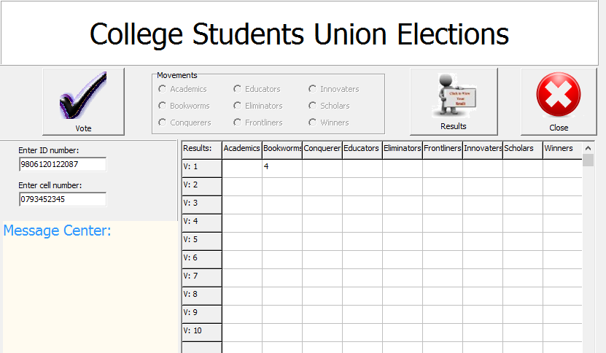

  - Write the code for the Results- button:
- Display the total number of the rating for each movement in row 12.
- Display the percentage votes (number of people who votes for this movement as a percentage of the number of people who voted) that each movement obtained in row 13.
- Display the movement that has won in row 14 – the movement with the highest total rating will be the winner. (17)

An example of the output after the following votes has been cast:
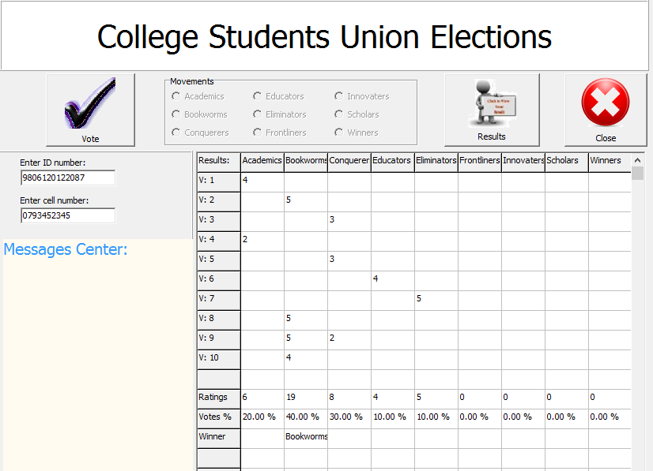

TOTAL FOR QUESTION 3: [50]
GRAND TOTAL: 150

