
NORTH WEST PROVINCE NATIONAL SENIOR CERTIFICATE
EXAMINATION
SEPTEMBER 2014

INFORMATION TECHNOLOGY
SECOND PAPER

DEPARTMENT OF EDUCATION TIME : 3 HOURS
MARKS : 150

GRADE 12

INFORMATION TECHNOLOGY
SECOND PAPER

SEPTEMBER 2014

THIS QUESTION PAPER CONSISTS OF 15 PAGES

INSTRUCTIONS AND INFORMATION

- This question paper consists of FIVE sections subdivided as follows :

SECTION A: Multiple-choice questions (10)
SECTION B: System Technologies (20)
SECTION C: Communication and Internet Technologies (33)
SECTION D: Data and Information Management (21)
SECTION E: Solution Development (29)
SECTION F: Integrated scenario (36)

- Answer ALL the questions.

- Read ALL the questions carefully.

- Number the answers correctly according to the numbering system
used in this question paper.

- Write neatly and legibly.

- Start each question on a new page.

SECTION A: MULTIPLE-CHOICE QUESTIONS

QUESTION 1

Various options are given as possible answers to the following questions. Choose the answer and write only the letter (A – D) next to the question number (1.1 – 1.10) in the ANSWER BOOK.

  - Which ONE of the following statements about a primary key in a database table is FALSE?

- It identifies each record with a unique value.
- It is used to ensure that there are no duplicate records in a database.
- A record can have more than one field that can be used as a primary key.
- The data type can only be Integer values. (1)

  - Which one of the following is not an example of application software?

- DirectX
- MS Office 2007
- Firefox
- Unix (1)

  - Modular design refers to...?

- Use modular programming techniques to make debugging easier while writing a program.
- Upgrade the computer by adding new parts.
- A neat ordered space where cables are tied together and all components are clearly visible inside the computer case.
- All the hardware found inside the computer case, assembled correctly. (1)

  - This processing technique is the ability of an operating system to allow programs to split themselves into multiple tasks that can run at the same time.

- Multiprocessing.
- Pipelining.
- Multithreading.
- Multitasking. (1)

  - Programs running consist of one or more processes. A process is...:

- Any sequence of instructions that can be executed by the CPU.
- A set of instructions meant to accomplish a single task.
- A single instruction from the system software.
- A part of a large program that runs independently. (1)

  - Firewire is...

- busy becoming the preferred method to connect peripherals.
- a data connection for the capture of digital data.
- a parallel communication standard allowing high speed data transfers.
- software preventing unauthorised access to a network. (1)

  - Which one of the following has not lead to the development of faster computer systems in recent years?

- Reduce the transistor count of the integrated circuits on microprocessors.
- Cache memory.
- Use of virtual memory.
- The use of RAID. (1)

  - The Symbian OS is an example of...

- a memory resident operating system.
- a single tasking operating system.
- an embedded operating system.
- proprietary software. (1)

  - Which one of the following does not break the copyright law?
- Downloading music from the Internet.
- Downloading music from the Internet, made available by podcasters.
- Installing a copy of your dad’s single-user license on your computer.
- Copying information from a web page into your PAT assignment. (1)

  - A user complains that his computer is very slow. What is the most possible cause?

- Lack of hard-disk space.
- Waiting for a printer to be connected
- Booting from a no system disk.
- External drives were disabled (1)
TOTAL SECTION A: 10
SCENARIO:
The Doggy Rescue organisation, a nationwide shelter for dogs, needs an experienced person to assist them with hardware, software, networks and Internet communication. You have offered to assist them during school holidays.

SECTION B: SYSTEM TECHNOLOGIES
SCENARIO:
The organisation recently updated the operating system on their computers from Windows XP to Windows 8. They need to be advised regarding issues related to hardware and software.

QUESTION 2
- The client complained that the computer slowed down since changing the operating system. Two hardware components that might needed to be upgraded is the RAM and CPU.

    - What can be the problem if they added 8GB of RAM and the computer recognise only 4GB of RAM? The RAM was tested and there is nothing wrong with it. It is also installed correctly. (2)
    - Name TWO other factors one must consider when upgrading the RAM. (Do not refer to the price in your answer.) (2)

    - The main function of the CPU is to process instructions. Describe in four steps the machine cycle that the CPU usually goes through to carry out an instruction. (4)

    - How does the CPU connect to the motherboard? (1)

    - The motherboard is a large circuit board in the computer case. Name THREE main functions of the motherboard. (3)

    - Doggy Rescue has bought a new laser printer, but when they connect the printer, a message prompts them to install the driver of the printer. Explain to them what a driver is. (2)

- Plug-and-Play automates the configuration process when they connect their flash-drive to the USB port of the computer. Briefly explain what happens during the process. (4)
- What does the acronym USB stands for? (1)

- You need to assure the organisation that it is safe to disconnect an external device and reconnect another device to the computer while it is on. What is the term that best describes this action? (1)

TOTAL SECTION B: 20

SECTION C: COMMUNICATION AND INTERNET TECHNOLOGIES
QUESTION 3:
Doggy Rescue needs to set up a computer network and they ask you to assist them.
3.1 Essential equipment that you need to set up a basic network includes a NIC that is usually on-board.
3.1.1 Explain to the organisation what a NIC is by referring to its function. (2)
3.1.2 Briefly explain what is meant by “the NIC is on-board” and what benefit this provides. (2)
3.2 The two broad categories of communication media are wired media and wireless media. Examples of wired media are UTP- and fibre optic cables. Differentiate between UTP and fibre optic cables by describing:
3.2.1 How data is transferred over the cables. (2)
3.2.2 The speed data is transferred (1)
3.3 There are different means to connect the network to the Internet. One of the connection methods is through ADSL. Describe THREE characteristics of an ADSL connection. (3)
3.4 A modem is needed for data communication. Briefly explain the function of a modem in data communication. (2)
3.5 Why do we need a router to make communication possible between networks? (2)
3.6 WiFi is a method to connect to an existing network wirelessly.
3.6.1 Name TWO advantages of a WiFi network. (2)
3.6.2 What is a disadvantage of a wireless network? (1)
3.7 We define networks according to their size and cover area by using acronyms such as LAN, GAN, etc.
3.7.1 What type of network will employees of Doggy Rescue set up to exchange photos wirelessly with their smartphones, using Bluetooth? Write out the acronym in full. (1)
3.8 Mrs Dibotelo, the manager of the organisation also wants to work from home. You suggest that she can use a VPN. Briefly explain to her what a VPN is. (3)

3.9 It can be a problem to sent large files via e-mail because the ISP has got a limit on the size of the attachment that can be sent.
3.9.1 Describe what an ISP is? (2)
3.9.2 An online storage-file sincing service can help Doggy Rescue to get around the problem to sent large files over the Internet. Briefly explain. (2)
3.9.3 Name ONE example of such an online storage system (1)
3.10 When they want to download large files from the Internet, they find it very time consuming. Sometimes downloads can even time out and leave them frustrated. You suggest that they use BitTorrent which is a peer-to-peer protocol.
3.10.1 Define a protocol in a network. (2)
3.11.2 Briefly explain how BitTorrent works. (4)
3.11 The employees have to travel to collect lost dogs. They need to use a GPS to pinpoint the physical location and to get directions. Give TWO other applications of GPS technology. (2)
TOTAL SECTION C: 34

SECTION D: DATA AND INFORMATION MANAGEMENT
QUESTION 4:
Doggy Rescue needs to store their data in a database. They will use databases for administration purposes and information about dogs rescued and given out for adoption.
4.1 Oracle, MySQL and MS Access 2007 are examples of database software. What are the advantages of database software? Name THREE. (3)
4.2 To be able to use a database to their benefit, they must be able to extract useful information from the database. Name THREE tasks that they must be able to perform for effective data maintenance. (3)
4.3 A database table consists of fields and records. When designing a database table, they will need to decide on exactly what the database is going to be used for. Name THREE factors to take into consideration when designing a database. (3)
4.4 It is important that they are aware of the Garbage In, Garbage Out (GIGO) principle when designing a database. Name TWO characteristics of quality data and give an example of each. (4)
4.5 A database management system (DBMS) is software that allows you to work with electronic databases and falls into two categories, desktop databases and server DBMSs.
Describe the main differences between the functioning of a desktop database compared to a server DBMS. (4)
4.6 A distributed database is a system where parts of a database are distributed across servers in separate locations. It will become necessary for Doggy Rescue to use a distributed database when the number of connected users of their database becomes too large or if their organisation extends over a large geographical area.
4.6.1 Give TWO problems associated with the using of a centralised database which cannot cope with the number of users. (2)
4.6.2 Data synchronisation is critical in a distributed database. Explain what data synchronisation is. (2)

TOTAL SECTION D: 21

SECTION E: SOLUTION DEVELOPMENT
QUESTION 5:
5.1 Doggy Rescue requested you to help them in designing computer programs to simplify their workload. You will have other programmers to help you, but they do not necessarily use Delphi as program language. You have decided to write algorithms so that the other programmers will be able to use the instructions in their programs.
5.1.1 Name THREE characteristics of a good algorithm. (3)
5.1.2 A unique network username needs to be generated for each new user. A text file called UserNames.txt has been created to store the usernames.
User names are created as follows:
Take the first character of the first name and add it to the surname of the user (for example Peter Kirsten – PKIRSTEN). Change all the letters to capital letters.
If a similar username is found in the text file, UserName.txt, another user name must be created, the next character must be taken and added to the last name (for example Peter Kirsten – EKIRSTEN) and soon. Each user name must be unique.
Develop an algorithm that can be used to develop a software solution to generate the user names in the way described above, and add the new user name to the existing text file. (13)
5.1.3 One of the programmers suggested that a text file containing the user name should be encrypted.
Do you support this suggestion? Substantiate your answer by defining encryption and indicating the purpose thereof. (3)

5.2 Doggy Rescue wants a database that will keep record of all people who adopt dogs. The fields of the table will be:
The adopter’s Title, Name, Surname, ID Number, Street Address, City and
Cell phone number.
One of the programmers suggested that a unique primary key must be created by using the following algorithm:
1. Type in the ID number of the adopter.
2. Year first two digits of ID number
3. Age current year – (1900 + Year)
4. Value Age * 1234567891
5. Primary Key remainder of value divided by 10 000.
The algorithm is used to write a program in the programming language that you are using. When the program is executed you find that the value calculated in step 4 gives an incorrect, negative value.
5.2.1 The program did not show any error during compilation, but the answer is wrong. What is this type of error called? (1)
5.2.2 Explain the reason why the error occurred. (1)
5.3 The following is an extract from the AdoptionTB table created in MS Access where records are stored of people who already adopt a dog from Doggy Rescue. You must write SQL statements for the solution of the given scenarios.
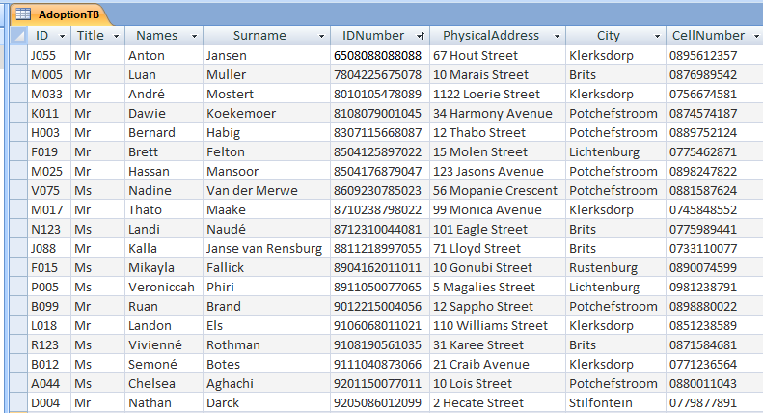

The design view of the AdoptionTB table:
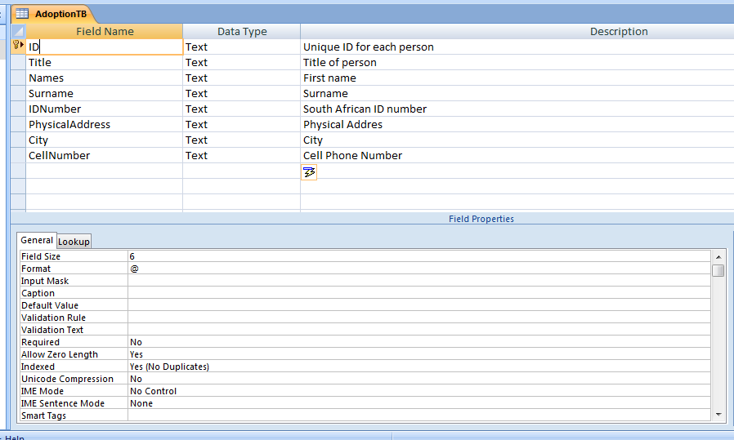
a

    - Display the Title, Surname and Names of all the persons who adopted dogs in the AdoptionTB table, sorted in alphabetical order by surname. (2)

    - Display all the Names, Surnames and Cities in the AdoptionTB table of all cities starting with a “B” (3)

    - Display the Names, Surnames, Street Addresses and Cities of all people with surnames starting from “F” to “M”. (3)
TOTAL SECTION E: 29

SECTION F: INTEGRATED SCENARIO
QUESTION 6
In December 2013, Instagram announced that it has over 150 million users. Instagram is a smartphone app where you can share photos and short videos with other users of Instagram.

Original author(s) | Kevin Systrom, Mike Krieger (Burbn, Inc.)
Developer(s) | Facebook, Inc.
Initial release | October 6, 2010
Development status | Active
Operating system | iOS 5.0 or later; Android 2.2 or later; Windows Phone 8
Size | 14 MB
Available in | 25 languages
Type | Photo & Video
License | Freeware
Website | instagram.com

6.1 Answer the following questions relating to Instagram:
6.1.1 What is an app? (2)
6.1.2 Name THREE ways in how Instagram can benefit the dog shelter. (3)
6.1.3 You can also use the Instagram app to create a mini blog.
a) What is a blog? (1)
b) Describe how does a blog work. (1) (4)
6.1.4 Other users can use your photos by making screen copies and sell it. A user’s photos were spread all over the world without her consent. What do we call this action when somebody uses your ideas? (1)
6.1.5 Instagram is Freeware software. Distinguish between Freeware and Shrinkwrap software. (4)
6.1.6 Instagram uses operating systems created for smartphones such as iOS, Android and Windows Phone 8 as a platform. Name THREE functions of an operating system. (3)
6.1.7 Why is a mobile system a bit of a disadvantage? (1)
6.1.8 A smartphone is a convergence device. What does the term convergence refer to? (1)
6.2 A way of creating funds by a social networking site is to sell your online behaviour and personal data to third parties. Spam can be a direct consequence when other companies get hold of your e-mail address. Some countries are starting to classify spamming as a crime and it also overloads the Internet with unnecessary traffic.
6.2.1 What is a spammer? (1)
6.2.2 Name TWO ways in how you can prevent spam. (2)
6.3 Another problem with social networking is when persons post personal details about themselves, like his/her cell phone number or physical location on the social network site. Cyber bullying is a direct consequence of such posts.
6.3.1 Explain what cyber bullying is. (1)
6.3.2 Why is cyber bullying worse than real life bullying? (2)
6.4 To buy application software is sometimes very expensive. Doggy Rescue is a non-profitable organisation and you have suggested that, where possible, they must make use of SaaS applications.
6.4.1 How does SaaS differ from purchasing software? (1)
6.4.2 Name TWO disadvantages when using SaaS applications. (2)
6.5 With Photosynth you (and other people) can upload photo takes at any zoom, angle, etc. of a location and have them all stitched together to create a pan-able, zoom-able mega panorama or 3D view of the scene. What does it mean if Photosynth has a ‘local front end’? (2)


6.6

Google Glass is a wearable computer with an optical head-mounted display. Google Glass displays information in a smartphone-like hands free format. Wearers communicate with the Internet via natural language voice commands. It has a touchpad on the side and a built in camera.
What concerns can be raised if a visitor uses it at the dog shelter? Name and discuss THREE concerns. (3)
6.7 Doggy Rescue wants to advertise their service on the World Wide Web and needs a Web Designer.
6.7.1 Describe the job of a Web designer. (1)
6.7.2 What skills does a Web designer need to have? (2)
6.8 A search engine is a gateway to the World Wide Web. Users do not always get the results that they are looking for when typing in their search terms. Briefly explain what click farms are and how they can negatively affect the quality of the results produced by search engines. (2)

TOTAL SECTION F: 36
GRAND TOTAL: 150

