NATIONAL SENIOR CERTIFICATE

GRADE 12

INFORMATION TECHNOLOGY P1
SEPTEMBER 2014

MARKS: 150

TIME: 3 hours

This question paper consists of 18 pages.

INSTRUCTIONS AND INFORMATION

- This question paper contains FOUR questions.

- Answer ALL the questions.

- The duration of this examination is three hours. Because of the nature of this examination it is important to note that you will not be permitted to leave the examination room before the end of the examination session.

- Make sure that you answer the questions according to the specifications that are given in each question. Marks will only be awarded based on the set requirements.

- Only answer what is asked in each question. For example, if the question does not ask for data validation, then no marks will be awarded for data validation.

- Your programs must be coded in such a way that they will work with any data and not just the sample data supplied or any data extracts that appear in the question paper.

- Save your work regularly on the disk (CD/flash disk/DVD, et cetera) that you have been given, or on the disk space allocated to you for this examination.

- Rename the examination folder you received with your name and surname. Make sure that your name and surname appears as a comment in the first line of code you did to answer a question. Also include the question number as part of the comment.

- If printouts are required make printouts of the code of all the programs/classes/units that you did and NOT of the code that is generated automatically.

- Printing must be done after the examination within the timeframe provided for printing.

- At the end of this examination session, you must hand in the disk/CD with all your work saved on it OR you must make sure that all your work has been saved on the disk space allocated to you. Ensure that all files can be read.

- You are provided with a disk or space on the hard drive that contains the files that you need to complete this question paper.

List of files provided:
QUESTION 1
culturenight.jpg
frmQuest1_p.dpr
frmQuest1_p.res
frmQuest1_u.dfm
frmQuest1_u.pas

QUESTION 2
clsQuest2_u.pas
frmQuest2_p.dpr
frmQuest2_p.res
frmQuest2_u.dfm
frmQuest2_u.pas

QUESTION 3
Question3.mdb
Question3.accdb

frmQuest3_p.dpr
frmQuest3_p.res
frmQuest3_u.dfm
frmQuest3_u.pas

dmQuest3_u.dfm
dmQuest3_u.pas

frmQuest3_1_u.dfm
frmQuest3_1_u.pas

frmQuest3_2_u.dfm
frmQuest3_2_u.pas

QUESTION 4
frmQuest4_p.dpr
frmQuest4_p.res
frmQuest4_u.dfm
frmQuest4_u.pas
Reservation.txt

Scenario:
To improve cultural activities there is decided to hold a yearly inter-school cultural night. Any school can participate in the activities. The activities include performing a play, choir, recitation and music performance. The overall winner is determined by calculating the average score of the four different activities.
SECTION A: General programming skills
Question 1
You are provided with an unfinished program frmQuest1_u and frmQuest1_p in the examination folder. You are going to use this program to configure the accounts for the different schools and to give information about the amount the school still owes for the entries for the Culture night.
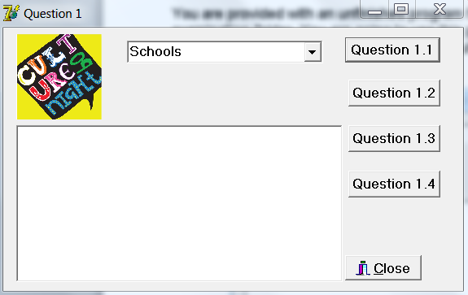

  - Write the program code for the event of the Question 1.1 button. [19]

1.1.1 Choose a school from the list in the combobox. If you don’t make a choice an error message must appear and the program must stop executing. (4)

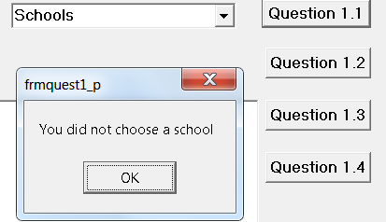

1.1.2 Make use of an “Inputbox” and type in the amount the school have already paid (Leave out the “R” in front – thus only the amount). Test if this amount is a valid number. Make use of a “MessageDialog” to display an error message if the number is not valid.
Please Note this Inputbox must appear repeatedly until a valid number is typed in.
(8)
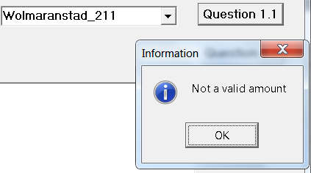
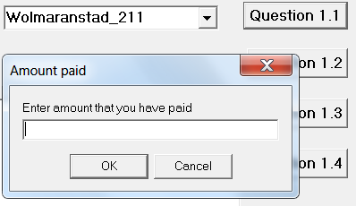
1.1.3 Make use of the string which you selected in the combobox and determine the name of the school and the number of participants from the school and save each in a different variable.
Example:
Wolmaranstad_211
SchoolName = ‘Wolmaranstad’
Number = 211
Display the school’s name and the number of learners underneath each other in the output component.
Also display the amount the school already paid. (7)
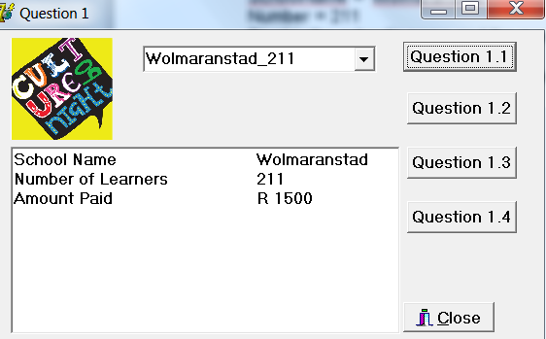

1.2 Write the program code for the event of the Question 1.2 button. [16]

1.2.1 If the entry fee is R 5.70 per learner, calculate the actual amount the school owes. Make use of a constant variable. Display the amount owing underneath the amount paid. (3)
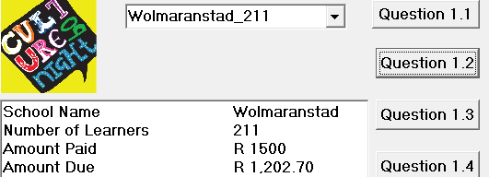

1.2.2 Calculate the amount the school still owes or the credit amount if the school has paid too much. Display the answer with the following messages:
• If the school still owes an amount:
‘Amount Owing: R ‘followed by the amount rounded to two decimal places.
• If the school paid more than was necessary:
‘Credit Amount: R ‘followed by the amount rounded to two decimal places. Ensure that this amount is displayed as a positive number. (5)
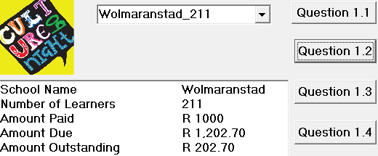
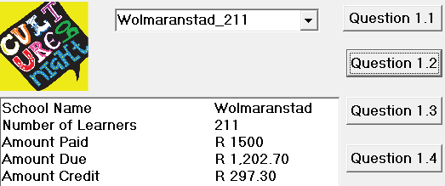

1.2.3 You have to generate a unique payment code for the school. The code must consist of the following:
- Two characters that are randomly chosen from the school’s name.
- These characters may not include vowels.
- They must be displayed as capital letters.
- After these two characters are generated, the amount the school owes or must get back are added at the end. Round this amount to the nearest integer before you add it.
- If you have to pay back a certain amount, ensures that a minus sign is displayed before the amount.
Display the Payment Code underneath Amount Outstanding/Amount Credit. (16/2=8)
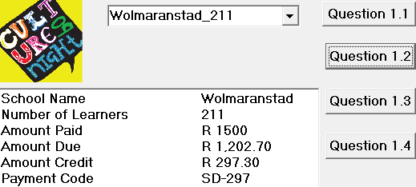
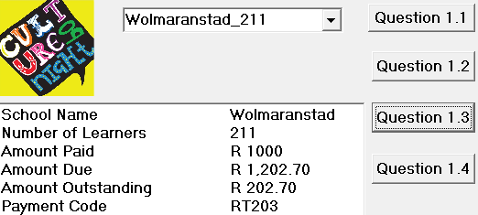
Note: Your codes will differ from these ones, because it is generated randomly.

1.3 Write the program code for the event of the Question 1.3 button. [12]

1.3.1 If the school already paid too much, a message must be displayed to indicate that the school has to receive money back. The amount to be paid back must be included in the message. There must be no minus sign (-) in front of the amount. (2/2=1)

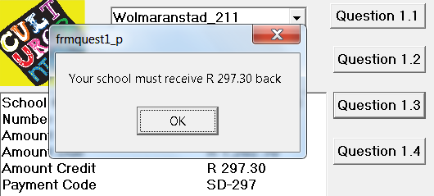

1.3.2 If the school has an amount outstanding, a discount must be calculated on this amount in the following manner.
Round the amount to the nearest integer. Determine if this number is a prime number, an odd number or an even number.

- 7% discount on the amount due if the number is a prime number.
- 5% discount on the amount due if the number is an odd number.
- 2% discount on the amount due if the number is an even number.

Display the discount and the total amount outstanding.
Note: A prime number has no other factors than only 1 and itself. (22/2=11)

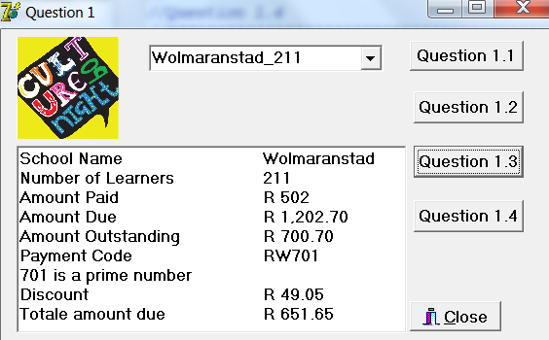

1.4 Write the program code for the event of the Question 1.4 button. [2]

1.4.1 Initialise the necessary variables. (2/2=1)

1.4.2 Clear the output component. (½)

1.4.3 Set the text property of the combobox back to ‘schools’. (½)

1.5 When you create your form (run your program), the picture on your form must become visible and fit properly. [2/2 =1] Total Section A: [50]

SECTION B: OOP and Database manipulation
Question 2 Object oriented programming [30]
You are provided with an unfinished program frmQuest2_u en frmQuest2_p in the examination folder. There is also the unfinished object class, clsQuest2_u. You are going to use this program to calculate the average score each school obtain and to indicate the overall winning school for the culture night.

Complete the code for each section of QUESTION 2 as described in QUESTION 2.1 to QUESTION 2.2 below.

Question 2.1
  - Open the Unit clsQuest2_u and write the following code as part of the class. Take note that the class is already defined and contains the necessary attributes (fields). You have to declare the different methods. (6)

    - Write a constructor create with parameters that receive the school name, score1, score2, score 3 and score4 from the application program. All the fields must be initialised in the constructor. (4/2=2)

    - Write a procedure CalculateAvg to calculate the average of the 4 different scores. (2/2=1)

    - Write a Get method to send the average back to the application program. (1)

    - Write a procedure DetermineHighest to determine the highest score of the four different scores. Make use of any suitable method to determine the highest score. (10/2=5)

    - Write a method called toString. The School’s name, the average score and the highest score of the four different scores must be displayed. Refer to the screen shot for an example of the output of the program. Also refer to Question 2.2.1. (4/2=2)
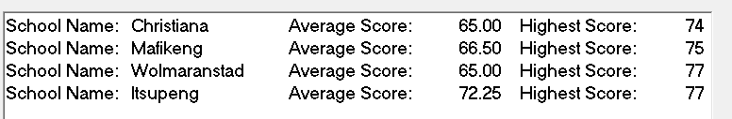

[17]

Question 2.2

Do the following in the main Unit of the application program. Open the file frmQuest2_p.dpr.
    - Write the program code for the event of the Question 2.2.1 button.
- Make use of the class unit and declare the variable objScore for the object based on the class TScore.
- When the button [Question 2.2.1] is clicked the user must select a school name in the combobox. A message must be displayed if the user forgets to select a school to indicate that a school has to be selected.
- Type in the scores for the four different activities, in the spinedit components. The maximum score per activity cannot exceed 100.
- Create the object objScore to save objects of TScore. You do this after you ensure that all the parameters do have values and are correct.
- Calculate the average of the four scores by calling the method CalculateAvg from the class TScore.
- Determine the highest of the four scores by making use of the method DetermineHighest from the class, TScore.
- Display the school name, the average score and the highest score in a RichEdit with the necessary labels. Make use of a suitable method from the class TScore. The Tab stops are already set in the FormCreate event. Do not change any of these codes.
- Read the school’s names and the average scores into two different arrays. The two arrays “arrSchool” and “arrScore” are already declared. Remember to keep track of the number of elements in the arrays. You wil need this information in Question 2.2.2. (14/2=7)

    - Write the program code for the event of the Question 2.2.2 button.
- Determine the winning school of the different schools that are displayed in the RichEdit. Sort the array containing the different averages of each school and display the school’s name and the average score (rounded to 2 decimals).
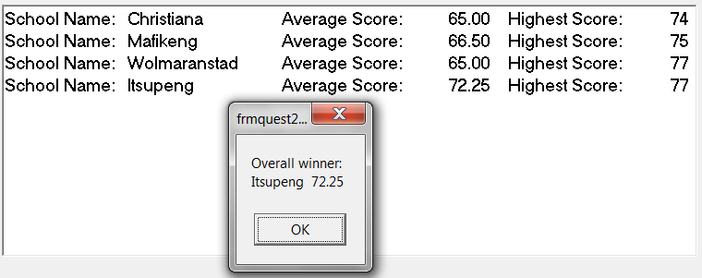
- Ensure that the message cover two lines. (10/2=5)
2.2.3 Close bitbutton: Set the object free. (1)
[13]
Question 3 Database manipulation [30]
The information about the different schools participating at the culture night is saved in the database. Make use of this information to do different calculations in Delphi.
There are two tables in the database Question3.
(Take note that there are two versions of the database (Access 2003 and Access 2010) available.
Schooltb contains information about the different schools participating at the culture night.
The construction of the Schooltb is as follows:
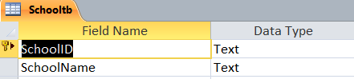
Information already saved in the Schooltb
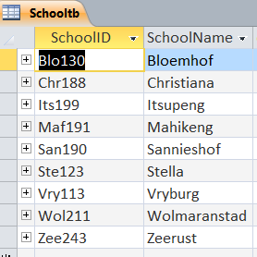
Participatetb contains the scores each school group received for their participation.

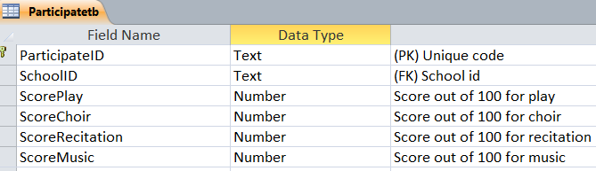

Information already saved in the Participatetbl
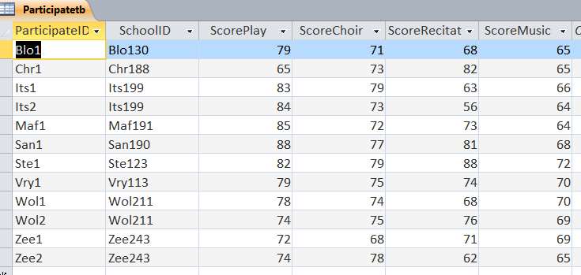

The relationship between the two tables

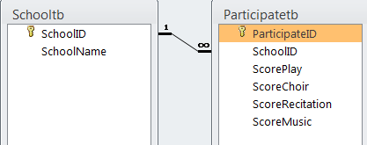

You are provided with an unfinished program frmQuest3_u and frmQuest3_p in the examination folder.

Take note: This is a multi-form solution. There are three different forms and three different units.
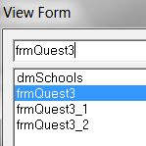
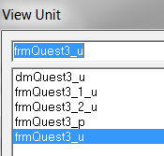

3.1 en 3.2: Write the program code for the event of the Question 3.1 and Question 3.2 buttons.

- Open the main form (frmQuest3_u). Write the code that will open the following forms, Quest3_1 en Quest3_2. Ensure that the user cannot go back to the main form if the sub forms are still open. (4/2=2)
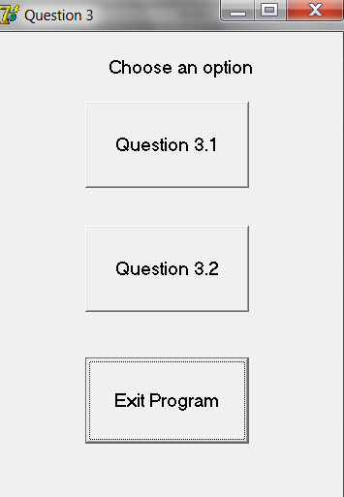

Database connection
A data module is available in your examination folder. It contains the correct components. Al you need to do is to set the connection string of conCulture in the Object Inspector and to set the ADO table components “Active” properties to true. You are allowed to change the name property of the components if you want to.
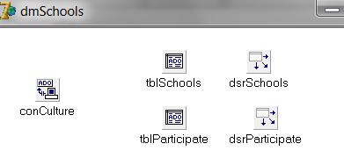

NB: If you cannot make the connection the code for the different buttons must still be written. The code will be marked.

3.1 Now work with form frmQuest3_1 and write the program code for the events for the
Question3.1.1 and Question3.1.2 buttons.

3.1.1 Update information: Update scores with 2%
- Click on the SchoolID in the School tabel. Thus selecting the school whose scores you want to update.
- This school’s information is then displayed in the Participant tabel.
Take note that one school can enter more than one group for the culture night.
- Display a message indicating how many records are being updated.
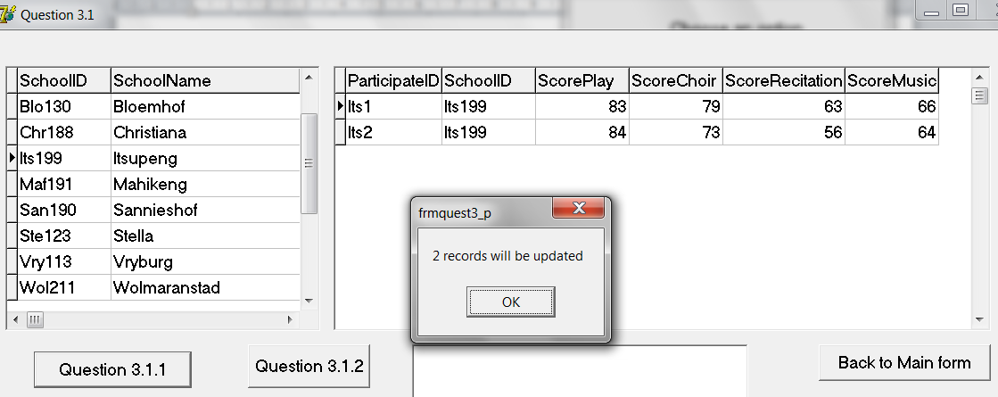
- Display the entire tabel again after the records are updated.
(16/2=8)

    - Calculate the average of the four different scores of only one group.
- Click on the ParticipantID in the Participant tabel. Thus selecting a group whose average you want to calculate.
- This school’s information must be displayed in the Participant Tabel.
- The average of the scores for play, choir, recitation and music must be calculated and display in the output component (RichEdit). (8/2=4)

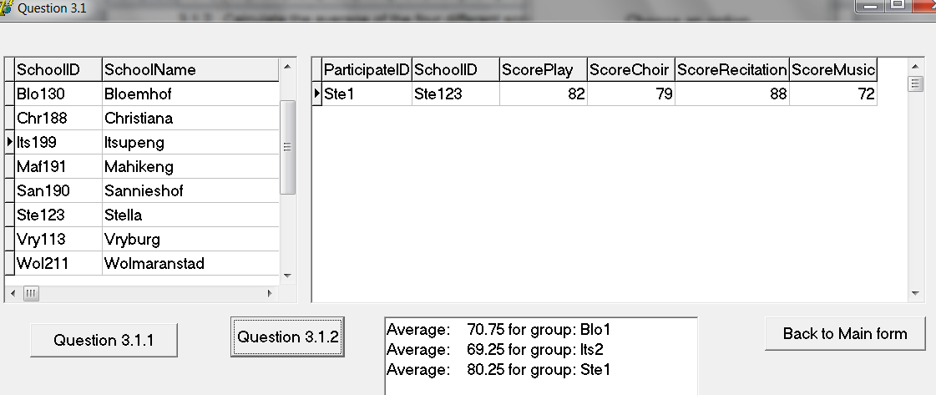
3.1.3 When the mouse moves over the output component all the records in the Participant tabel must be displayed again. (2/2=1)
3.1.4 Back to Main form: Write code to go back to the main form. Clear the output component when you move back to the main form. (2/2=1)
3.2 Now work with form frmQuest3_2 and write the program code for the events for the
Question3.2.1 and Question3.2.2 buttons.

3.2.1 Calculate the average of a specific field you select.
- Choose a field in the radiogroup whose average you want to calculate.
- Display the field name and the average score in the output component. (10)
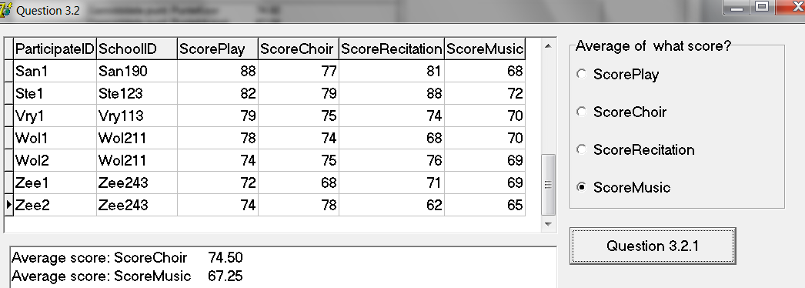
3.2.2 Sort the tabel according to the field you have selected.
- Select a field in the radiogroup to sort from the smallest to the highest score.
- Display the sorted information in the dbgrid. (3)

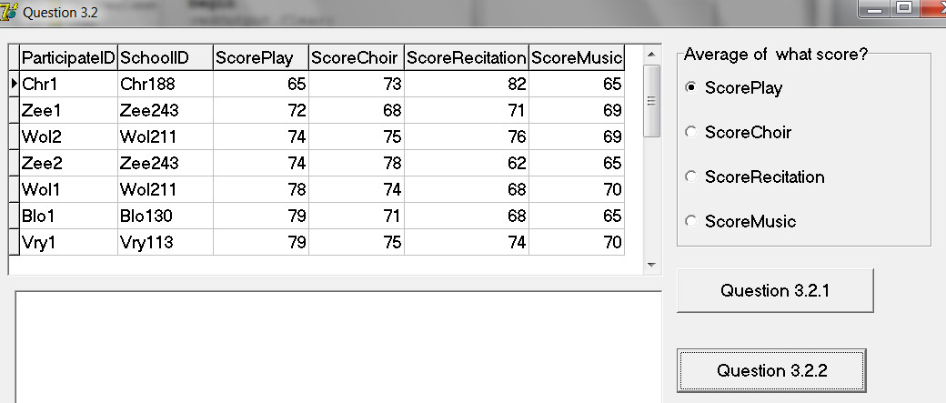
In this example the ScorePlay field is sorted.
3.2.3 Back to Main form: Write code to go back to the main form. (1) [14]
Total Section B: [60]

SECTION C: Problem solving
Question 4

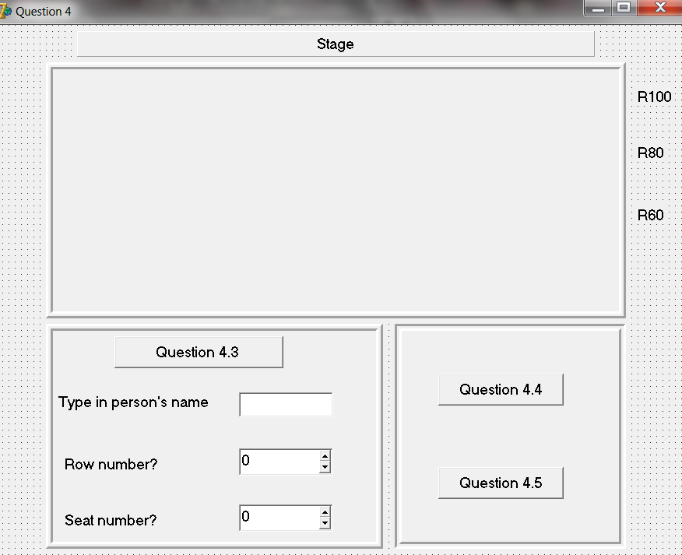
You are provided with an unfinished program frmQuest4_u and frmQuest4_p in the examination folder. Included in the folder is a text file Reservation.txt. You are going to use this program to make seat reservations and other calculations for the culture night.
There are already several seat reservations made. The details of these reservation are saved in the text file Reservation.txt.

A Stringgrid component represents the hall in which seats can be reserved. There are 10 rows (numbered from ‘A’ to ‘J’) and 10 seats (numbered 1 to 10) in each row.
The cost for the seats in the first three rows are R100 each, the cost for the seat in the following two rows are R80 each and the last four rows cost R60 per seat.

4.1 Write the program code for the Form Activate event. [17]

4.1.1 Create a stringgrid component (stgReserve) dynamically. The stringgrid must be displayed on the existing panel (pnl1) and comply with the following properties:
Height := 300;
Left := 10;
Top := 10;
Width := 730;
Rowcount := 11;
Colcount: = 11; (10/2=5)
4.1.2 Display the row – and column heading as indicated. (See example at the bottom of the page). (6/2=3)

4.1.3 Read the existing reservations saved in the text file from the file Reservation.txt and save the information in a two dimensional array.
- The name of the person, who has made reservations, will be displayed in the place that he/she has reserved.
- The X represents seats that are not reserved.
- Make use of data validation to ensure that the text file exist and stop program execution if it does not exist.
- Separate the different reservations (names) from each other en save it in the array. (16/2=8)
Example of data in the text file:
Chris,Jan,Gert,Piet,X,X,X,X,San,Annie,
Andre,Jay,Marizaan,Jacques,Annamie,X,X,X,X,X,
Philip,X,Juan,X,Emma,X,Su-Ann,X,Marelize,Joram,

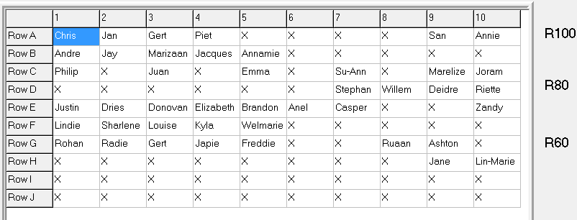
4.1.4 Call the Display procedure (see 4.2) and display the information in the stringgrid. (1)

4.2 Procedure Display: You have to display the content of the array more than once and as such you have to write a user defined procedure to display the information in the stringgrid. It is a simple procedure and no parameter transfer is required. [6/2=3]

4.3 Write the program code for the event of the Question 4.3 button.
[6/2=3]
- The name of the person doing the reservation must be typed into the edit component.
- By making use of the SpinEdit component, the user indicates which row and which seat he/she wants to reserve.
- If the seat is already reserved, display a message to indicate that the seat is not available.
- If the seat is available, the name of the person must be added in the correct position in the two dimensional array.
- Call the Display procedure again to display the new information in the stringgrid.
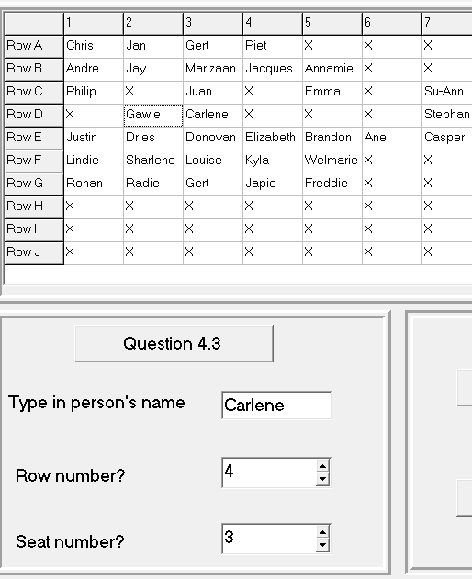
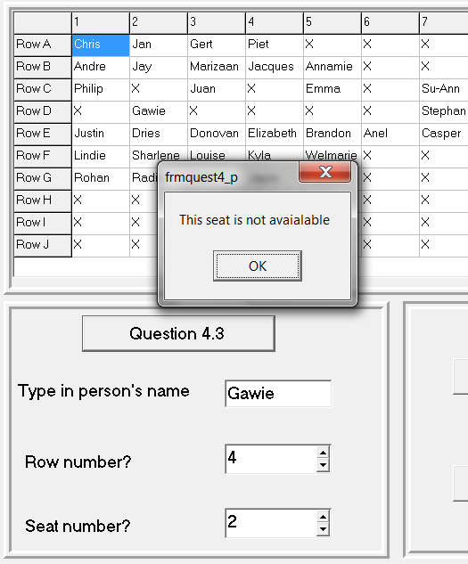
4.4 Write the program code for the event of the Question 4.4 button. [11]

4.4.1 Create a RichEdit component (redOutput) dynamically. It must comply with the following properties:
Top: = 140;
Width: = 520;
Left: =200;
Height: = 320; (2/2=1)

    - Calculate how many seats are still available in each row. Display each row and the number of seats available in the richedit.
Also calculate the total number of seats available. Display the answer in the richedit. (8/2=4)
4.4.3 Calculate the total amount already received for the reserved seats. Remember the cost for the seats in the first three rows is R100 each, the cost for the seat in the following two rows is R80 each and the last four rows cost R60 per seat.
Display the answer in the richedit. (12/2=6)
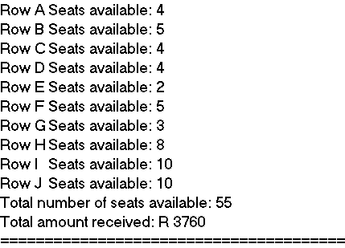

4.5 Write the program code for the event of the Question 4.5 button.
Prove of the total number of seats available and the amount already received must be saved to a text file. The date and time when this prove was saved must be included. This information must be saved in a text file called Summary.txt. [6]

    - Write code to determine the current date and time. (2/2=1)

    - Open a text file to add new information to existing information. Make use of data validation to prevent a runtime error if this file does not exist, (8/2=4)
    - The richedit that was created dynamically must be set free. (2/2=1)

Example of information saved in the Summary.txt.

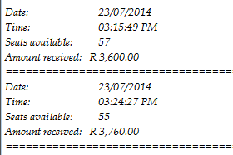

Total Section C: [40]

