GRADE 12
PROVINCIAL FORMAL ASSESSMENT TASK

SEPTEMBER 2014

INFORMATION TECHNOLOGY

PAPER 1 (Practical)

TIME: 3 HOURS MARKS: 150

Instructions:
- This question paper takes the form of an integrated scenario. If you are unable to complete any part of the paper and a following section requires you to make use of data derived from the previous section, continue with the coding regardless.
- Save work regularly.
- Manage your time carefully.
- Do not do extra work outside of what is required.

Question 1: Problem Solving [50]
Your task is to provide instructions control an automaton.
You have been provided with an interface with certain code provided.
- This automaton is used to search grids. It is dropped in position [0,0] in a 10 x 10 grid with instructions to search the grid based on certain rules.
- You have to locate a randomly placed item.
- The automaton’s first step is to check the block immediately to its right and below it. If the item is found the program ends. If not, the search begins.

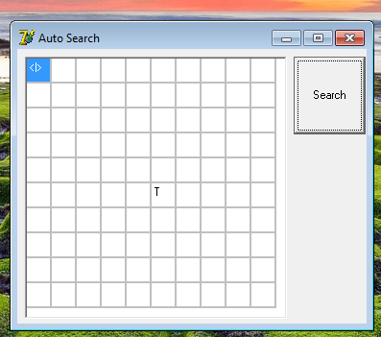

- You have to code the rules provided in such a way that the automaton searches the grid automatically once the start command has been given.

The search button activates a timer that allows the automaton to move on block per second. The version you have - moves to the right and down.

Task: You must complete the code - allow the automaton to locate the search item.

The rules are as follows:
- It may not leave the boundaries of the grid.
- It must, upon starting, check the block below it and immediately to its right.
- The search object is randomly placed every time the program is run. The automaton is placed in position [0,0].
- You must change the direction of the automaton’s travel randomly on each block. When any boundary is reached, you must make the automaton head in a different direction. The automaton must have complete freedom of movement inside the grid.
- You must keep track of how many moves the automaton makes.

Question 2: Object Orientated Programming [50]
You have been provided with a partially completed app. The purpose of this app is to assist in the creation of a program that will sit between a Digital Media Archive and a user. You need to complete the program as follows:
- You need to fully code the contents of the object class in a separate unit file. This will consist of the following private fields:
Taken_By
Date_Taken
Image_File
Caption
Category
Updated_by

You may use a parameterised constructor that takes the information provided and stores it in a single object based on your template. Name your class DigiArc. (20)
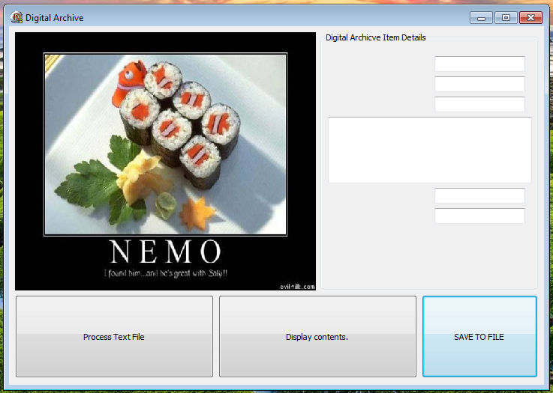
As proof of concept, complete the designed form that displays an image in a frame, the caption in a memo and edits for other information. You only need one object based on your template.
- The information to be placed in the object is extracted from a text file that contains sample data. Use file access and string manipulation to populate the object’s fields. Display the contents of the object by using button 2. (15)
- Allow the user to modify any of the data in the object apart from the caption. Update the changes to the object and once this has been done, save the changed data back into a text file called YourName.txt. (15)

Question 3: General Programming [50]
FizzBuzz in a game in which players count from 1 up to some number N, but when they reach a multiple of three, they say Fizz instead of the number; similarly, multiples of five are replaced with Buzz. Numbers that are multiples of five and three are replaced with FizzBuzz. You have to use a global array of type string.
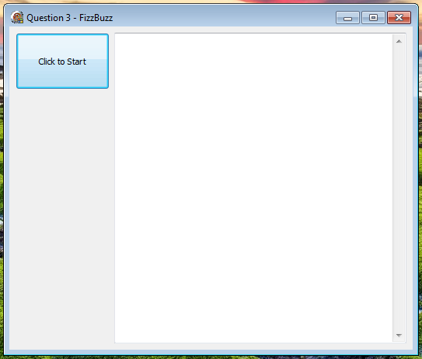

Allow a user to specify number between 1 and 1000 (including both) to evaluate. Provide output in the format illustrated below to the supplied memo box. Use a procedure for this.

You are required to record some statistics regarding the game:
- Record how many times Fizz, Buzz and FizzBuzz appear.
- Record how many other numbers appear.
Lastly, you must save each sequence in a text file, use a procedure for this. The procedure gets as parameters the current system date, and the four counters for the occurrences. Use the following format:

===============================
2014-09-01
===============================
1
2
Fizz
4
Buzz
Fizz
7
8
Fizz
Buzz
11
Fizz
13
14
FizzBuzz
16
===============================
Fizz: 3
Buzz: 2
FizzBuzz: 1
Other: 9
===============================

TOTAL:150

