COORDINATE GEOMETRY EXERCISES
1. Determine the equation of the circle with centre $\left(3 ; -2\right)$ and which passes through the point $\left(6 ;2\right)$.
2. Determine the equation of the circle with centre $\left(-2 ;10\right)$ that touches the $y$-axis.
3. Find the coordinates of the centre and the radius of the circle with equation:
$x^{2}-4x+y^{2}+2y-2y-20=0$
4. $P\left(-2 ;3\right), Q\left(2 ;3\right)$ and $R\left(3 ;2\right)$ are three points on the $x-y$ plane:
4.1 Prove that all three points lie on a circle with its centre at the origin.
4.2 Give the equation of the circle through the points P, Q and R.
4.3 RD is a diameter of the circle PQR. Determine the equation of RD.
4.4 Determine whether the point $F\left(-2 ; -4\right)$ lies inside or outside the circle PQR. Give a reason for your answer.
5. Prove that the line $3x+4y=25$ is a tangent to the circle $x^{2}+y^{2}=25$.
6. In the diagram, M is the centre of the circle and KL is a diameter where K is the point $\left(-2 ; -6\right)$ and L is the point $\left(4 ;2\right)$. 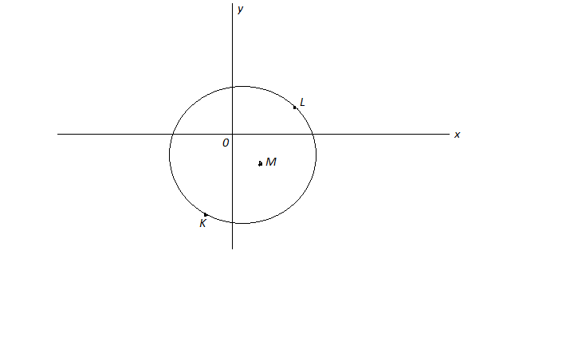
6.1 Determine the equation of the circle.
6.2 Determine the equation of the tangent to the circle at the point $N\left(-3 ;1\right)$, where N is a point on the circle.

7. In the figure, the circle with centre $C\left(x ;y\right)$ passes through the point $B\left(5 ;4\right)$ and touches the straight line with equation $y=x+3$ at the point $A\left(1 ;4\right)$.
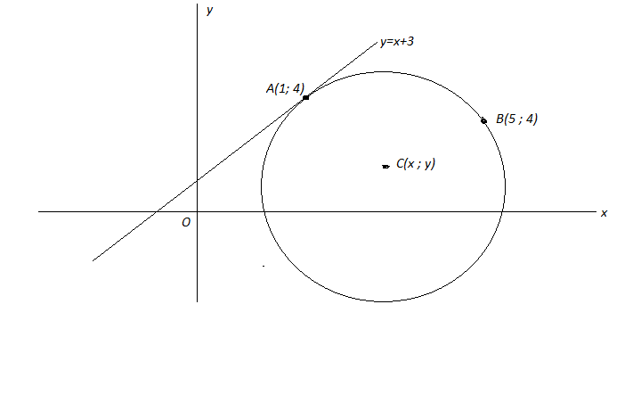
7.1 Find the equation of AC.
7.2 Calculate the coordinates of C.
8. In the figure, the circle passes through the point $P\left(-1 ;1\right)$ and $Q\left(3 ; -3\right)$. The centre of the circle lies on the straight line with equation $x-3y+2=0$. Determine the equation of the circle in the form: $Ax^{2}+By^{2}+Cx+Dy+E=0$.
