HIGH SCHOOL

School’s logo/badge

GRADE 12

PREPARATORY EXAMINATION 2013
INFORMATION TECHNOLOGY PAPER 2 – THEORY
AUGUST 2013

MARKS: 180
TIME: 3 HOURS

EXAMINER: Own Name
MODERATOR(S): Someone at your school

This paper consists of 21 pages.
Please ensure that you have a complete question paper.

Topic | Term | Assessing | TOTAL
Preliminary Examination | 3 | Paper 2 | 180
Date |  | September 2013

INSTRUCTIONS AND INFORMATION
- This paper consists of FIVE sections and SIX questions set out as follows:
SECTION A: Question 1: Multi-choice questions (10)
SECTION B: Question 2: Hardware and Software (70)
SECTION C: Question 3: E-communication (21)
Question 4: Social and ethical issues (9)
SECTION D: Question 5: Algorithms and Planning (49)
SECTION E: Question 6: Integrated Scenario (21)
- Answer ALL the questions.
- Read ALL the questions carefully.
- Generally the mark allocation will be an indication of the number of facts/reasons that are needed.
- Number the answers correctly according to the numbering system used in this question paper.
- Write neatly and legibly.
- Start a question on a new page e.g. if question 2 ends at the bottom of the page then start question 3 on a new page.
- Draw a line across empty unused folio pages.
- Write your name and surname on top of any loose pages.
- Do only what each question is expected from you to do.

Answer the following section on the answer sheet.

SECTION A – Short questions

Question 1 – Multiple Choice Questions
Various possible options are provided as answers to the following questions. Choose the most correct answer and write only the capital letter next to the question number in your answer sheet. (e.g: 1.11 E)
 | An approach to writing a program in which the details of the code are left until the end, and the entire program is first broken up into broad tasks (methods) that must be accomplished in order to successfully achieve the goal of the program is known as……
 | A | Inheritance
 | B | GUI programming
 | C | Bottom-up modular programming
 | D | Top-down modular programming | (1)
 | A virtual private network (VPN) is a network which …
 | A | uses the Internet to allow computers to connect as though they were connected in a LAN.
 | B | is a private network that does not make use of cables or other communication media?
 | C | is distributed over great distances (usually between continents).
 | D | can communicate information over great distances without needing to make use of an ISP. | (1)
 | Database Management software incorporates a feature known as record-locking. The purpose of this feature is :
 | A | To ensure that no user can make changes to the table structure of the database without the correct permissions.
 | B | To ensure that only the administrator can access all information and that ordinary users can only access data for which they have pre-defined rights.
 | C | To allow each record to have a primary key, thereby allowing it to be locked.
 | D | To prevent more than one user from accessing particular data in the database at exactly the same time, as this could lead to inconsistent changes to the data. | (1)

 | Scott Fahlman, at Carnegie Mellon University, was the first person to be documented suggesting to people that they use punctuation marks to express how they are feeling e.g. :-) for happy or :-( for unhappy. These became known as … .
 | A | Spam emails
 | B | Junk mail
 | C | Emotion-icons
 | D | Phishing | (1)
1.5
 | Which ONE of the descriptions listed below is most likely a description of the device pictured above?
 | A | An unpowered USB HUB
 | B | A powered USB HUB
 | C | A USB – FireWire adapter
 | D | A USB to Laptop computer port adapter | (1)
 | A CPU design philosophy that involves giving the CPU a large set of powerful instructions that it can execute are called … .
 | A | RISC
 | B | CISC
 | C | Pipelining
 | D | Clock multiplication. | (1)
 | Open Source Software is software that …
 | A | is made available with a license that allows a person to modify the source code, but not to sell the software for profit.
 | B | can only be sold if the changes that have been made to the software are not plagiarised.
 | C | can be modified and is used in the operating of a system, such as Linux.
 | D | is not usually very popular, owing to the costs involved in acquiring and maintaining the software. | (1)

 | The device shown below:
 | 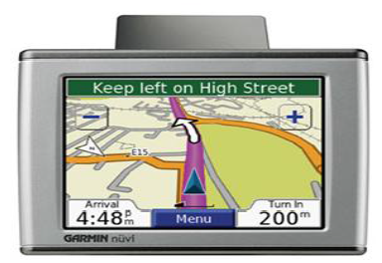
 | A | Needs to connect to a computer in order to be able to function correctly.
 | B | Can perform many different functions under the control of a multi-tasking operating system.
 | C | Receives Global Positioning System (GPS) signals for the purpose of determining the device's current location on Earth.
 | D | None of the above descriptions are true. | (1)
 | Malware that resides on your computer gathers personal information about you and sends this to a third party via an Internet connection is known as :
 | A | Phishing
 | B | A Trojan Virus.
 | C | A Worm Virus.
 | D | Spyware | (1)
 | The communications protocol responsible for the delivery of email messages from one server to another is SMTP. What does SMTP stand for?
 | A | Switching Mail Transmission Protocol
 | B | Silent Minimal Technology Protocol
 | C | Simple Mail Transfer Protocol
 | D | Secondary Mail Technology Protocol | (1)
[10]

Answer the following sections on the folio paper.

SCENARIO:
Cloud computing is the concept of a computer obtaining resources on demand from a computer network. These resources could be:
- Applications (such as word processors or spreadsheet programs)
- Data, such as databases or files
- Utilities, file services, email, etc.

In cloud computing, the user’s computer may contain very little software and data; it often is merely a screen to show processes that take place somewhere else.
An analogy for cloud computing is
“The most common analogy to explain cloud computing is that of public utilities such as electricity, gas, and water. Just as centralized and standardized utilities free individuals from the difficulties of generating electricity or pumping water, cloud computing frees users from certain hardware and software installation and maintenance tasks through the use of simpler hardware that accesses a vast network of computing resources (processors, hard drives, etc.). The sharing of resources reduces the cost to individuals.”

© Wikipedia – 2011.

SECTION B: HARDWARE AND SOFTWARE

Question 2: HARDWARE AND SOFTWARE

 | A major advantage of the “cloud computing concept is the fact that a user’s hardware can be more minimalist”. The CEO of AMD, Rory Read, said fairly recently that AMD were gearing up to make CPU chips for netbooks and mini-notebook computers, in order to play a role in helping to shape the cloud computing data centres of tomorrow.
 |  | All CPUs are divided into parts that do specific jobs.  Name and briefly describe the function/job of THREE components (parts) of a standard CPU chip. | (6)
 |  | Name another company (besides AMD) that manufactures CPU chips. | (1)
 |  | You are told that the CPU that is in the netbook computer that you are buying has 64-bit architecture.
 |  | - What does this mean? | (1)
 |  | - Carefully explain the complete consequences of changing the architecture from 32-bit to 64-bit. | (4)
 |  | Newer processors have been designed to make better use of each clock cycle and incorporate pipelines.
 |  | - Briefly explain what a pipeline is. | (1)

 |  | - Explain how the pipeline can be used to speed up the processor. | (4)
 |  | Another recent development in CPU architecture is multi-core technology.  Briefly state what this means. | (1)
 |  | Does a 128 bit processor currently exist? If so, in which device would you find it? | (1)
 | One of the most important components of any computers processing components is the RAM.
 |  | What does the acronym RAM stand for? | (1)
 |  | What is stored in RAM while the computer is running and processing information? | (2)
 |  | What is the standard size of RAM that a new computer is equipped with? | (1)
 |  | How does ROM differ from RAM? | (1)
 | Netbook computers usually have less powerful hardware than laptops, and some do not even have a conventional hard drive, using a SSD instead.
 |  | What is a SSD? (You should say what it stands for and briefly describe what it is.) | (2)
 |  | A conventional hard disk has traditionally been used to store software that a computer holds.
 |  | - Increasing the capacity of a hard disk involves increasing the amount of data that can be recorded on the same amount of space. Give TWO ways in which this can be achieved. | (2)
 |  | - In the past, large disks have been used to hold information used in data mining. What is data mining? | (2)
 |  | Explain why netbook computers that employ a cloud computing strategy do not make use of conventional hard disk drives. | (2)
 | Cloud Storage refers to data stored on large server computers, hosted by companies that operate large data centres.These servers need to provide fast, reliable storage of data for all people who use them.
 |  | Give TWO advantages of using these remote servers to store your information, rather than on your actual computer. | (2)

 |  | RAID is a commonly used solution for servers with very large space, speed and security requirements.
 |  | - Briefly describe what RAID (Redundant Array of Inexpensive Disks) technology is. | (2)
 |  | - RAID levels describe the way in which data is put onto the disks. Briefly describe how data striping (RAID level 5) works. Your explanation should include the idea of fault tolerance. | (3)
 | Cloud computing could not exist without the concept of computer networks, and is reliant on fast connections and large bandwidth in order to be successful.
 |  | What is meant by bandwidth? | (2)
 |  | In order for your netbook to connect to a network, it requires a network card. This hardware component allows the computer to communicate over a network.
 |  | - What is the most popular network card? | (1)
 |  | - Do you always have to buy a network card if you want to connect to a network? Justify your answer | (2)
 |  | The medium (or channel), e.g. a cable, that carries data across the network, can have strengths and weaknesses which are based on physical characteristics.  Two of these are attenuation and electro-magnetic interference (EMI). Briefly describe what these two terms mean AND state if it is a strength or weakness. | (4)
 |  | Connecting to the Internet is critical for successful cloud computing to take place. In recent years, wireless Internet connections have become a popular method of connecting as they are fast and flexible. Briefly describe TWO wireless connection technologies for connecting to the Internet that are available in this country. | (4)
 |  | Besides a computer, network card, and communication channel name TWO more items needed to set up a network. | (2)
 | Although netbook computers are being used for cloud computing do not usually have a lot of software installed on them, there is still a need for an operating system
 |  | What is an operating system? | (2)
 |  | An operating system forms part of which type of program? | (1)
 |  | Name one type of user interface that system software uses. | (1)

 |  | A Web operating system (sometimes referred to as a WebTop) turns the desktop of your computer into a service that runs on the Internet rather than on the local computer. These services can include a file system and an application management system.
 |  | - Briefly explain why you think a web operating system would be suited to cloud computing. | (2)
 |  | 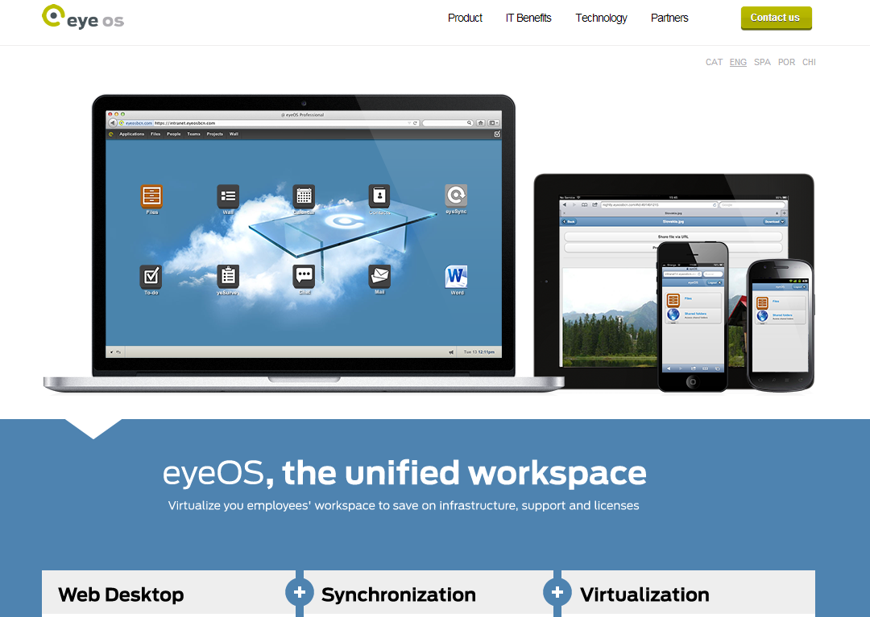  - When using the WebTop (like “eyeOS‟, shown below), you are essentially using the Internet to work as a desktop, rather than an actual desktop on the computer.  Give TWO advantages of this concept. | (2)
 |  | Modern Operating Systems make use of the concept of virtual memory.
 |  | - What is virtual memory? | (2)
 |  | - Briefly explain how virtual memory works. | (2)
 |  | - Give TWO advantages of virtual memory. | (2)
 |  | - Do you think that computers designed for cloud computing would be suitable for implementing virtual memory? Justify your answer. | (2)
[70]

SECTION C: APPLICATIONS AND IMPLICATIONS

Question 3: E- COMMUNICATION
 | Although the Internet is an incredible communications tool, it was never designed to be safe and trustworthy. One of the strongest arguments against the cloud computing concepts of online software and data storage relates to security (the safety of your data).
 |  | Data can be lost or corrupted accidentally or as a result of malicious hackers.
 |  | - There is some controversy in the computer world over the term “hacker”. Explain what a hacker is, referring to the TWO forms a hacker can take. | (2)
 |  | - Give TWO ways of protecting data against accidental loss. | (2)
 |  | - Give TWO ways of protecting data from malicious intent (these must be different from the answers you have given in 3.1.1.b) | (2)
 |  | Communicating private, confidential information, like credit card details, requires very thorough security systems to ensure that these details are not stolen and misused.  Banks and shopping sites use public key encryption in order to make sure that private data is not stolen.  Briefly explain how public key encryption works. | (3)
You start to do banking over the Internet and notice a yellow lock showing in the corner of your browser.

 |  | - The lock is being displayed to indicate that the site is secure. What other indicator on this webpage will tell you the same thing? | (1)

 |  | - If you click on the yellow lock, the following window is displayed:  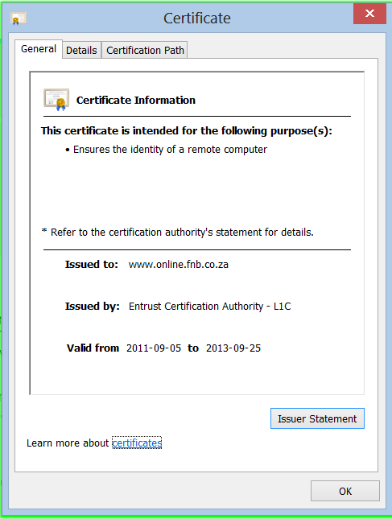  Explain what this is, and what part it plays in keeping your Internet experience secure. | (3)
3.2 | Consider the following website and answer the questions that follow:  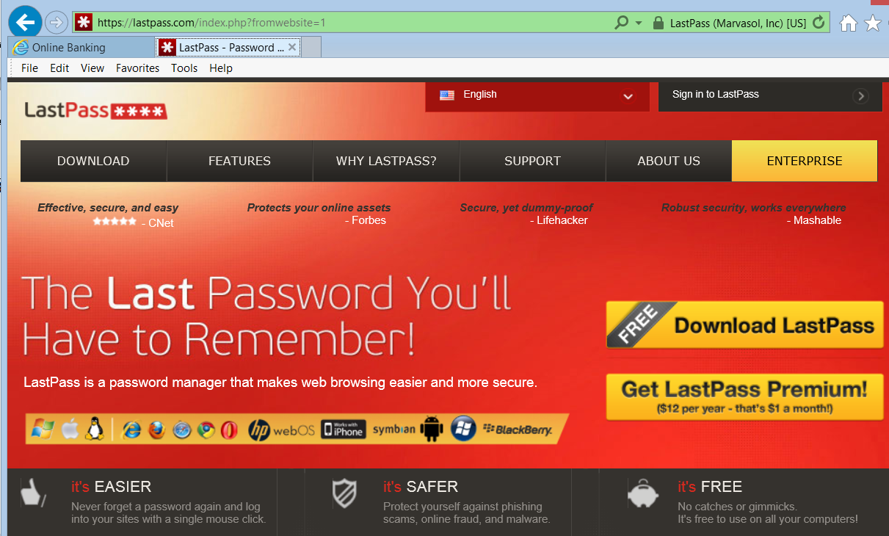

 | “LastPass” is a free password software package that, once installed, automatically fill in passwords, usernames, personal details etc. into other website pages, thereby preventing the user from having to remember different passwords for online email, banking etc. The user remembers one strong password for LastPass, and it remembers all the other passwords for you.
 | 3.2.1 | Do you think this software package is trustworthy? Briefly discuss the implications of installing a package such as this on your computer. | (2)
 | 3.2.2 | The package claims to be able to generate strong passwords for you. Give THREE rules that should be applied when generating a strong password. | (3)
 | 3.2.3 | Banks and other financial institutions also strive to make your Internet transactions with them secure. There have been situations in the past where people have sued the institution when their security has been compromised and their money has been stolen. Give THREE ways in which banks try to improve the security of your “banking via the Internet” sessions. | (3)
[21]

Question 4:

 | Blogs, wikis, IM, podcasts, forums and emailing lists are all used to publish information. Together they form what is commonly known as the ”New Media.” New Media makes the communication and publishing of information very easy.
 |  | Give TWO advantages and ONE disadvantage for making use of New Media.
 |  | - Advantages | (2)
 |  | - Disadvantage | (1)
 |  | Briefly explain what a blog (mentioned in the quote above) is. | (1)
 |  | New Media makes it much easier for computer ethics to be contravened. What is meant by computer ethics? | (1)

 | “Social Networking sites are very attractive to business. They contain so much more intimate information about people and what they like and do.”
 |  | Briefly describe a scenario in which the above statement could disadvantage an ordinary person using a social networking site. | (2)
 |  | Briefly describe a scenario in which the above statement could advantage an ordinary person using a social networking site. | (2)
[9]

SECTION D: DATA- AND INFORMATION MANAGEMENT

Question 5: ALGORITHMS AND PLANNING

An area in which the general public have embraced cloud computing is that of e-mail services. Web-based e-mail services, such as Gmail and Hotmail provide millions of users with e-mail addresses that can be accessed around the globe. You have decided to create a small web-based e-mail service, called MyMail and are going to store all user mail information on a database. You are going to store information about each of your clients (i.e. each of the people who register an e-mail account with you).
AND
You are going to store the details of each e-mail that is sent or received by your server. These details will include:
- the e-mail addresses of the sender and receiver of the email
- the subject of the e-mail
- any attachments it might have
- and the actual e-mail message

You database designer has unfortunately created one table with all the information stored in it.
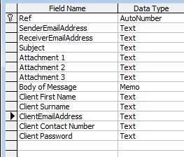

Examine the table and answer the questions that follow.

The database is clearly not normalised and therefore will not be efficient.
You must assume that you would store the following in separate tables:
- the information of your clients.
- the information of any messages that are in-bound (your client would be the receiver of the e-mail).
- the information of any messages that are out-bound (your client would be the sender of the e-mail) and
- an unlimited number of attachments for any of the e-mails.

Show how you would normalise the database by separating the data into FOUR separate tables as shown below.

Clients | Inbound Mails | Outbound Mails | Attachments

Copy the tables above into your answer booklet and complete the question.

You need to show for each table:
 |  | - The fields that the table will contain. | (4)
 |  | - The primary key (PK) of each table | (4)
 |  | - Any foreign keys (FK) that you consider to be needed to establish relationships. | (3)
 |  | - The relationships between the tables. | (4)
 |  | The general properties of the Client First Name field are shown below:
 |  | - Explain what it means to have a field size of 50 for this field, and briefly discuss its suitability. | (2)

 |  | - Examine the Validation Rule for this field and supply a suitable Validation Text (error message), based on the rule. | (1)
 |  | - The Client First Name field must be a compulsory field. Which property must be changed to ensure that the user does not leave this field open? | (1)
 | You have employed web designers who will supply the Internet interface to your MyMail site. They need to select a suitable language in which to program. HTML is the basic language understood by all web clients and is able to deliver platform independent applications.
 |  | What does the acronym HTML stand for? | (1)
 |  | What is the meaning of “platform independent applications”? Explain why this is important in terms of web site design. | (2)
 |  | The design of a web site is important for a number of reasons. Give THREE principles that the designers should adhere to in order to create an efficient, successful product. | (3)
5.3 | The programmers have created an algorithm that checks e-mail addresses for validity when they are entered. An e-mail is considered valid if it has a @-sign in it and if it has a full stop followed by a recognisable word – such as .com.  Examine the algorithm below and answer the questions that follow: (NB: “Endings.txt” is a text file containing a large number of e-mail country codes and other endings such as: .co.za, .com, .co.uk, .edu, .gov etc.)
1: adr ← the e-mail address entered on the web site
2: x ← the location (index) of an @-sign in the String adr
3: y ← the location (index) of a ”.” (full stop) in the String adr
4: if x = -1 OR y = -1
5: Print “invalid email address”
6: else
7: S ← read a line from “endings.txt” file
8: while not end of file loop
9: if S is found(located) within adr
10: isFound ← true
11: else isFound ← false
12: end loop
13: if isFound = true
13: Print “valid e-mail address”
15: if isFound = false
16: Print “invalid e-mail address”
17: end else

 | 5.3.1 | Programmers speak of the validity of data, and the verification of data.  Briefly explain these two concepts and how they differ. You should use the example of an e-mail address to illustrate your answer. | (2)
 | 5.3.2 | There are TWO errors in the algorithm that will cause the program not to work.  Briefly explain what these errors are (please refer to the line numbers where the errors occur), and provide a solution to fix each error. | (4)
 | 5.3.3 | All errors are not the same, some occur as the code is written, while others pop up at a later stage.  Carefully explain the following types of errors. Your explanation should include a reason why they occur. | (3)
 |  | - Syntax error | (3)
 |  | - Logical error | (3)
 |  | - Runtime error | (3)
5.4 | The Client information is going to be used in programs that develop statistics about the users of the website.  Study the class diagram below and answer the questions that follow:  CLIENT  Private  - ClientRef  - ClientFirstName  - ClientSurname  - ClientDOB  - ClientEmailAddress  Public  - Client()  - Client(ClientFirstName,ClientSurname)  - Client(ClientFirstName)  - getFirstName()  - setFirstName(name)  - getSurname()  - setSurname(surname)  - getStarSign()  - toString()
 | 5.4.1 | Use examples from the above class diagram to indicate where you would add overloading and what the function of it is. | (3)

 | 5.4.2 | Delphi uses accessor and mutator methods to move information to and from the attributes of the class.
 |  | - Explain why this is done. | (2)
 |  | - From the class diagram above give an example of an accessor method. . | (1)
 |  | - From the class diagram above give an example of a mutator method. | (1)
 |  | - The getStarSign() method does not correspond to any of the existing attributes. Is this an error? Explain your answer. | (2)
5.5 | Give an algorithm that is used to get the highest and the average number values in an array. The array declaration is as follows:  rNumber : Array[1..100] of real; |  | (6)
[49]

SECTION E: INTEGRATED SCENARIO

Question 6: INTEGRATED SCENARIO
Scenario:
“At the online Non-profit Technology Conference, keynote speaker, Ami Dar, founder and executive director of Idealist.org, made a splash when he described his Idealist.org office in Portland, OR.
Dar spoke of the way his office has turned to cloud computing, in part to cut costs but, more importantly, to free the staff from wires and regimentation from the top.
At Idealist.org, employees have laptops (choosing their own), and use Google Apps and Skype to replace servers, a LAN, and a phone system, said Dar. The only rules are that everyone must use Google Calendar and Salesforce.
Memos are scarce in the Idealist.org office since employees communicate by email (email client of their choice), an internal blog, and through Skype plus video.
Dar wasn't always so laid back, he says, but cost savings and functionality, plus employee preference for personal choice, portability, and a relaxed working environment, drove the conversion to the cloud. He told the story of an employee travelling in India who didn't need to lug a computer at all, but simply went to an Internet cafe to work.
Oh, by the way, there is “no IT person at Idealist.org”. Every person is his/her own IT expert!
Idealist.org does all this while running a site where 84,000 non-profit organisations from 180 countries have profiles; and 50,000 unique visitors show up each day. “

The above extract shows that using cloud computing can be a very effective substitute for traditional solutions

 | Many companies have a LAN in place to provide connectivity between the computers. .
 |  | Describe what a LAN topology is, giving TWO examples of a topology as part of your answer. (You can use drawings if you wish.) | (3)
 |  | Ami Dar states that he has replaced servers and phone systems with Google Apps and Skype.
 |  | - Briefly describe what Skype is. | (2)
 |  | - What protocol does Skype make use of? | (1)
 | In order for the cloud computing scenario above to be effective, it is important that the computers being used have fast Internet connections and make use of web caching.
 |  | Briefly describe how web caching works. | (3)
 |  | Assume that the computers at Idealist.org connect to the Internet via wireless routers that are distributed throughout the company buildings.
 |  | - Give TWO advantages of using a wireless LAN for the Internet connection. | (2)

 |  | - Give TWO disadvantages of using a wireless LAN to connect to the Internet. | (2)
 |  | - What do you need to link your workstation to a wireless LAN. | (1)
Google Docs is one of several web applications provided by the Google Apps service.
Documents, spreadsheets, and presentations can be created with Google Docs, imported through the web interface, or sent via email. Documents can be saved to a user's local computer in a variety of formats, including ODT, HTML, PDF, RTF, Text and Microsoft Word. Documents are automatically saved to Google's servers to prevent data loss, and a revision history is automatically kept.
Documents can even be shared, opened, and edited by multiple users at the same time.

Google Docs home page:

When you open a document, you can view it as follows:

 |  | You can see from the screen shot that the word-processing application is easy to use, and allows for the saving (downloading) of the document in various formats.  Briefly explain the difference between Text format and Microsoft Word format of a document. | (2)
 |  | Explain why it might be advantageous to be able to store your Google Docs documents in PDF format. | (2)
 |  | “Documents are automatically saved to Google's servers to prevent data loss, and a revision history is automatically kept.”
 |  | - Give ONE advantage, other than to prevent data loss, for storing documents on Google’s servers. | (1)
 |  | - Give ONE disadvantage for storing documents on Google’s servers. | (1)
 |  | - Provide a solution for the disadvantage that you have given for question 6.3.3 b). | (1)

[21]

TOTAL: 180

INFORMATION TECHNOLOGY GRADE 12
ANSWER SHEET

Name:
Section | Theme | Your Marks | Total
A | Question 1 – Short Questions |  | 10
B | Question 2 – Hardware and Software |  | 70
C | Question 3 – E-Communication  Question 4 – Social and ethical issues |  | 21  9
D | Question 5 – Algorithms and Planning |  | 49
E | Question 6 – Integrated Scenario |  | 21
Total |  |  | 180  100

Section A Question 1 [10]
Answers
1.1
1.2
1.3
1.4
1.5
1.6
1.7
1.8
1.9
1.10

