HIGH SCHOOL

<<LOGO OF COLLEGE / SCHOOL>>

INFORMATION TECHNOLOGY: PAPER 1 (PRACTICAL)
PREPARATORY EXAMINATION
SEPTEMBER 2013

EXAMINER: |  | TIME: 3 HOURS
MODERATOR: |  | TOTAL: 120 MARKS

This paper consists of 17 pages.

PLEASE READ THE FOLLOWING INSTRUCTIONS CAREFULLY:
- This question paper consists of 17 pages, check that it is complete.
- Owing to the nature of this three-hour examination, it is important to note that you will not be permitted to leave the computer-lab before the end of the examination period.
- This paper is divided into THREE sections. ALL sections are compulsory.
- It is to be answered using Object-Oriented Programming principles. Your program must make sensible use of methods and parameters.
- Only answer what is asked in each question. For example, if the question does not ask for data validation, then no marks are awarded for it.
- You are advised to look at the supplied data files carefully.
- Your program should always be coded to answer the question in the way it has been formulated. You are not allowed to only copy the given output supplied in the question paper.
- To help you to understand each question better, you have to read the entire question before answering any sub-questions.
- If you cannot get a section of code to work, comment it out so that it will not be executed and so that you can continue with the examination. If possible, try to explain the error to aid the marker.
- Save your work at regular intervals as a precaution against power failures.
- There might be a technical interruption that prevents you from writing the examination, e.g. a power failure, when you resume writing the examination, you will be given the time remaining when the interruption began, and an additional 10 minutes. No extra time will be given to catch up work that was not saved!
- Save all your solutions in file folders with the question number and your name and surname as the name of the folder, example Q2_ElvisBlue.
- Type in your name and surname as a comment (//) on the first line of every unit.
- During the examination, you may use the manuals originally supplied with the hardware and software. You may also use the HELP functions of the software. You may not use any other resource material.
- At the end of this examination session, you must make sure that all your work has been saved on the hard drive/network as explained to you by the invigilator/teacher. Ensure that all files can be read.
- Make printouts of the coding of all the units/classes of all the programming questions you have done. You will be given half an hour to print after the completion of this examination.

Take note: Section B and Section C is not dependent on any work done in Section A.
Please check the following important files provided are all present:
Folder Section A:
- Encyclopedia_P.dpr Delphi Project
- Encyclopedia_P.res RES file
- Encyclopedia_U.dfm Delphi Form
- Encyclopedia_U.pas Delphi Source File
- SuperTeamDB.mdb Microsoft Access Database
Folder Section B:
- clsSuits_U.pas Delphi Source File
- data1.txt Text Document
- data2.txt Text Document
- data3.txt Text Document
- data4.txt Text Document
- data5.txt Text Document
- frmQ2_P.dpr Delphi Project
- frmQ2_P.res RES file
- frmQ2_U.dfm Delphi Form
- frmQ2_U.pas Delphi Source File
- IronManQ2.exe Application
Folder Section C:
- Q3_P.dpr Delphi Project
- Q3_P.res RES file
- Q3_U.dfm Delphi Form
- Q3_U.pas Delphi Source File


SECTION A:
HERO ENCYCLOPEDIA (SQL and DATABASE CONNECTIONS) 37 MARKS

Note: You are strongly encouraged to make a backup of your database. The following queries will change the data in your database: Q1.5, Q1.6 and Q1.10. If you wish to re-test these queries, you will need to be able to restore the original data.

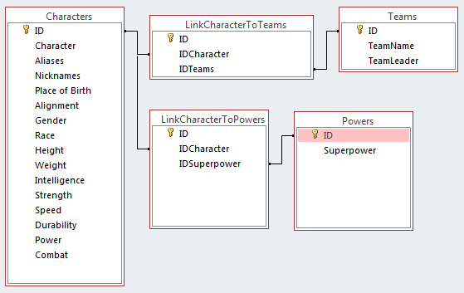
The relational structure given below has been used for storing the details of the characters, their super powers and the teams to which they belong:

The supplied database contains FIVE different tables, each with the following sample data and structure:

CHARACTERS:

Description of the fields of the Table (Characters):

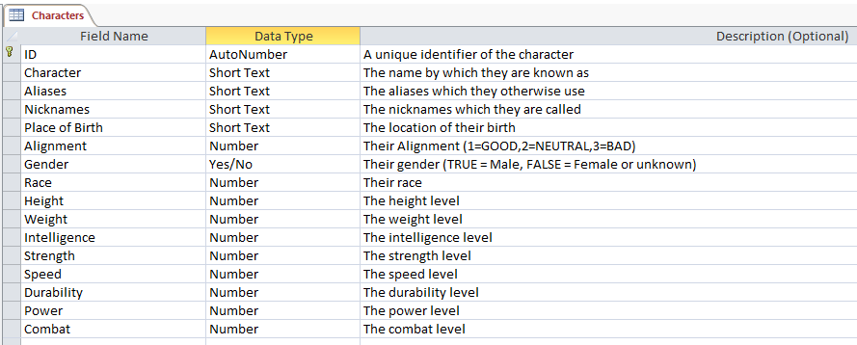

Screen Shot of the Contents of Table (Characters):

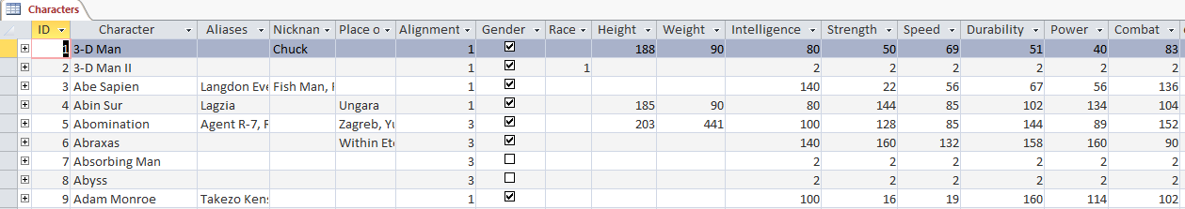

POWERS:

Description of the fields of the Table (Powers):

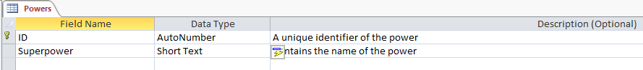

Screen Shot of the Contents of Table (Powers):

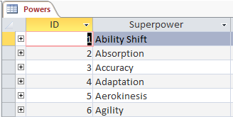

TEAMS:

Description of the fields of the Table (Teams):

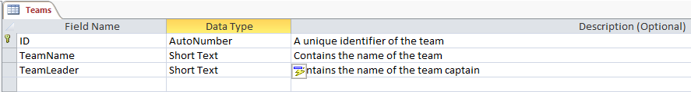

Screen Shot of the Contents of Table (Teams):

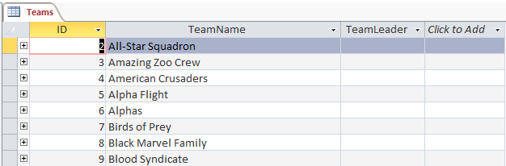

QUESTION 1

Do the following:
- Rename the exam folder Section A as Q1_XXXX, where XXXX must be replaced with your Name and Surname.
- Open Delphi and then open the project file pENCYCLOPEDIA_SQL.dpr in the folder Q1_XXXX.
- Add your Name and Surname to the right of 'HERO ENCYCLOPEDIA: ' in the caption of the form.
- Go to 'File|Save As …' and save the main unit as Q1XX_U.pas (where XX represents the 1st capital letter of your Name and the 1st capital letter of your Surname).
- Go to 'File|Save Project As …' and save the project as Q1XX_P.dp (replace XX with your initials as explained above).

For each of the following, create the necessary SQL statements to run in the supplied program when the appropriate button is clicked.
1.1 | Select all the characters (hero/villian) from the database that have a GOOD or NEUTRAL alignment. Display only the name, gender and race. | (3)
1.2 | Determine the tallest character (hero/villian) in the database.  Display only the height (as shown below), ensure that you rename the column for height as: Tallest  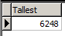 | (4)

1.3 | Determine the average weight of the all the HUMAN race characters. Display only the average weight (as shown below), ensure that you rename the column for weight as: Common Weight  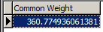 | (4)
1.4 | Determine the number of super powers that are listed in the database. The number of super powers is constantly changing as new mutants and super hero’s (and villians) join the ranks.  Display only the number of super powers (as shown below), ensure that you rename the column as: noOfPowers.  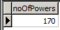 | (3)
1.5 | The super hero “Two-Face”, has changed his alignment from GOOD to EVIL. Create a SQL statement to modify his alignment when BUTTON 5 is clicked. Hint: Use your solution of QUESTION 1.1 to confirm the change of the number of GOOD heroes.  Sometimes there are just those situations that make us all weak. | (4)
1.6 | A new Team of super hero’s has been formed for the Defence of Justice. Create a SQL statement to add this team to the database when BUTTON 6 is clicked. | (4)
  ID | TeamName | TeamLeader
  10 | Avengers | Captain America
1.7 | Allow for the user to input a Team Name to search for in the program. The database must return the Team Leader of that Team Name. | (4)
1.8 | Determine the characters whose super power is ‘Telepath’. Display the team name as well as the name of the character (hero/villian) whose power is ‘telepathy’. | (5)
1.9 | Display all the female hero’s characters names in the database. | (3)
1.10 | Create a SQL statement to remove all characters that where born at “Place of birth unknown” when BUTTON 10 is clicked as these characters (heroes/villians) have now perished. | (3)

QUESTION 1 TOTAL: 37

The online resource below has been used in the setting of this question. Special thanks to the extraordinary ordinary individuals who have assisted in the generation of this data.

Works Cited
Lingen, J. t. (2010). Superhero Database: Superheros, Villians, Teams and Superpowers. Retrieved 05 2013, from http://www.superherodb.com/: http://www.superherodb.com/

SECTION B:
RETURN OF IRON MAN (OBJECT ORIENTED PROGRAMMING) 60 MARKS
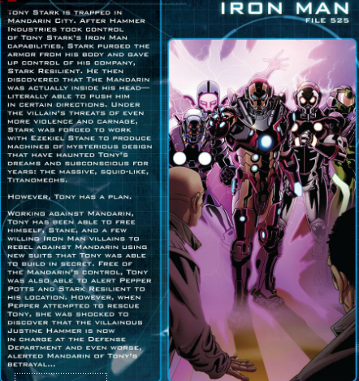

Iron Man has yet again to unleash his full furry onto the Madarin, and once again must face the incredible odds of a combined villianous army. In an attempt off-set the dangers of the squid-like Titanomechs, he has designed a new suit with even greater capacities to change against his various enemy’s powers.

QUESTION 2

Do the following:
- Rename the examination folder Section B as Q2_XXXX, where XXXX are replaced with your Name and Surname.
- Open Delphi and then open the project file frmQ2_P.dpr in the folder Q2_XXXX.
- Add your Name and Surname to the right of 'Iron Man: ' in the caption of the form.
- Go to 'File|Save As … ' and save the main unit as frmQ2XX_U.pas (where XX represents the 1st capital letter of your Name and the 1st capital letter of your Surname).
- Go to ‘Project|Add to project … ' and add the class clsSuits_U.pas to it.
- Go to 'File|Save Project As …' and save the project as frmQ2XX_P.dpr (replace XX with your initials as explained above).

2.1 | Iron Man has designed a special unit called TSuit which you are required to assist him in creating. The new suits capabilities and specifications are given below and uses some existing components and modules already existing in his previous suits:
2.1.1 | The constructor receives the following information as parameters:  - An fuel level, represented by a number between 100.00 and 0.00  - A shield status, represented by: ON (true) or OFF (false) if the shield is powered or not  - An array of seven weapons, represented by characters (‘A’-‘Z’) that can be fired.  Initialize the various fields using the parameters received by the constructor. | (4)
2.1.2 | Write a method called calculateFuelUsed that will determine the amount of fuel to be used up whenever Tony launches the Iron Man lift rockets into action. This method must accept a distance as a parameter and return if there will be enough fuel to make the jump or not.  FORMULA: fuel to be used = (distance / 75.50); when the shield is ON  OR fuel to be used = (distance / 66.66); when the shield is OFF | (5)
2.1.3 | Write a method called fireWeaponIfExists that will allow for Tony to enter a weapon as a parameter to be fired as a character for when a key is pressed on the TForm. Should the weapon exist in the array of weapons, the first one to match must be fired and then removed from the list of available weapons. | (8)
2.1.4 | Write a method called countWeaponOfType that will allow Tony to confirm how many weapons of a certain type still exists in the array of weapons. The number matching a character given as a parameter should be returned. | (4)
2.1.5 | Write a method called changeShieldStatus that will change the state of the shield. | (3)

2.1.6 | Tony has had a toString method that constructs and returns a string consisting of the properties of the various fields of his suit onto his internal display unit. Add code to the method so that the string will include the headings, labels and contents of the array in the following format:  Example of the output when the string is returned by the toString method is displayed: | (5)
  Fuel: XX.XX
  Shield Status: XX
  Weapons Available: X, X, X, X, X, X, X = X
  A = x
  B = x
  C = x
  Fuel: 79.99
  Shield Status: ON
  Weapons Available: A, A, B, C, A, C, = 6
  A = 3
  B = 1
  C = 2
 |  | [29]
2.2 | Tony has also made the latest suit to be adapted and changed when needed into a more advanced battle. The new advanced unit is called TBattleSuit that has the following additional properties and capabilities:  - A turboCharge level, a value between 100.00 and 0.00  - A secondaryFuel level, a value between 100.00 and 0.00  Initialize the various fields using the parameters received by an appropriate constructor. | (3)
2.2.1 | Write a method called calculateFuelUsed that will determine the amount of fuel to be used up whenever Tony launches the Iron Man lift rockets into action as the formula has changed due to the additional capabilities. The method must still accept a distance as a parameter and return if there will be enough fuel to make the jump or not in both the primary and secondary fuel tank.  FORMULA: fuel to be used = (distance / 72.00); when the shield is ON  OR fuel to be used = (distance / 65.25); when the shield is OF | (5)

2.2.2 | Write a method called useTurboCharge that will allow Tony to operate at superfast speeds for a random period of time less than the turbo charge level available. The method must increase the fuel amount (in the primary tank) by the following formula:  FORMULA: fuel increase by = 1.25 * period of supercharge.  Remember to reduce the amount of turbo Charge when used. | (5)
2.2.3 | Tony has had a toString method that constructs and returns a string consisting of the properties of the various fields of his suit onto his internal display unit with the additional features details as well. Add code to the method so that the string will include the headings, labels and contents of the array in the following format: | (3)
  Fuel: XX.XX
  Shield Status: XX
  Weapons Available: X, X, X, X, X, X, X = X
  A = x
  B = x
  C = x
  Secondary Fuel: XX.XX
  Turbo: XX.XX
  Example of the output when the string is returned by the toString method is displayed:
  Fuel: 79.99
  Shield Status: ON
  Weapons Available: A, A, B, C, A, C, = 6
  A = 3
  B = 1
  C = 2
  Secondary Fuel: 100.00
  Turbo: 65.45

2.3 | Modify the provided TForm with the given components such that Tony will be able to test his new suit’s design on various instruction settings. You have been supplied with FIVE various test-flight files for testing of the suit’s capacity.
2.3.1 | Allow Tony to build a test suit that will use the stored instructions found in the text files “data1.txt”, “data2.txt” to “data5.txt” to try out, one after the other, and one at a time.  The text files have the following properties to its instructions:  The first line contains if it is a Battle suit or a Normal suit. The next lines contain the actions which the suit must perform.  Where: J = Jump, F = Fire Weapon, S = change Shield status, T = use Turbo Charge  In the event of a JUMP being tested, the fuel to be used must be checked. In the event of the distance being too great then the following warning message must be displayed:  “WARNING: DISTANCE TO JUMP EXCEEDS FUEL AVAILABILITY”.
  BATTLE
  J,100.00
  J,30.00
  F,A
  S
  J,10.00
  T
  J,15.00
  F,A

Examples of the screen shots:
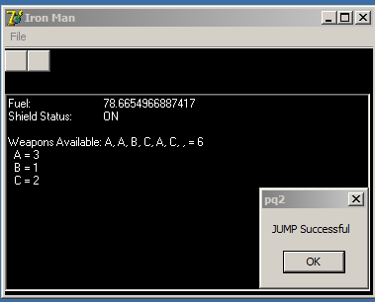  Figure 1:Trying to use JUMP in Normal Suit | 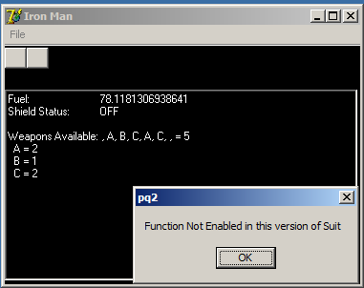  Figure 2:Trying to use TURBO in Normal Suit

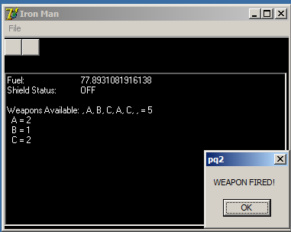  Figure 3:Trying to use FIRE in Normal Suit | 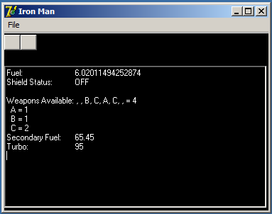  Figure 4:Trying to use Battle Suit (with Turbo)

(15)
[31]

QUESTION 2 TOTAL: 60

SECTION C:
HULK VS WOLVERINE (STRINGS AND PROBLEM SOLVING) 23 MARKS
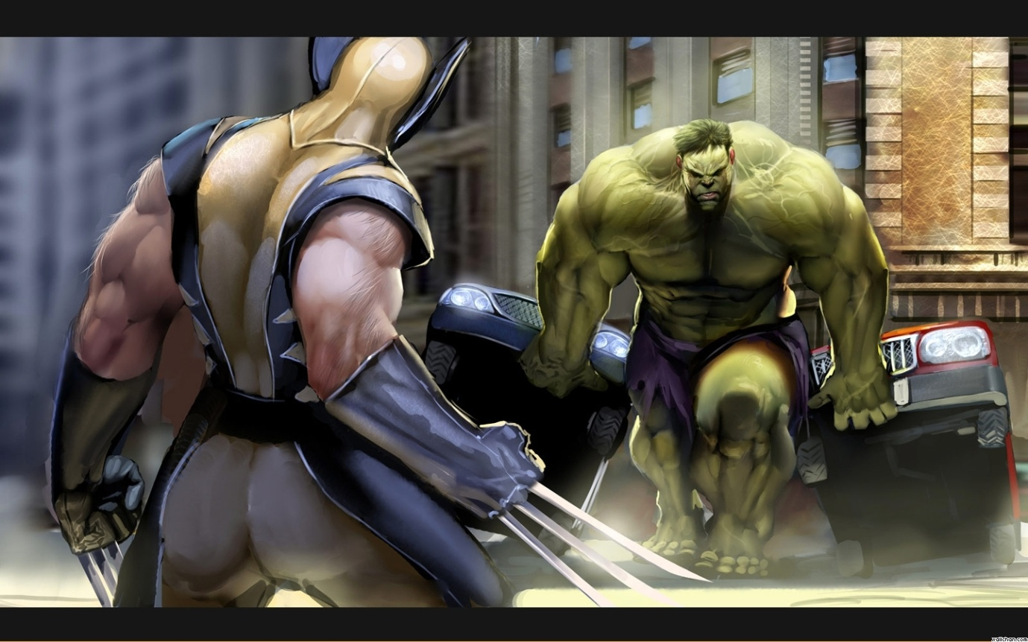
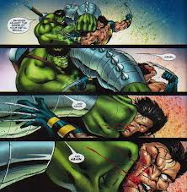 | 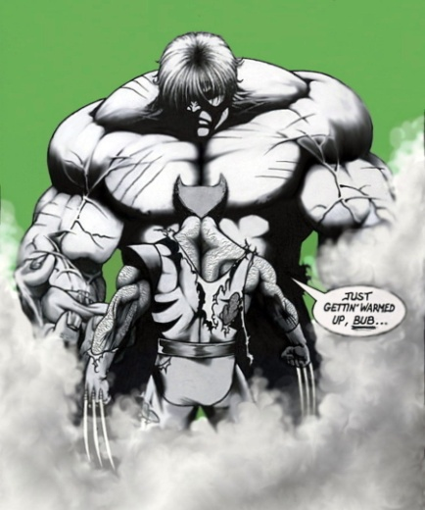 |  The Hulk: “Little man thinks he can fight Hulk? HULK IS STRONGEST THERE IS!”

An Epic Battle of Wolverine vs. The Incredible Hulk is about to be undertaken. As these two titanic forces meet in battle the fate of the entire world may hang in the balance of luck and pure brute force. Hulk has been insulted by Wolverine once more for speaking nonsense… the poor beast still struggles with his words.
Wolverine however is no wet dog when it comes to a battle, and with those regenerative powers of his, he may actually be a match for the wrath of the beast.

QUESTION 3

Do the following:
- Rename the examination folder Section C as Q3_XXXX, where XXXX are replaced with your Name and Surname.
- Open Delphi and then open the project file Q3_P.dpr in the folder Q3_XXXX.
- Add your Name and Surname to the right of 'HULK VS WOLVERINE: ' in the caption of the form.
- Go to 'File|Save As … ' and save the unit as Q3XX_U.pas (where XX represents the 1st capital letter of your Name and the 1st capital letter of your Surname).
- Go to 'File|Save Project As …' and save the project as Q3XX_P.dpr (replace XX with your initials as explained above).

3 | Hulks random speech is not random at all; but rather a mixed code that only makes sense to the beast. The following are the rules for his manner of speech.
3.1 | Modify the program Q3XX_U.pas so that the following properties are set for Hulk’s speech when a sentence is entered and the decode button is pressed:  RULE: The words entered must be reshuffled so that all the even words are displayed first (in order) and then the odd words in reverse order.  The phrase (normal sentence): HULK IS THE STRONGEST THERE IS  Becomes the reshuffled sentence: IS STRONGEST IS THERE THE HULK  The program must be able to take a sentence of any length and reshuffle it according to the above rule. | (9)
  Normal Sentence | HULK | IS | THE | STRONGEST | THERE | IS
  Word Number | 1 | 2 | 3 | 4 | 5 | 6
  Reshuffled Sentence | IS | STRONGEST | IS | THERE | THE | HULK
  Reshuffled Word Number | 2 | 4 | 6 | 5 | 3 | 1

3.2 | Hulk is no softy and as his temper rises, he launches a series of attacks at Wolverine (the poor dog vs. the beast).
3.2.1 | Hulk launches a series of power blows at Wolverine based on this insult. The poor beast releases a randomly strong punch at Wolverine whenever the HULK punch button is pressed. His power strikes range from 20 to 100 KG.  Wolverine attempts to block each blow with a power strike ranging 10 to 80 KG.  Set the properties for the various characters, ensure that the correct range is available for the respective character. | (4)
3.2.2 | When the punch button and properties of the power strikes are set, the power bars for each character is filled in. The following conditions determine the fate of our hero’s in this epic battle:  The difference of the two forces (HULK’s vs. WOLVERINE’s) is calculated and the REMAINDER of the force by FOUR is used to determine the outcome:  FORMULA: OUTCOME = (HULK POWER – WOLVERINE) REMAINDER OF 4 | (10)
  Remainder | MESSAGE TO BE SHOWN
  0 | Wolverine Knocked Out
  1 | Wolverine Blocks the Punch
  2 | Wolverine Dodges the Punch
  3 | Wolverine Knocked Back
  Otherwise | Wolverine Knocks out HULK!

The layout of the form follows on the next page.

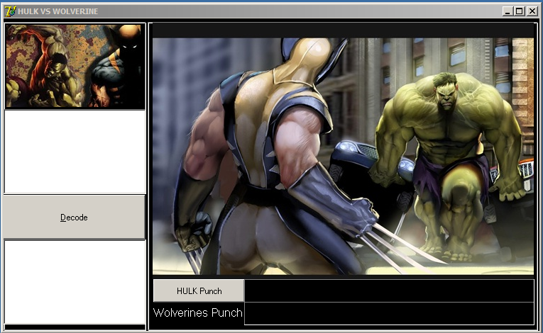
3.2
3.1
3.1 | Click on the Decode button to decode the Hulks speech. The content of the words for the above memo must be reshuffled according to the rules and then displayed in the new layout in the below memo.
3.2 | Click on the HULK Punch to activate the timer and progress bars for both the HULK and Wolverine’s punch. When the HULK’s punch lands (fills to the required value), then the outcome of the battle must be displayed in a message box. The outcome is dependent on the formula given.

QUESTION 3 TOTAL: 23

GRAND TOTAL: 120

