
PREPARATORY EXAMINATION

GRADE 12

SEPTEMBER 2013

COMPUTER APPLICATIONS
TECHNOLOGY P1

MARKS: 200

TIME: 3 HOURS

This question paper consists of 19 pages and a separate information sheet.

INSTRUCTIONS AND INFORMATION

1. | Owing to the nature of this three-hour examination, it is important to note that you will NOT be permitted to leave the examination room before the end of the examination period.
2. | Insert your examination number in the header of EVERY document that you create or save.
3. | The invigilator will give you a disk containing all the files needed for the examination OR you will be told where the files can be found on the network or computer. If a disk has been issued to you, you must write your examination number and centre number on the label. If you are working on the network, you must follow the instructions provided by the invigilator.
4. | A copy of the master files will be available from the invigilator. Should there be any problems with a file or files, you may request another copy from the invigilator.
5. | This question paper consists of SEVEN questions.
6. | Answer ALL the questions.
7. | Ensure that you save each document using the file name given in the question paper. Save your work at regular intervals as a precaution against possible power failures.
8. | Read through each question before answering or solving the problem. Do NOT do more than is required by the question.
9. | At the end of the examination you must hand in the disk given to you by the invigilator with ALL the files saved on the disk, OR you should make sure that ALL the files are saved on the network/computer as explained to you by the invigilator/educator. Make absolutely sure that all files can be read.
10. | The separate information sheet that has been provided with the question paper MUST BE COMPLETED AFTER THE 3-HOUR EXAMINATION SESSION. Hand it to the invigilator at the end of the examination.
11. | During the examination you may make use of the help functions of the programs which you are using. You may NOT use any other resource material.
12. | If data is derived from a previous question that you cannot answer, you should still proceed with the questions that follow.
13. | Unless instructed otherwise, formulae and/or functions must be used for ALL calculations in questions involving spreadsheets. Absolute cell references must be used only where necessary to ensure that formulae are correct when they are copied to other cells in a spreadsheet.
14. | In all questions involving word processing, the language should be set to English (South Africa). The paper size is assumed to be A4 portrait, unless instructed otherwise.
15. | Generally, 1 mark is allocated per action; therefore a 2-mark question would usually require TWO actions, et cetera.
16. | The examination folder/data disk that you receive with this question paper will contain the folder and files listed below. Ensure that you have a folder and all the files before you begin this examination.
 | - AFCON 2013 | Folder
 | - 02_CAF | Image file
 | - 03_CAF SA | Image file
 | - 03_CAF Trophy | Image file
 | - 03_Soccer Ball | Image file
 | - 04_SA | Image file
 | - 04_Soccer City | Image file
 | - 06_SAFA | Image file
 | - Q2_CAF | Word processing file
 | - Q2_Contact Us | Word processing file
 | - Q3_Host Cities and Stadiums | Presentation file
 | - Q3_Poster | Word processing file
 | - Q4_Host Cities | Spreadsheet file
 | - Q5_Travel | Spreadsheet file
 | - Q6_AFCON Schools | Database file
 | - Q6_Provinces | Database file
 | - Q6_Logo | Image file
 | - Q7_Callup | Word processing file
 | - Q7_SA Squad | Spreadsheet file

SCENARIO

The South African Football Association (SAFA) in conjunction with the African Cup of Nations Local Organising Committee (AFCON LOC) will be organising the 2013 African Cup of Nations, to be held in South Africa from 19 January to 10 February 2013.

You have been chosen by SAFA to assist in the following tasks:
- Editing of documents received from the Confederation of African Football (CAF)
- Creating posters to be sent to different CAF regions
- Maintaining a database of players’ travelling costs and lodging expenses.

QUESTION 1

You saved all files and folders that you received from the Confederation of African Football in the AFCON 2013 folder. You are busy creating a file structure that will make your work easier.

Work in the AFCON 2013 folder and organise your files and folders.
1.1 | Move all image files from the AFCON 2013 folder to the FLAGS folder. | (2)
1.2 | Save the file Committee Members in the AFCON 2013 folder as a word processing template. | (1)
1.3 | Add a password “afcon” to the file Countries Hosted CAF in the AFCON 2013 folder. | (1)
1.4 | Create a shortcut to the South_Africa image file in the FLAGS folder and place the shortcut in the CAF REGIONS folder. | (2)
 | Save and close all files. | [6]

QUESTION 2

Open the word processing file Q2_CAF.
2.1 |  | Key in your initials and your surname in the centre of a header. Use  a field and insert the name of the file as a field to the right in the header. |  |  | (2)
2.2 |  | Find the words South Africa and replace them throughout the document with the words Africa De Suede. Ensure that the words Africa De Suede are formatted to bold. |  |  | (2)
2.3 |  | Modify the style Heading 2 so that it has the following properties:
 |  | 2.3.1 |  | font: Comic Sans MS | (1)
 |  | 2.3.2 |  | automatically updated | (1)
 |  | 2.3.3 |  | renamed as AFCON 2013. | (1)
2.4 |  | Create an automatically updated table of contents below the words Table of Contents on the first page of the document. |  |  | (1)
 |  | Show two levels of headings in the table of contents: Heading 1 as the first level heading and the AFCON 2013 heading as the second level heading. |  |  | (2)
2.5 |  | Add a footnote to the name Sepp Blatter (highlighted in a blue colour) under the heading Future. The footnote should read: FIFA President. |  |  | (2)
2.6 |  | Set a first line indentation of 0.5 cm to the first paragraph in the document. |  |  | (2)
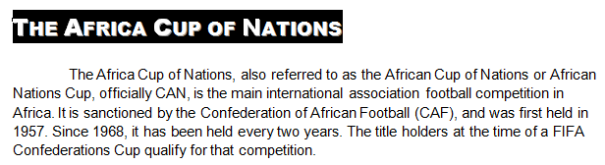

The Africa Cup of Nations, also referred to as the African Cup of Nations or African
Nations Cup, officially CAN, is the main international association football competition in
Africa. It is sanctioned by the Confederation of African Football (CAF), and was first held in
1957. Since 1968, it has been held every two years. The title holders at the time of a FIFA
Confederations Cup qualify for that competition.

2.7 | - Apply automatic page numbering in the centre of the footer of the  document.  - Use a Roman number to number the table of contents page as i.  i  - Apply the page numbering format Page X of Y to number the rest of the pages in the document.  - The page numbering must start on the second page of the document and the number of this page must be page 1 of 6. Refer to the screenshot on the next page.  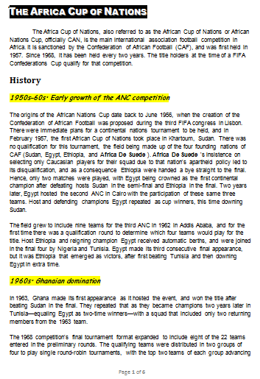  The Africa Cup of Nations, also referred to as the African Cup of Nations or African Nations Cup, officially CAN, is the main international association football competition in Africa. It is sanctioned by the Confederation of African Football (CAF), and was first held in 1957. Since 1958, it has been held every two years. The title holders at the time of a FIFA Confederations Cup qualify for that competition.  History  1950s-60s: Early growth of the ANC competition  The origins of the African Nations Cup date back to June 1956, when the creation of the Confederation of African Football was proposed during the third FIFA congress in Lisbon. There were immediate plans for a continental nations tournament to be held, and in February 1957, the first African Cup of Nations took place in Khartoum, Sudan. There was no qualification for this tournament, the field being made up of the four founding nations of CAF (Sudan, Egypt, Ethiopia and L’Afrique du Sud). L’Afrique du Sud’s insistence on selecting only Caucasian players for their squad due to that nation's apartheid policy led to its disqualification, and as a consequence Ethiopia were handed a bye straight to the final. Hence, only two matches were played, with Egypt being crowned as the first continental champion after defeating hosts Sudan in the semi-final and Ethiopia in the final. Two years later, Egypt hosted the second ANC in Cairo with the participation of these same three teams. Host and defending champions Egypt repeated as cup winners, this time downing Sudan.  The field grew to include nine teams for the third ANC in 1952 in Addis Ababa, and for the first time there was a qualification round to determine which four teams would play for the title. Host Ethiopia and reigning champion Egypt received automatic berths, and were joined in the final four by Nigeria and Tunisia. Egypt made its third consecutive final appearance, but it was Ethiopia that emerged as victors, after first beating Tunisia and then downing Egypt in extra time.  1960s: Ghanaian domination  In 1963, Ghana made its first appearance as it hosted the event, and won the title after beating Sudan in the final. They repeated that as they became champions two years later in Tunisia – equalling Egypt as two-time winners – with a squad that included only two returning members from the 1963 team.  The 1958 competition's final tournament format expanded to include eight of the 22 teams in the preliminary rounds. The qualifying teams were distributed in two groups of four to play single round-robin tournaments, with the top two teams of each group advancing  Page 1 of 6 |  |  |  | (1)  (1)  (1)  (1)
2.8 | Locate the text Contact us (highlighted in a green colour) on the last page of the document. Add a text box to the right of the text Contact us. |  |  |  | (1)

2.9 | Open the Q2 Contact Us file.
2.9 | 2.9.1 | Insert the Wingding 45 symbol in front of the postal address line of the address. | (1)
2.9 | 2.9.2 | Now copy the address and paste it in the text box in the Q2_CAF file.  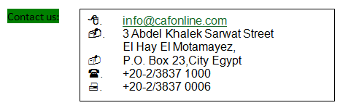 | (1)
2.10 | Continue working on the last page of the document. You will now work in the table BAFANA BIG SHOTS.
 | Use any leader tab which is set at 6 cm/2.4 inches and make provision for space to write down or to key in the email address of the coach. Refer to the screenshot below. |  | (2)
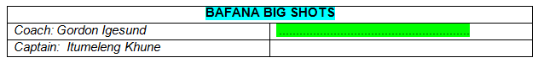

Save and close all files. |  |  | [23]

QUESTION 3
The African Cup of Nations Local Organising Committee (AFCON LOC) requested you to create a poster for the African Cup of Nations to be hosted by South Africa in January 2013.
Open the file Q3_Poster. Key in your initials and your surname in the header of the document. Refer to the screenshot below, which resembles the final poster.
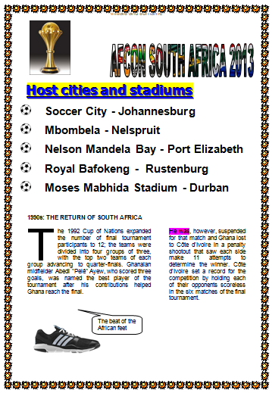

1990s: THE RETURN OF SOUTH AFRICA
he 1992 Cup of Nations expanded  the number of final tournament participants to 12; the teams were divided into four groups of three  with the top two teams of each Group advancing to quarter-finals. Ghanaian Midfielder Abedi "Pelê" Ayew, who scored three goals, was named the best player of the tournament after his contributions helped Ghana reach the final. | He was, however suspended for that match and Ghana lost to Côte d'Ivoire in a penalty shootout that saw each side make 11 attempts to determine the winner, Côte d'Ivoire set a record for the competition by holding each of their opponents scoreless in the six matches of the final tournament.

T

The beat of African feet

3.1 | Fill the WordArt/Fontworks heading AFCON SOUTH AFRICA 2013 at the top of the page with the image which is saved as 03_CAF SA. | (2)
3.2 | - Format the heading Host Cities and Stadiums (highlighted in yellow  colour) to a font size of 28 pts and the emboss effect.  - Insert a hyperlink on the heading Host Cities and Stadiums (highlighted in yellow colour) to link to the presentation file named  Q3_Host Cities and Stadiums. | (2)  (2)

3.3 | Customise the bullets in the bulleted list underneath the heading Host Cities and Stadiums by using the image file saved as 03_Soccer Ball. | (2)
 | 
3.4 | Format the line spacing of the bulleted list to 12 pt before the paragraph and to ‘At least 20 pt’ line spacing. | (2)
3.5 |   Insert the image file saved as 03_CAF Trophy and paste it at the top left of the poster. Resize the image to a height of 4 cm/1.57 inches and  a width of 3 cm/1.18 inches. | (3)
3.6 | Convert the text starting with the words ‘The 1992 Cup of Nations’ and ending with the text … ‘the final tournament’, to two columns with a line between the columns. | (2)
 | - Format the columns as follows:  Column 1 width: 9 cm/3.79 inches  Column 2 width: 5.6 cm/1.95 inches.  Ensure that the pinkish highlighted text starting with the words, “He was …” starts at the top of the second column. | (3)
 | 3.6.2 Add a drop cap to the letter ‘A’ (the first letter in the first column which is highlighted in a blue colour). The drop cap should drop  5 lines and the distance between the drop cap and the second letter should be 0.25 cm/0.098 inches. | (3)
3.7 | Insert any callout shape at the bottom of the page to the right of the image of the soccer boot. Add the following text to the callout: ‘The beat of African feet’. Ensure that this text is vertically centred in the callout shape. | (3)
3.8 | Group the callout that you inserted in QUESTION 3.7 with the image that appears at the bottom left of the page. | (2)
 | 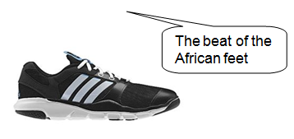
3.9 | Insert an art page border with a width of 10 pt in the document. | (2)

3.10 | Remove the bookmark placed on the words South Africa. | (1)
3.11 | Remove the comment that appears in the first line of the text (just below the WordArt heading). | (1)
Save and close Q3_Poster. |  | [30]

QUESTION 4
The venues for the soccer matches were announced in May 2012. Soccer City will host the opening and the final matches. Other venues/stadiums which are selected for the matches are Mbombela, Nelson Mandela Bay, Royal Bafokeng and Moses Mabhida.
Retrieve the spreadsheet which is saved as Q4_Host Cities. Work in Sheet 1.

4.1 | Work in cell A1. Use the text function to format the text in cell A13 to capital letters. The text in cell A13 has to appear in cell A1. | (2)
4.2 | Do the following:
 | 4.2.1 Merge and centre the cell range A1:J1 horizontally. The text in this cell range must also be centred vertically in the merged cells. | (2)
 | 4.2.2 Fill the merged cell range A1:J1 with a greenish colour. | (1)
 | 4.2.3 Apply a bolded font and a reddish font colour to the text AFCON 2013 Stadiums Capacity in the merged cell range A1:J1. | (2)
4.3 | Add a border around the cell range A1:J7. | (1)
4.4 | Ensure that all sub-headings in the range A2:J2 are visible and are  displayed as below:  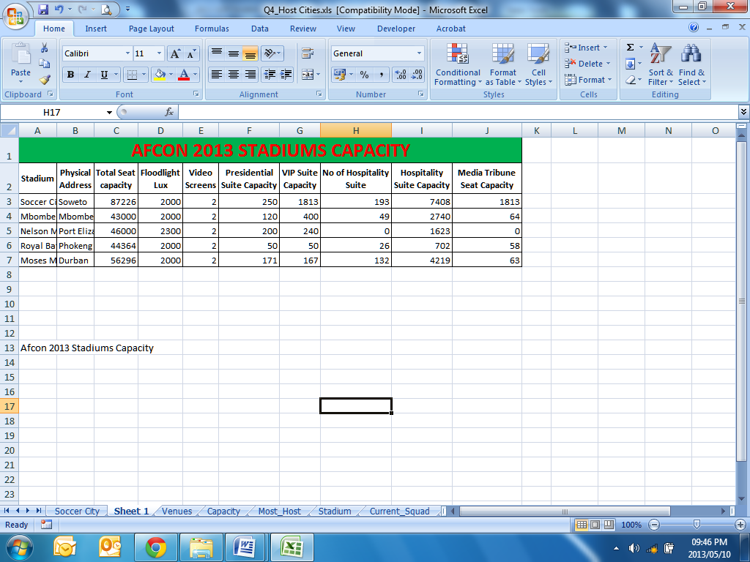 | (2)
4.5 | Arrange the data so that the stadium with the lowest total seat capacity will appear first and the stadium with the highest total seat capacity will appear last. | (2)
4.6 | Calculate in cell A9 the total number of Hospitality Suites (column I) of all stadiums that have more than 1 000 hospitality suites. Use a function. | (3)
4.7 | In cell C10, calculate the percentage seating capacity (column C) of the Royal Bafokeng Stadium. Round the percentage seating capacity off to  2 decimal places. | (6)
4.8 | Refer to the screenshot on the next page when you do this question. This screenshot resembles the final chart.  4.8.1 Edit the bar chart that appears in sheet 1 to a 3D column chart. | (1)
 | 4.8.2 Move the 3D column chart so that it is displayed in a new sheet. | (1)
 | 4.8.3 Rename the sheet in which the chart appears to Soccer City.  4.8.4 Ensure that the longest column has a different colour from the other columns.  4.8.5 Values must be shown as data labels above the columns.  4.8.6 Fill the background of the chart with the image file saved as 04_SA. Apply a transparency of 50%.  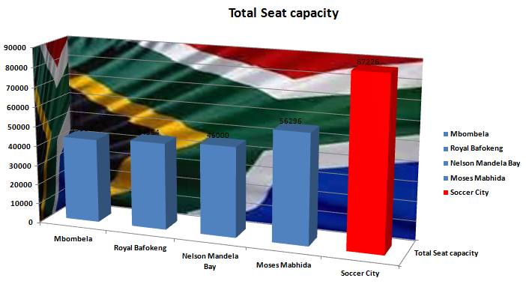 | (1)  (1)  (1)  (2)
4.9 | Work in the Venues worksheet.  Use the Vlookup function in cell C3 to display the number of people (spectators) to be accommodated at a specific stadium in the Venue worksheet. Use the vlookup table in the Capacity worksheet to display the number of people (spectators) to be accommodated at a specific stadium. Use absolute cell referencing and copy the function down to  cell C7. | (5)
4.10 | Work in the Stadium worksheet.  Use conditional formatting in column B to format the cells of all venues that can accommodate more than 45 000 spectators to a green background colour. | (3)

4.11 | Work in the Stadium worksheet. Refer to the screenshot below.  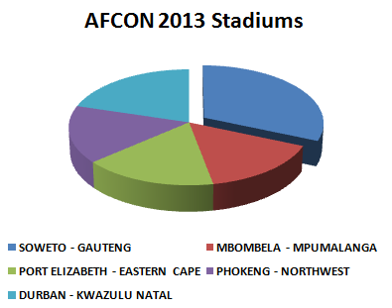  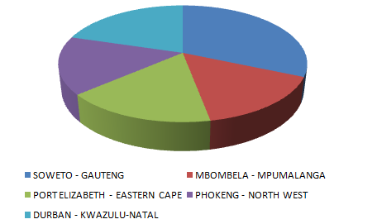
 | Create a pie chart to indicate how many people can be accommodated at a venue. |  | (1)
 | Title of chart: | AFCON 2013 Stadiums | (1)
 | Legend: | Must be shown at the bottom of the chart. | (1)
 | Explode the slice of the chart that displays the stadium that can accommodate the most people. |  | (1)
Save and close the Q4_Host Cities file. |  |  | [40]

QUESTION 5

The South African Football Association Local Organising Committee (SAFA-LOC) offered to refund each player for travelling costs and lodging expenses. You are responsible for keeping records of the payments which have to be made to the players. Retrieve the spreadsheet which is saved as Q5_Travel. Work in the S & T worksheet.
5.1 | Format the values in cells J3:J25 to South African rand. |  | (1)
5.2 | The code in column B is made up as follows:
- the first 3 letters of the town or city (column D), and
- the first 3 letters of the surname. Note that only the letters in the
surname will be used and no initials and also NOT the space
between the initials and the surname!
 | Create the code for I Khune in cell B3. |  | (6)
5.3 | Calculate in cell H3 the time in minutes that I Khune travelled to Johannesburg from Bloemfontein. I Khune travelled at 120 km/h. |  | (3)
Players may claim for the days that they are away from home. The criteria for the claims are as follows:
- 0 days if the distance is less than 500 km
- 1 day if the distance is between 500 km and 1 000 km
- 2 days if the distance is more than 1 000 km.
5.4 | Use a nested IF-function in cell I3 to determine the number of days that I Khune may claim for using the criteria listed above. | (4)
5.5 | Calculate in cell J3 the travel claim for I Khune, who will be travelling from Bloemfontein. Use the distance in cell E3 and the rate in cell J1. | (2)
5.6 | Use a suitable function in cell D27 to calculate the third highest total claim in column L. | (3)
5.7 | Use a suitable function in cell D28 to calculate the total amount of all travel claims in column J of R2 300 and more. | (3)
5.8 | Work in the Distance worksheet. Use a function in cell B20 to find the average distance from Johannesburg in column B. Round the answer off to the nearest whole number. | (4)
5.9 | Work in the CAPS worksheet in cell D27. Use a function to display the number of players who achieved 40 and more caps (number of call-ups to the Bafana Bafana squad). | (3)
Save and close the Q5_Travel file. |  | [29]

QUESTION 6
The AFCON 2013 Local Organising Committee (AFCON 2013-LOC) promotes interest of soccer to the youth. They organised an inter-school competition. A database of all competitors has already been created. You are requested to assist in the administration of the database.
Retrieve the database, which is saved as Q6_AFCON Schools.
6.1 | Work in the table saved as Goals.  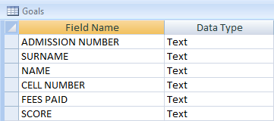
 | 6.1.1 | Set any of the fields in the table as the primary key field. |  | (1)
 | 6.1.2 | Now format the fields in the above table as follows:
 | SURNAME  The surname must be displayed in upper case even when it was not originally entered in lower case.  NAME  The field size must be set to 15 characters.  Enter a caption for this field: No nicknames allowed.  CELL NUMBER  Apply a suitable data type.  Create an input mask for this field. Use spaces in the cellphone numbers. The cellphone numbers must be displayed as XXX XXXX XXX.  This field must be a required field.  FEES PAID  Apply a suitable data type so that the user can tick when the fees are paid. If fees are not paid, no tick should appear.  SCORE  Choose a suitable data type for this field.  The text in this field must be right aligned.  Add a validation rule to this field so that no scores of 50 and above will be accepted.  Add a suitable validation text to this field. |  |  | (1)  (1)  (1)  (1)  (2)  (1)  (1)  (1)  (1)  (1)  (1)

6.2 | Add the following records to your table.
 |  | (1)
  Admission No | Surname | Name | Cell Number | Fees Paid | Score
  HY12345 | Saunders | Jason | 0822112526 | Yes | 20
  IW44987 | Jackson | Seriah | 0722565854 | No | 15
6.3 | Retrieve the query saved as Schools. Insert a calculated field called VAT. Calculate 14% on the amount paid by the schools in this field. Only schools from Wynberg must be displayed. The VAT field must be formatted to currency and two decimals must be displayed. | (6)
Save and close the Q6_AFCON Schools file.
6.4 | Open the database called Q6_Provinces. Work in the table saved as Delegates.  The table holds data about schools that will participate in a competition that will be offered by the AFCON 2013 LOC during the September school holidays. This competition will take place in Bloemfontein. Schools from the following provinces will be attending: Free State (FS), Northern Cape (NC), Gauteng (GP) and KwaZulu-Natal (KZN). Each team will be accompanied by  a teacher. The names of the learners and the teachers are recorded in the table Delegates.
 | 6.4.1 Create a query called Delegates Query based on the table Delegates. This query will display all females from the Free State (FS) and the Northern Cape (NC). Only the names, gender and province fields must be displayed. | (3)
 | - Use the table saved as Delegates and create a query called Other Provinces that displays the details of all delegates that will participate in the competition except delegates from the Free State. Display the Surname, Name and Province fields in the datasheet view. Sort the query alphabetically according to the Name field. | (4)

6.5 | Use the table saved as Delegates to create a form saved as InputForm. The Inputform will be used to add new records or edit existing records of the delegates. All fields in the table Delegates should be displayed in the form.  - Create a combo box on the form called Provinces so that a list of all provinces that will participate in the competition will be displayed. These provinces are: Free State, Northern Cape, Gauteng and KwaZulu-Natal. Format the font colour of all provinces displayed in the combo box to a blue colour.  - Add the logo saved as Q6Logo to the title of the form. The logo must be tiled. |  | (4)  (2)
6.6 | Create a report based on the SA_Squad table. Save this report as SA_Squad. |  | (1)
 | 6.6.1 | Display the Jersey Number, Position and Player Name in the report. | (1)
 | 6.6.2 | Apply the block layout and the civic style to your report. | (2)
 | 6.6.3 | Group the report according to the Position field. | (1)
 | 6.6.4 | Sort the records alphabetically according to the Player Name field. | (1)
 | 6.6.5 | Format the date in the page footer of the report to the short date format. | (1)
 | 6.6.6 | Format the background of the report header to any light colour. | (1)
6.7 | Now do the following calculation in the report:
 | Calculate the number of players per group. Add a suitable label Players per group when you do this calculation. |  | (4)
6.8 | Use all fields in the Delegates table and create a report called Final. |  | (2)
6.9 | Do the following calculation in the report:
 | Calculate the average amount of hostel fees paid. Format this field to currency. |  | (4)
6.10 | The hostel staff needs to know how many teachers will attend the competition.  They have to plan for accommodation and meals. The head of the hostel  needs this information in a spreadsheet.  Export the query saved as Teachers’ Info to a spreadsheet.  Save the spreadsheet as Teacher Info. |  | (1)  (1)
Save and close all files. |  |  | [53]

QUESTION 7

The South African Football Association Local Organising Committee (SAFA-LOC) would like to send letters to all team managers to inform them about the call-up of players for the Bafana Bafana team.
Open the file Q7_Callup.
7.1 | Move to page two of the document and work in the Players’ Reply Slip. Form controls have been added to the second column of the reply slip.  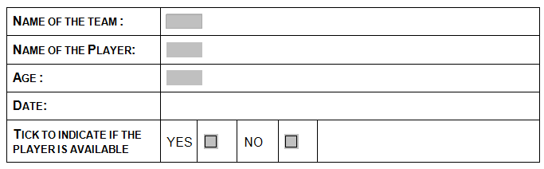
 | Format the form controls as follows:
 | 7.1.1 | The following options must be added to the drop down field that appears to the right of the cell that contains the text Name of the Team:  - Bloemfontein Celtic  - Orlando Pirates  - Kaizer Chiefs  - Supersport | (2)
 | 7.1.2 | Format the text form field in the cell to the right of the cell that contains the text Name of the Player so that only 20 characters will be accepted. The text must be displayed in title case. | (2)
 | 7.1.3 | Format the text form field in the cell to the right of the cell that contains the text Age to number. | (1)
 | 7.1.4 | Add a suitable text form field in the cell to the right of the cell that contains the text Date. Apply the MMMM-YY format. | (2)
 | 7.1.5 | Format the check box in the cell to the right of the cell that contains the text Yes so that the check box is checked. | (1)

7.2 | 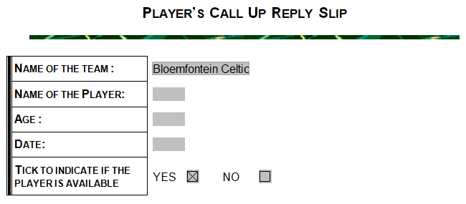Format the table that holds the form controls so that it resembles the screenshot on the next page. |  | (3)
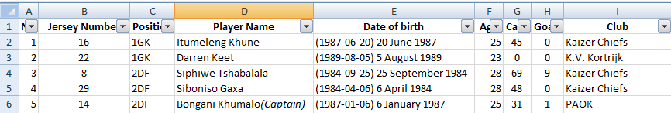7.3 | Open the Q7_SA Squad spreadsheet and work in the SA_Squad worksheet. Refer to the screenshot below.
 | 7.3.1 | Apply filtering to the spreadsheet so that the data in the spreadsheet can be filtered. | (1)
 | 7.3.2 | Copy the range A1:I24 from the Q7_SA Squad worksheet and paste it as a hyperlink in the appropriate space (this space is highlighted in a greenish colour) in the Q7_Callup document. | (2)
 | Save the Q7_SA Squad file, but continue working in the Q7_Callup file.

7.4 | Use the mail merge feature of your word processor to create merged letters to send to all teams to inform them about players who have been selected for the SA Squad. These players will represent the country during the AFCON 2013 matches in South Africa.  Use the SA_Squad table in the Q6_Provinces database as the data source for the mail merge. Add fields in the space provided in the document for the Player Name and the Club Name.  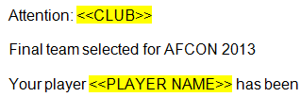  Perform a mail merge and save the merged document as Q7_Letter_Players. | (5)
Save and close all files. |  | [19]
TOTAL: 200

