Name of School
INFORMATION TECHNOLOGY P1
PRACTICAL EXAMINATION
Preliminary Examination 2013
Grade 12
Time | 180 minutes |  | Examiner | Mr/s X
Marks | 120 |  | Moderator | Mr/s Y

This question paper consists of xx pages and an information sheet.

Question | Suggested time | Marks
Question 1 SQL  Question 2 OOP  Question 3 PROBLEM SOLVING | 50 minutes  75 minutes  55 minutes | 25  60  35
TOTAL | 180 minutes | 120 marks

INSTRUCTIONS AND INFORMATION
- Owing to the nature of this three-hour examination, it is important to note that you will NOT be permitted to leave the examination room before the end of the examination period.
- Insert your full name in the header as a comment on top of units.
- You will be told by the invigilator where the files can be found on the network or computer. If you are working on the network, you must follow the instructions provided by the invigilator.
- A copy of the master files will be available from the invigilator. Should there be any problems with a file, you may request another copy from the invigilator.
- This question paper consists of 3 questions.
- Answer ALL the questions.
- Ensure that you save each document using the file name given in the question paper. Save your work at regular intervals as a precaution against possible power failures.
- Read through each question before answering or solving the problem. Do NOT do more than is required by the question.
- At the end of the examination you should make sure that ALL the files are saved on the network/computer as explained to you by the invigilator/teacher. Make absolutely sure that all files can be read.
- During the examination you may make use of the help functions of the programs which you are using. You may NOT use any other resource material.
- If data is derived from a previous question that you cannot answer, you should still proceed with the questions that follow.
- NOTE: For all pictures of program output shown below for all questions: 1-3, the black and white border is not part of the program output. It is intended to show pictures as different from tasks instructions.
1 | Question 1 : SQL  Scenario  Data on College Students Union elections have been presented for analysis in 3 tables namely: Voterstlb, Candidatestlb and Votestlb.  Figures 2, 4 and 6 show the design views of these tables and the figures 3, 5 and 7 shows the datasheet views.  Figure 1 shows how the 3 tables are related to each other. The file CSU.mdb with the tables has been provided in the examination folder. Open the database and view the records and fields of the tables before you start answering the questions. Take note, the Candidate Name in the Votestlb is the foreign key.  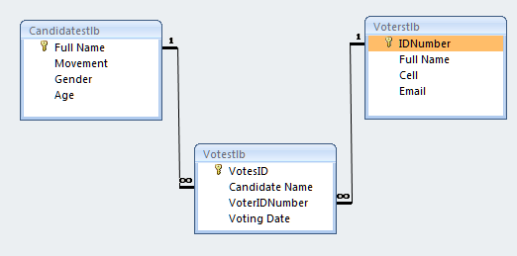  Figure 1: This diagram shows three table and their relationships  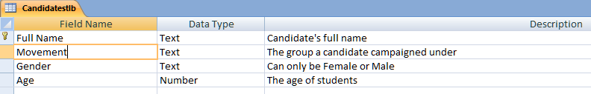  Figure 2: Shows the design view of the Candidates table  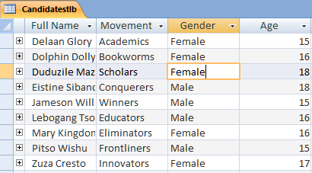  Figure 3: Shows the table view of the candidates table  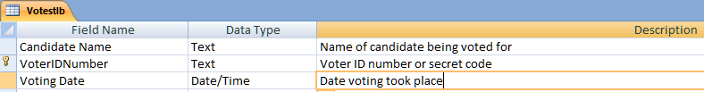  Figure 4: Shows the design view of the Votes table  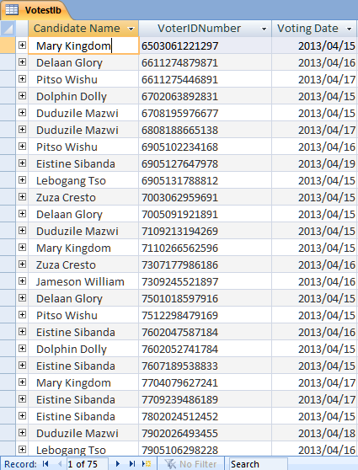  Figure 5:Shows the datasheet view of the Votes table  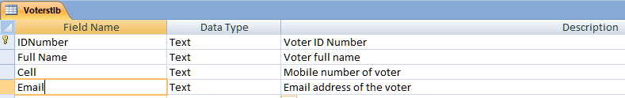  Figure 6:Shows the design view of the Voters table  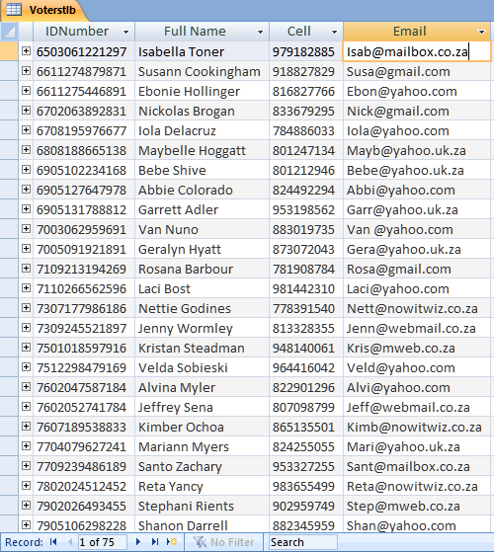  Figure 7:Shows the datasheet view of the Voters table
 | 1.1 |  | Display all voters who use yahoo for their emails. Display their names and emails only, sorted by names ascending.  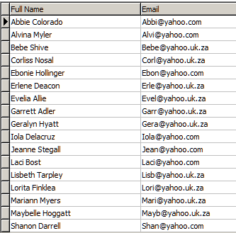 | L | 4
 | 1.2 |  | Cell numbers are 9 digits.  They are to be displayed in an international format.  Create a query to display the Names and cell number( as [Mobile Number]) in international format .e.g. +27-853652365 for voters with ID Numbers ending with 9  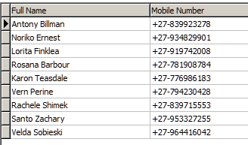 | L | 3
 | 1.3 |  | Create a query to show how many votes were cast on a day a user chooses e.g.15.  The code should have a input from the user.  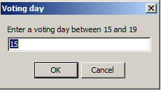  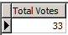 | L | 3
 | 1.4 |  | Write code to display all voters who voted for Eistine Sibanda. Show names and Candidate name.  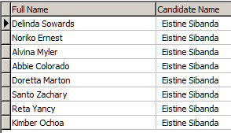 | M | 3
 | 1.5 |  | Create a query to display the total votes for candidates that exceeded 8  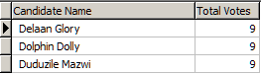 | H | 3
 | 1.6 |  | Write a query to insert a candidate  By name Julian Doe, movement Mind Crackers, gender Female and age16.  After inserting the record display it. | M | 3
 | 1.7 |  | Two voters managed to vote more than twice and that is against the voting regulations. Their votes should be disqualified.  Create a query to delete the voters with ID Numbers:  7501018597916 and 8006151671223  After deleting the two records display the total of all voters.  NOTE: Deleting is irreversible and so backup the database first  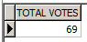 | M | 3
 | 1.8 |  | One of the voters would like to update details.  Create a query to change cell number of voter with ID number 9008194737346 to 826832705 and email to Piro@gmail.com | M | 3
 |  |  |  |  | 25
 |  | L 10, M=12, H= 3 |  |  | [25]
 |  | LEVEL OF DIFFICULT BREAK DOWN
Low, Medium, High
40% 48% 12%
(%) Percentage

2 | Question 2 : OOP  Scenario  In developing the Voter Entity, you are required to add a new voter, read voters from the voters.text file, update a voter details, delete a voter and search for a voter using his/her ID Number as shown in Figure 1 below:  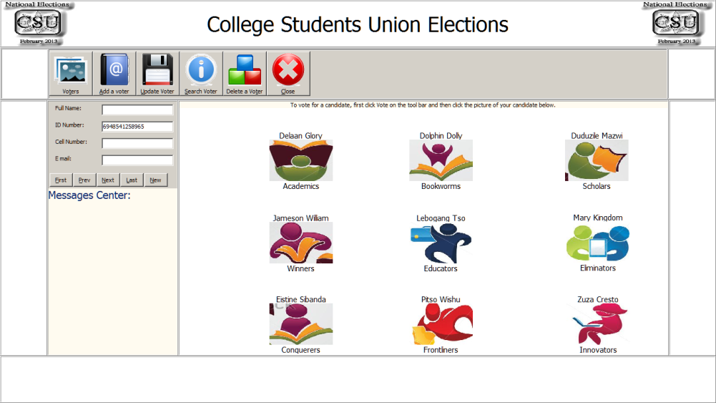  Figure 8: Main form of the CSU  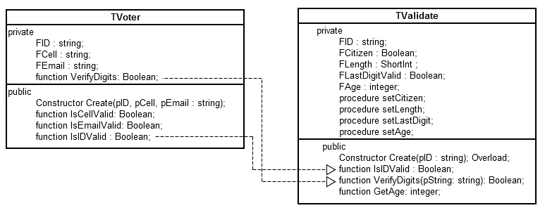  Figure 9: Shows two classes and their relationships  Figure 2 shows that the two methods of TVoter class call two methods of TValidate class in their implementation.  Complete all tasks in Question 2 by coding them according to given specifications.
 | 2.1.1 |  | Go to the unitVoter and implement the constructor Create.  Create sets the fields values of FID, FCell and FEmail | L | 2
 | 2. 1.2 |  | Implement the IsCellValid by  - Check the field FCell is not empty and if it is, give an appropriate message and change bValid to false  - Assign false to bValid if length of FCell is not 10  - Also assign bValid false if FCell does not start with these codes  082  077  084  079  072  - Call TVoter verifyDigits function and it returns false then set false to bValid and  Return bValid | M | 9
 | 2. 1.3 |  | Implement VerifyDigit method of TVoter by using the method VerifyDigits of TValidateID.  NOTE!: You need to create an object within exception handling and destroy it after using it | L | 3
 | 2. 1.4 |  | Code the method IsEmailValid by checking for the existence of ‘@’ character and checking that the length is at least 5 characters long.  If any of the above is not there then set bValid to false and return it. | M | 3
 | 2. 1.5 |  | Create code to validate the ID by using the IsIDValid method of the class TValidate.  NOTE!: You need to create an object within exception handling and destroy it after using it | L | 3
 | 2.2 |  | Before a dynamic array is populated with value, it length must be set.  In order to set the length of dynamic array that will keep changing length of records a method to give us the length of the text file is needed.  Create a method called TextFileLength which takes a text file as a string and return its length as an integer. | M | 3
 | 2.3 |  | Voters’ details in a text file called ‘voters.txt’ need to be processed.  - Create a 2 dynamic array of TVoter with 4 column for ID Number, Full Name, Cell Number and Email. Name it arrVoters.  - Create a method ReadFileVoters with 3 parameters namely: string for a file name, an array of TVoters, integer for the length of the array.  Read through the text file ‘voters.txt’ populating the dynamic array. | H | 10
 | 2.4 |  | Before registering an voter, his/her ID must be checked that it is not registered already.  Write a method called SearchID that will take in a string for ID Number and return four values  - An array to be searched  - Integer for the length of the array  - A Boolean value to indicate the ID was found during the search.  - An integer value to tell the position of the ID number showing where it was found in the array. | M | 7
 | 2.5 |  | Write a method called  AppendToFile to add voter details entered on the edtFullName, edtIDNumber..etc to a text file ‘voters.txt’ if tlbarRegisterVoterClick is clicked.  A string like one shown below should be built  2948541258965%thandi%0724740812%thandi@dotcom  Before appending a record check that the controls are not empty | M | 5
 | 2.6 |  | Create code to remove a voter from the text file and call it from Delete Voter button.  HINT: Search through the array, mark the record to be removed with ‘x’  Save the array to a ‘voters.txt’ except for the record marked with ‘x’.  Or  Use any of your own algorithms that will work. | H | 5
 | 2.6 |  | Create code to update contents of a saved voter and save changes to the text files ‘voters.txt’ | H | 4
 | 2.7 |  | Create code for each of the buttons for navigation so that users of the College Students Union can move through registered records.  Add any more variables if you see necessary to make this possible | M | 5
 |  | L 9, M=32, H= 19 |  |  | [60]
 |  | LEVEL OF DIFFICULT BREAK DOWN
Low, Medium, High
15% 53% 32%
(%) Percentage

QUESTION 3: PROBLEM SOLVING

The CSU election committee requires that student leaders should not only be elected, but also be rated on a 5 point rating scale from 1 to 5 during the actual election.

The lower number say 1, represents a voter’s feeling that the leader is least effective and the higher number, e.g. 5, shows that the voter feels the leader is most effective. The College Students Union Elections System is a working prototype for consultation purposes.

As a graduating Gauteng Matriculant IT student, you are to demonstrate your problem solving skills through usage of Delphi components, data structures, custom types and I/O routines.

3.1 | 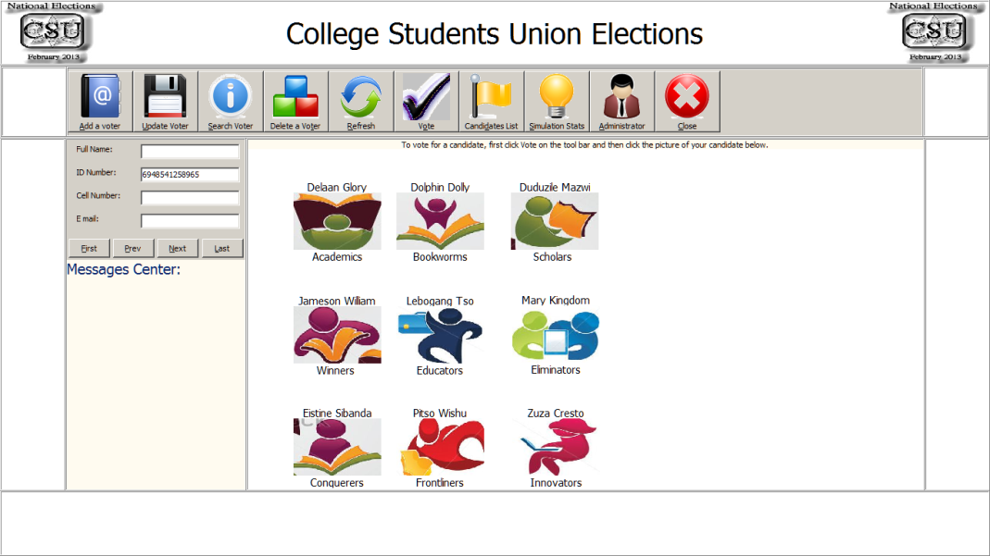  Figure 10: Front GUI of CSU  The Picture above shows the GUI part of the leaders rating system: College Students Union Elections. The system allows voters to register their full name, ID Number, Cell Number and Email. These details are used to authenticate and authorise a voter to rate a candidate. There are 9 candidates displayed with their academic group name and symbols  e.g.   Figure 11: Example of a Candidate displayed  Do the tasks given below to add functionality to this application.
 | 3.1.1 | Go to the keydown event method of the edtFullName. Select the edit control, then select the object inspector, click events and double click OnKeydown.    Write code to check each digit of the name and surname entered. If the character entered is not a letter of alphabet or space, a message shown below should be displayed.  When a user clicks Ok button, the wrong character should be removed and only correct characters should remain so that a user does not retype them.  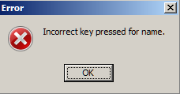  Figure 12: Message displayed when the edit box for full name receive incorrect characters like?>; Only letters alphabet and spaces are allowed. | M | (4)
 | 3.1.2 | There is a need to check before voters vote that they are registered.  There is a 2 Dimensional array already populated with 5 voters from the text file ‘voters.txt’ for you to us.  Create a method IsVoterRegistered to search for an ID number. It should take one parameter an ID Number and return a boolean value.indicating that the ID number being searched for is in the 2 Dimensional array.  In the 2 Dimensional array arrVoters the first column stores the ID number. | M | (4)
 | 3.2  3.2.1  3.2.2  3.2.3  3.2.4  3.2.5  3.2.6  3.2.7  3.2.8 | The whole of 3.2 is coded in the procedure ReceiveVote  Go to the procedure TfrmCSU.ReceiveVote(var img : TImage; imgFile, sCandidate, sMovement: string);    Figure 13: Shows the GUI before a vote is made  Below the statement randomize,  Create code to get ID Number, Cell Number and Email from the user as shown in figures 5, 6 and 7. If a user clicks cancel the voting procedure must be aborted.  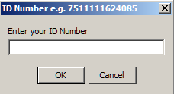  Figure 14: A box for receiving ID Number  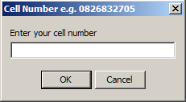  Figure 15: A box for receiving Cell Number  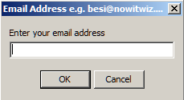  Figure 16: A box for receiving email address  The next task is for you to  Create code to validate the ID, Cell Number and Email using the methods found in the class TVoter shown below:  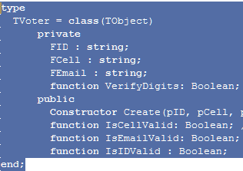  Figure 17: Class TVoter  The methods are IsCellValid, IsEmailValid and IsIDValid. Also use the method IsVoterRegistered to verify that the voter is eligible for voting.  Create messages to tell the user where validation failed e.g. You are not registered, Your email is not valid etc.  Write code to generate a 5 digit random Voting pin number and emulate sms it to the user by using the lblMessage component to display it for the user. This is to guard against robots voting online. An example is shown below:  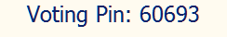  Figure 18: Display of a Voting Pin  Use a box to allow the voter to type the Voting Pin. Write code to verify that the voter entered pin is the same as one send. Display appropriate messages if a voter succeeds here or fails.  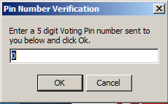  Figure 19:A box for receiving Voting Pin number  Write code for the user to get a rating as shown below for the candidate clicked. Write code to verify that the rating is between 1 and 5. See figure 11.  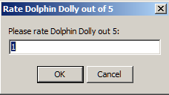  Figure 20: A box for receiving for receiving ratings Numbers from 1 to 5  Create a single instance of TVote, pass 5 parameters to the constructor:  sCandidate,sMovement, sID, iRating, sDate  Remember iRating is a number, convert it to text.  Call the method EncryptIDAndSaveVote  Free the TVote instance created within this procedure.  Display the message shown below to the user.  :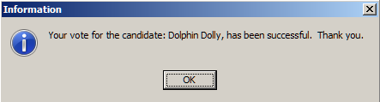  Figure 21: Message to the user the voting and rating of a candidate was a success.    Figure 22: The GUI showing that Dolphin Dolly has been voted and rated. | L  H  L  M  M  L  L  L | (3)  (3)  (3)  (3)  (3)  (1)  (1)  (1)

 | 3.3 |  | The code for question 3.3 and 3.4 is to be done in the tlbSimulationClick procedure. Double click the Simulation Stats toolbar button.  Create code to simulate 2000 votes randomnly generated for 9 candidates. Each voter elects only 1 candidate and for the selected candidate, the voter rates the candidate out of 5 using stars as shown in the picture below.  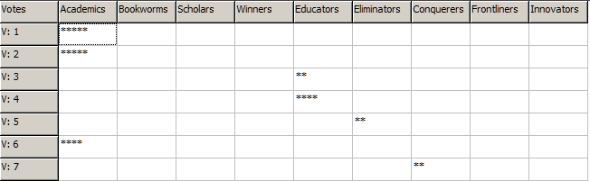  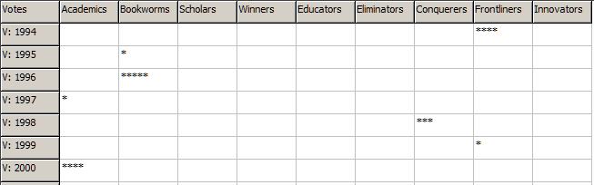Figure 23: Simulated ratings of 9 candidates by 2000 voters | M | (3)
 | 3.4 |  | Add code to the procedure in 3.3 to add up all votes for each candidate. Total votes for 4 and 5, 3 and Total votes for 1 and 2. Use the string grid to display the totals as shown below.  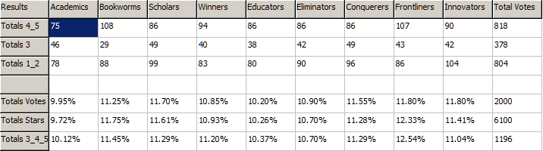  Figure 24: Analysis of votes  Add code to the procedure in 3.3 to Total Votes for each candidate, Total stars for each candidate and totals for ratings 3_4_5 for each candidate.  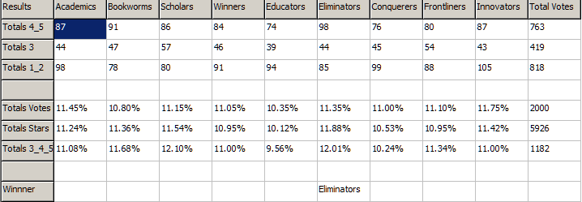  Figure 25: Analysis of 2000 voters' ratings of 9 Candidates.  Add code to find totals of votes as a percentage of all votes, totals of Stars as a percentage of all stars and totals of ratings 3_4_5 as a percentage of all 3_4_5 ratings.  Find and display the winner as follows:  The student leader with the highest total stars, highest totals of 3_4_5 will have the name of the movement displayed in the row Winner as shown in Figure 15. | H | (6)
 |  | L 9, M=18, H= 9 |  |  | [35]

