Teaching Programming with a Problem-solving Emphasis
- Grade 11
- high-level language
- having done an introduction to programming using Scratch in Grade 10
- having done some basic programming (preferably also with a problem-solving emphasis) ion the high-level language
This is just an example! In the same way ANY problem can serve as a basis for teaching programming:
- It’s real – that’s why I call all my programs “apps”. This rubs off on the learners.
- It’s on-the-job training.
- It’s problem-solving all the way!
- It should be a lot more exciting than just teaching about all features that the Java language consist of.
Also note that NOT everything has to be taught every time, just what’s new or needs to be revised.
- Once learners are familiar with the planning stages (Lessons 1 & 2) they can be done in one lesson, or given for homework.
- Once the learners have a plan (done in class) the coding can be given as homework (provided they know all the necessary coding structures), else that has to be introduced in class.
- The teacher will carefully choose the problems to lead the learners to new learning. Teacher will focus on that NEW structure(s), etc. The rest can be done by the learners at home or in class.
Testing/examining should follow a similar pattern (without the planning and GUI design phases).
Example Problem/Task:
“A local supermarket employs casual workers on Friday afternoons and on weekends. The owner has asked you to write a program for calculating and storing the wages these casual workers will receive.”
Lesson 1: Planning, IPO and TOE analysis, development of algorithm for calculation
Revision of Grade 10 work (IPO) and Grade 11 extension (TOE with GUI components)
Brainstorming with the learners:
“What are the inputs that must be available?”
- Hours worked
- Hourly wages
- Overtime
- Sunday work
- Name of worker
“What are the required outputs?”
- Wages
- Print-out and/or file for storage
I (= inputs) | P (= processing required) | O (= outputs)
- Hours worked  - Hourly wages  - Overtime  - Sunday work  - Name of worker | - Calculating wage  - Formatting for printing/storage  - Printing  - Storage | - Wages  - Print-out and/or file for storage

T (=task) | O (= object, component) | E (= event)
Input for  - Hours worked  - Hourly wages  - Overtime  - Sunday work  - Name of worker | Text field  Text field or spinner or constants  Calculation  Checkbox  Text field
Processing  - Calculating wage  - Storage | Method  Method | Calculate button  Next button
Outputting  - Wages  - Printout | Text field  Text area | Calculate button  Next button

Develop algorithm for calculation of wages:
“Can’t be”

Hours > 24?
Yes

No

Hours > 8?

Yes

No

Overtime = hours – 8
Normal hours = 8
Overtime = 0
Normal hours = hours

Wages = normal hours * pay
+ overtime * overtime pay

Sunday?

No

Yes

Wages = wages * 2

Lesson 2: GUI design and renaming of components
NB: GUI design can be done directly in NetBeans. Good practice for the order and placement of components needs to be discussed (from top-left to bottom-right, etc.)
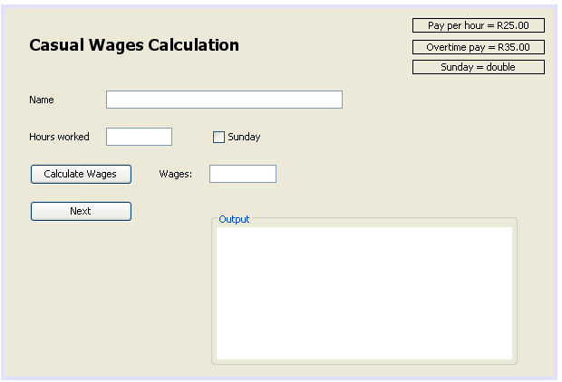
Rename components that you want to use:
- lblNormalPay
- lblOvertime
- lblSunday
- txfName
- txfHours
- txfWages
- chbSunday
- btnCalculate
- btnNext
- txaOutput
Reasons for renaming have to be discussed!
Set constants:
Decide whether your learners need this at this stage, else later with another problem.
- private final double PAY_PER_HOUR = 25.00;
- private final double OVERTIME_PAY = 35.00;
- private final double SUNDAY_FACTOR = 2.0;
Discuss reasons and appropriate use of constants!

Lesson 3: Program the basic functional program to execute as specified.
Program the method to calculate the wages using the algorithm developed before
private double getWages(double hours) {
double overtime = 0.0;
double normalHours = 0.0;
if (hours > 8) {
overtime = hours - 8;
normalHours = 8;
} else {
overtime = 0;
normalHours = hours;
}
double wages = normalHours * PAY_PER_HOUR + overtime * OVERTIME_PAY;
if (chbSunday.isSelected()) {
wages *= SUNDAY_FACTOR;
}
return wages;
}
Add action event to the Calculate button:
Call the getWages method. Format the output and send to the wages text field. (Teach String.format if not done previously!)
if (hours > 24) {
JOptionPane.showMessageDialog(null, "Can't be! Hours must be smaller than 24.");
} else {
double hours = Double.parseDouble(txfHours.getText());
double wages = getWages(hours);
String output = String.format("R %5.2f", wages);
txfWages.setText(output);
Add action event to Next button:
Get worker’s name from name text field and calculated wages from wages text field.
Output these to the output text area in columns.
String name = txfName.getText();
String pay = txfWages.getText(); // already formatted
txaOutput.append(String.format("%-35s%14s%n", name, pay));
Make sure the text area’s font is set to a non-proportional font (like Courier New), otherwise the spaces you add while formatting will have different lengths and the columns will NOT be straight!
Discuss how to set fonts, both via the Properties box and via code:
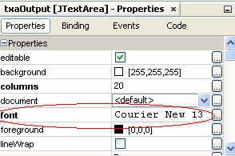 | Font cour = new Font ("Courier New", 0, 13);  txaOutput.setFont(cour);

Lesson 4: Add Usability/HCI features to make the program more robust
Add code to ensure that the relevant fields are filled before proceeding.
private void btnNextActionPerformed(java.awt.event.ActionEvent evt) {
String name = txfName.getText();
if (name.equals("")) {
JOptionPane.showMessageDialog(rootPane, "Name is missing, please fill in");
txfName.requestFocus();
} else {
private void btnCalculateActionPerformed(java.awt.event.ActionEvent evt) {
double hours = 0;
if (txfHours.getText().equals("")) {
JOptionPane.showMessageDialog(rootPane, "Hours field MUST be filled first");
txfHours.requestFocus();
} else {
By disabling/enabling the buttons make sure that only ONE button at a time is available and that ALL fields are filled with correct input.
In this way you guide the user to the correct/error-free use of the app.
Also include code to clear all fields when calling “Next” and to set the cursor back to the top.
private void btnCalculateActionPerformed(java.awt.event.ActionEvent evt) {
double pay = getWages(txfHours.getText());
String output = String.format("R %7.2f", pay);
txfWages.setText(output);
// toggling buttons:
btnNext.setEnabled(true);
btnCalculate.setEnabled(false);
}

private void btnNextActionPerformed(java.awt.event.ActionEvent evt) {
String name = txfName.getText();
String pay = txfWages.getText(); // already formatted
txaOutput.append(String.format("%-35s%14s%n", name, pay));
// toggling buttons:
btnNext.setEnabled(false);
btnCalculate.setEnabled(true);
// clearing all fields:
txfName.setText("");
txfHours.setText("");
txfWages.setText("");
chbSunday.setSelected(false); // NB: checkbox uses different methods!
// setting cursor back to the top:
txfName.requestFocus();
}
Set Next button’s properties to be disabled at the start – untick “enabled” box [OR add code to the constructor (WagesAppUI()after the initComponents() call): btnNext.setEnabled(false);]

Lesson 5: Add code to print and/or save the output (as it appears in the output text area)
Write methods to print and save:
NB: The TextArea class has a built-in print method which connects directly with the Windows print interface! Try it.
private void printOutput () {
try {
txaOutput.print();
}
catch (Exception e) {
e.printStackTrace();
} }
For saving use either PrintWriter or FileWriter classes (both in java.io). BufferedWriter is more complicated! Remember: Files MUST be closed at the end.
private void saveOutput() {
String outp = txaOutput.getText();
try {
// PrintWriter pw = new PrintWriter ("Wages.txt");
// pw.print(outp);
// pw.close();
FileWriter fw = new FileWriter ("Wages.txt");
fw.write(outp);
fw.close(); // VITAL, file must be closed!
}
catch (Exception e) {
e.printStackTrace();
} }
Add PRINT and SAVE buttons to your UI (there is lots of space beneath the NEXT button).
Add action events to the two buttons, calling the relevant methods.
Add usability/HCI by disabling the buttons before anything is written to the text area (done with the NEXT button).
- Disable each button in its properties box – untick “enabled”.
- Enable each button in the NEXT button after adding data to the output text area.
btnSave.setEnabled(true);
btnPrint.setEnabled(true);
- Disable the buttons once they have been used.
OPTIONAL EXTRA: Add a dialog box (JOptionPane.showInputDialog()) to ask for the file name before saving.

Add a CLEAR button to start a new set of calculations TOGETHER with the usual (i.e. what learners are used to from their MS programs Word and/or Excel) checking that you cannot clear without at least a warning about saving first.
PLEASE NOTE: There is a lot of problem solving in getting the sequence of events right, to only warn about saving first if there is unsaved text (no warning if all is in fact saved). This may not be the “number-crunching-type” of problem solving of the past, but nevertheless very intricate, logical work!
private void btnClearActionPerformed(java.awt.event.ActionEvent evt) {
if (btnSave.isEnabled()) { // i.e. when something new has been added to the Output
int answ = JOptionPane.showConfirmDialog(null, "Do you want to save first?");
switch (answ) {
case JOptionPane.YES_OPTION:
saveOutput(); // NO BREAK – note fall-through!
case JOptionPane.NO_OPTION:
clearOutputArea();
break;
case JOptionPane.CANCEL_OPTION:
txfName.requestFocus();
}
} else {
clearOutputArea();
}
}
private void clearOutputArea() {
txaOutput.setText("");
txfName.requestFocus();
count = 0;
btnClear.setEnabled(false);
btnNext.setEnabled(false);
btnPrint.setEnabled(false);
btnSave.setEnabled(false);
}
Adding up of wages on the same “sheet” (i.e. processed in the same batch:
Introduce a global variable “total” so that it is accessible to all methods.
Add the total (with label) to the bottom of all printouts and saved files.
In the same vein more sophisticated features can be added, either at this stage (if the learners are ready for it) or later (coming back to the program).
This document should be used in conjunction with the Java project “CasualWagesApp” done in NetBeans 7.2.1.
NB: In Grade 11 everything is done in ONE class, the form/frame class.
In Grade 12 the auxiliary methods would be moved to/coded in a provider class.
Good Luck!
Max Brock, WCED, July 2013

