
August 2013

Computer Applications Technology Grade 10
Example of theory question paper with revision and examination strategies
Compiled by:
C Labuscagne

Contents

Foreword 4
How to use this guide: 4
Revision and examination strategies 5
Before the examination 5
Revision 5
Organisation 7
During the examination 7
During reading time 7
After reading time 7
When answering the questions 7
Before the end of the examination 8
After the exam 8
Clue words in examination questions 8
Composition of the CAT theory examination paper 13
Sections and mark allocation 13
Section A – Short questions 13
Section B – Questions per topic 13
Section C – Integrated scenario 14
Cognitive levels 14
Lower order thinking – Knowledge 14
Middle order thinking – Understanding and application of knowledge 14
Higher order thinking – Analysing, evaluating, synthesising 14
Maximise your marks 15
Multiple choice questions 15
Modified true and false 15
Modified matching 16
Paragraph/short answer questions 16
Integrated scenario 17
Problem solving questions 17
What not to do or write... 17
Examination paper – an example 19
Instructions 19
Section A – Short questions 20
Question 1 – Multiple choice 20
Question 2 – Modified true and false 22
Question 3 – Modified matching 22
Section B 24
Question 4 – Systems Technologies 24
Question 5 – Internet and Network Technologies 25
Question 6 – Information Management 26
Question 7 – Social Implications 27
Question 8 – Solution Development 27
Section C – Integrated Scenario 31
Question 9 31
Memorandum 35
Section A – Short questions 35
Question 1 35
Question 2 35
Question 3 35
Section B 36
Question 4 36
Question 5 36
Question 6 37
Question 7 38
Question 8 38
Section C – Integrated Scenario 40
Question 9 40
Paper analysis 42
Content coverage 42
Cognitive levels 42
References 43
Acknowledgment 43

Foreword
These guidelines are aimed at Grade 10 Computer Applications Technology teachers and learners to be used as a teaching, learning and revision tool to prepare learners for the theory examination. It highlights examination strategies, explain how to answer questions and provide exemplar questions and answers.

How to use this guide:
- Work through the examination strategies and tips provided. (See pages 5 – 18)
- Work through the question paper and memorandum. (Refer to pages 19 – 41)
- Refer back to the examination strategies section if necessary to
  - discuss how different types of questions should be approached and answered.
  - discuss the clue words in each question in terms of their meaning and what is required when answering the question.

Revision and examination strategies
When writing an examination you are required to demonstrate your ability and understanding of what you have learnt. You will be successful if you use the correct techniques and strategies as outlined below.

Before the examination

Revision
- Plan and manage your time effectively. Prepare a pre-examination study timetable. Divide your time between your examination subjects.
- Listen and make a note of the verbal clues that your teacher may give during the teaching and learning time.
- Use concept maps/diagrams to make summaries.
- Study actively – verbalise and visualise your revision.
- Aim for understanding, not just memorising the material by asking questions such as:
(Note: not all questions may always be applicable)

  - Example: The concept of a folder in CAT


  - Try to visualise the concept or find an analogy, for example, think about a folder as a filing cabinet.

- Work individually and in study groups (2- 3 learners). Decide on a time and place to meet the study group. Each member must prepare summaries and questions and should get a chance to ask questions. The other members must help to answer the questions and help those members that need help.
- Revise activities from your textbook and work through problems with understanding an insight. Revision without the ability to apply your knowledge is not useful.
- Work through previous examination papers (under examination conditions) and discuss your answers with your study group or teacher (where possible). Do not use previous examination papers to ‘spot’ questions that you think may be asked in the examination!
- Take effective breaks (planned and limited). Plan for regular physical exercise between studying.

Organisation
- Stick to your normal everyday routine as far as possible. Go to bed at your usual time (get enough sleep) - synchronise your body clock with examination times.
- Have your examination resources on hand, for example, pens, calculators, ID, etc.
- Check the day/time/place of your examination.
- Check your travelling time and transport, so that you are not late for your examination.

During the examination

During reading time
- Read through the instructions.
- Read through the entire paper.
- Allocate time proportionally to the value of each question. (Roughly, 1 minute per mark)
- Tick or mark questions that you immediately know you can do.

After reading time
- Re-read the instructions carefully.
- Re-read the questions carefully and underline key words and phrases.
  - Underline or highlight examination clue words (see the table with exam key words on pages 9 – 12).
  - Underline or highlight key subject terminology.
- Decide on the order in which you will answer the questions. Start with the topic/questions that you know best to give yourself a good start.

When answering the questions
- Number your answers clearly and accurately according to the numbering system in the question paper.
- Work thoroughly but quickly.
- Firstly, answer the questions that you know the answer to.
- Secondly, answer the questions that you find difficult, particularly if they are worth more marks.
- Take note of the words/figures that are emphasised/underlined/italicised, etc.
- Relate the context of the questions to the CAT content/what you have learned in CAT.
- Where a context such as a scenario/case is provided, especially in Section C – Integrated Scenario, make sure you understand the context/scenario/case:
  - relate the questions to the scenario or case.
  - provide answers in such a manner, that they relate to the scenario or case.
Note: See the section (pages 15 – 18) on answering specific types of questions (multiple choice, paragraph, etc.) for more tips.

Before the end of the examination
- Never leave the examination before the time.
- Use any spare time that you have to:
  - Re-attempt the questions you found too difficult at first.
  - Check your answers thoroughly
    - Re-read the question and the answer and make sure that you have answered the question!
- Make sure the examiner will be able to read all your answers and diagrams – they must be clear (labels/annotations provided where applicable) and legible.
- Make sure your name and/or ID number/examination number appear on all the papers you hand in for marking.
- If you find that you are running out of time, never leave a question out completely. At least, give the examiner an outline of how you planned to answer that question/the remainder of the question.

After the exam
- Review your examination paper, if necessary, and discuss it with your teacher/study group.
- Consider how you could improve your examination performance next time. Make it a learning experience!

Clue words in examination questions
Questions normally contain a clue word.
Clue words are the words that an examiner uses to guide you in exactly what to include in your answer.
You should be able to answer questions as clearly as possible when you understand the precise meanings of the clue words in questions.
A table with common clue words and their meaning, which you may find in a CAT theory examination paper, appears below.

Clue Word | Meaning | Example | Notes
Analyse | Find the main ideas, how they are related and why they are important.  Look for patterns or organisational principles.  Identify problems or causes. | Analyse the correct use of word processing features in the following screenshot: | Break into parts/sections. Study each part – look at the detail. Find patterns/clues/problems/look for solutions. Examine and interpret the interrelationships and hierarchy of each as they relate to the whole.  Infer from data
Categorise | Group concepts/ideas that are similar/have the same characteristics/ functions or belong together.  How should things be organised? | Categorise the following computer devices: keyboard, CPU, printer, mouse, hard drive, SSD according to their main function. | Which categories can describe the function/features?  Understand relationships.  Similar to classify
Classify | Sort concepts/ideas according to categories or specific features showing to which category or group they belong | Classify the following list of computer devices as input, output or storage devices | Similar to categorise
Comment on | Discuss, criticise, or explain the meaning as completely as possible.  Judge the value or appropriateness of something by applying proper criteria in a logical manner. | Comment on the use of a wireless network in the following case: | Fill in the gaps in terms of:  What? Where? When? Who? How? Why?  Highlight advantages and disadvantages/motivating or explaining why it is a good idea/not a good idea/what is wrong/which parts are good/how to improve, etc.
Compare | Show both the differences and the similarities of specific concepts. | Compare ROM with RAM | Find a relationship between two concepts.  Which features/functions/uses are alike/differ?
Contrast/  Distinguish | Compare by showing the differences or unique and distinguishing characteristics between concepts | Contrast ROM and RAM or  Distinguish between a PAN and a HAN | Identify the features of each, look for the ones that make them different  How does one thing differ from another?  Which features/functions/uses are different?
Criticise | Give your judgment or reasoned opinion of something, showing its good and bad points. | Criticise the use of the keyboard when playing games. | What are the advantages and disadvantages?  Why is it better to do it in a specific way rather than another way?
Define | Give a clear, concise formal meaning of a term or concept.  The definitions should distinguish the concept from related terms/concepts.  This is often a matter of giving a memorised definition. | Define phishing. | Give characteristics/features/functions  What is it?/What does it do/used for?/How does it look?  Use short, concise description of main features, focus on facts – sentence or two.  The reader must know exactly what you talk about and should not confuse it with something similar.
Describe | Write a detailed account or verbal picture in a logical sequence or story form.  Give the main features by expanding the statement. | Describe phishing. | Tell a story about the issue in question.  The reader should get a clear understanding of what it is/how it works or happens/why it happens/who or what is involved/where it is or takes place/when it happens.  Show your understanding of the concept.
Diagram | Make a graph, chart or drawing. Be sure to label it and add a brief explanation if necessary. | Diagram a generic ICT system. | Visual representation of the main ideas/concepts/parts of something
Differentiate | Compare two concepts and give the differences or unique and distinguishing characteristics between them | Differentiate between ROM and RAM. | Similar to contrast/distinguish
Discuss | Write about a concept giving all the information.  Present arguments for and against a point of view and reach a conclusion. The arguments must be supported with appropriate evidence or examples. | Discuss the use of a PAN in a home office. | Analyse the situation, look at the advantages and disadvantages, decide what will work/not work, explain why it will be a good idea or not a good idea.  Judge the value.
Elaborate | Give more detail or explain or justify an answer or statement | Elaborate on the advice given to Mr X regarding buying a laser printer.
Evaluate | Give an opinion, supported by some expert opinions, of the truth or importance of a concept. Show the advantages and disadvantages. | Evaluate the merit of buying computer X for person Y | Why would computer X be better than computer A?  Judge the value of a situation/advice/concept.
Examine | Investigate, critically, appraise (evaluate, judge, weigh up) a subject in detail | Examine the two methods | Similar to analyse
Explain | Give full reasons or justifications for something, or how and why something happened or works. Focus on interpretation of cause and effect.  Clarify, interpret, and elaborate. Give reasons for differences of opinion or results, and try to analyse causes | Explain how phishing works. | If you have trouble working out how to start answering a question that asks you to "explain", imagine you are telling a friend about the topic  You need to explain things about the topic such as:  What is it, Where/When is it used/found, Why it is used/needed, How is it used/happen, What is the problem/consequences, Who is involved
Identify | Recognise and name or provide a fact.  Single out from other information. | Identify the port used to connect the printer. | Similar to name
Illustrate | Explain or make clear by concrete examples, comparisons or analogies or sometimes with visual element, such as a picture, drawing, figure, graph, or diagram. | Illustrate the information processing cycle. | Draw a diagram or give a real life example.
Interpret | Give the meaning using examples or personal comments/understanding to make something clear. | Interpret the tone of the e-mail message given below:  I hate you when you do this | Deduce the meaning of something.  Come to a conclusion about something.  Translate knowledge into context to show understanding.
Justify | Give a statement of why you think something is the way it is. Give reasons for your statement or conclusion. | Justify the use of a table instead of tab stops in the following instance: | What is the situation?  Why is the one better than the other?
List | Produce a list of words, sentences or comments.  Give a short, brief statement, term or words | List the types of information sources one could use when doing research. | Give main ideas, e.g. features, advantages, etc.  Mostly recalling facts that you have learned and should know.
Motivate | Provide a reason or justification for an answer or statement. | Motivate the use of line and paragraph spacing when working in Word. | Why do you say so/suggest something, Why did it happen, Why is this better than that?  Why should you do it this way?
Name/ Mention | Identify the concept and provide a fact | Name one storage device. | Similar to list or identify
Outline | Give a general summary. It should contain a series of main ideas supported by secondary facts. Show the organisation of the idea. | Outline the information processing cycle. | Similar to summarise.
Order | Provide a chronological or value-based answer by listing several items (terms or events) in correct sequence. | Order the storage media according to their capacity | List/arrange from small to large, few to many, slow to fast, write down the steps in order of execution, etc.
Prove | Show by using an argument or logic or fact that something is true. | Prove that the majority of people like X by looking at the following survey results: | Find evidence to support generalisation/statement/ conclusion, etc.
Relate | Show the connection between things, indicating how one causes or is like another. | Relate the following terms and explanations: | Match two concepts that belong together.
Review | Give a survey or summary in which you look at the important parts or major points and criticise if necessary.  Comment on what is given. | Review Mr X’s monthly computer maintenance tasks. | Briefly analysing each and commenting on them.  Check if all necessary tasks are listed, frequency of tasks, etc.  Make recommendations where necessary or suggest changes.
State | Describe the main points in specific terms. Use brief, clear sentences. Omit details or examples. | State the functions of the operating system.
Suggest | Analyse or examine a problem/case and give possible reasons/ideas/solutions | Suggest a computer configuration for Mr X. | What is the situation/what is given?  What is needed? What would be the best?  Why this?  Consider needs, pro’s and cons.
Summarise | Give a brief, condensed description of the main ideas. Similar to developing an abstract. | Summarise the problems experienced in the following case: | Similar to outline.
Trace | Follow the development, progress or history of something, normally from the point of origin, typically in chronological order. | Trace the error in the spreadsheet calculations. | Why is the answer wrong? Find the problem.

Composition of the CAT theory examination paper

Sections and weightings
The theory examination paper (or Paper 2) in CAT is made up of three sections shown in the table below:
Section | Type of questions | % of question paper
Section A | Short objective type questions | ± 17%
Section B | Questions per topic | ± 50%
Section C | Integrated scenario | ± 33%

Section A – Short questions
You would typically find the following types of questions in Section A:
- Multiple choice
- True and False or Modified True and False
- Matching columns or Modified Matching
(See pages 15 – 17 for more information on how to answer these types of questions)

Section B – Questions per topic
The questions in Section B address each of the following topics in CAT:
- Systems technologies
Questions on hardware, software, computer systems and computer management tasks such as maintaining your computer (housekeeping) or working with electronic files/folders.
- Network and Internet technologies
Questions on networks (e.g. PAN, HAN) and e-communication such as the Internet and e-mail.
- Information management
Questions about finding, processing, interpreting and presenting data and information.
- Social implications
Questions about the impact of computer and communication technologies on the environment, people’s health and lives as well as legal, ethical, security and safety aspects regarding the use of these technologies.
- Solution development
Theory questions about the application packages (word processing, spreadsheet and presentation programs) that you have studied. These questions typically test when and how these applications are used or how to solve troubleshooting problems within these applications.
Typical questions would be questions that require
- an answer where you also may be required to show your understanding by motivating your answer or providing an example.
- you to write short paragraphs to explain or describe a concept.
- you to compare or distinguish between concepts.
- you to analyse or evaluate a situation/case and to give advice, suggest a solution, comment on a situation, etc.
(See pages 15 – 17 for more information on how to answer these type of questions)

Section C – Integrated scenario
In Section C you have to apply your theory knowledge to a specific situation or scenario.
Questions in this section will include all topics listed in Section B (see page 13).
Typical questions in this section will be similar to the questions in Section B, but the difference is that you need to apply your answer to a given scenario, such as making recommendations to fit the circumstances in the scenario.
(See pages 15 – 17 for more information on how to answer these type of questions)

Cognitive levels
Cognitive levels refer to the mental processes (e.g. memorising, reasoning, problem solving, decision-making, etc.) that are involved when you answer a question. In other words, you are required to give a fact that you have learned and can simply recall but sometimes you have to demonstrate your understanding about a concept. Other times you have to apply the knowledge that you have learned or you have to analyse and reason and give a solution or new ideas.
The CAT theory question paper addresses different levels of thinking involved in the understanding of content:

Lower order thinking – Knowledge
These types of questions make up 30% of the paper and are questions that you should be able to answer easily if you have studied and know the theory content.
Lower order thinking questions typically test your knowledge, where you show that you can recall or recognise what you have studied. These questions usually require factual answers such as a definition or listing specifics such as advantages or disadvantages.

Middle order thinking – Understanding and application of knowledge
These types of questions make up 40% of the paper and are questions that are moderately easy to answer if you have studied and know the theory content.
Middle order thinking questions typically test if you understand the meaning of the content and can apply your knowledge to a new situation. These questions would typically expect of you to interpret something by, for example, explaining why something happened, infer from data or predict consequences.

Higher order thinking – Analysing, evaluating, synthesising
These types of questions make up 30% of the paper and are usually more difficult to answer as they depend on your knowledge and understanding of the content. These questions would, for example, require you to understand relationships, recognise patterns or combine content/facts that you have learned in order to suggest a solution to a problem.
Higher order questions typically test if you can identify problems such as inconsistencies; be able to distinguish between different methods/approaches/solutions and be able to identify and justify the best or most appropriate method/approach/solution or even come up with a better one.

Maximise your marks
Think about what the question is actually asking. What are you expected to include in your answer? What material will be relevant? The most common complaint from markers is that the learner didn't answer the question.
Demonstrate that you are answering the question - In your introduction show how you understand the question and outline how you will answer it. Make one point or argument per paragraph/sentence and summarise to show how it answers the question. Short paragraphs with one or two pieces of evidence are sufficient. In your conclusion summarise the arguments to answer the question.
When answering any question, refer to the bullet on page 5:
‘Aim for understanding, not just memorising the material by asking questions such as:’
and the example on page 6, to ensure that you think of everything regarding the concept.

Multiple choice questions
- Try to think of the answer before you look at the choices.
- Examine the sequence of questions. Does that give you any clues?
- Read all the alternatives before choosing the answer.
- Make certain you are choosing the 'best' answer to the question.
- Remember that wrong options are often based on common misconceptions.
- Cross out the options that you know for certain are the incorrect answers.
- Never leave out a multiple choice answer – make an educated guess for unknown answers unless you are penalised for wrong answers.

Modified true and false
- Read the statement carefully. Focus on the bold/underlined word(s).
- Re-read the statement and determine whether it is true or not. Cover the bold/underlined word(s) and think what you need to put there to make the statement true.

- Re-read the changed statement and ensure that it is now true.

Modified matching
- Read through the question. Determine the context of the question (what is it about?):
  - Definitions or acronyms to be matched with descriptions?
  - Computer maintenance or troubleshooting tasks to be matched with computer related problems?
  - Etc.
- Read through the list provided. The list can be a list of definitions/concepts/actions/solutions/ objects/troubleshooting options.
- Read through the question statements.
- Read the first question statement.
  - What is the problem/issue/concept described?
  - Re-read the list of definitions/concepts/actions/solutions/ objects/troubleshooting options provided. Which one(s) will solve the problem/relate to the question statement?
  - Write down, from the list provided, all the actions/solutions/options/concepts/objects that relate to the question statement/solve the problem in the question statement.

Paragraph/short answer questions
These type of questions usually require a brief and more descriptive answer.
- Read and analyse the question
  - Recall what you know.
  - Select the relevant facts.
  - Write down initial ideas.
  - Organise into logical order—follow basic essay procedure, i.e. introduction, points, conclusion.
  - Begin writing.
- Keep time allocations proportional to marks.
- Keep number of facts proportional to marks – typically one fact per mark.
- Provide definitions where necessary.
- Identify key concepts or main ideas.
- Write legibly, clearly and simply.
- Illustrate theory with concrete examples. (Where applicable)
Note from examiner:
The commonest fault in any written work is a failure to keep to the point and not to answer the question. When you write an examination answer you are engaged in an assessment of what is relevant. What does the question ask?
- Make sure you answer the question that is on the paper and not the one you hoped would be there!
Note from examiner:
If there is a `computer crime’ example which the textbook or the teacher always quotes, give a different example if you can. Quoting the same example just shows that you have remembered it. Quoting a different example (provided it is a true example of the issue it is used to illustrate) shows that you have understood that issue well enough to identify an example for yourself; it is much more impressive.

Integrated scenario
With the integrated scenario, you normally need to apply your knowledge within the situation/scenario.
Questions normally require brief, descriptive answers, explanations, motivations, suggestions or examples.
- Read the scenario/case carefully.
- Underline facts/main ideas about the scenario/situation/people/case that may influence your answer.
- Relate the answer to the situation/people in the scenario/case – what they do and may need to be able to do it better or differently or suggest a solution that will help them or improve the specific situation.

Problem solving questions
These are normally higher order questions that require you to examine, analyse or assess the situation or problem, determine what you have to work with, what inferences you are able to make or how things relate to each other or can be combined to solve the problem.
- Read and understand the problem – state in your own words.
- Determine what is given and what is needed. What needs to be done/solved?
- Devise a plan/strategy. Look for patterns, think of related problems/known solutions.
- Implement the plan/strategy/write down the solution.
- Think about the solution. Does it make sense? Is there a better solution?

What not to do or write...
- Don't try to shoehorn in something interesting as part of your answer just because you have revised it. If it isn't relevant to the question, don’t write it – it can lose marks.
- Don't repeat a memorised answer just because it seems to be on the right topic. The question may be in a different context.
- Don't use SMS speak or slang.
- Don't use vague words such as ‘it’ when asked to define something. For example, if asked what a computer virus is, don’t say ‘It is something that corrupts your computer’. This answer could describe many different things. Rather use the correct descriptive terminology and say that ‘A computer virus is malicious software that…’.
- Avoid giving general adjectives as ‘faster, cheaper and easier’ when asked to give advantages. These terms are often generalisations and are not always true as they depend on the specific situation. If you need to use these, clearly indicate ‘faster than what’ and motivate or substantiate the statement, e.g. ‘faster than… because ….’
- Don’t simply restate a direct implication of what you have stated as a new fact. For example, if you have stated (correctly) that ‘RAM functions quicker than storage’, then storage is obviously slower than RAM – and is not a ‘new’ fact.
- Avoid sweeping statements that may only be partially true. Often learners will say ‘a laptop cannot be upgraded’. This is not true as it can be upgraded, it might just be more expensive to do it or to source parts.
- Avoid generalisations such as ‘Open source software is of a poor quality’. While this might be true in some cases (or in your specific experience), it is certainly not true in all cases. Other common examples of these generalisations include statements such as ‘Desktop computers are always faster than laptops’ and ‘Wireless networks are always slower than cabled networks’.
- Be careful of giving the same answer for two different questions. It is very unlikely that the examiners would want the same answer for two different questions.
- Avoid waffling if you struggle to write ‘flowing’ paragraphs. Rather give your answers in bullet format but with full sentences.
- Never write only ‘yes’ or ‘no’ as an answer – that will not gain you any marks. You have to substantiate the ‘yes’ or ‘no’, for example, giving a motivation or explanation of why it is ‘yes’ or ‘no’.
- Do not try to squeeze your answer into the bottom of a page; rather carry on the next page.
- Don’t cram as much as you can on to one page, leaving spacing between your answers improves the readability of the paper.
- Don’t expect the marker to fill in gaps. Assume the marker is not a computer person and that he/she may not understand what you imply. Your answer must therefore be clear and contain all the facts/detail/descriptions/explanations/motivations/examples so that anybody (even if they have no computer knowledge) will be able to understand clearly what you describe.
- Don’t leave out any questions. At least try to answer the question even if it means that you have to guess.
- Don’t provide a long list if a question only asks for, e.g. two advantages. The marker will not choose the best/correct ones, he/she will simply mark the first two. If you give more than two (or the requested number), make sure that the ones you are most certain of, are at the top.

Theory examination paper – an example

Grade 10 Theory paper: End-of-year

Time: 3 hours Total: 140

Instructions
- This question paper consists of THREE sections:
Section A: Short questions [25]
Section B: Questions per topic [75]
Section C: Integrated scenario [45]
- Answer ALL the questions
- Number the answers correctly according to the numbering system used in this paper.
- Start EACH question on a NEW page.
- Do NOT write in the right-hand margin.
- Read ALL the questions carefully
- In general, a mark is allocated per fact. A 2-mark question would therefore require two facts, etc.
- Write neatly and legibly

Section A – Short questions [25]

Question 1 – Multiple choice [10]
Various options are given as possible answers to the following questions. Choose the most appropriate answer and write only the letter (A–D) next to the question number (1.1–1.10), for example 1.11 D
1.1 Which ONE of the following options describes the type of devices used to keep an electronic record of work done on a computer?
A Input
B Output
C Processing
D Storage
1.2 Which ONE of the following describes software that one can download from the Internet and which one can use free of charge for a limited period.
A Freeware
B Shareware
C Open source
D Proprietary software
1.3 Changing the appearance of a document is called…
A editing.
B reviewing.
C formatting.
D developing.
1.4 Which ONE of the following errors refers to the #VALUE! error indicator in a spreadsheet?
A Misspelling of a function name
B Reference to a deleted cell
C Multiplying a text value with a numeric value
D Dividing a numeric value by zero (0)
1.5 Which ONE of the following is NOT a good technique used to refine an Internet/web search?
A Using one word only
B Specifying the domain
C Using quotation marks
D Using operators such as ‘and’ and ‘not’

1.6 Which ONE of the following actions is NOT an example of input?
A Tapping an icon on a touch screen
B Listening to music played on your computer
C Clicking the bold command in the word processor
D Transferring photos from your digital camera to your computer’s hard disk
1.7 Which ONE of the following will the operating system use to decide which program to use to open a file?
A File name
B File size
C File path
D File extension
1.8 Which ONE of the following is NOT an example of a communication medium?
A Radio waves
B Hyperlinks
C Light waves
D Copper wires
1.9 Which ONE of the following refers to system software that is used for routine computer maintenance?
A Accessories
B Gadgets
C Driver programs
D Utility programs
1.10 Which ONE of the following is NOT part of a formal, written report?
A Introduction
B Conclusion
C Sources
D References

Question 2 – Modified true and false [8]
The following statements (2.1 – 2.5) are either true or false.
- Firstly, state whether each statement is True or False.
- Secondly, correct each of the false statements by rewriting the statement to make it true. In other words, replace the bold-printed, underlined portions with the correct term.
For example, consider the following:
Our country is known as Namibia.
False. Our country is known as South Africa.
Note: No marks will be awarded for simply negating the false statement.
2.1 Without drivers, the hardware that you connect to your computer—for example, a video card or a printer—will not work properly.
2.2 The Recycle Bin icon on the desktop represents a temporary storage area in your computer's memory (RAM) where deleted files are temporarily stored.
2.3 Ergonomics is the term used to describe environmental awareness when using computers.
2.4 A touch screen serves both as input and output device.
2.5 Text in a .rtf file cannot contain any formatting.

Question 3 – Modified matching [7]
Various actions or tasks can be used to manage files or to troubleshoot or prevent computer related problems.
The table that follows provides a list of computer-related problems in Column A and a list of actions or tasks that can be done to solve or prevent the problems in Column B.
- From the list (A – K) in Column B (actions or tasks), (all) the action(s), select (all) the task(s) or action(s) that will solve the problem in Column A (3.1 – 3.7).
- Write only the letter(s) from the list (A–K) in Column B next to the question number (3.1–3.7) in Column A, for example:
3.8 P, Y, X
Which of the actions or tasks in Column B would be advisable (sensible) in order to solve or avoid the problems in Column A?

Note:
- More than one task or action can apply to some problems or situations.
- Some tasks or actions may be used with more than one problem or situation (question).
- Some tasks or actions may not be used at all.
- No mark will be awarded for writing down any non-applicable tasks or for not writing down more than one task should more than one task or action could be used to solve or prevent the problem.
Column A |  | Column B
Problem or situation |  | Task or action
3.1 | When trying to open a file, a message informs the user that the file is corrupt; consequently, the data or information is lost. | A Organise files by file type  B Naming files using logical file naming conventions  C Back up files regularly  D Compress files  E Organise files into folders and subfolders in a logical hierarchal (tree) structure  F Convert a file to PDF.  G Scan files for malware  H Update virus definitions regularly  I Save a file as another type  J Open a file with another program  K Perform a clean-up operation
3.2 | When sending a file as an attachment via an e-mail, the e-mail bounces back and displays the following message:  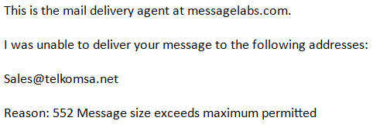
3.3 | The user struggles to find files on the computer.
3.4 | After copying files from another person’s flash disk, the user discovers that his computer is infected with a virus.
3.5 | Before sending a Word document (.docx) to another person, the user remembers that no Office suite is installed on that person’s computer.
3.6 | There is a lot of unused or broken shortcuts on the user’s desktop.
3.7 | The user wants to free space on his external hard disk.

Section B [70]

Question 4 – Systems Technologies [18]
4.1 Define the following terms:
4.1.1 Operating system (2)
4.1.2 Central Processing Unit (CPU) (2)
4.1.3 File path (2)
4.2 Distinguish between RAM and ROM in terms of their purpose or function. (4)
4.3 Study the following two adverts and answer the questions that follow:
Line |  | Computer A  All-in-one desktop |  | Computer B  Ultrabook
1 |  | Intel Core i7-4770K 3.5 GHz processor |  | Intel Core i5-3317U 1.7 GHz processor
2 |  | 16 GB of DDR3-1866 RAM |  | 4 GB RAM
3 |  | 27 inch 10 pr touch LCD widescreen |  | 13.3 inch touch screen
4 |  | 3 GB GeForce GTX 780 graphics card |  | Intel 1 GB HD Graphics 4000 card
5 |  | 1 TB hard drive |  | 500 GB hard drive
6 |  | Blu-Ray disc |  | Dual-Layer DVD+/-RW
7 |  | 4 USB 3.0 ports |  | 3 USB 2.0 ports
8 |  | 1.3 Megapixel webcam |  | Integrated webcam
9 |  | 802.11ac dual-band Wi-Fi |  | Wi-Fi, Bluetooth enabled
10 |  | Windows 8 |  | Windows 7
11 |  |  |  | 1.3 kg
12 |  |  |  | 6 hour battery life
13 |  | Wireless keyboard and mouse
14 |  | Gaming and everything else |  | General Purpose use

4.3.1 Name the processor speed of the computer with the highest speed. (1)
4.3.2 Name the size of Computer A’s primary or main memory. (1)
4.3.3 Name the storage capacity of the computer with the largest storage capacity. (1)
4.3.4 Besides the size, name another specification regarding computer screens that are also regarded as important. (1)
4.3.5 State what USB ports are used for. (1)
4.3.6 The weight for Computer B is indicated as 1.3 kg. State why there is no weight given for Computer A? (1)
4.3.7 In line 14, the use of the computer A is stated as “gaming and everything else”.
Explain why it could be used for everything else, if it is a gaming computer. (1)
4.3.8 Name the technology in the advertisements that is used to connect up to eight devices in a network over short distances. (1)

Question 5 – Internet and Network Technologies [12]
5.1 Define the following terms:
5.1.1 Search engine (2)
5.1.2 Content aggregator (2)
5.2 Differentiate between the Internet and the World Wide Web (WWW). (2)
5.3 Study the following e-mail:
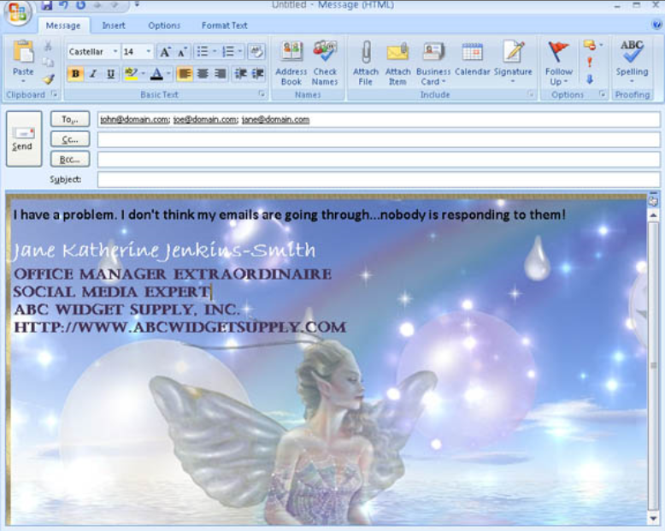
5.3.1 Contrast the use of the and the section in the e-mail. (2)
5.3.2 Consider the context of the e-mail message and list TWO e-mail etiquette (netiquette) rules that have been violated. (2)
5.4 List TWO disadvantages of a Personal Area Network (PAN) (2)

Question 6 – Information Management [13]
6.1 List TWO different types of information sources (2)
6.2 Illustrate the difference between data and information using an example. (2)
6.3 Study the following information presented in the graph that follows:
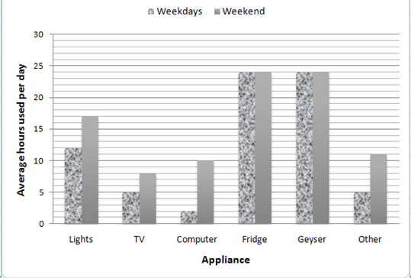
6.3.1. Describe what the graph measures. (1)
6.3.2 Name the appliance with the least total usage. (1)
6.3.3 After the refrigerator and the geyser, name the appliance that is used most on weekdays? (1)
6.3.4 State your opinion of why most appliances are used more during weekends than during the week. (1)
6.3.5 What advice will you give to households if they want to save electricity?
Motivate your answer (2)
6.4 List THREE different types of actions that you could perform on data to extract information, in other words, help to interpret it or make sense of it. (3)

Question 7 – Social Implications [10]
7.1 Define the following e-mail terms:
7.1.1 Hoax (2)
7.1.2 Spam (1)
7.2 Study the following phishing example:
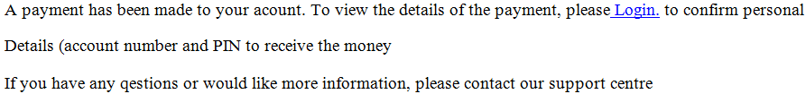
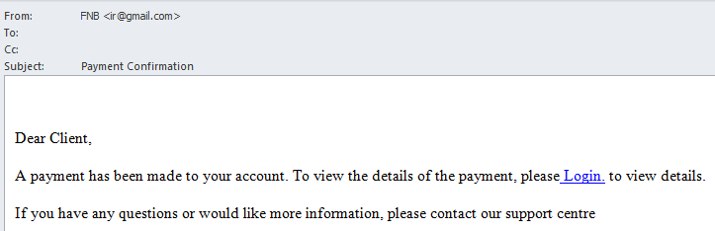
7.2.1 Describe TWO features in the e-mail that confirms the e-mail to be a phishing attempt. (2)
7.2.2 Explain the main difference between phishing and pharming. (2)
7.3 Study the following extract from a case and answer the questions that follow:
John was the head of a new division of End Corp., a small company with about 45 PCs. John was hired to reduce expenses for the company and so he would only authorise the purchase of one copy of each software program the company uses. . His rationale was, "we bought it, and we can do what we want to do with it."
Adapted from: http://www.siia.net/index.php?option=com_content&view=article&id=338&Itemid=351
7.3.1 Identify the term that describes the case. (1)
7.3.2 State ONE possible consequence for the developers of the software programs. (1)
7.3.3 State why the examiner provided the URL. (1)

Question 8 – Solution Development [17]
8.1 Describe the difference between the use of the hard enter (Enter-key) and the soft enter (Shift+Enter) when typing in a word processing application. (2)
8.2 A word processing course claims that using a word processing application correctly will have the following advantages:
- Save time and increase productivity
- Increase accuracy
List TWO features or functions of a word processor that will save time or increase productivity. (2)
8.3 Study the following extract from a word processing document:
Someone tried to manipulate the following sentences to be in the middle of the page:
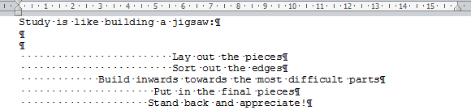
After changing the font type only, the sentences were no longer in the middle of the page:
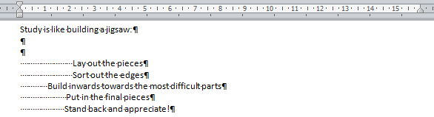
8.3.1 State why this happened. (1)
8.3.2 State what should have been done to prevent this from happening when the font is changed. (1)
8.4 Study the following extract from a word processing document:
All the words ‘the’ have been formatted as bold, red and a bigger font size than the rest of the words.
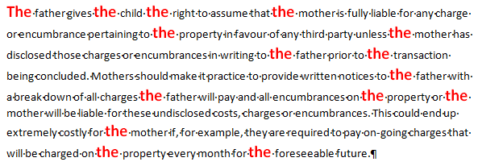
Describe the quickest way to select all these (‘the’) words. (2)

8.5 Consider the following data stored in a spreadsheet:
 | A | B | C | D | E
1 | Jenkins | Samantha | 0828835120 | R 50.00 | 10
2 | Baloyi | John |  | R 75.00 | 10
3 | Govender | Vishal | 082987852 |  | 10
4 | Pugh | Allan | 084654258 | R 60.00 | 10
5 | Mosuwe | Tebogo | 071123654 | R 55.00 | 10
6 |  |  | 4 |  | 51
7 |  |  | 0
8.5.1 Name the data type of the data in the following columns:
a) Column C (1)
b) Column D (1)
8.5.2 The following formulas were typed in cell C6 and cell C7, respectively:
- In cell C6: =COUNTA(C1:C5)
- In cell C7: =COUNT(C1:C5)
Explain why the formulas produce different answers. (2)
8.5.3 The following formula was typed in cell E6: =E1+E2+E3+E4+E5
Explain why the incorrect answer is given in cell E6. (2)
8.5.4 Write down the formula in cell D6, if the formula in cell E6 (=E1+E2+E3+E4+E5 ) is copied to cell D6. (1)
8.6 Study the following slide from a presentation program:
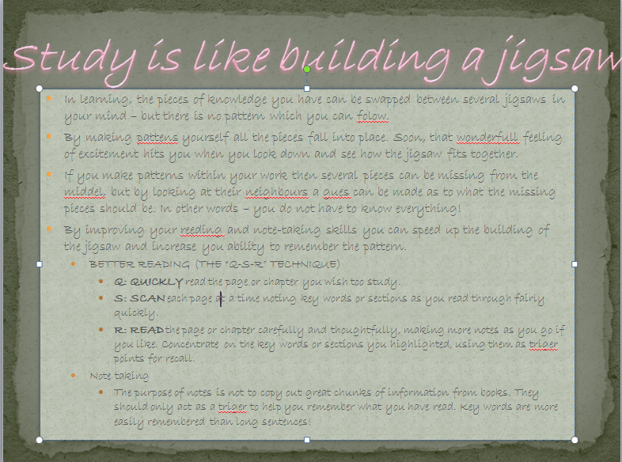
The person that created the slide did not follow good principles.
List TWO problems with the slide. (2)

Section C – Integrated Scenario [45]

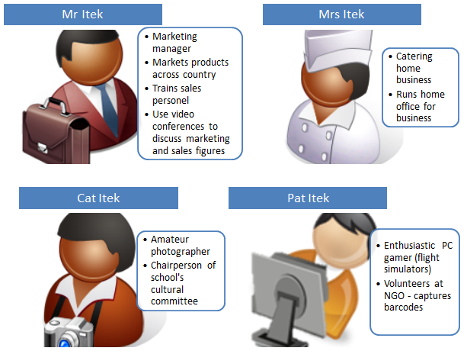
The Itek family has been using a desktop computer connected to a printer and a 3G device for Internet access at home for some time. However, now that Mrs Itek has started her own catering business that she runs from home together with the two children’s increasing need to use the computer and the printer as well as to access the Internet for assignments and hobbies, they realised that the current situation is not working.
For example, sometimes when Mr Itek is busy working on the computer, Mrs Itek needs to send a quotation to a client or one of the children needs to browse the Internet or print an assignment.
A family friend, Mr Knowitall, has recommended buying more computers, an ADSL Internet connection and setting up a Wi-Fi (wireless) home network.

Question 9 (45)
9.1 Describe the advantages for the family should they follow Mr Knowitall’s recommendations in terms of the following:
9.1.1 a) Using only one printer. (1)
b) Motivate your answer. (1)
9.1.2 a) Accessing the Internet when they are all at home and need to use it. (1)
b) Motivate your answer. (1)
9.1.3 a) The use of security software such as an anti-virus program. (1)
b) Motivate your answer. (1)
9.2 The Itek family will have to buy specialised network equipment to set up the wireless home network.
List the network device they will need. (1)

9.3 Buying proprietary software for use by all family members could be expensive, as they will have to buy a licence for each computer.
Describe a solution should they…
9.3.1 a) want to use proprietary software, but spend less money. (1)
b) Motivate your answer. (1)
9.3.2 a) not want to pay for the software at all. (1)
b) Motivate your answer. (1)
9.4 Mrs Itek’s business administration involves, among other things, the following:
- Compiling and sending quotations
- Compiling and sending invoices
9.4.1 List TWO applications (the type of application, not a brand name) that she will need and that would best fit the purpose to achieve the above. (2)
9.4.2 Name the type of document that she could create with these applications doing quotations and invoices for a client to save time and that she could use each time she compiles a quotation or invoice for a client. (1)
9.5 The Itek family’s Internet service provider is Polkadot. As part of their contract, the Itek family receives one free e-mail address. Should they need more e-mail addresses, they need to pay an additional fee per month for each additional e-mail address.
Mrs Itek’s business’ name is Haybo! Catering.
    - Suggest a suitable e-mail address for Mrs Itek’s business. (2)
9.5.2 Mrs Itek does not want the rest of the family to use her business e-mail address. However, Mr Itek does not want to pay extra for additional e-mail addresses.
State how they could each get their own e-mail address at no cost. (1)
9.6 Mr Itek is a marketing manager. His duties are, among others, as follows:
- Address audiences at different locations across the country to introduce and promote his products.
- Train sales personal
- Participate in video conferences to discuss marketing strategies and sales figures with branch managers across the country
9.6.1 a) List the type of computer you would recommend for Mr Itek. (1)
b) Motivate your answer. (1)
9.6.2 List the application that he could use as support when addressing audiences or training sales personnel. (1)
9.6.3 Other than a keyboard and mouse, list ONE essential input device that he will need to perform his duties. (1)
9.6.4 Other than a printer, list ONE essential output device that he will need to perform his duties. (1)
9.7 Mr Itek stores sensitive sales information on his computer. He uses a login ID and his numeric birth date (2305) as password to access his computer. However, he is scared that someone my crack or tap his password and gain access to his computer.
    - State TWO ways in which he could strengthen his password. (2)
    - List ONE example of an authentication device, which could be used as part of his computer system to gain access to his computer and that could give him an extra layer of security. (1)
9.8 Mr Itek wants to find out how his clients feel about and experience specific products.
Name an appropriate tool to gather such information. (1)
9.9 Mr Itek wants to share the product catalogue with all his clients across the country as it contains detailed descriptions and full colour pictures of all the products . He downloaded the .pdf product catalogue from the company website. The download note indicates the size of the file as 23 GB.
9.9.1 Describe the best way to share the catalogue with all his clients. (2)
9.9.2 State TWO possible reasons for uploading the file in .pdf format. (2)
9.10 Cat Itek is chairperson of the school’s cultural committee. The committee wants to document their school’s history, memorable past events, memorable teachers as well as particular achievements of ex learners. They decided to involve all ex learners in this project and suggested to use a Wiki for the purpose.
Comment on the use of a Wiki for this project. (3)
9.11 Cat Itek is also an amateur photographer and serves as the the official photographer for the school’s monthly newspaper. She used to use her cell phone but now wants to buy a digital camera.
9.11.1 State an important specification she needs to take into account when buying a digital camera. (1)
9.11.2 List the type of storage device her digital camera may need. (1)

9.12 Pat Itek is a computer gamer, enthusiastic about flight simulators.
As part of his class’ community project, he volunteered to help with administrative tasks at a welfare organisation. As he has his own computer, his task would be to capture barcodes into a database.
9.12.1 List ONE specific output device that would enhance his gaming experience by making it more realistic. (1)
9.12.2 List TWO specific input devices, in addition to a keyboard and mouse, which he is expected to have. (2)
9.13 Each member of the family does quite a lot of printing on a regular basis:
- Mr Itek: Large quantities of colour brochures.
- Mrs Itek Quotations, invoices, price lists, letterheads, business cards.
She also sends and receives many faxes.
- Cat Itek Assignments, photos.
- Pat Itek Assignments.
The family can afford only one printer.
9.13.1 a) Describe the type of printer you would suggest for the family? (3)
b) Motivate your answer. (1)
9.13.2 a) If they could afford a second printer, describe the type of printer that you would suggest? (2)
b) Motivate your answer. (1)

Total: 140

Memorandum

Section A – Short questions [25]

Question 1 (10)
1.1 | 1.2 | 1.3 | 1.4 | 1.5 | 1.6 | 1.7 | 1.8 | 1.9 | 1.10
D | B | C | C | A | B | D | B | D | C
(10)

Question 2 (8)
2.1 True
2.2 False Replace underlined part with hard disk
2.3 False Replace underlined part with Green computing
2.4 True
2.5 False Replace underlined part with .txt
(8)

Question 3 (7)
3.1 | C, G, H
3.2 | D, I
3.3 | A, B, E
3.4 | G, H
3.5 | F, I
3.6 | K
3.7 | D, K
(7)

Section B [70]

Question 4 (18)
4.1.1 An operating system is software that manages the computer's memory, processes, and all of its software and hardware (2)
4.1.2 The CPU is hardware within the computer that is responsible for the processing of instructions and calculations . (2)
4.1.3 A file path is a sequence of folders ending in the file name that points to a unique location in the file system (2)
4.2 RAM temporarily stores the data/instructions the computer is currently working on
ROM permanently stores the instructions that must boot the computer (4)
4.3.1 3.5 GHz (1)
4.3.2 16 GB (1)
4.3.3 1 TB (1)
4.3.4 Resolution (1)
4.3.5 Connect peripherals/devices (1)
4.3.6 Laptop is a portable device and weight matters or effects portability/desktop PCs are not being carried around, so weight does not matter (1)
4.3.7 A gaming computer is a very powerful computer with high specifications and can therefore be used for any other tasks that normally will require less (or equal) power or lower specifications (1)
4.3.8 Bluetooth (1)

Question 5 (12)
5.1.1 A search engine is a program that is designed to search for information on the World Wide Web (2)
5.1.2 Content aggregator refers to a web site or computer software that collects and combines specific type of information from multiple online sources for reuse or resale. (2)
5.2 The Internet is a global area network.
The WWW is a service offered on the Internet. / Collection of interactive documents, saved on the computers connected to the Internet and that one can access via the Internet (2)
5.3.1 Cc – contains additional recipients that will be visible to all recipients of the mail
Bcc – contains additional recipients that will not be visible to other recipients of the mail (2)
5.3.2 Any two of the following: (2)
- No subject line
- No salutation
- Background not appropriate for formal business e-mail
5.4 Any two of the following (2)
- Limited range
- Security, especially with wireless connection
- All devices need to be wireless enabled when a wireless connection is used
- Depending on the wireless connection (Bluetooth), the number of devices that can be connected is limited.

Question 6 (13)
6.1 Any two of the following (2)
- Internet
- Printed media
- Electronic media
- People (surveys, interviews)
6.2 Any suitable example that shows the difference between data and information (2)
6.3.1 The number of hours that appliances in a household are used per day (1)
6.3.2 Computer (1)
6.3.3 Lights (1)
6.3.4 People are at work/school during the biggest part of weekdays and use most of the appliances (except fridge and geyser) in the evenings only. (1)
6.3.5 Switch off the geyser during the day over weekdays as it is only needed in the evenings (2)
6.4 Any three of the following: (3)
- Calculations
- Sifting
- Sorting
- Counting
- Order
- Compare

Question 7 (10)
7.1.1 Misleading, not true e-mail message that is sent to you as the truth (2)
7.1.2 Unwanted e-mail (1)
7.2.1 Any two of the following: (2)
- Bank’s e-mail address in FROM: line is a Gmail address
- No recipients in the TO: field
- Providing a link to log in
- Asking for confidential information such as PIN
7.2.2 Phishing requires an action on the user’s side, i.e. clicking a link (sent via e-mail) that leads to false website
Pharming automatically re-directs user to false website, even when user entered the correct web address (URL) (2)
7.3.1 Copyright infringement (also accept software piracy) (1)
7.3.2 The developer loses revenue (1)
7.3.3 The URL is provided to acknowledge the source. (1)

Question 8 (17)
8.1 The hard enter (Enter-key) ends a paragraph.
The soft enter (Shift+Enter) ends a line. (2)
8.2 Any two of the following: (2)
- Find & Replace
- Templates
- Copy & Paste
- Styles
- Automatic TOC, referencing
- Mail merge
- Spell checker
- Auto correct
8.3.1 The spacebar was used to center the sentences. (1)
8.3.2 Use center paragraph alignment to avoid this happening when the font changes. (1)
8.4 Click on any formatted ‘the’ word
Use the ‘select text with similar formatting/style’ command (2)
8.5.1 a) Text (1)
b) Currency (also accept Accounting) (1)

8.5.2 COUNTA counts all non-empty cells, regardless of the data type of the data in the cells (1)
COUNT counts only the cells that contain number values. (1)
8.5.3 The numbers have decimals but are formatted to display no decimals. (2)
8.5.4 =D1+D2+D3+D4+D5 (1)
8.6 Any two of the following: (2)
- Too much text/information on slide
- Font type not readable
- Font too small
- Font colour and background contrast do not enhance readability
- Sentences too long – should use keywords only
- Spelling mistakes
- Too many bullet points on one slide

Section C – Integrated Scenario [45]

Question 9
9.1.1 a) The family will all be able to use only one printer (the same printer) (1)
b) Each one will be able to print via the network to the same printer from their own computers. (1)
9.1.2 a) Everyone will be able to access the Internet at the same time (1)
b) The wireless network will enable them to access the internet from their own computers wherever they are sitting (1)
9.1.3 a) Updating security software regularly are made easy via the network . (1)
b) Security software on each computer could automatically update via the Internet each time they log onto the computer and Internet (1)
9.2 Wireless modem-router (1)
9.3.1 a) Obtain a multi-user license (1)
b) Multi-user licenses are cheaper than buying single licenses for each computer (1)
9.3.2 a) Use open-source software (1)
b) Open-source software can be downloaded free of charge (1)
9.4.1 Spreadsheet and e-mail software (2)
9.4.2 Template (1)
9.5.1 HayboCatering@polkadot.co.za
Using the company’s name or part of it Using the correct part after @ (2)
9.5.2 Register a free web-based e-mail address such as Gmail (1)
9.6.1 a) Mobile computer, e.g. laptop (1)
b) He will travel a lot and will need a computer where he goes (1)
9.6.2 Presentation software (1)
9.6.3 Webcam (1)
9.6.4 Data projector (1)
9.7.1 Any two of the following: (2)
- Not use obvious personal information such as birth date
- Make longer
- Combine birth date with other characters
- Use mix of letters, numbers and special characters
9.7.2 Biometric device such as fingerprint scanner (1)
9.8 Questionnaire/survey (1)
(Also except Google docs survey or similar answers that describes a survey/poll)
9.9.1 Send the link (URL) via e-mail to all his clients (2)
9.9.2 Any two of the following: (2)
- Not be changed easily by other people
- Make it more portable, i.e. people downloading it may not have the software it was created in
- Reduce size
9.10 A Wiki would be ideal as old scholars from all over the world will be able to contribute
A Wiki is a website that allows different people across the world to collaborate and contribute creating or editing content wherever they are.
Content can include pictures, community sites, etc. (3)
9.11.1 The resolution / megapixels (1)
Also any one of the following could be marked correctly:
- sensor crop factor,
- manual control options,
- interchangeable lenses
9.11.2 Memory card (1)
9.12.1 Any one of the following: (1)
- Surround sound speakers
- Surround sound wireless headset
9.12.2 Barcode scanner and gaming device such as joystick (2)
9.13.1 a) Colour laser multifunctional printer . (3)
b) Laser printer is cheaper for printing volumes and one wants to print brochures using full colour.Will also be able to send and receive faxes. (2)
9.13.2 a) Inkjet printer with photo quality (2)
b) for Cat to print quality photos . (1)

Paper analysis

Content coverage
The following graph shows the analysis per topic:
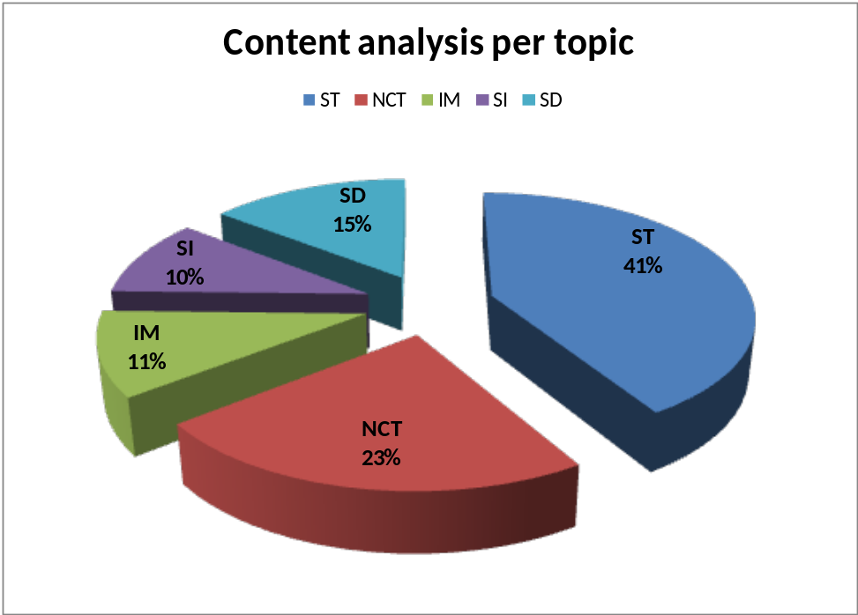

Cognitive levels
The following graph shows the cognitive analysis:
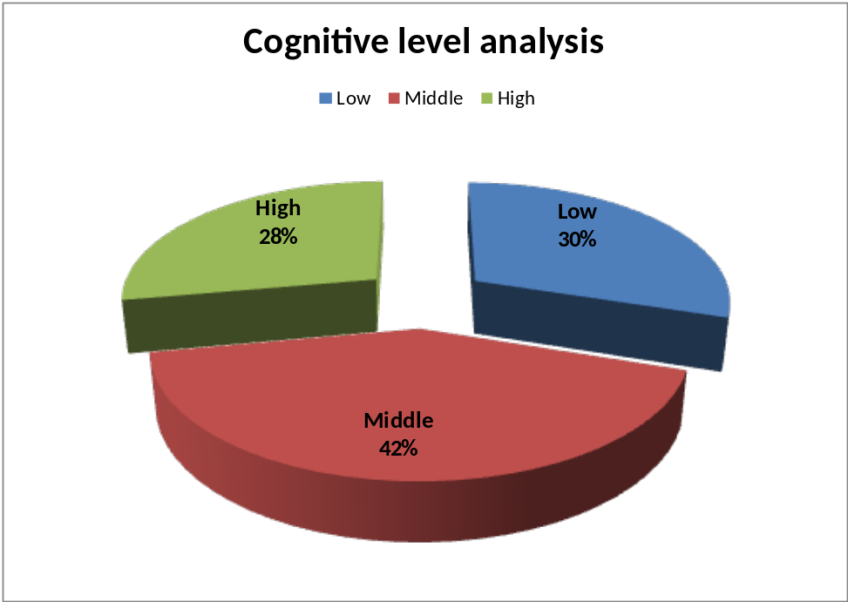

References

The University of New South Wales. (n.d.). The Learning Centre Academic Skills Resources. Retrieved July 15, 2013, from Exam Skills: Clue Words: https://student.unsw.edu.au/clue-words
University of Oregon. (n.d.). Bloom's Taxonomy of Cognitive Levels. Retrieved July 28, 2013, from Teaching Effectiveness Program: http://tep.uoregon.edu/resources/assessment/multiplechoicequestions/blooms.html
University of Sussex. (n.d.). Exam writing techniques. Retrieved July 18, 2013, from Study success at Sussex: http://www.sussex.ac.uk/s3/?id=71

Acknowledgment
Thank you to all the people that contributed to this document.
From KZN to WC, via EC and GP, passing NW.

Note that some clue words includes or refers to other clue words

