MAY 2012 2 HOURS
INFORMATION TECHNOLOGY – PAPER ONE
BL TOTAL = 100
GRADE 10

Surname
Name
Class

INSTRUCTIONS
- Create a folder in your U-drive and name it BL + “your username” + ScratchExam.
The folder will therefore have a name of the format:
BL sikzawg ScratchExam

- Answer ALL the questions.

- Your work should be saved at regular intervals in case of a power failure.

- Please read the questions carefully. Do not do more than is required.

- You may answer the questions in any order.

6. You need to hand in your question paper at the end of the examination with the flowchart from Question 1.

7. Please fill in your details in the table provided at the top of this page.

8. Do not wear sunglasses during this exam.

QUESTION 1

Create a flowchart, on the paper provided, that continuously asks for a number until the user specifies that there are no more numbers. It then displays the biggest even number from the numbers that were given as input.
It must include the following specifications:
- The input and output must be displayed, as shown in the diagrams,
via the sprite.
- Save this as Q1 in your ScratchExam folder.

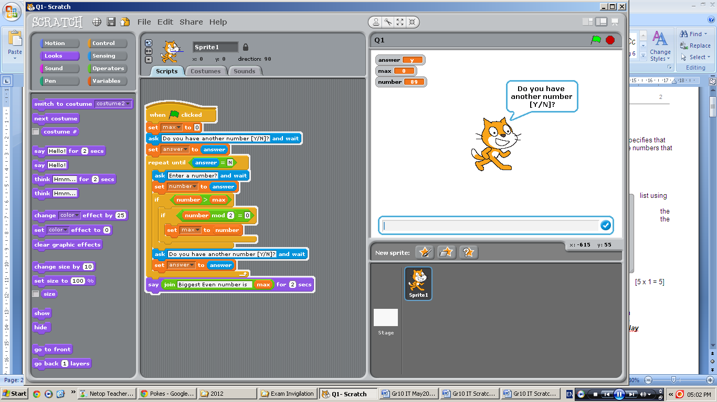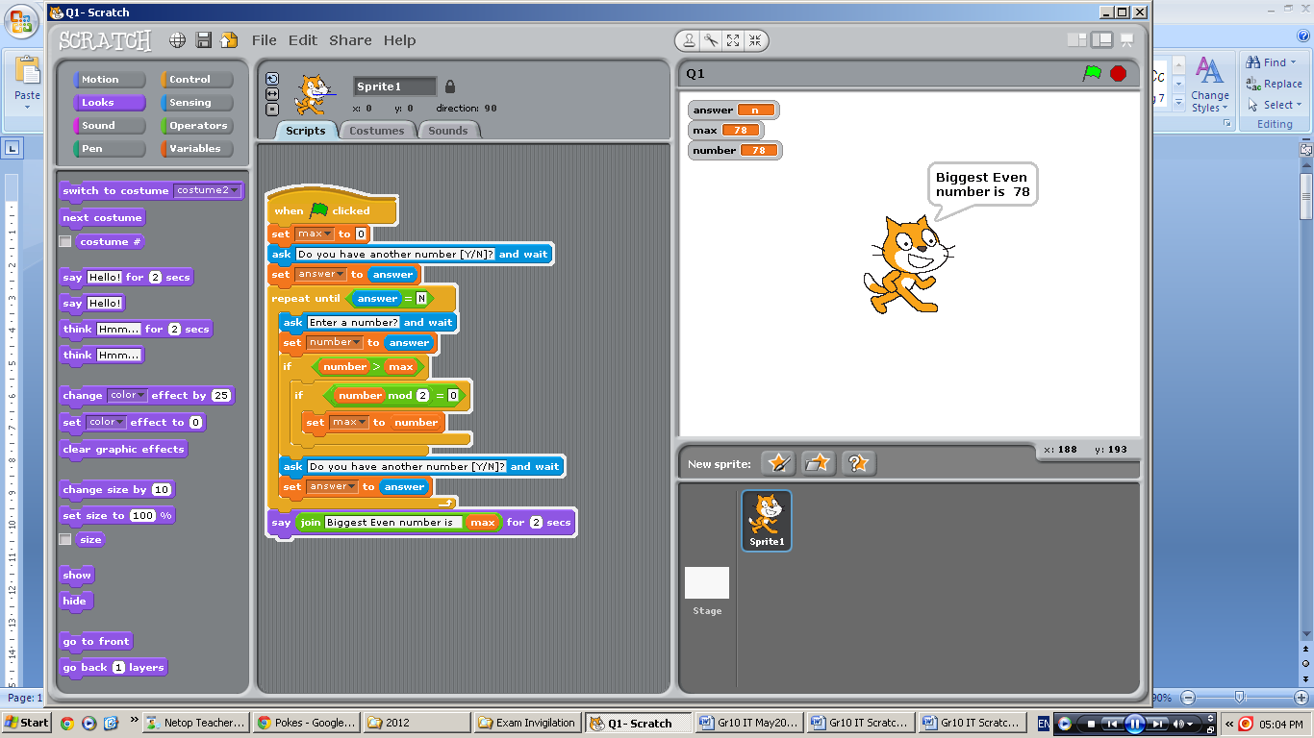
[10]

QUESTION 2

Create a Scratch program that asks the user for a positive number and then displays all the prime numbers (numbers that only have 2 factors) from 1 till the number given by the user.
Example: If the user gives 10 as input, the program must display 2, 3, 5, 7.

It must include the following specifications:
- Each time a prime number is found, you must display it for 1 second.
- Save this as Q2 in your ScratchExam folder.

HINT: First write the script that checks if a number is a prime number and then modify this code to find all the prime numbers.
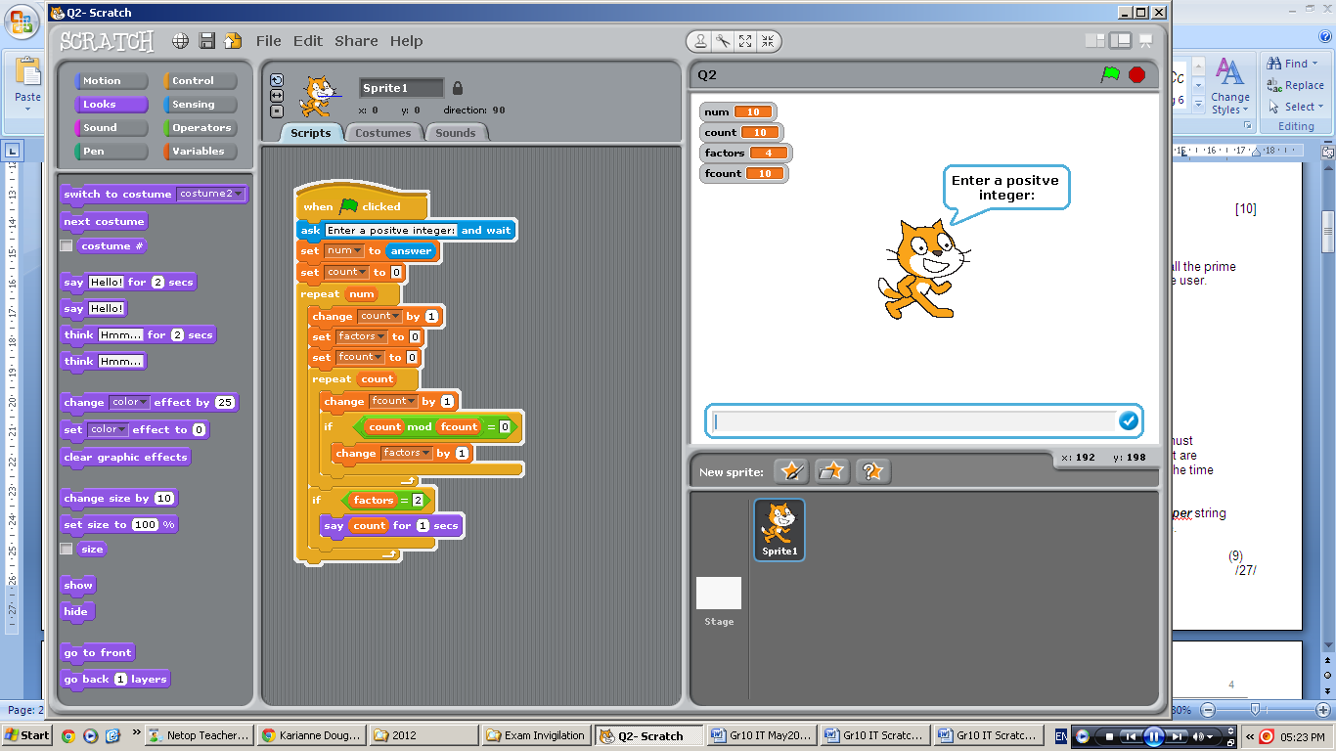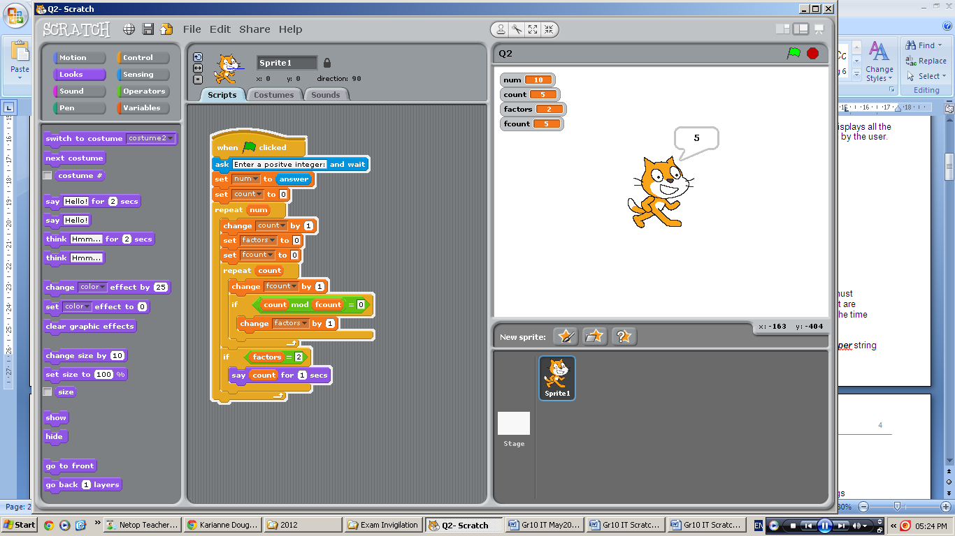
[13]

QUESTION 3

Create a Scratch program that calculates your McDonald’s order by clicking on the items that you want to order. Each click means you want one order of that item. Multiple items can be clicked and multiple clicks on one item are allowed.

It must include the following specifications:

- Make use of the sprites and costumes provided on the T-drive in the
T:\2012\Grade 10\IT\MacD Sprites folder to make your stage look as shown in the diagrams.
- You may make use of multiple variables but only the five that show the quantity of each item must be visible.
- Make sure only the necessary variables are set to be used for all sprites, those that are not needed by other sprites must be restricted to only that sprite.
- The script must start with Ronald-costume1
- A welcoming message and then an instruction message must be displayed (for 2 seconds each).
- The sprites for the different food items must not be visible until after the messages have been displayed
- The user can then click on the different food sprites to order one of that food item. They can click on a sprite multiple times to increase the quantity of that food item for the order.
- During this ordering process, the Ronald-costume2 costume must be used.
- Once the user has finished ordering, they can press the spacebar to find out their total for the order. This is calculated as:
  - Big Macs are R 20 each
  - Quarter Pounders are R 23 each
  - McChicken burgers are R 19 each
  - Fries are R 5 each
  - Milkshakes are R 8 each
- The total must be displayed for 5 seconds as shown in the diagram below.
- Ronald-costume3 must be used when showing the total for the order
- 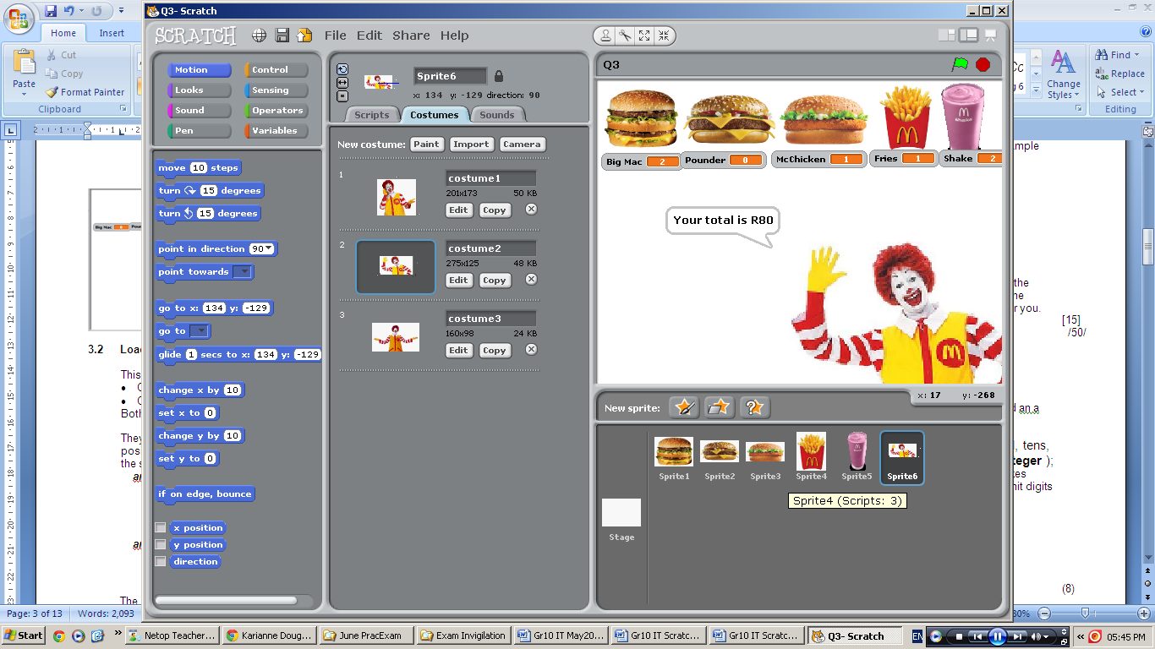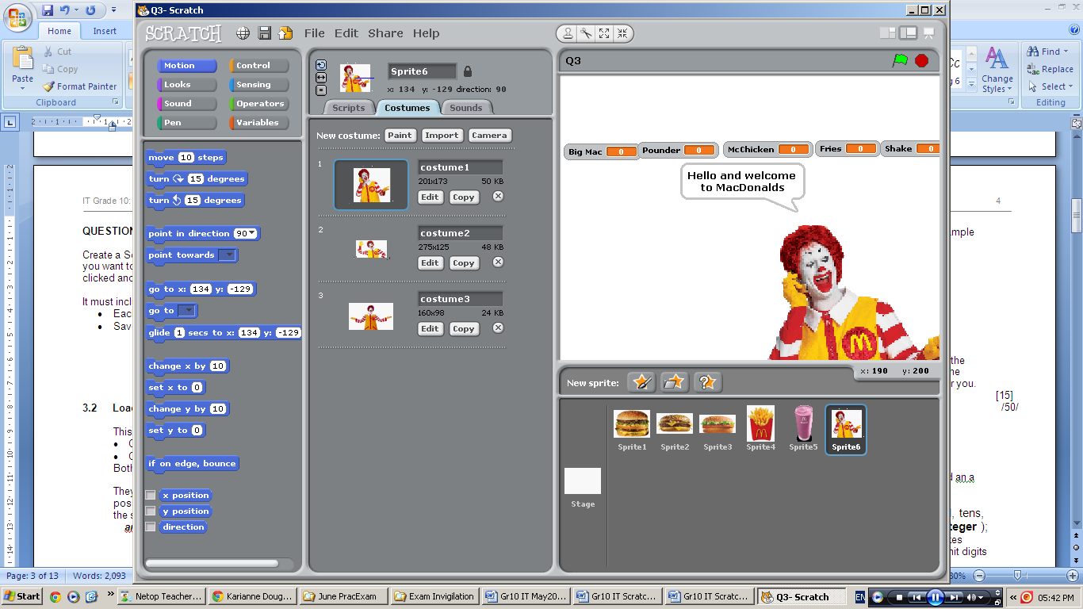Save this as Q3 in your ScratchExam folder.
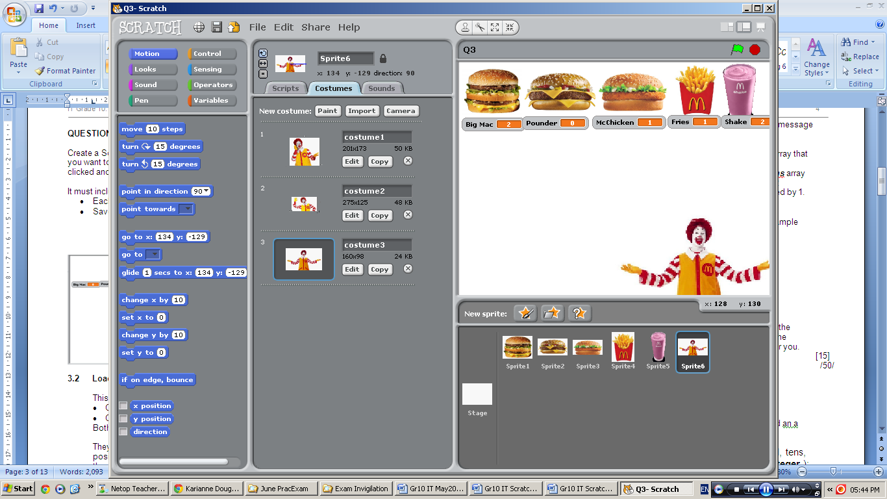[27]

QUESTION 4

Create a Scratch program that displays an animation of two sprites running a race. The sprites run at different speeds so the slower sprite will get a head start. When the slower sprite reaches a yellow line, the other sprite can start. The winning sprite is the first sprite to reach the red finish line.

It must include the following specifications:

- Make use of the sprites and costumes provided on the T-drive in the
T:\2012\Grade 10\IT\Headstart Sprites folder to make your stage look as shown in the diagrams.
- Make use of boy4-walking-a and boy4-walking-b costumes for the fast sprite.
- Make use of girl1-walking and girl1-standing costumes for the slow sprite.
- Position the yellow line in the bottom half of the screen at x = -65
- Position the red line at x = 220
- The slow sprite must do the following:
  - Start with the standing costume at the bottom half of the screen on the left side.
  - The slow sprite must move towards the red line at 12 steps every 0.1 seconds, making sure to alternate between costumes to give a running effect.
  - Only once the sprite touches the yellow line, can the fast sprite start the race
- The fast sprite must do the following:
  - Start with the standing costume at the top half of the screen on the left side at the SAME x position as the slow sprite.
  - Once the slow sprite touches the yellow line, the fast sprite can start the race.
  - The fast sprite must move towards the red line at 20 steps every 0.1 seconds making sure to alternate between costumes to give a running effect.
- Both sprites must stop moving the moment one of them touches the finish line.
- Save this as Q4 in your ScratchExam folder.
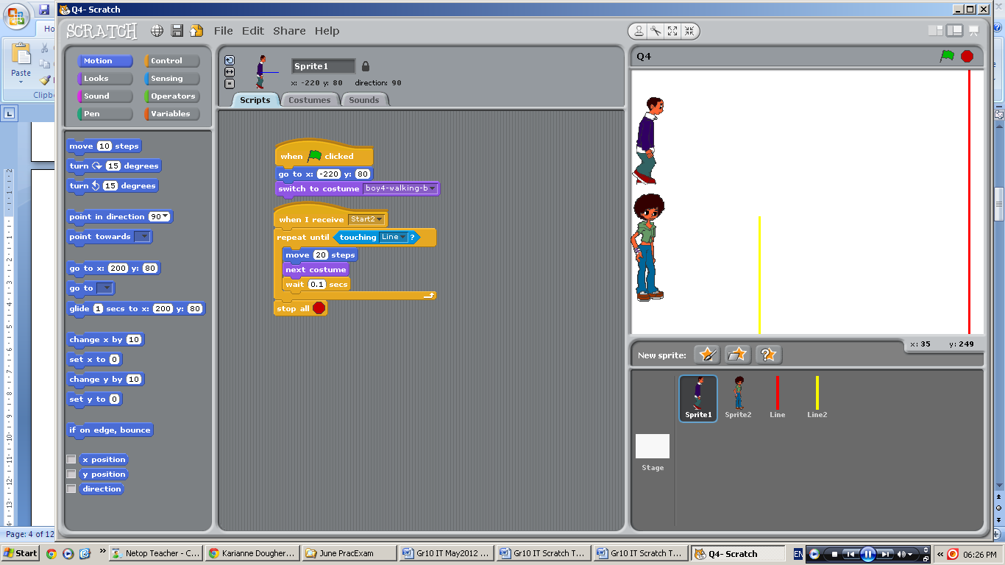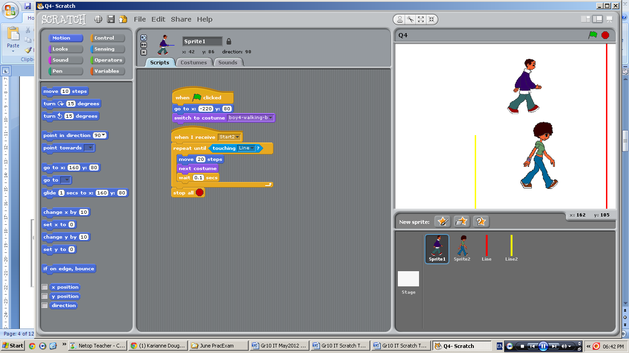

[23]
QUESTION 5

Create a Scratch program that gets a number from the user and then searches for that number in a list. If the number is found in the list, the sprite must display both the number before and the number after the found number in the list.

It must include the following specifications:
- You must create a list that contains at least 10 numbers but there can be no duplicates. You do not need to create the list using scripts.
- Ask the user for a number to search in the list.
- If the number is found, the number before it in the list and the number after it in the list must be displayed for 1 second each.
- If it is the first or last number that is searched for, then only the one number needs to be displayed (number after for the first number, the number before for the last number).
- If the number is not found in the list, nothing must be displayed.
- Save this as Q5 in your ScratchExam folder.

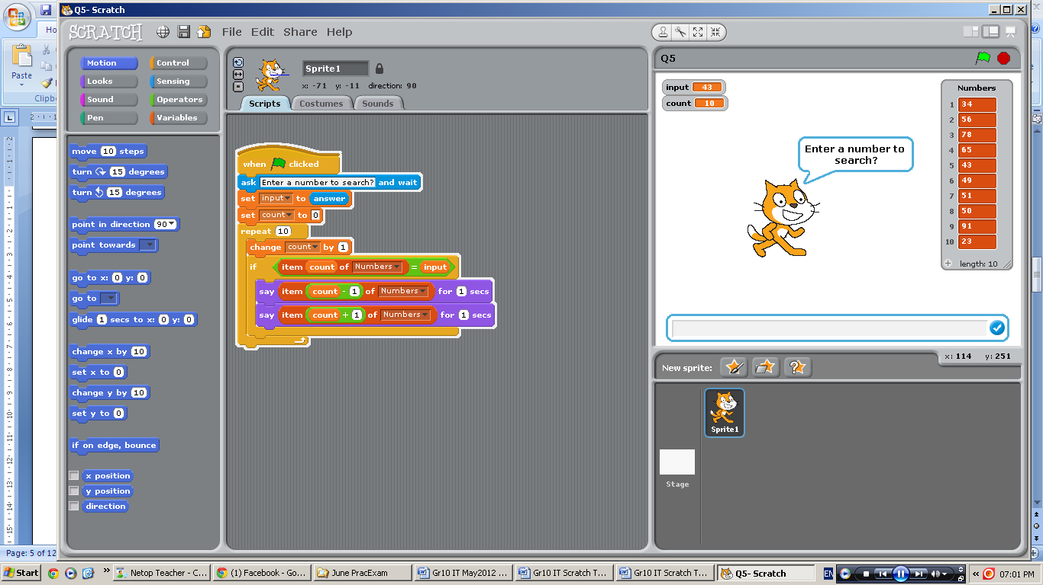
[11]

QUESTION 6

Create a Scratch program that has two lists of names. The program will take all the items from the one list and add then to the other list, BUT only adding those items that are not already in the first list. In other words, combining both lists with no duplicates.

It must include the following specifications:

- You must create a list (Data1) that contains the following names:

Bob | Joe | Jane | Tim | Sue | Abigail | Jack

You do not need to create the list using scripts.

- You must create another list (Data2) that contains the following names:

Mark | Abigail | Lee | Jane | Richard | Bruce

You do not need to create the list using scripts.

- Once the program is started, it will go through Data2’s items and add only the ones that are not already in Data1, into Data1.
- The end result is that Mark, Lee, Richard and Bruce must be added to the Data1 list.
- Save this as Q6 in your ScratchExam folder.

HINT: You may need to make use of two looping variables.

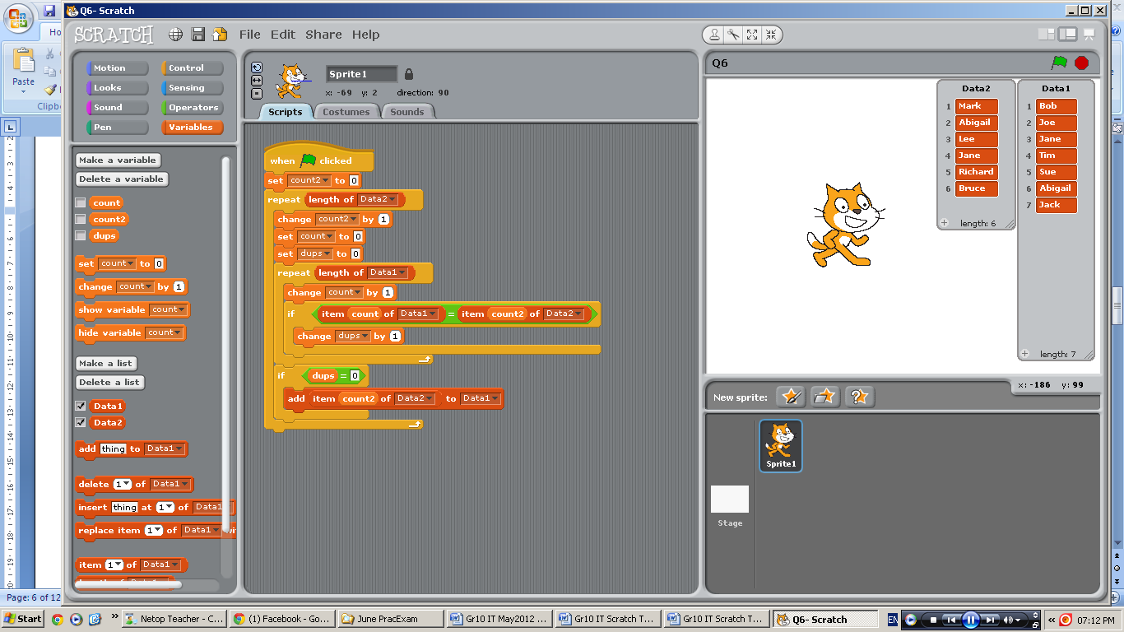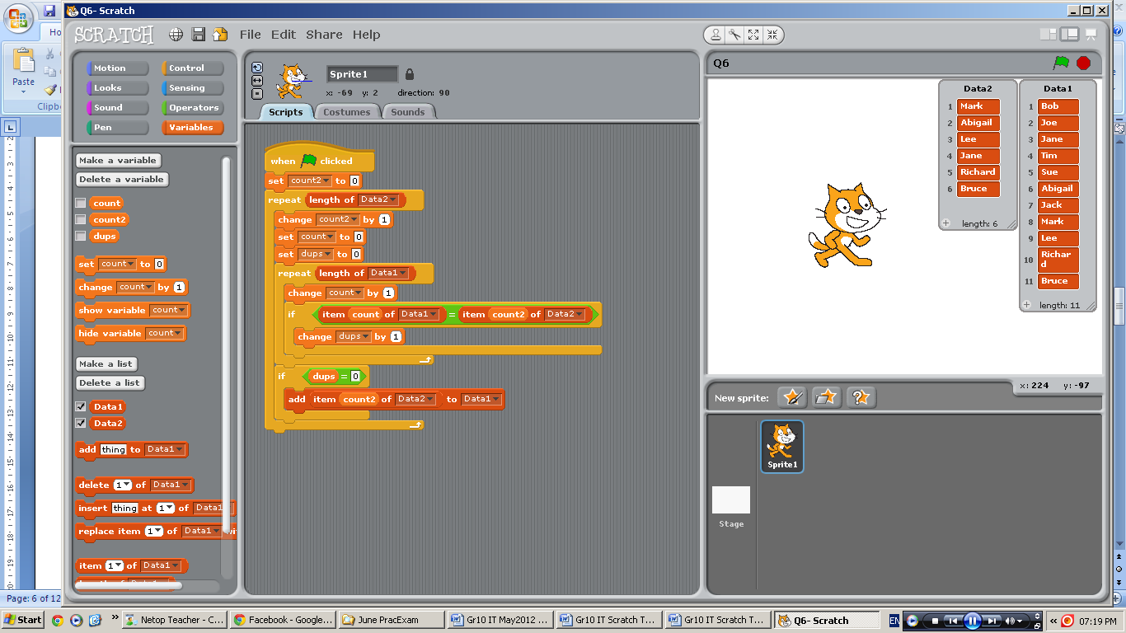
[16]

TOTAL = [100]

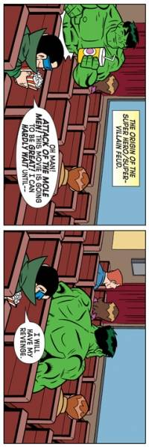

Grade 10
INFORMATION TECHNOLOGY – PAPER ONE
MEMORANDUM

QUESTION 1 SAMPLE CODE [10]
- Initialise max variable
- Ask if number is needed
- Correct loop
- Ask for number
- Check if max
- Check if even
- Display

- Matches flowchart
- Flowchart is correct

QUESTION 2 SAMPLE CODE [13]
- Ask for number
- Initialise looping variable (count)
- Correct loop
- Increase looping variable (count)
- Initialise factors count
- Initialise second looping variable
- Second loop
- Increase second looping variable
- Check if factor
- Increase factor count
- Check if has only 2 factors
- Display for 1 second

QUESTION 3 [27]

Mark Allocation for Ronald sprite
- Correct use of costumes
- Initialise all variables
- Messages are suitable
- Broadcast to show food items
- Wait for spacebar to be pressed
- Calculate each food items total
- Calculate total
- Correct display for 5 seconds

Mark Allocation for other sprites
- Increase correct variable when clicked
- Hide at start
- When receive broadcast show sprite
- Do for other four sprites
- Correct Variables used for all sprites
- Others used only for Ronald sprite

Sample Code
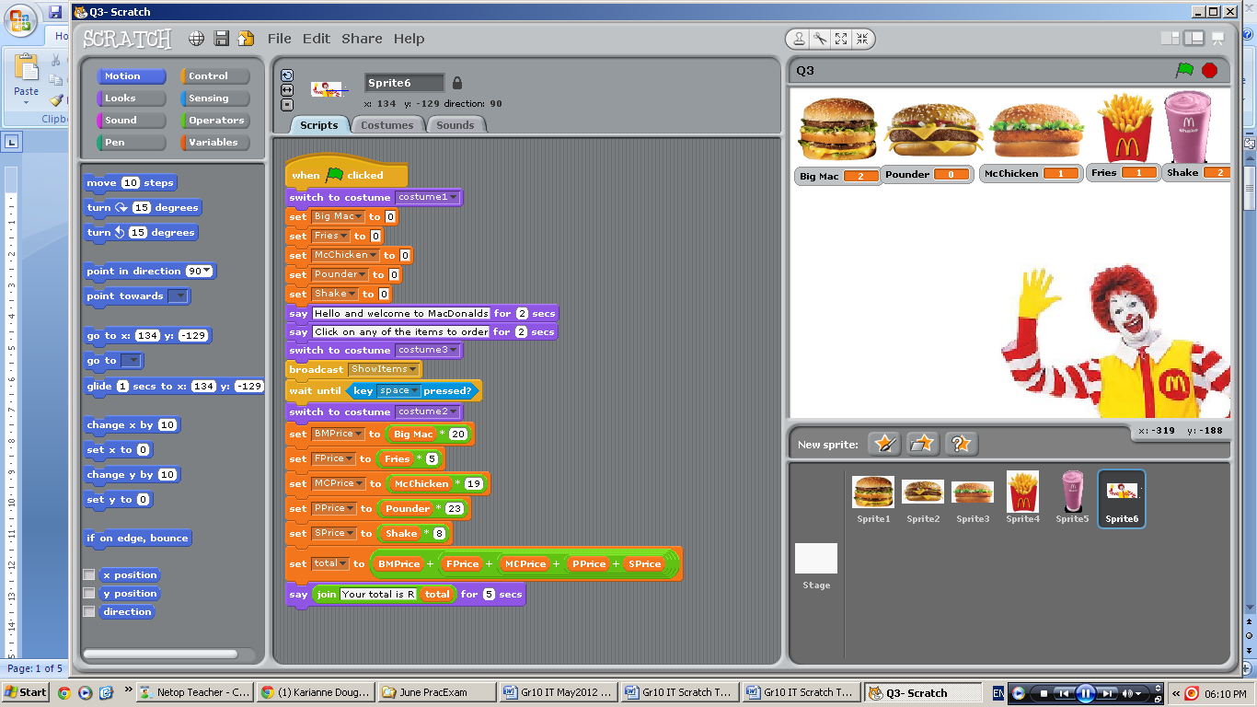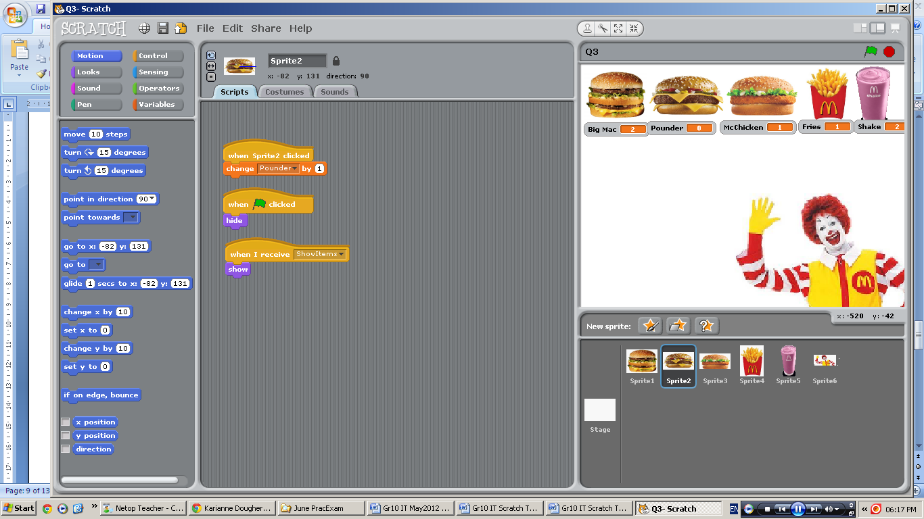
QUESTION 4 [23]
Mark Allocation
- Stage setup
  - Correct use of sprites
  - Correct use of costumes
  - Correct positioning of yellow line
  - Correct positioning of red line
- Slow sprite
  - Starting position and costume
  - Correct move and costume change every 0.1 seconds
  - Broadcast if touching yellow line
  - Repeat until red line touched
  - Stop correctly
- Fast sprite
  - Starting position and costume
  - Start moving once broadcast received
  - Correct move and costume change every 0.1 seconds
  - Repeat until red line touched
  - Stop correctly

SAMPLE CODE
Slow Sprite Fast Sprite
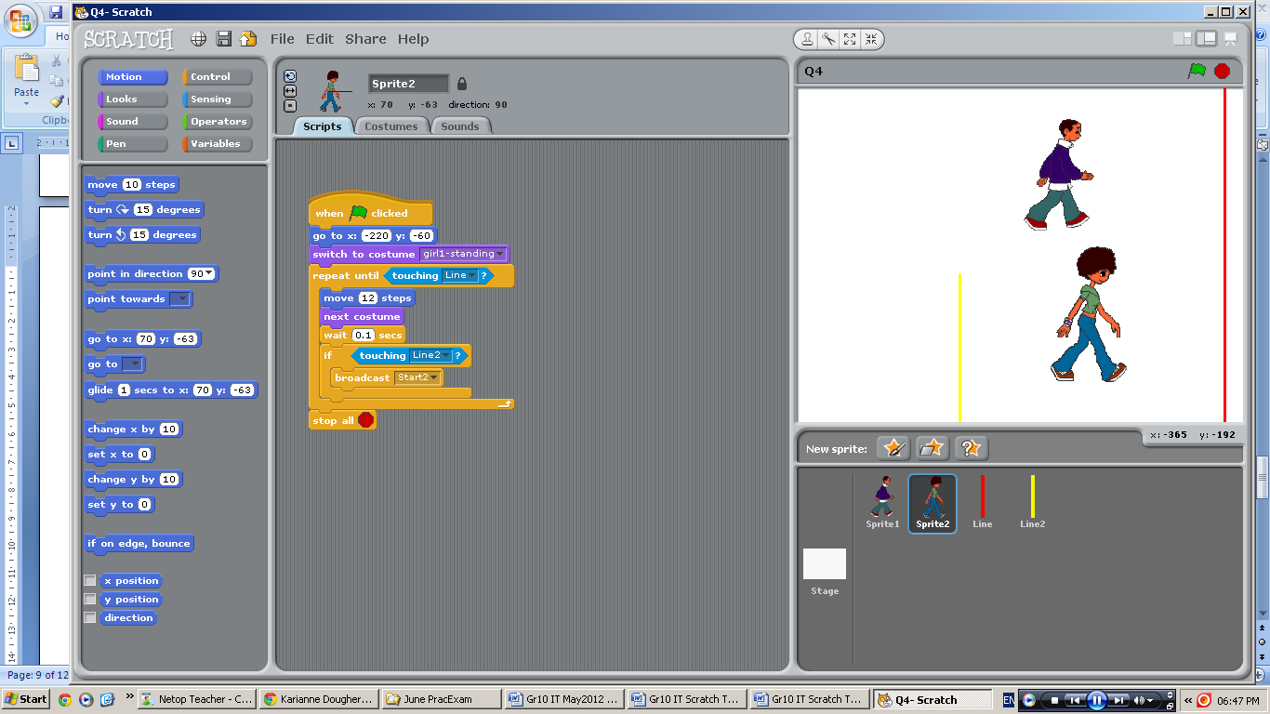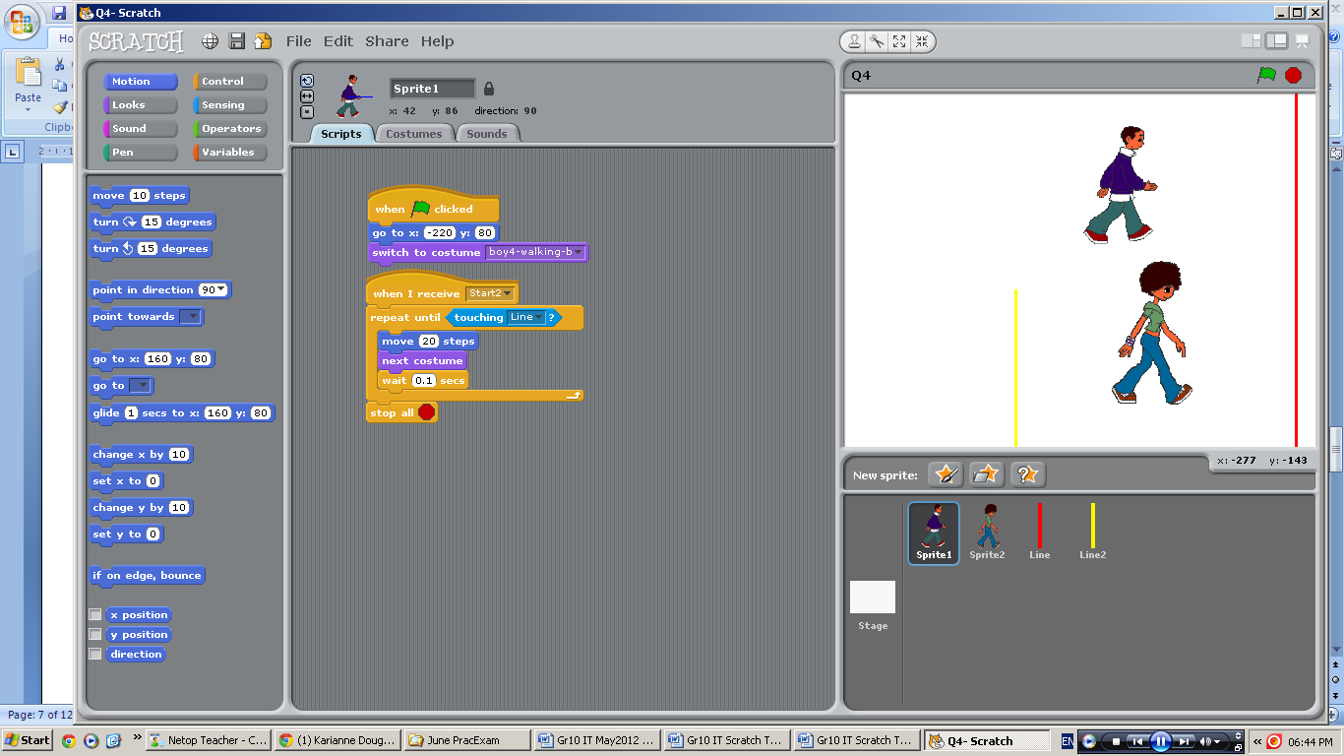

QUESTION 5 [11]

Mark Allocation
- List correctly setup at least 10 no duplicates
- Ask for number to search
- Initialise looping variable
- Repeat length of list
- Increase looping variable
- Check if input same as each number in list
- Display before number
- Display after number

SAMPLE CODE
QUESTION 6 [16]
4.1 Mark Allocation
- Initialise looping variable 1
- Correct loop of correct list
- Increase looping variable 1
- Intialise looping variable 2
- Intialise duplicate counter
- Correct loop of correct list
- Increase looping variable 2
- Check if item from Data1 = item form Data2
  - Increase counter
- If no duplicates
  - Add correct item to Data1
SAMPLE CODE

Total = 100

