NORTH WEST PROVINCE    DEPARTMENT OF EDUCATION | NATIONAL SENIOR CERTIFICATE  EXAMINATION  SEPTEMBER 2012  COMPUTER APPLICATION TECHNOLOGY  SECOND PAPER  TIME : 3 HOURS  MARKS : 150

GRADE 12

COMPUTER APPLICATION TECHNOLOGY

SECOND PAPER
SEPTEMBER 2012

This examination paper consists of 13 pages

INSTRUCTIONS AND INFORMATION

1. This question paper consists of SECTION A and SECTION B.
2. Answer ALL the questions.
3. Number the answers correctly according to the numbering system used in this question paper.
4. Start EACH question on a NEW page (or according to requirements).
5. DO NOT write in the right-hand margin.
6. Leave a line between each sub question.

SECTION A
QUESTION 1
Various options are provided as possible answers to the following questions. Choose the answer and write only the letter (A – D) next to the question number
(1.1 –1.10) in the ANSWER BOOK, for example 1.10 D.
- Which one of the following websites is known for uploading or downloading videos?
- News24
- Yahoo!
- Amazon
- YouTube (1)
- Which one of the following application programs will be used to open and read a *.pdf file?
- WordPad
- Adobe Reader
- MS Word
- NotePad (1)
- ‘Extra’ drives like ‘Z’ of ‘T’ drives indicate that the user ...
- has a virus on his computer.
- is connected to the Internet.
- is part of a network.
- is using illegal piracy software. (1)
- The digital divide refers to the...
- availability and access to technology.
- use of technology in cities and rural areas.
- use of new technology compared to the use of old technology.
- use of digital versus analogue technology. (1)

- Which ONE of the following is the correct string that is used to specify the executable files?
- *.*
- *.exe
- Program*.*
- ??.exe (1)
- Which ONE of the following will NOT be considered when choosing an ISP?
- Amount of data used per month.
- Location of the Internet Service Provider.
- The availability of assistance after hours.
- The type of browser software on your computer. (1)
- The unit used to measure the quality of the image is
- ppm
- Ghz
- ppi
- HD (1)
- The e-mail promising money if forwarded to at least 10 people, is
called a …?
- Trojan.
- Worm.
- Phishing.
- Hoax. (1)
- Which ONE is NOT an example of a mobile type of PC?
- Notebook
- Tablet
- Laptop
- Server (1)

- Which ONE of the following make use of an optical storage device?
- Flash drive
- Hard disk
- Compact disc
- Memory card (1)
[10]
QUESTION 2
Choose a term/concept from COLUMN B that matches a description in COLUMN A. Write only the letter (A – P) next to the question number (2.1 – 2.10) in the ANSWER BOOK, for example 2.11 P

COLUMN A | COLUMN B
2.1 A small text file saved automatically on your computer by a website | A | LAN
2.2 1024 Gigabyte | B | Bluetooth
2.3 An input device installed to carry live video feed to  a website | C | Mega bite
2.4 An example of wireless data connection | D | Defrag
2.5 An example of a dedicated Internet connection | E | Dial-up
2.6 An utility program that reorganises the filing system of  the computer. | F | GOOGLE
2.7 Used by memory to keep instructions in the correct  order | G | Webcam
2.8 Example of a web browser | H | Clipboard
2.9 Example of a search engine | I | Internet Explorer
2.10 A device that has both input and output capabilities | J | Cookie
 | K | Scanner
 | L | ADSL
 | M | Terabyte
 | N | Touch screen
 | O | Windows
 | P | Scandisk
[10]
SECTION B
SCENARIO
You are a CAT student that has been appointed at the Rising Star Agency (RSA) for the holidays as an administrative assistant to Mr. Vilas, an agent to many famous actors in South Africa. Mr. Vilas travels a lot and works mostly from home.
QUESTION 3
3.1 Mr. Vilas wants to upgrade his office at home. You are put in charge of the project.
3.1.1 You suggest that Mr. Vilas buys a laptop. Name THREE advantages of a laptop compared to a desktop. (3)
3.1.2 He uses his smart phone almost continuously. Name TWO significant functions of smart phones that distinguish them from cell phones? (2)
3.1.3 He is very concerned about green computer use. Name ANY TWO ways in which you can make his office more ‘green’? (2)
3.1.4 You refer in your report to the fact that all devices are ergonomically correct. Mr. Vilas wants to know what is meant by ergonomics. Define ergonomics and give ONE example. (4)
3.1.5 Mr. Vilas very often participates in many video conferences. He has access to the Internet. Which other hard- and software does he need to hold video conferences? (3)
3.1.6 Mr. Vilas wants to know why you sometimes accept the most expensive quotes.
Explain to him and in your explanation refer to the THREE critical hardware specifications you always look for in a quote. Motivate by referring to their functions. (6)
3.2 The old desktop PC contained a lot of important data. A lot of compact disks were used to backup this data.
3.2.1 Which removable storage device is capable of large data storage, replacing all the CDs? (1)
3.2.2 Name THREE potential disadvantages of saving data on a removable storage device (CD/memory stick, etc.) instead of the saving of data on a hard disk. (3)

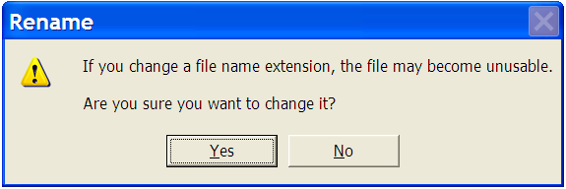
3.2.3 While Mr. Vilas is working on his data in order to make backups, the following error message appears on his screen:
(a) Briefly explain what a file name extension is. Give ONE example. (2)
(b) Explain why does this error message appear and why will the file become unusable. (3)
(c) Give TWO examples of file extensions commonly used to save images. (2)
3.3 There is also a printer installed in the office.
3.3.1 It is 4-in-1 printer. Except for printing, name the other THREE functions of the printer. (3)
3.3.2 Why is it a disadvantage to refill the ink cartridges instead of buying a new one in the first year? (1)
3.3.3 Which port is usually used to connect the printer to the PC? (1)
3.3.4 The printer’s driver is already installed. What is the function of the driver? (1)
3.3.5 If the CD with the driver program is lost, where can Mr. Vilas get another driver? (1)
3.3.6 A long document is printing. Mr. Vilas wants to go to town and he cannot wait for the printing to finish. Explain to Mr. Vilas the function of the printing queue. (2)
3.4 Mr. Vilas considers purchasing a tablet as well.
3.4.1 You support the idea. Give TWO examples why users prefer a tablet computer to a laptop. (2)

3.4.2 There are mainly two operating systems (OS) competing in the tablet and apps world. Name these TWO operating systems. (2)
3.4.3 What type of network will be created if Mr. Vilas connects his laptop, his tablet and his smart phone to one another? (1)
3.4.4 Many devices connecting to the tablet with a USB port are ‘plug-and-play’. What does the underline phrase mean? (2)
[47]
QUESTION 4
  - All the users’ instructions from the computers and software are saved in .pdf format, for Mr. Vilas to read it later.
    - What does the extension .pfd stand for? (1)
    - Distinguish between files saved in pdf format and files saved in MS Word format. (2)
    - What is the most commonly used program to read .pdf files (give the brand name)? (1)
  - Application software still has to be bought for Mr. Vilas.
    - Explain to Mr. Vilas the difference between a single user licence and a site licence. Which type of licence will be the best for Mr. Vilas? (3)
    - Mr. Vilas must decide between using MS Office Suite or Open Office. Evaluate both, referring to an advantage of each. (3)
  - The new computer has Windows 7 installed as operating system.
    - Name a function of the operating system. (1)
    - Name THREE housekeeping tasks that Mr. Vilas has to perform regularly. Motivate your answer. (6)
  - Mr. Vilas notices that you have already bought and installed security software. He wants to know why it is so important.
    - This includes an antivirus program. Define a virus. (3)
    - Describe to Mr. Vilas any TWO ways in which he can keep his computer virus free. (2)

    - Explain to Mr. Vilas the dangers against which the security suite is protecting his system. What is meant by each item?
      - ‘Spyware’ (2)
(b) ‘Spam’ (1)
(c) Malware’ (1)
[26]
QUESTION 5
5.1. Mr. Vilas’ work is to a great extent dependent on the Internet.
5.1.1 What type of network is the Internet an example of? (1)
5.1.2 Mr. Vilas says his whole house should be like a ‘hot spot’. What does he mean? (2)
5.1.3 The following is a list of terms associated with certain website/-services. Write down only the NAME of the website:
(a) ‘tag’ ‘like’ ‘poke’
(b) ‘tweet’
(c) ‘moola’ ‘tradepost’ (3)
5.1.4 Name TWO functions of the ISP? (2)
5.1.5 Explain why BANDWIDTH is an important factor to consider when using the Internet. (2)
5.1.6 Describe to Mr. Vilas the advantages of ‘uncapped’ Internet access above capped Internet access. (2)
5.1.7 He shows you the RSA website. The URL is: http://www.risingstaragency.co.uk
(a) Explain the co and uk parts of the URL. (No marks will be awarded for writing out the abbreviations). (2)
(b) The fact that the URL are underlined (and blue), indicates that it is a hyperlink. What is a hyperlink? (2)

5.2 One of the advantages of the Internet is e-mail.
5.2.1 Compared to faxes, name TWO advantages of e-mail. (2)
5.2.2 What is netiquette? Give TWO examples of netiquette applied to e-mails. (2)
5.3 Mr. Vilas asks you to set his homepage to Google.
5.3.1 What is a homepage? (1)
5.3.2 Explain step-by-step how you will set Google as the homepage if you are NOT connected to the Internet. (2)
[24]
QUESTION 6
6.1 Mr. Vilas’ personal assistant (Claire) who sometimes assists him in his administrative duties, is not that accomplished in MS Office. After the office is upgraded, she has a few questions.
6.1.1 She saves all her files in the ‘My Documents” folder. Why is this not a sound policy to follow? What do you suggest she does instead? (2)
6.1.2 Explain to her the advantages of a shortcut on the desktop. (2)
6.1.3 Which key on the keyboard can she use to gain direct access to the start menu without using the mouse? (1)
6.1.4 Where can she set certain dates and times on which household tasks will be performed automatically? (1)
6.1.5 These 4 controls are seen everywhere in Windows. Name each. (4)
A B C D
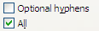
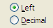
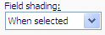

6.2 Claire has trouble with MS Excel.
6.2.1 She wants to print a spreadsheet, but it prints across 3 pages. Explain to her step-by-step how (and where) she can change the setting so that all will be printed on one page. (2)
6.2.2. The formula on one of the sheets is: =$C$1+B3
Name AND explain the difference between the TWO types of cell references used, in this formula. (4)
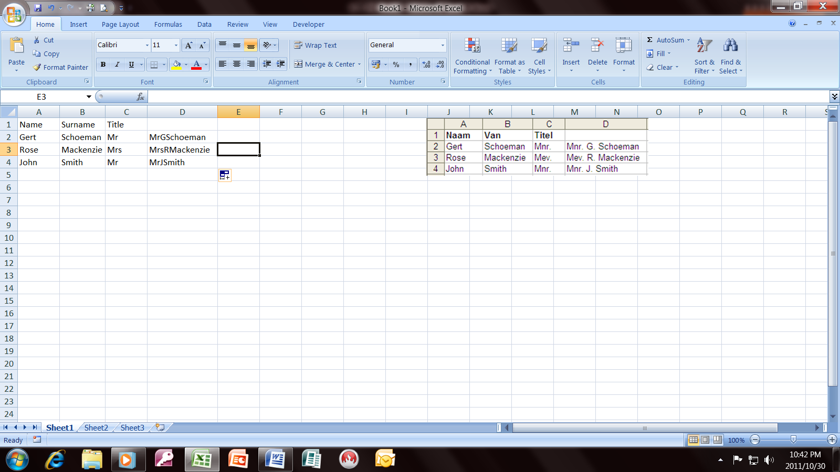
6.2.3 The following is an example of one of Claire’s spreadsheets:
Give the function used in cells D2:D4 to bring about the results seen in column D. (4)
6.2.4 Which type of graph (chart) is the best to use when comparing percentages (%)? (1)
6.2.5 As soon as she changes the format of a cell to ‘currency’ the dollar ($) symbol appears instead of the Rand (R) symbol. Which setting does she need to change for the Rand symbol to appear automatically? (1)
6.3 Claire has never worked with ‘styles’ in MS Word.
6.3.1 Name any TWO advantages of working with ‘styles’? (2)
6.3.2 Explain the importance of working with ‘styles’ if you want to create a table of contents automatically. (2)
6.4. She wants to change the existing client database to become more user friendly.
6.4.1 Explain to her how the following field properties contribute to more accurate data input:
(a) ‘Input mask’
(b) ‘Validation rule’
(c) ‘Validation text’
(d) ‘Required’
(e) ‘Format’ (5)

6.4.2 Explain to Claire how she can get the new client contact list (created in MS Excel) as a table in MS Access, without typing it again. (1)

6.4.3 Which item in MS Access is the most suitable to key in data? (1)

[33]
GRAND TOTAL: 150

