Grade 10 CAT Exemplar Paper 1 (Practical) – CAPS 2012 [150]
The Social Sciences teacher needs help to prepare documents for lessons on the topic, Solar Systems. S/he gathered information about the topic but needs you to help with the formatting and editing of some of the documents so that it would be more accessible and easy to use during the lessons as well as be more appealing to the learners.
Question 1 [40]
The teacher received a document, where background information was copied and pasted from different sources, to hand to learners, but does not like the layout and formatting of the document.
Open the file, q1_Background_Information_Data, and format the document as follows:
- For the whole document:
  - Change the font face of the whole document to Calibri. (2)
  - Left align all the text in the document. (1)
  - Change the line spacing of the whole document to 1.15 Multiple. (3)
  - Add 10 pt spacing after all the paragraphs. (2)
  - All the paragraphs’ first line is indented – remove the first line indentation for all paragraphs. (2)
- One section of the document was typed using capital letters. Change this section to sentence case. (1)
- Use quick styles and format the different headings as follows: (5)
  - Use Title Style for the main heading – Our Universe
  - Use Heading 1 for all the paragraph headings (currently bold: Planets, Moons… , Asteroids… , Comets… , Dwarf Planets… , Meteors & Meteorites… , The Kuiper belt… , Where do you live… )
  - Use Heading 2 for all the sub-headings (under some of the headings: What is it like on … , The address game
- Change the first letter of the first paragraph (The sun warms us everyday…) to a drop cap. (1)
- Apply a light blue shading to the first paragraph (up to …asteroids and ice) (2)
- Format the third paragraph (Did you know…) to appear in a dark grey colour and bold. (2)
- Change the list of objects that follows the 6th paragraph (Our solar system is one of many…) – starting with, a star – the sun, and ending with, several dwarf planets to a bulleted list (2)
- Replace all occurrences of the word, structure, with the word, system. (2)
- Remove the header (Social Sciences) in the document. (1)
- In the footer, insert automatic page numbers for all pages, except the first page. (2)
- Format all bold text to also have a shadowed effect. (2)
- Find the two sentences that start with My Very Educated Mother… and centre both the
sentences. (2)
- Correct the spelling in the document – ignore names of planets/objects.
(Ensure that the language is set to English SA) (3)
- The heading, Comets – The icy travelers, should start on a new page. (1)
- Find the second last occurrence of the words, solar system, and insert a hyperlink to the document, Our_Solar_System. (2)
- Save the document as q1_YourName in the Answers folder (2)
Question 2 [13]
One of the tasks that learners need to complete is to build a model of the solar system. To complete the task, they have to scale the distances and measurements and need some background on units of measurement.
Open the document, q2_History of Unit Measurements_Data and format as follows:
Note: Do not change anything that is not requested.
- Set all the margins (top, bottom, left and right) to 2.5 cm
(Make sure that the page size is A4) (2)
- Split the document into columns as follows: (4)
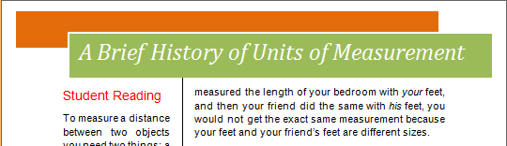
  - Two columns, with a narrow left column and a wide right column
  - Space between columns: 1 cm
  - Insert a line between the two columns
- Insert a built-in text box from the gallery (Tiles Sidebar) at the top of the first page. (2)
- Replace the text in the text box with the following:
A Brief History of Units of Measurement
- Switch on the automatic hyphenation. (1)
- Find the following text: (778 million kilometres)
Replace the space between 778 and million with a non-breaking space so that number 778 and the word million will always stay together. (1)
- Convert the last section of the text (which is separated by tabs) to a table. (2)
- Make sure that the two columns on the second page are of equal length, i.e. the two columns contain more or less the same amount of text / text is balanced between the two columns. (1)
Question 3 [13]
The learners should understand the scale of the model and real life objects are used to compare the sizes of the planets.
Open the document q3_ActualObjectDiameter and do the following:
- Set the page orientation to portrait (1)
- Set the cell alignment as follows:
  - First two columns: Centre Left (1)
  - Last column: Centre right (1)
- The picture of the pecan that represents Jupiter, is too large. Change the picture as follows:
  - Crop the picture to get rid of as much white space around the pecan as possible (2)
  - Set the size to: Height – 2.5 cm and Width – 3 cm (2)
  - Centre align all the pictures (their centres must be in line). (2)
- Change the heading of the table to look as follows: (4)
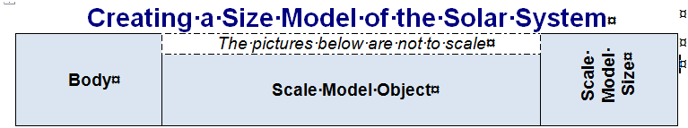
Question 4 [29]
The teacher needs to prepare a spreadsheet for learners which they could use to do their calculations. You first need to test it before it is given to learners.
Open the spreadsheet, q4_Planet_Info_Data, and format the sheet as follows:
- Insert the -symbol into cell D6 (1)
- Split cells H8:H9 into two separate cells (1)
- Merge the cells in the heading row (row 1) (1)
- Format the cells in B7:B8 to display as follows: (4)
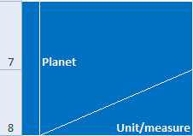

- Complete the information in the table by using functions and/or formulas to display the following:
- In cell H21, determine the total number of moons (2)
- In cell D21, determine the average distance to the sun (2)
- In cell G10, for each planet, calculate the actual diameter in km, e.g.
the diameter of the earth is 12 756 km, therefore in cell G10 the diameter will be 1 (F10) times that of the earth (2)
- In cell D10, type a formula that will determine the distance in astronomic units (AU), if 1 AU = 150 000 000 km
Display the results for all planets and show only 1 decimal place (3)
- In cell K10, calculate John’s weight (in kg) on the other planets if he weighs 70 kg on earth
A person’s weight (in kg) on another planet is 10% of his/her weight on earth times the gravity of that planet (Note that the calculated on earth will be a little less than what is given in column J, due to the fact that the earth's gravity is not exactly 1). (3)
- Use functions and/or formulas to complete the information in the Interesting facts (grey) block to display the following:
  - In cell D23, calculate the distance between Earth and Mars (remember that distance is normally shown as a positive value) (3)
  - In cell D24, determine the shortest distance to the sun
(distance from the sun of the planet closest to the sun) (2)
  - In cell D25, calculate the circumference (C) of the earth, if C = πd, where
d = diameter and π is represented by the PI-function (2)
  - In cell D27, determine how many planets are further from the sun than the earth (3)
Question 5 [11]
There is an interesting relationship between the arrangements of the planets around the sun. The differences in the distances from the sun between subsequent planets show an interesting pattern. This was calculated before Uranus, Neptune and Pluto were discovered and astronomers actually found Uranus because they used this pattern.
Open the spreadsheet, q5_Planet_Arrangement_Data and do the following:
- Rename the worksheet to Bode’s Law (1)
- Change the headings of the table to display as follows: (2)
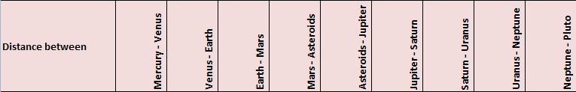
- Use the distances between the planets (row 6) and draw a graph to visually represent these differences.
The graph should display on a new sheet using structure and showing the information as shown below: (8)

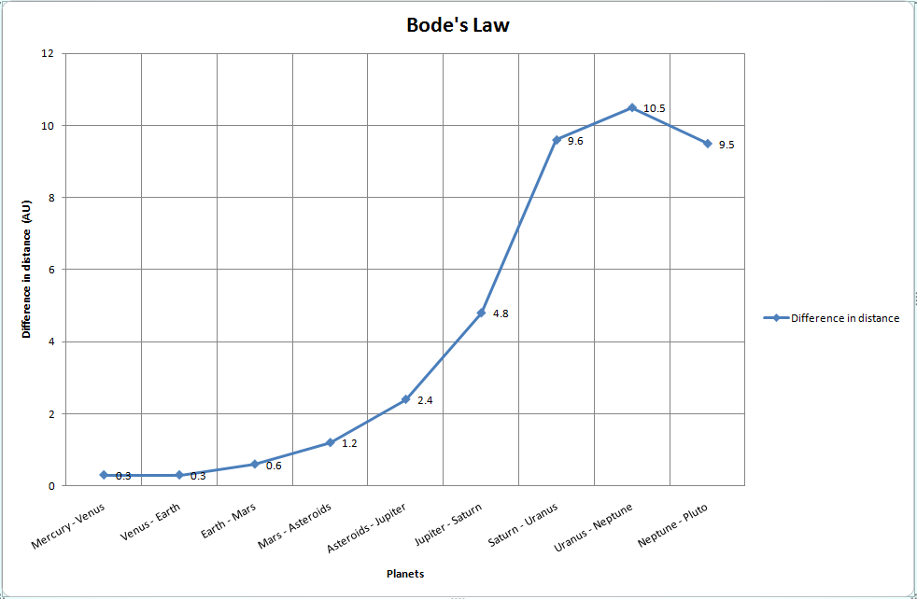
Question 6 [11]
The teacher compiled a presentation on the topic to be used as part of the lesson presentation and asks your help to finalise the presentation
Open the document, q6_Presentation_Data and do the following:
- Change the layout of the second slide to display as follows: (3)
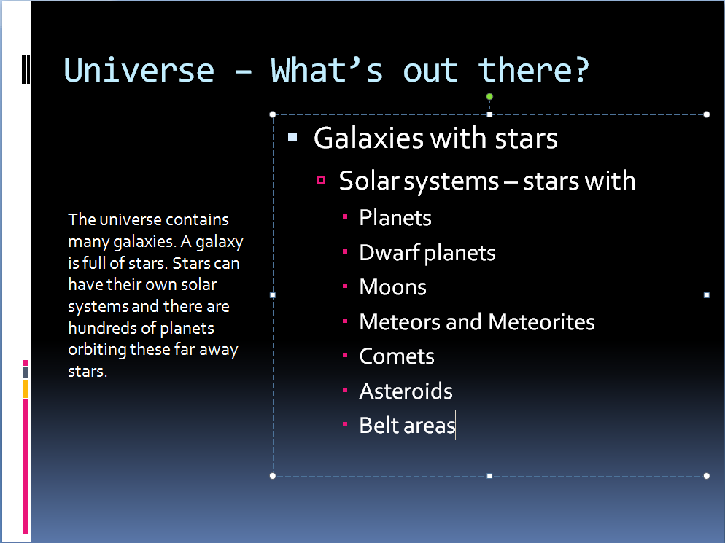

- Open the document, Teacher_Notes, and copy the explanatory text into the notes section of the last slide (slide with table) (2)
- Insert a blank slide between slides 5 and 6 (1)
- On the slide with the picture of our solar system (slide number 4), add an arrow with the word, Sun, that will point to the sun. The arrow should fly in. (4)
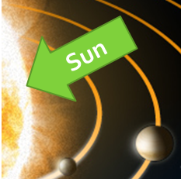

- Change the view to Notes Page view and save the presentation with this view. (1)

Question 7 [23]
The teacher needs to design worksheets on the topic. A worksheet was forwarded to the teacher via e-mail in the format of a rich text file and somehow some formatting was lost. Format the worksheet according to the faxed example provided.
Open the document q7_Worksheet_Data and do the following (see example below):
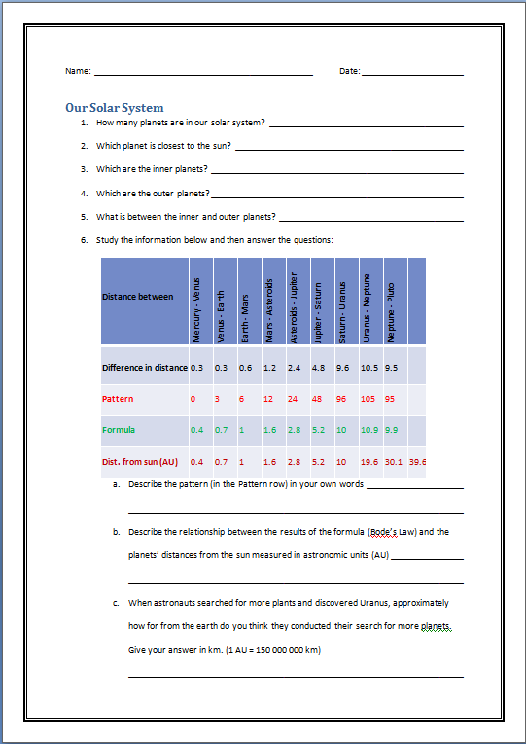
- Save the document as a word document (1)
- Add the part where learners need to fill in their names and the date as follows: (6)

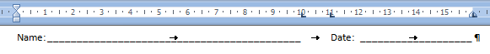
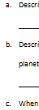
- Use automatic numbering to number the sub questions for question 6. (2)

- For questions 1 – 6, use tab settings to provide lined space for learners to write their answers. Ensure that learners will have enough space to write their answers. (3)
- Add a suitable page border (1)
- Insert the table (A4:J8) from the spreadsheet, q5_Planet_Arrangements_Data, and do the following:
  - Add an extra column at the end of the table (1)
  - Add the row with the information about the differences in distance between two consecutive planets (A3:K3) to the bottom of the table (2)
  - Adjust the table (rows and columns) to auto fit according to the contents (1)
  - Centre the table. (1)
- Insert the following comment for the words, Bode’s Law in question 6 b (2)
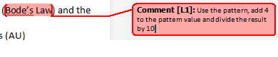
- For question 7, change the bulleted section (from star to Kuiper belt) on the second page into an appropriate SmartArt diagram, e.g. (3)

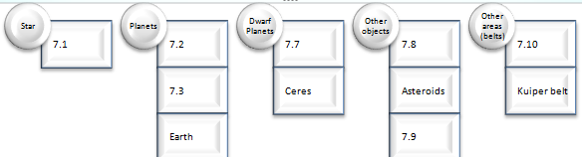

Ensure that all information displays and that the hierarchy remains the same.

