GradE 11
Practical Assessment Task
Computer Applications Technology
DBE
1/1/2012

Instructions to learners

COMPUTER APPLICATIONS TECHNOLOGY
GUIDELINES FOR
PRACTICAL ASSESSMENT TASK
GRADE 11
2012

LEARNER INSTRUCTIONS

What is the PAT?
The PAT is a research project in which you will have an opportunity to demonstrate your information management skills. You will also be required to demonstrate your ability to use the applications which you have studied during the year to produce quality outputs in the form of:

- A concise description of the problem and the task
- A set of quality questions (See Annexure A)
- A list of appropriate information sources
- Evaluation of the sources
- Completion of a questionnaire (See Annexure B)
- Evaluation and sifting of information
- Management and analysis of data
- A report on computer accessibility options
- A presentation which summarises your findings and recommendations
The PAT will be done in three phases. Your teacher will provide you with dates and deadlines for each phase.

The PAT counts 25% of your final mark for CAT, therefore it is vitally important that you strive to produce work of a high standard.

Topic
The everyday use of information and communication technology such as computers, cell phones, Internet, etc. become increasingly important in the workplace and in our homes. This means that our interaction with these technologies should be as comfortable and productive as possible.
You sometimes assist a non-profit community organisation dedicated to providing a correct and easier life for all people and especially for people with disabilities (such as blindness or visual impairment, quadriplegics, etc.) and diseases (such as arthritis, etc.). One of their projects for these people is to help them to use ICTs (computers, Internet, cell phones, etc.).
After the president of the organization read an article about universal design (designing products and environments so that anyone can use it easily), the organization decided that it was their duty to raise awareness regarding accessibility issues.

They decided to compile a report on this topic, which can be used to create an information brochure.
The main question they raise, and would want answered is:

What information and advice will inform people about accessibility issues regarding the use of ICTs?

At a meeting they decided that an investigation be instituted to ensure that these people, their families and the wider community have the right information, access to ICTs and how to make ICT’s more accessible to people that are affected by these defects.

The organisation provides a few suggestions and questions that can serve as a guide to collecting data and information that is needed to inform those involved.
They also realise that they must determine the following:

- What is accessible usage of ICTs?
- What do the people know about accessibility issues, ways of making ICT devices and user interfaces more accessible?
- People's attitudes and actions regarding these accessibility issues.
- Which people are affected by these issues?
You will be the project manager appointed to this project.
The President has sent the work already done during the meeting, as well as a few notes and suggestions.

The work done so far, include the following:

- Suggestions and questions as a guide for obtaining the necessary information (Appendix A).
- A framework of a questionnaire with notes that can be used to provide information about people's attitudes, awareness and knowledge about this issue in (Appendix B).
To ensure that the project successfully completed and will meet the requirements formulated in the main question, the president distributed the project in three phases. The main purpose of this is that you report often (after each phase) to the organization regarding the progress and work done in each phase

- An overview of the phases and tasks are on page 6 of this document.
- The instructions for the three phases are on pages 6 – 17 of this document.
After each phase you need information and evidence with you when finished.
The final report must at least contain the following:

- A brief description and background on ICT accessibility and those who are affected.
An analysis of the survey.
- General trends or patterns in terms of attitude / behavior and awareness / knowledge regarding accessibility issues identified by the survey.
- Information about accessibility issues (at least two) preventive measures, solutions, alternative devices or software, methods, tips, etc. – those that occur most in the community (as identified by the questionnaire).
- Other accessibility issues (minimum two) that you consider important and that people should be aware of, including alternatives, solutions, tips, etc.
Supporting information such as queries and reports from a database regarding accessibility issues or any other related issues.
- Tips.
- Any other information that will address the problem and the main question.

Tasks
The project will need to be done in three phases.

Phase 1
In this phase you will have to:
- Define in your own words exactly what the problem is and what you are required to do.
- Finalise a list of quality questions (at least 15) to guide your investigation (Annexure A).
- Finalise the questionnaire (Annexure B).
- Identify sources to find quality information.
  - Use the questionnaire, the Internet and at least one other source to find data and information
  - Evaluate sources identified
- Administer the questionnaire to at least 15–20 people.
- Gather data and information.

Phase 2
In this phase you will have to:
- Evaluate, summarise and manipulate the data and information you have found from the Internet, the questionnaire and the other source(s).
- Process the data gathered from the questionnaire and any other data, using a spreadsheet.
- Create a database with information gathered to answer questions and provide reports.
  - Ideas for which data to using in a database:
    - Accessibility
    - Type of challenge, effects that limit accessibility, ICT equipment / component involved, statistics, etc.
    - Available solutions
    - Type dysfunction, device involved, alternative device, image alternative device, costs, possible software solution, computer settings, etc..
    - Any relevant data based information.
- Look for patterns or trends.
- Plan the report.

Phase 3
In this phase you will have to:
- Interpret data and information, combine and remix the information to show your understanding and to answer the main question.
- Type up the report making use of good word processing techniques.
- Prepare a presentation, based on the report, to present to the community forum.

General
- For each phase you are expected to hand in your own, original work.
- Consult with your classmates and your teacher to ensure that your PAT is of a high standard.

Instructions for Phase 1
This phase of the PAT consists of the following parts:
- Determine what needs to be done – get 100% clarity.
- Create a list of good, quality questions to identify the information you will need for the project.
- Complete the questionnaire.
- Identify sources where the information could be found and gather the data and information.
- Evaluate the websites and other sources that you intend to use.

Define the task
- Create a suitable file structure like the one below to save your work. It is your responsibility to ensure that you keep a backup copy of all your work.

- Create word processing document for phase 1 in which to record your work in this phase. Give the document a sensible file name such as Phase 1 Working Document. Save it in the Phase 1 folder.
- To be sure that you understand why you are doing this investigation, you should be able to define what you are required to do in your own words. This is called the task definition. Use the following questions to help you write your own task definition:
- Why are you doing the investigation?
- What are the main tasks that you need to carry out?
- How will you go about it?
- What information do you need? (broadly described)
- Where will you find the information you need? (broadly described)
- Who is the information for?
- How must your information be presented?
- When must the task be completed?

Ask questions that will guide your investigation
- Read the main question that the president wants to answer. This should guide you to identify quality questions that will help you to find the information that you need.
- Use the suggested questions provided (Annexure A) and evaluate these questions to determine the ones you could use. Keep in mind that you will also need data and information that would be appropriate to
- process using a spreadsheet
- capture and manipulate using a database—perform queries and generate reports.
- Brainstorm some headings (at least four) which you can use to organise your information. The questions provided could help you to identify some headings (See president’s notes in Annexure A).
- Add questions of your own to complete your list of questions (at least 15).
- Evaluate the quality of the questions. Check for different types of questions or questions that show different levels of thinking, e.g. questions that will
provide facts (who, when, where, what, how many, etc.)
direct enquiry, examination, investigation (why, how, etc.)
support predictions or help with adjustments (what if, if, etc.)
support judgement or help to critique, review or find meaning (would it be better if, what recommendation, what would be best, etc.)
- Discuss your headings and questions with your teacher or classmates.
- Make your own final selection of headings (at least four) and questions (at least 15) which you will use to complete the project.
- Check your final list against the task definition and the main question that has to be answered to make sure that you stay focused on the problem and the task.

Complete the questionnaire
- Use the outline of the questionnaire with the notes provided (Annexure B) to complete the questionnaire.
- The questions in the questionnaire should provide you with the information that you need specifically from the people in your community and will not find in other sources, e.g.
- data that you could process to determine their behaviour or attitudes
- what they know and have experienced with regard to accessibility options
- Remember that questions with only one answer or questions where people can choose an answer from a list are often easier to process.

Gather information and data
- Choose at least four headings with relevant questions from your final list.
- For each heading complete a table like the one below.
- Start each heading on a new page of your word processing document.
- You must have at least 15–20 questions in total.
- Indicate the type or level of thinking for each question to show that you have thought about the quality of your questions.
- For each question, write down a possible source where you are likely to find the information for that question.
- You should use the questionnaire, the Internet and at least one other source.
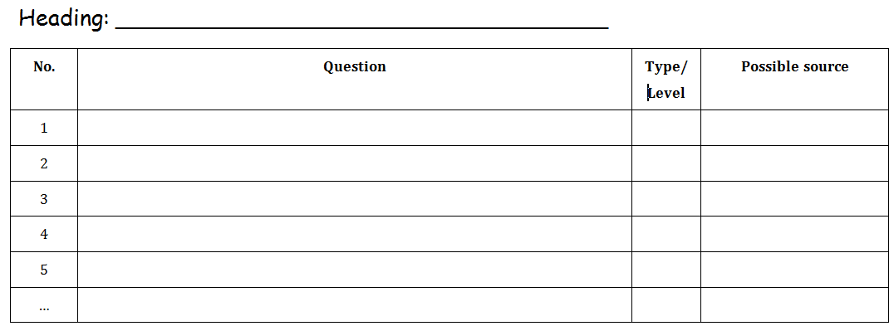
Figure 1: example of Question and source table
- Hand the questionnaire to at least 15–20 people.
- Collect the questionnaires after they have been completed and file them in a safe place.
- Save a copy of each website that you intend to use in the Saved Websites folder.
- Gather all other information and data you will need to complete the project. Save electronic copies of the information and data where possible.
- Evaluate the sources that you intend to use. For each source, complete a table like the one below to indicate that you have considered the trustworthiness of the source:
- Complete a column for each website (you should use at least three).
- Complete a column for other source(s) (at least one).
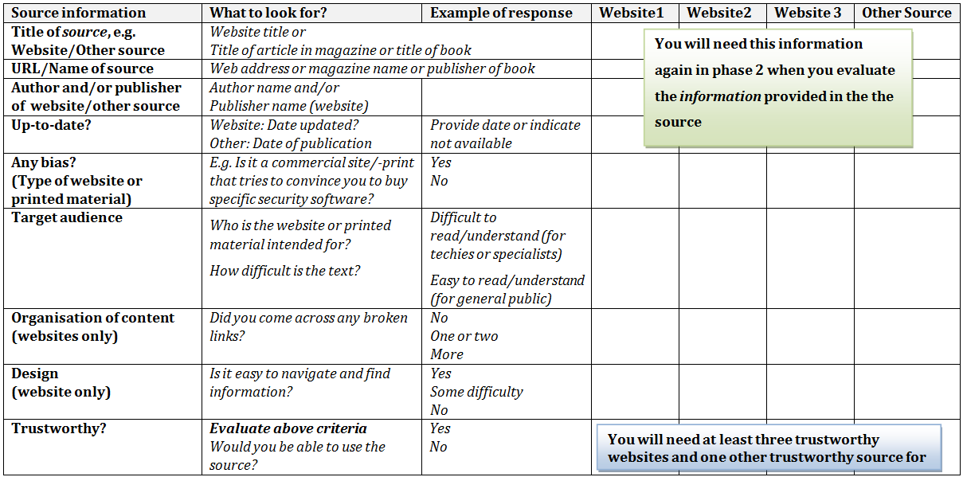
Figure 2: example of source evaluation table
Note: If any of the sources are not trustworthy you may need to find more sources for Phase 2

Hand-in for Phase 1
Once you have completed phase one of the project:
- Submit your entire PAT folder to your teacher. The following should be in your Phase 1 folder:
A single document typed in a word processor with
  - Your task description
  - A table (see example above) for each of the headings you chose
  - A table (see example above) for each website and other resource that you intend to use
  - The completed questionnaire
- Copies of websites you intend to use; saved in the appropriate folder.
- You must also hand in a file or plastic sleeve containing your completed questionnaires as well as any other evidence which could not be saved electronically.
- Your teacher will give you the date on which to submit your phase 1 for assessment.

Instructions for Phase 2
There following are parts to this phase.
- Evaluate and summarise all information found from trustworthy sources.
- Plan the report
- Use information found and gathered and create a database with relevant information that could be queried and provide reports.
- Analyse the survey results in a spreadsheet

Engage with and use information and data
- Evaluate the quality of the information you found in the sources that you identified as trustworthy in phase 1. For each source (e.g. website, article in magazine, etc.) complete a table like the one below to indicate that you examined the quality and usefulness of the information provided in the source (content of the sources that you are now going to use).
(Some information can be copied from the table in phase 1 as it is repeated for completeness)
Note: You may not copy and paste any information from the websites or other source into your phase 2 document. If you do, you will not earn any marks for this section of the task.
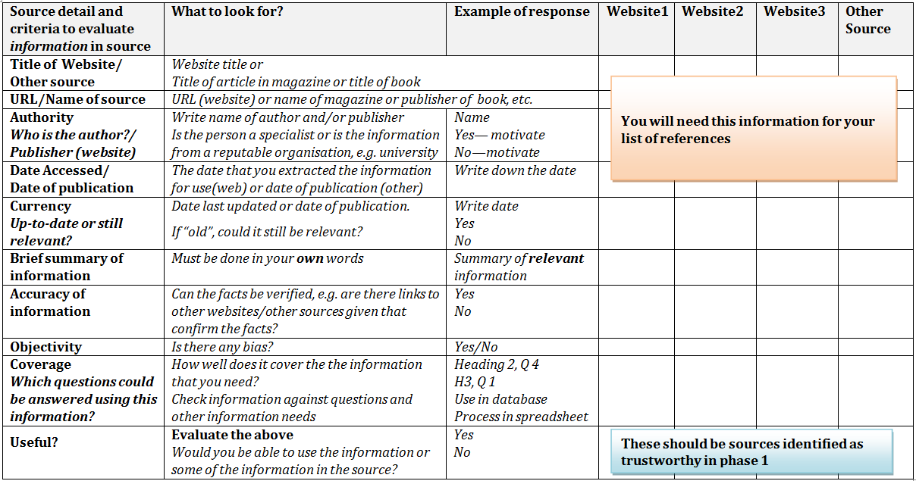
Figure 3: example of information evaluation table
- Record all the information you need to create a list of references.
- Make sure that you have evidence of the source(s) you used.

Plan the report
- Create a report outline or use a diagram, mind map or storyboard:
  - Indicate which information will be used in the database and what queries and reports will be done.
  - Plan the introduction—provide key words.
  - Plan the body—use the headings and questions from phase 1and indicate which information could be organised under each heading.
  - Plan the conclusion—provide key words.

Process data and analyse questionnaire results
- Analyse your questionnaire results in a spreadsheet.
- Capture the questionnaire results in a suitable format.
- Make use of suitable formatting to ensure that anybody will be able to easily interpret the results.
  - Make use of formatting features such as colour, borders, word wrap and font styles.
  - Make sure that column and row headings are formatted differently to other data.
- Make use of formulae and/or functions to answer data questions.
- Summarise the results.
- Use a column/bar or line graph or a pie chart in your spreadsheet program:
  - Illustrate a summary of your questionnaire data or results graphically—you should have a least one graph, although more would be useful.
  - You should be able to use these graphs in your report and presentation.
  - Apply what you have learned in Mathematics/Mathematical Literacy when creating the graphs.
- Process and analyse any other information or data that may require the use of a spreadsheet.
- Save the spreadsheet in your Phase 2 folder. Make sure that you use a meaningful file name such as Questionnaire Analysis.

Generate queries and reports
- Create a database with a meaningful filename and save it in your Phase 2 folder. The information must be relevant to the investigation. See page 4 for additional information.
- Capture appropriate data and information (at least 15 records) that could be used to answer or support questions.
- Make use of appropriate fieldnames and data types.
- Create queries (at least two) and at least one report to provide information or answer questions—you should be able to use the information obtained from these queries and report(s) in your final report and/or presentation.

Hand-in for Phase 2
Once you have completed phase two of the project:
- Submit your entire PAT folder to your teacher. The following should be in your Phase 2 folder:
  - The completed spreadsheet with the analysis.
  - The completed database with relevant queries and report(s).
  - A single document typed in a word processor showing
    - a table (see table above) with summaries of information and notes regarding the quality and usefulness of the information
    - reference information
    - information for database and what queries and report(s) to expect
    - the planning of the report
- Your teacher will give you the date on which to submit your phase 2 work for assessment.

Instructions for Phase 3
There following are parts to this phase.
- Interpret data and information, combine and remix the information to show your understanding and to answer the main question.
- Type up the report making use of good word processing techniques. Use your own words.
- Prepare a presentation using a presentation program such as PowerPoint.

Report
- Create a document in your word processor. Save this document in the Phase 3 folder using a meaningful file name such as Report Accessibility.
- Apply your word processing skills you have learned to produce a quality document. Take note of the style guide – see Annexure C.
- Your report must consist of the following
- A title page
- A table of contents
- Use your planning from phase 2 to complete the report. The following outline could be used:
  - Introduction
  - Body
    - Headings from phase 1 and 2 with appropriate and relevant information under each heading as well as supporting evidence such as graphs, tables, data, etc. where appropriate.
    - Interpret and integrate information where necessary.
    - Look at the sequence and flow of the information.
    - The information you give must be written in your own words.
    - You will be heavily penalised if you copy and paste large chunks of text directly from the Internet or any other source. Plagiarism is totally unacceptable.
    - Be original and creative.
  - Conclusion
  - List of references.
    - Make use of either the Harvard or APA referencing style.
    - The information you need should be found in the summary documents you created in phase 1 and/or phase 2.
- You are free to organise the information in any logical and coherent way if you wish.
- Use of graphics and/or graphs
  - The graphics and/or graphs included must be meaningful and add value to the document.
  - Graphs, tables, data, summaries, etc. must be easy to read and interpret.
  - Provide captions.
  - Graphics obtained from the Internet or other sources must be acknowledged.
- Use a word processing function to insert page numbers into the footer of the document. Page numbers should not be used on the title page.

Presentation
- Create a presentation in your presentation program. Save it in your Phase 3 folder making use of a meaningful file name such as President Accessibility.
- Your presentation should have at least the following slides
- A title slide
- A contents slide
- Introduction
- Different slides discussing the different ideas or concepts
- Questionnaire results
- Conclusion and recommendations
- The presentation should be a summary of the report. Large amounts of text are not required. You should not simply copy and paste what you did in the report into the presentation. You will be penalised heavily for doing this.
- Use hyperlinks to other information should you need to show or discuss more detail.
- Make sure that your presentation has a consistent appearance.
- Similar elements on a slide such as headings should be formatted in the same way.
- Slides should have the same background.
- The text on each slide must be easy to read when projected onto a screen in a classroom.
- Add graphics and/or graphs or tables where appropriate.
- Choose an appropriate transition effect and apply it to all slides except the title slide.
- Apply appropriate animation to no more than one element on each slide.
- It is not considered good style to animate headings.
- Remember that the presentation is for the community forum members. Make sure that the animations you choose are appropriate and are not distracting or disturbing.
- The timing of the presentation must be controlled by the presenter. It should not run automatically.

Hand-in for Phase 3
Once you have completed this part of the project:
- Submit your entire folder to your teacher—make sure that the spreadsheet, database, report and presentation are saved correctly.
- Hand in the file containing the completed surveys as well as any other evidence you have collected.
You should have completed and submitted this project before you start your end of year examinations.
Not submitting your PAT will mean that your marks will be incomplete and will affect your results and promotion to the next grade.
- Your teacher will give you the date on which to submit your phase 3 work for assessment.

Annexure A

Notes from meeting
The president made the following decision:
We need to make people in our community aware about accessibility options of ICT’s to people with disabilities. Before we can do this we have to determine what the general public know about accessibility issues, people’s attitudes toward these accessibility issues and which people are affected by these issues.
After reading about accessible computer interaction for people with disabilities, especially quadriplegics, this project is prioritised.
http://uir.unisa.ac.za/bitstream/handle/10500/465/kotze%20%26%20eloff.pdf?sequence=1
So, what can we do? The organisation needs to present a final recommendation on how to inform people regarding the use of ICT’s.
Questions brainstormed by the members regarding the information they might have to find:
- What does the term ICT refer to?
- How many people with disabilities are using computers?
- What types of ICT’s and accessibility options are available for people with disabilities?
- What recommendation could we make regarding accessibility options?
- If people are informed, would they benefit from using computers?
- Would a more accessible GUI interface assist people with disabilities?
- How could people be made aware of accessibility options?
- Which people are influenced by accessibility options?
- Etc.

Annexure B

Questionnaire outline
Remember that we need responses that will tell us what they know and how they behave, such as whether they use or are aware of accessibility options
From the decision made and questions that the members brainstormed, I have suggested a few questions for the questionnaire. Look at them and see if you could use them

It would be appreciated if you would take the time to complete this survey. The information will be treated confidentially. You do not have to supply your name.
Write your answer in the space provided.
Gender: ___________ (M for male, F for female) Age: ___________ (In years)
- Do you have a disability? Yes
- If yes, what type of disability do you have? Choose an item.
- If no, how many people do you know that have a disability? Yes
- Do you or the people you know use computers? Choose an item.
- If you/they use computers, which accessibility options of
Windows is used?
- Etc.
Thank you for completing the questionnaire.

Annexure C

Style guide for word processing documents

Title page
- Text should be centred both vertically and horizontally on the page
- Text should be typed using a font size of about 20 pt.
- This should be the only page on which you make use of a page border.
- Avoid “arty” borders and backgrounds.
- Do NOT use Word Art/Text Art.

Headings
- The font used should be easy to read, e.g. Cambria
- Different levels of headings should be clearly distinguished.
- Font size should vary between 12 to 18 pt.
- Ensure that headings stand out clearly from other text.
- Make use of heading styles from the quick styles gallery (Office 2007/2010) for easy and quick formatting of headings and to ensure that headings are formatted in a consistent way.

Body text
- Use a font that is easy to read and that are the same as the heading font or matches the heading font, e.g. Calibri.
- Font size should not be larger than 12 pt and not smaller than 10 pt.
- Ensure that all body text is formatted in a consistent way. Using styles from the quick styles gallery would help to ensure consistency.
- Body text should be distinguished from headings.
- Body text should be left aligned.

Page layout
- Use word processing functions to add page numbers.
- Make use of page breaks to start new pages.
- Make use of lists where appropriate to support readability.
- Use sufficient white space.
- Tables, charts and other graphics should have appropriate captions.

General formatting and editing
- Keep it simple—this is not an art or design competition—it is the quality of the report and content that matter.
- Spell check your document. Professional documents are error free.

