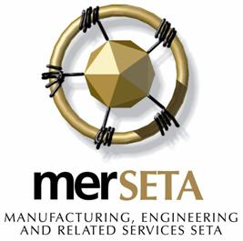

VEDANTA TRAINING CENTRE T/A
TATA SKILLS DEVELOPMENT CENTRE
PO Box 328, Richards Bay, 3900
28 Ceramic Curve, Alton, Richards Bay, 3900
Tel: 035 7512052 Fax: 0865113779
Email: tataskillsdevelopment@gmail.com 17-A/ACC/0278/08

24 February 2010

ATTENTION: ERNEST – CETA HEAD OFFICE

MOU APPLICATION FROM:

VEDANTA TRAINING CENTRE – TRADING AS TATA SKILLS DEVELOPMENT CENTRE
MERSETA ACCREDITATION NUMBER: 17-QA/ACC/0278/08

I have spoken to Naphtaly at our head office at MERSETA and he informed me that I can send our MOU application directly to you for approval.

Please receive hereby our MOU secondary application from CETA to deliver the full qualification: Community House Building.

Attached to this letter, please find the completed secondary CETA application forms.

I have send a copy of this application to Naptaly at our MERSETA head office in Johannesburg.

Should you have any questions regarding this MOU application, please do not hesitate to contact me.

Yours in training

RIA ENSLIN
TRAINING MANAGER

TEL: 0834686281

