SEPTEMBER 2009 PRELIM EXAM
PAPER 2: THEORY

TIME: 3 HOURS
MARKS: 205
INSTRUCTIONS:
- Write neatly
- Answer all 5 questions
- Complete the Trace Table on the sheet provided.

Question 1: (20)
Multiple Choice Questions: (5 x 2 = 10)
1.1. The chipset … (2)
  - is responsible for all communication on the motherboard.
  - determines the minimum capabilities of the motherboard.
  - determines the maximum capabilities of the motherboard.
  - is not of any importance on the motherboard.
1.2. The North Bridge is responsible for … (2)
- the front side bus speed.
- communication between the PCI Express and the CPU.
- communication between the CPU and the USB ports.
- communication in general on the motherboard.
1.3. A built in video card is … (2)
- located in the South Bridge.
- controlled by the South Bridge.
- controlled by the North Bridge.
- located in the Bus link.
1.4. The front side bus is … (2)
- also known as the system bus.
- also known as the external bus.
- used to cart data to the USB ports from permanent storage.
- used to cart data to the permanent storage from the USB ports.
1.5. The expansion bus … (2)
- does not allow data to be transferred.
- is not also known as the PCI bus.
- is also known as the PCI bus.
- can be removed for cleaning.

True or False: In the case of false, explain your answers. (5 x 2 = 10)
1.6. Devices in the PCI slots are portable and there can be up to 10 of them. (2)
1.7. FireWire will one day replace USB. (2)
1.8. AGP is a relatively new standard capable of extremely fast data transfer. (2)
1.9. All processors use FLU and ALU. (2)
1.10. Registers are permanent storage structures. (2)
(20)

Question 2: (55)
- What is RAID? (2)
- What is RAID level 0 and how does it work? (2)
- What is RAID level 5 and how does it work? (2)
- How can end users improve their secondary storage? (5)
- Name five (5) possible methods for improving the CPU (5)
- What is the twofold problem with the internet? (4)
- What is a ‘DoS’ attack? (3)
- What are ‘key loggers’? How does one get rid of them? (3)
- What is ‘phishing’? (2)
- Describe social engineering and explain what it is used for? (4)
- What is a firewall and how does it work? (4)
- How does public key encryption work? (3)
- What does authenticity of data refer to? (2)
- What does validity of data refer to? (2)
- What does verifying data entail? (2)
- The statement is made that Information Technology makes the world a better place. Name and briefly discuss at least five (5) areas in which ICT makes the biggest difference. (10)
(55)

Question 3: (50)
- Design a trace table for the following scenario. You are provided with the following data file. The data is comma delimited. (25)
Acronym | Meaning | HV_Google | HV_Yahoo | HV_Windows_Live | HV_Lycos | HV_Netscape
3G | Third-generation | 86 | 21 | 28 | 67 | 32
ACL | Access Control List | 43 | 9 | 48 | 7 | 84
AIF | Audio Interchange Format | 91 | 37 | 77 | 33 | 70
AID | Advertiser ID | 31 | 17 | 33 | 47 | 25
AIP | Association of Internet Professionals | 48 | 15 | 87 | 29 | 77
ANSI | American National Standards Institute | 88 | 82 | 3 | 14 | 15
AJAX | Asynchronous JavaScript and XML | 59 | 1 | 77 | 65 | 77
API | Application Program Interface | 21 | 68 | 59 | 95 | 64
ARP | Address Resolution Protocol | 67 | 30 | 9 | 77 | 50
ASCII | American Standard Code for Information Interchange | 57 | 95 | 68 | 34 | 1
ACE | Accredited System Engineer | 77 | 75 | 20 | 15 | 91
ASF | Advanced Streaming Format | 86 | 69 | 29 | 10 | 63
ASIN | Amazon.com Standard Item Number | 16 | 28 | 54 | 96 | 18
ASP | Active Server Pages or Application Service Provider | 18 | 58 | 50 | 29 | 16

You must design a trace table to simulate the entering of this data into seven (7) arrays. Use the attached sheet to do this. Keep track of all the variables required. The data is read in line by line so you will need to do string manipulations.
- Now that you have completed the trace table for this scenario, complete the Delphi code for this trace table. Remember to comment you code. Use all the variables and components you need. Use the code segment below as you starting point:

procedure TForm1.FormCreate(Sender: TObject);
begin

end;
(25)(50)

Question 4: (60)
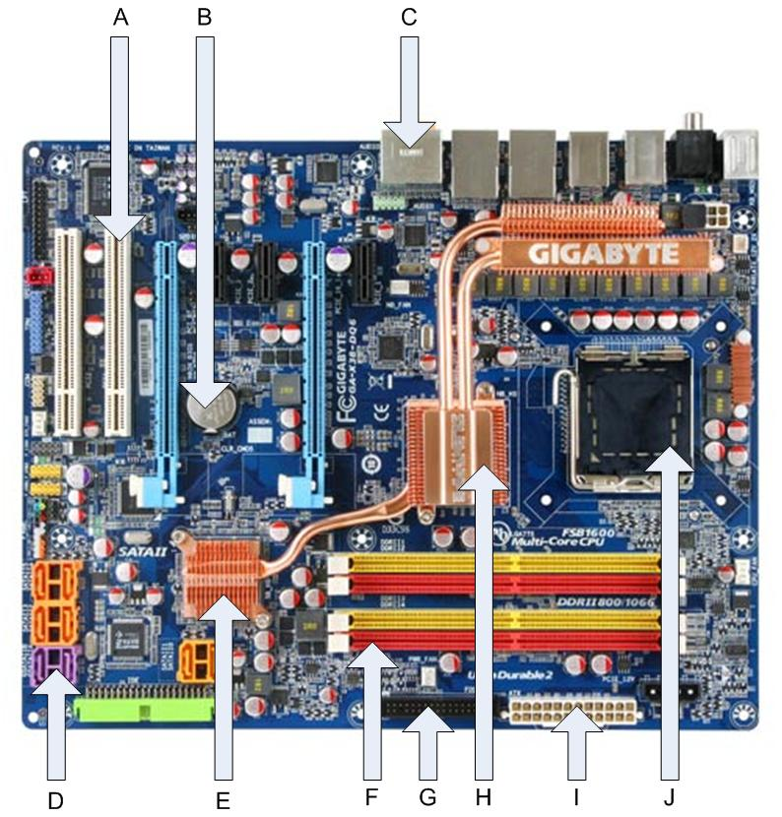

- Name all the marked components. (10)
- What is the FSB? (2)
- What are the functions of the North Bridge? (5)
- What are the functions of the South Bridge? (5)
- What is the role of the External Bus? (2)
- What are the following types of Memory used for? (10)

  - ROM
  - CMOS
  - DRAM
  - SRAM
  - Flash RAM

- Describe the machine cycle. (5)
- What are the reasons for using a network? (5)
- What do the following acronyms stand for and what are they used for? (16)

  - LAN
  - WAN
  - TCP/IP
  - IrDA
  - WiFi
  - RFID
  - FTP

(60)
Question 5 (20)
- What is the role of Cache memory and caching in the CPU? (3)
- What is virtual memory and what is its role in PC performance? (3)
- What is GIGO? (2)
- What can a person do to protect their data and computer? (5)
- What is identity theft, and how does it happen? (4)
- What is does the ethical use of data and ICT hardware entail? (3)

(20)

TOTAL: 205

